**How to print the skin of BOXZ**

1. deactivated “Auto-Rotate and Center”, “Page Scaling” select “None”(Don’t use any Scaling, just 100%).  
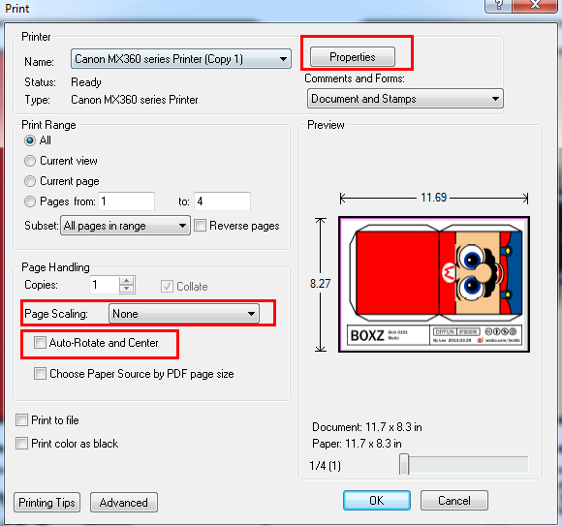

2. Open printer Properties, “Printer Paper Size” select “A4”, and choose “Landscape”.  
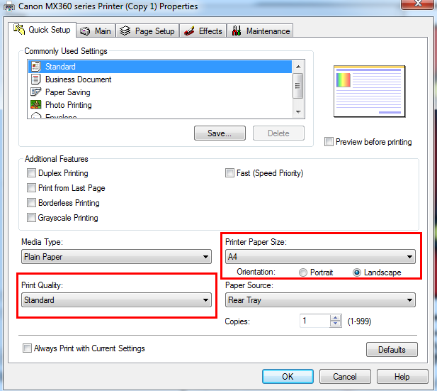

3. You could change “Print Quality” as you wish.

4.Print the skin and measure the length of side is “130MM”.