1’It has column names: Gender, Height, Weight, separator is “,”

***1.***

**a’several ways: use df[1:10,], or head(df, 10), tail(df, 10)**

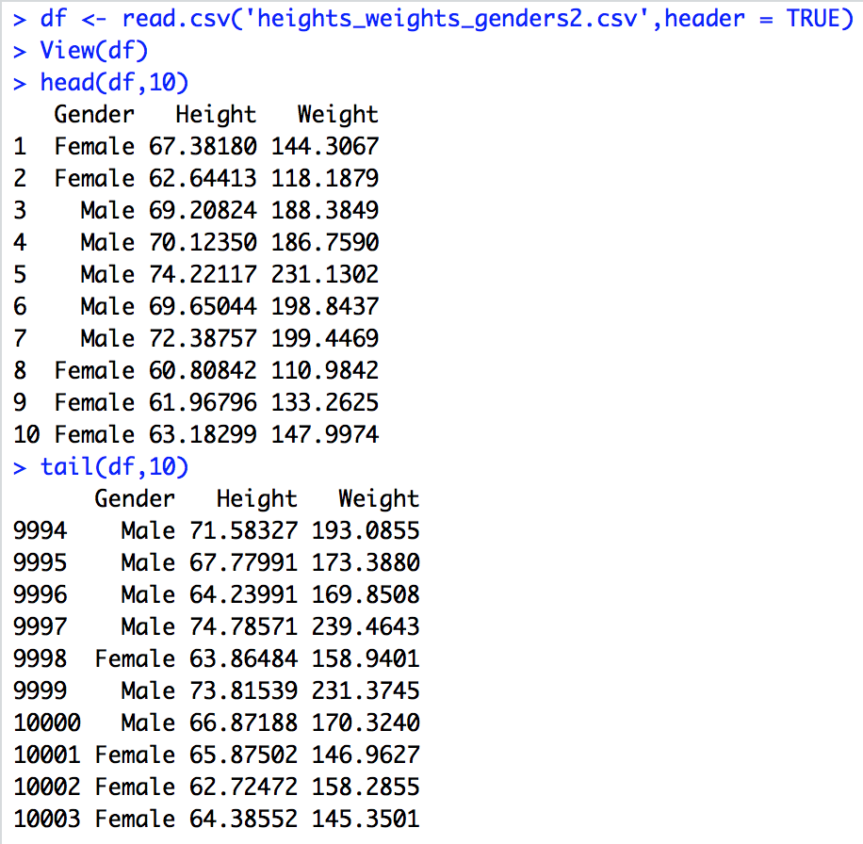

**When use as.is.**

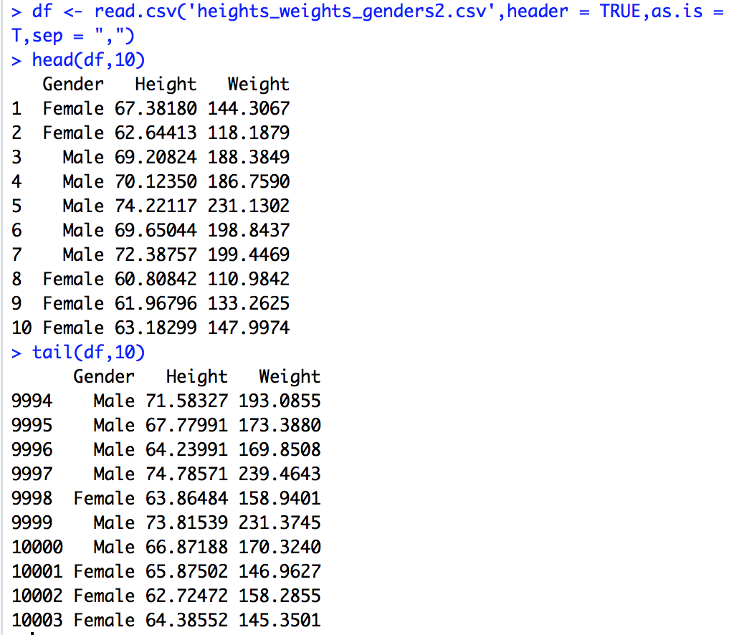

**b’10003, 3**

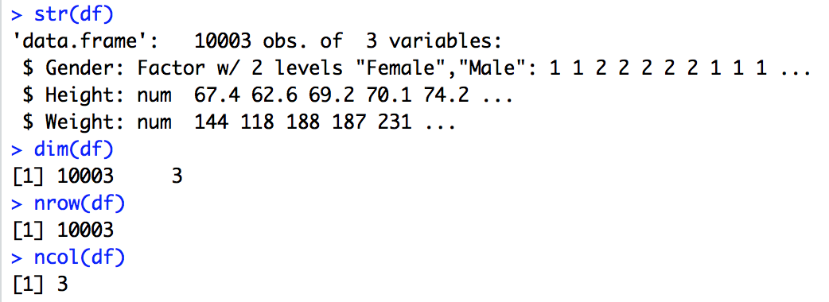

**Since it is stange, that means Gender has some other value, when using as.is, it behaves good. But we can’t find differences through this way.**

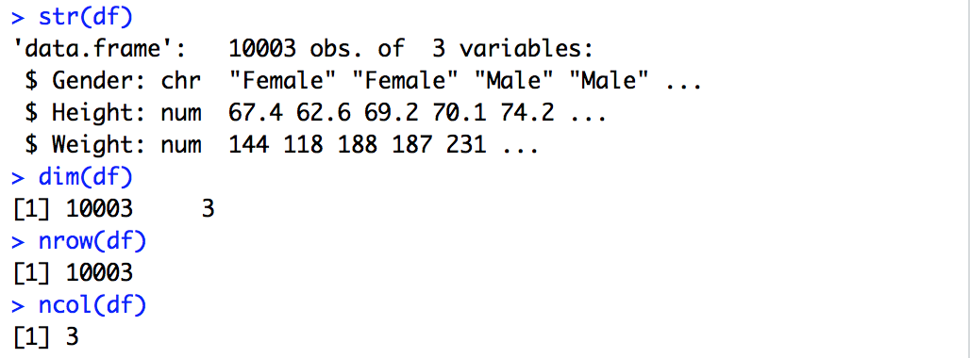

**So latter I think it’s better for us to don’t use as.is in this assignment.**

**C’factor numeric numeric**

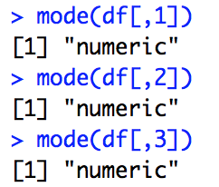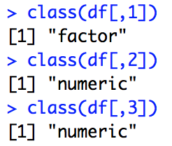ß

**D’Height.max = 79.00, Height.min = 54.26, Weight.max = 270.0, Weight.min = 64.7**

**When give as.is attribute.**

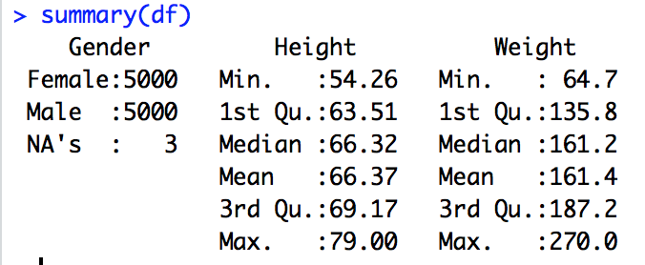

**E’4425, 5266, 9222**

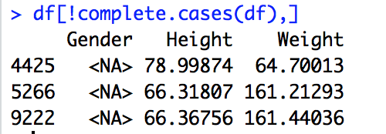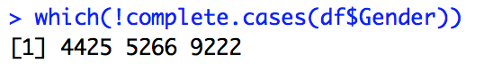

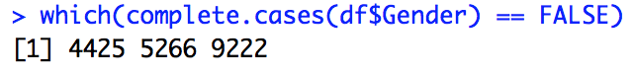

**F’3**

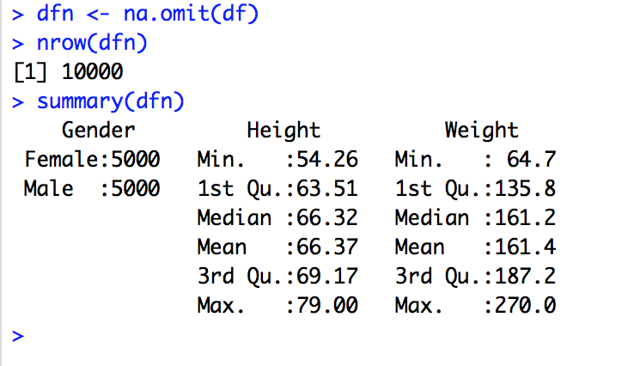

**G’**

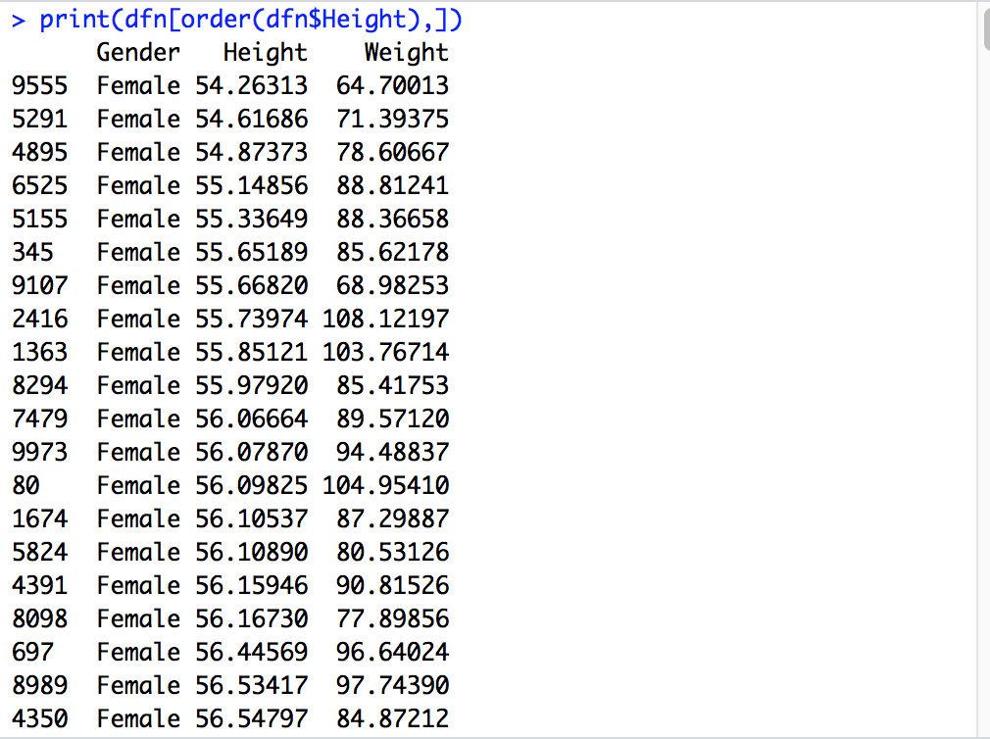

**H’**

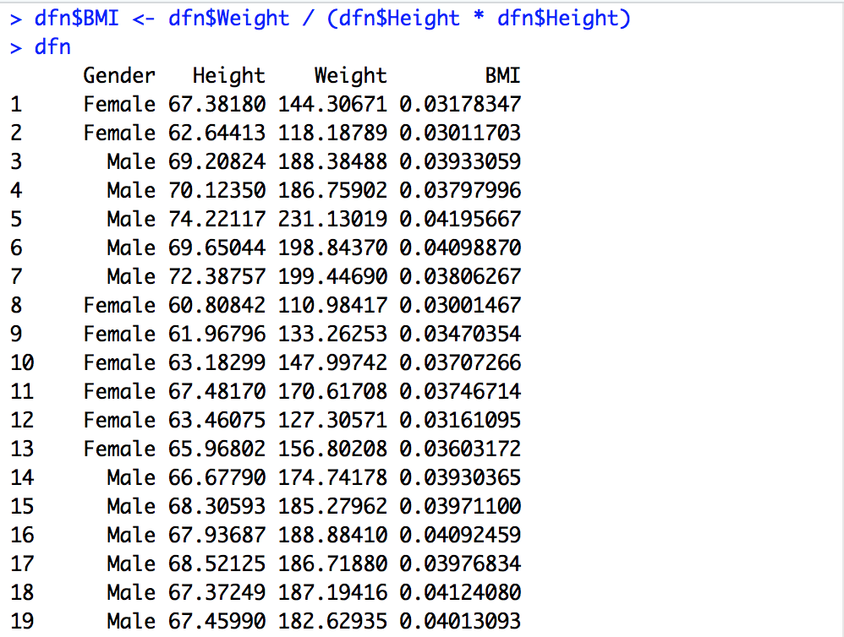

**2.**

**A’. They are almost presenting a linear relationship.**



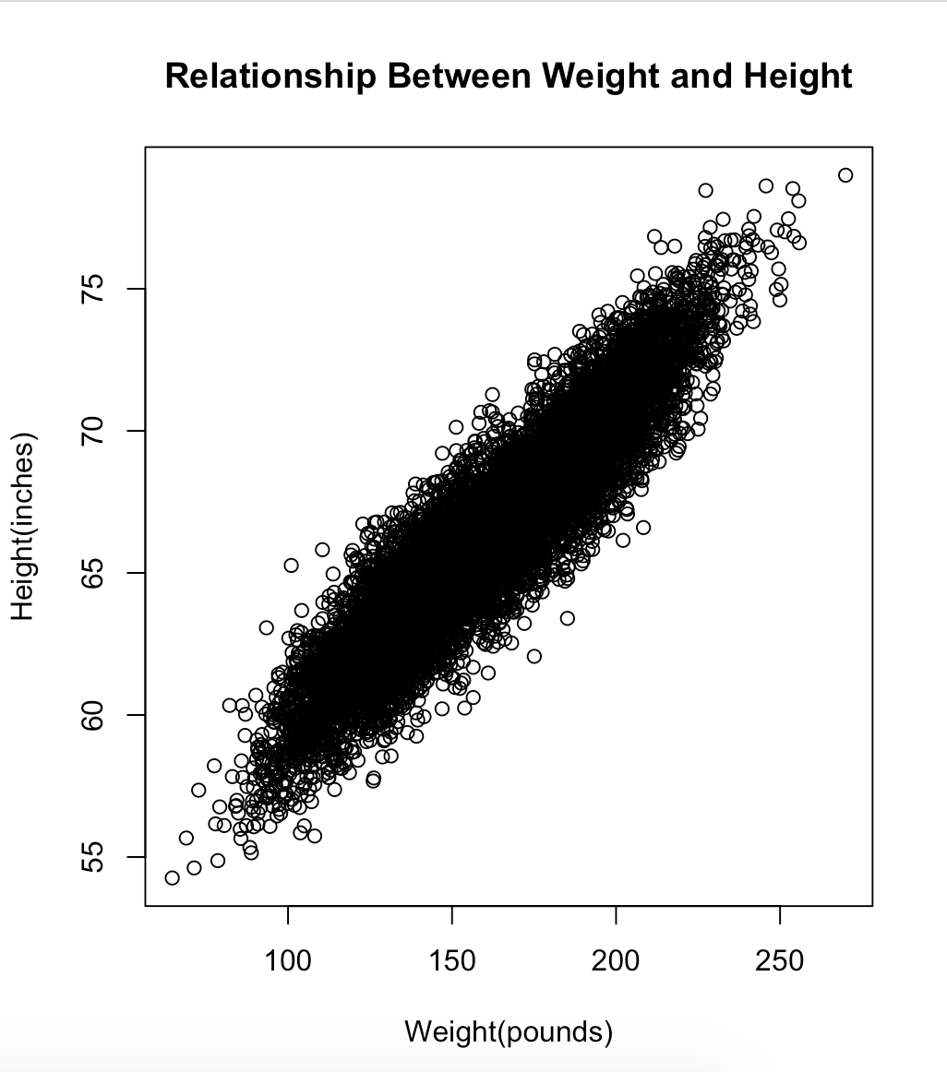

**B’**

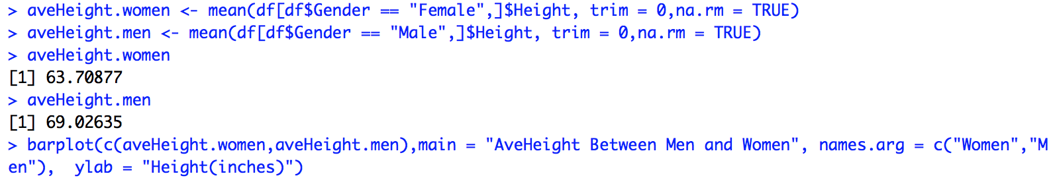

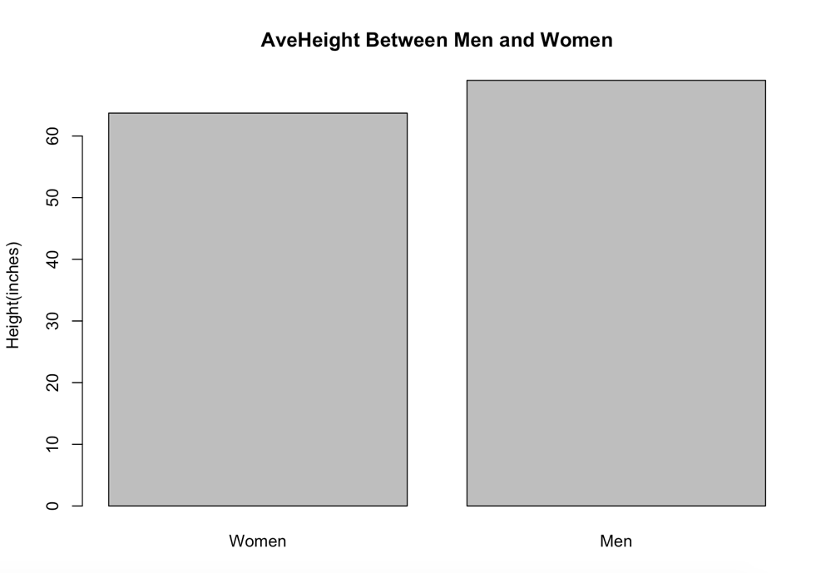

**C’**



