Result:

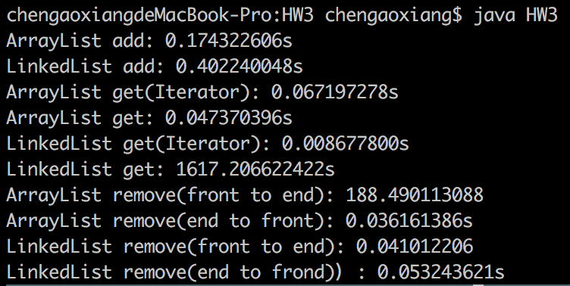

As what I think, when the spend of those operations depend on the direction.

For arraylist, when add/remove element from front to end, it will move all the array, so it cost tons of time, O(n). While linkedlist is faster, O(1).

For linkedlist, when get element without using iterator, since it will search element from front to end, it will cost tons of time, O(n^2). While get function in arraylist is much faster, O(1).

When using iterator, linkedlist get is faster than arraylist, when from end to frond, arraylist remove is faster than linkedlist.