1. Output from program

Result:

Approach1:

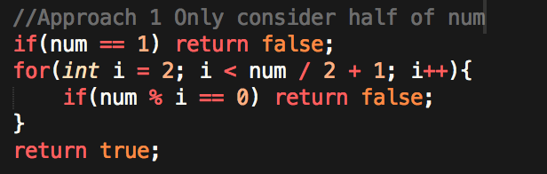

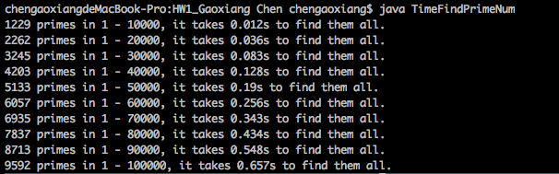

Approach2:

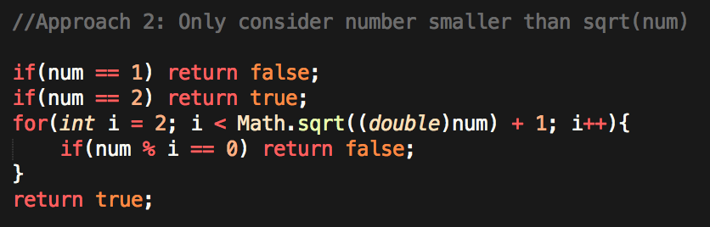

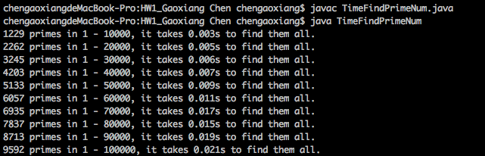

Approach3:

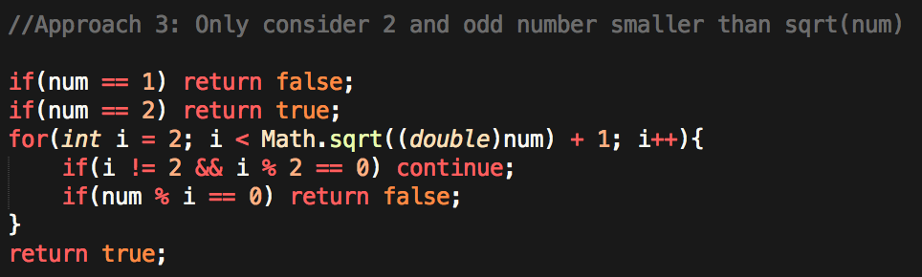

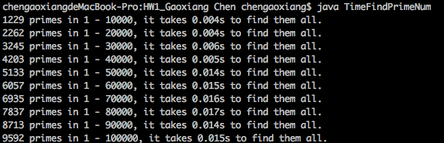

Approach4:

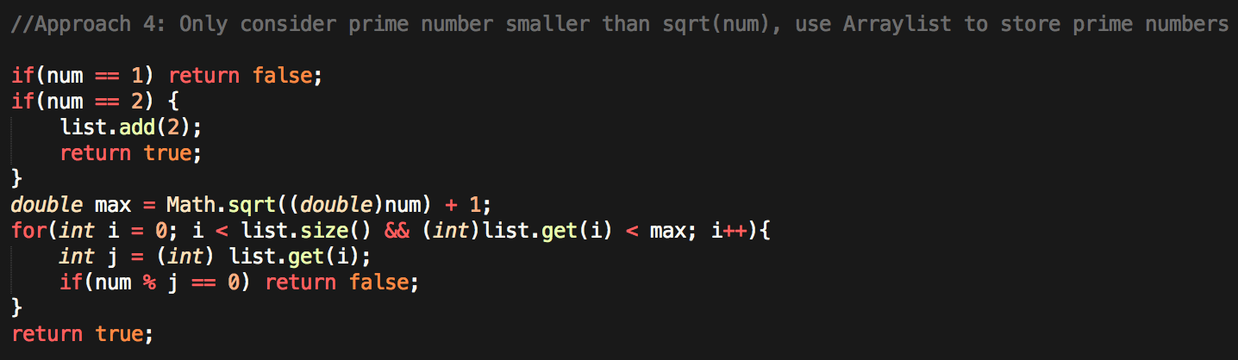

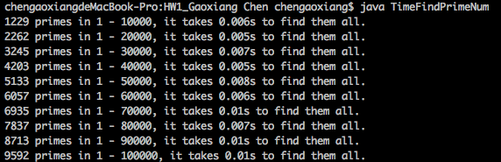

1. Plot（Approach 1）

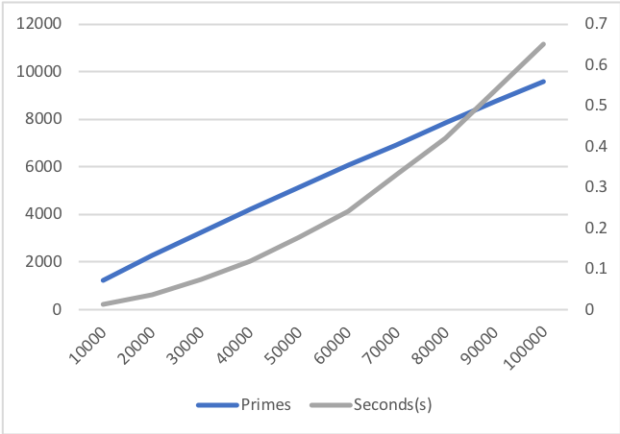

1. When counting 100000-1000000, there are dramatic difference between different algorithms.

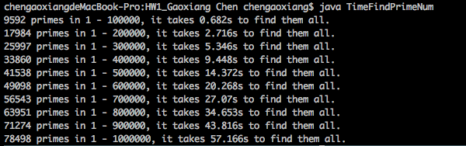(1)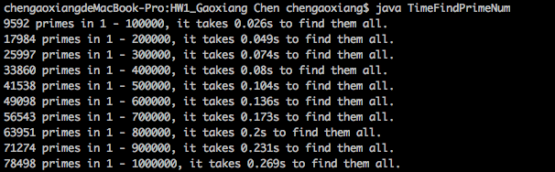(2)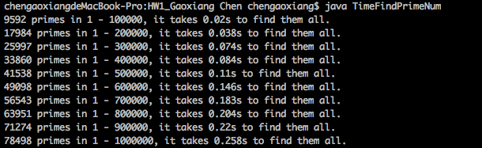(3)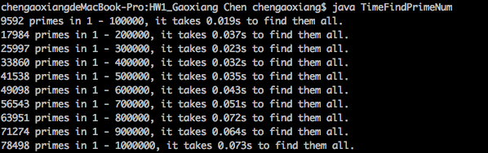 (4)