**Name: Gaoxiang Chen, ID: 4295735**

**INFSCI 2710 Database Management, Fall 2018**

**Homework 2: Relational Algebra, SQL**

**100 pts**

**Due Date: 2/14, at the beginning of the class. Hard copy, please type and print your answers.**

**Note**: Use MySQL to answer all questions. **For each question you need to provide the SQL query and** **also the screen shot of the output of that query** from either phpMyAdmin, MySQL Workbench or from the terminal (if from terminal, make sure it is formatted properly).

**Preparations**: Download code from the class page and load data into MySQL. Running follow by the order create_table.sql -> insert_data.sql

Consider the following schema:

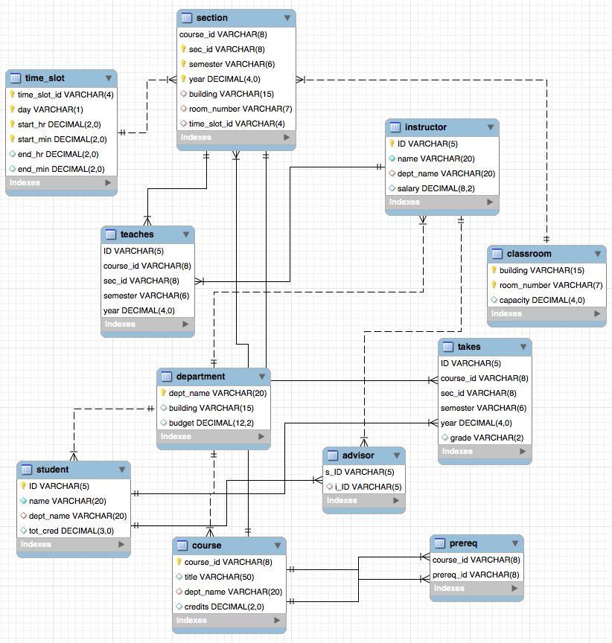

Don’t try to write/adjust your SQL queries by looking the provided data too much. When

checking your homework, we will run your queries on a larger dataset.

Q1[5pt] Count the number of instructors form Physics department.

Answer:

SELECT count(*)

FROM instructor

where dept_name = "Physics"

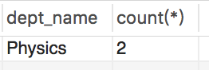

Q2[5pt]: Find the names of courses in Computer science department which have 3 credits.

Answer:

SELECT title, dept_name, credits

FROM course

where dept_name = "Comp. Sci."

and credits = 3

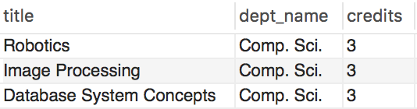

Q3[5pt]: Find all the courses’s name taken by student 98988

Answer:

SELECT T.ID,C.title

FROM takes T, course C

where T.course_id = C.course_id

and T.ID = 98988

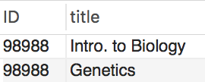

Q4[10pt]: As above but show the average salary of all the instructor of those courses taken by student 98988.

Answer:

select avg(I.salary)

from instructor I

where I.ID in (select T1.id

from teaches T1, takes T2

where T1.course_id = T2.course_id

and T2.ID = 98988)

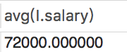

Q5[10pt]: Find the students’ name who take the course in the different department as the student.

Answer:

Select()

select S.name

from student S

where S.ID in (select distinct S1.ID

from student S1,

(select T1.ID as ID, C1.dept_name as D

from course C1, takes T1

where C1.course_id = T1.course_id) as S_T_D

where S_T_D.ID = S1.ID

and S1.dept_name <> S_T_D.D)



Q6[10pt]: Find the maximum and minimum enrollment across all sections, considering only

sections that had some enrollment, don't worry about those that had no students taking that section.

Answer:

select max(CC.count), min(CC.count)

from (SELECT count(*) as count

FROM takes

group by sec_id, semester, year) as CC



Q7[5pt]: Find each student ID and the count of courses he/she takes. Display the student ID and course count.

Answer:

SELECT S.ID, T.Count

from student S left join (SELECT T1.ID as ID, count(*) as Count

from takes T1

group by T1.ID) as T

on S.ID = T.ID

group by S.ID

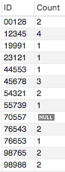

Q8[10pt]: Find the student who take more courses than the other students. Display the student ID and course count.

Answer:

select T1.ID, count(*)

from takes T1

group by T1.ID

having count(*) >= all((select count(*)

from takes T2

group by T2.ID))

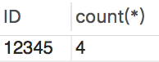

Q9[10pt]: Find the student and the largest classroom (biggest room capacity) among all the class he/she has taken. Display the student ID and the room capacity.

Answer:

Select T.ID, max(C.capacity)

From takes T, section S, classroom C

Where S.course_id = T.course_id

And S.sec_id = T.sec_id

And S.year = T.year

and S.semester = T.semester

and S.room_number = C.room_number

group by T.ID

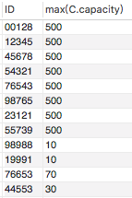

Q10[15pt]: Find the student (ID) from history department who has taken classes in the largest classroom (biggest the room capacity) compare with other students in history department. Display the student ID and the corresponding room capacity.

Answer:

Select T.ID, max(C.capacity)

From takes T, section SE, classroom C

Where SE.course_id = T.course_id

And SE.sec_id = T.sec_id

And SE.year = T.year

and SE.semester = T.semester

and SE.room_number = C.room_number

and T.ID in (

select T1.ID

from takes T1, student ST

where T1.ID = ST.ID

and ST.dept_name = "History")

group by T.ID

having max(C.capacity) >= all((select C1.capacity

From takes T2, section SE2, classroom C1

Where SE2.course_id = T2.course_id

And SE2.sec_id = T2.sec_id

And SE2.year = T2.year

and SE2.semester = T2.semester

and SE2.room_number = C1.room_number

and T2.ID in ( select T3.ID from takes T3, student ST2 where T3.ID = ST2.ID and ST2.dept_name = "History")))



Q11[15pt]: Find the department that its students take more courses on average than other departments. Display the department, and average count of courses that its student take.

Answer:

select DC.D, avg(DC.s_class)

from (Select S.dept_name as D, count(*)as s_class

From takes T, student S

Where S.ID= T.ID

Group by T.ID) as DC

group by DC.D

having avg(DC.s_class) = (select max(AVG_DSC.AVG_C)

from (select DC.D as D, avg(DC.s_class) as AVG_C

from (Select S.dept_name as D, (count(*)) as s_class

From takes T, student S

Where S.ID= T.ID

Group by T.ID) as DC

Group by DC.D) as AVG_DSC)

