COURSE CODE/TITLE: |  |  | SECTION: | CPE11S4
DATE PERFORMED: | Sept 2 2026 |  | DATE SUBMITTED: | Sept 2 2026
NAME: | Evangelista Sean Andrei P. |  | INSTRUCTOR:

ACTIVITY NO. ___ | [ACTIVITY NAME]
1. PROCEDURE OUTPUT
What procedures did you perform?

2. ANSWERS TO SUPPLEMENTAL ACTIVITY
1. Problem: Daily Step Goal Tracker
You are tasked with developing a Daily Step Goal Tracker for a fitness app used by casual walkers. Users log their steps in batches throughout the day (e.g., after each walk) instead of all at once, and the app needs to tell them when they've hit their goal. To make their job easier, create a program that:
- asks the user to enter their daily step goal before logging begins.
- repeatedly asks the user to enter the number of steps taken in a session.
- keeps a running total of steps logged so far, adding each new session's steps to it.
- After each session is entered, displays the current running total.
- Continues asking for session steps, using a loop, until the running total meets or exceeds the daily goal.
- Once the goal is reached or exceeded, displays a congratulations message along with how many sessions it took and the final total step count.
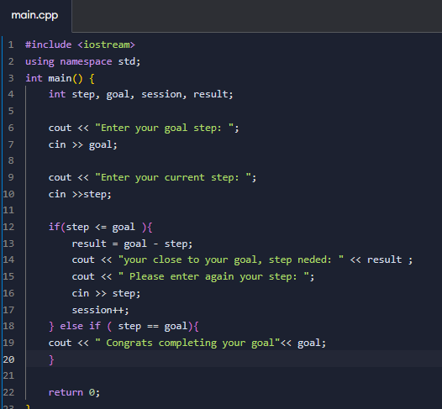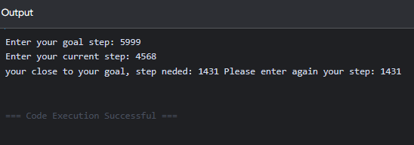

2. 2. Problem: Workout Duration Validator
You are tasked with adding an input-validation step to the same fitness app. Before a workout can be logged, the app needs to make sure the user enters a sensible duration — this exercises a validate-and-reject loop rather than a running-total loop. Create a program that:
- repeatedly asks the user to enter their planned workout duration in minutes.
- checks whether the entered value is valid, it must be greater than 0 and no more than 180 minutes.
- if the value is invalid, displays an error message explaining the valid range, and asks again.
- Continues asking, using a loop, until the user enters a valid duration.
- Once a valid duration is entered, displays a confirmation message showing the workout duration and how many attempts it took to enter a valid value.
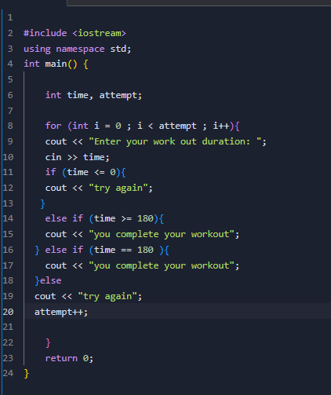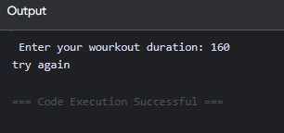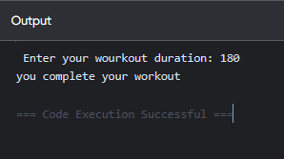

3. ARTIFICIAL INTELLIGENCE (AI) USE DISCLOSURE STATEMENT
I hereby declare that artificial intelligence (AI) tools were used, if applicable, in the preparation of this academic work. The following indicates the nature and extent of AI assistance:

Tools Used:
Examples: ChatGPT, Microsoft Copilot, Grammarly, QuillBot, etc.

Purpose of Use:
Examples: grammar correction, idea generation, formatting, summarization, code assistance, explanation of concepts, etc.

Extent of Use:
Explain how AI was used and confirm that it did not replace original thinking, analysis, authorship, or completion of the required work.

By submitting this activity, I affirm that my use of AI complies with T.I.P.’s AI usage policy and does not exceed the permitted limits for similarity, automated content generation, or academic assistance.

I understand that any false, incomplete, or misleading disclosure may be subject to investigation in accordance with due process and may result in sanctions for violation of existing T.I.P. policies.

Lab activities, templates, and related instructional materials shall not be reuploaded, reproduced, distributed, or shared with external organizations or third parties without the prior express written permission of the Technological Institute of the Philippines.

