Business Intelligence: EBUS3030
Assignment 1:
BIA Inc Best Performing Sales Staff Analysis

Team C2C:
Aaron Moss
Lakshya Dutt
Tyler Dowton

Contents
Introduction: 3
Data Model: 3
Extract Transform Load (ETL) Processing Utilised: 3
Output Analysis: 3
Executive Summary: 3

Introduction:

Data Model:
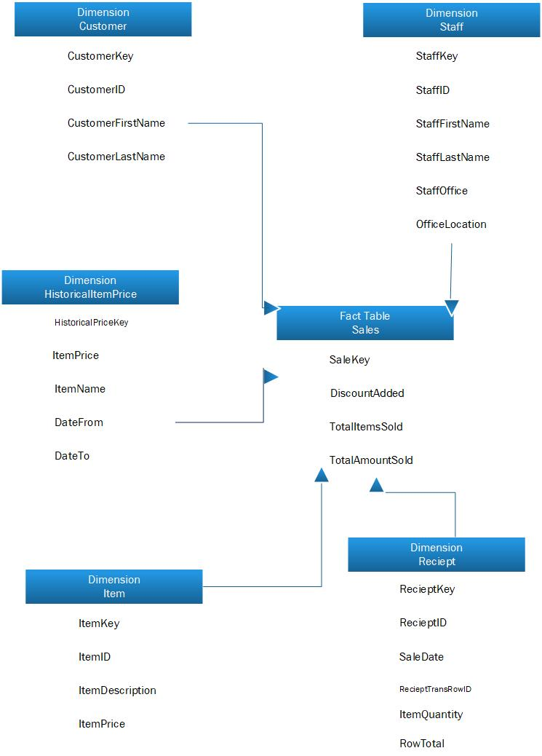

Data Model Table (Below):
Datamart Design Aspect | Notes/Outcomes/Decisions
Functional Requirements | All customers are to be stored only once and do have a unique identifier in order to provide their information to the system and look up their record and sales they are involved in  The receipt field is to hold many line items  A sale with over 5 line items of 5 different items allows the customer access to an 18% discount  The system is to look up the total of sales by finding the record, multiplying the cost per item to the amount purchased, and adding up the items to retrieve a total  Each receipt id is associated with one and only one staff member, and each receipt has its own unique id  Item prices are stored in the system when a price changes, as the system needs to keep a record of  The system is to show whether or not a discount was added to the sale  Output top sales performers within the DBMS environment
Design Process | Analysed the entities provided in the excel file, after analysis, our group concluded that we should break down the field into relevant sections and created a rough table to place related entities. For example all attributes that are directly related to just staff are to be used in a staff dimension, this is the same with the customer section of the design. Our next decision was to then break it down and ensure all data needed is placed inside the star schema and our design also directly links to the Datamart Business rules outlined for us.
Schema Design | With the design of the schema, we looked at all dimensions to ensure correct data is entered into each dimension, and that the foreign keys could then be placed in the fact table and will directly correlate with the dimension tables. The design process of the schema also looked at how we can break data up, for example we considered adding office as its own separate dimension, but believed that since it’s the staff only who are associated with the office, that office should be linked to a particular staff member and therefore placed in the staff dimension. We designed it around the fact that the user of the system Is a head sales executive that is looking for very particular information and would not be highly interactive with the system, and will purely be pulling out the data they need to gather information.
Naming Conventions | Naming conventions for the schema: Prefixes used for the dimension tables (Dim) as well as using Fact to outline the fact table was used so we could clearly define and understand what is a dimension table, and what is a fact table, PascalCase is used here as a naming convention through personal choice
Space Considerations | We have created keys for each table which clearly defines a row, which eliminates the need of creating duplicate data in other tables as the key already defines the data. For example Customer Id covers their first name and last name etc. With the design I also concluded what the data types should be and how large each section of data should be so we do not use un-needed space, for example, VARCHAR(4) On CustomerID.
Assumptions / Key Decisions

Extract Transform Load (ETL) Processing Utilised:

Output Analysis:

Executive Summary:

