School of Computer Science and Statistics

RISC-V CPU Animation

Seán Candon
16321521

April 2020

A Final Year Project submitted in partial fulfilment of the requirements for the degree of B.A.(Mod.) Computer Science

Declaration

I hereby declare that this project is entirely my own work and that it has not been submitted as an exercise for a degree at this or any other university.

Signed:__________________ Date:__________________

Abstract

The RISC-V CPU Animation is a web-based learning tool designed to assist students in learning about CPU pipelining and RISC concepts via a basic implementation of the RISC-V (pronounced “risk five”) instruction set. RISC-V is a new open-source hardware instruction set architecture (ISA) based on pre-existing RISC principles. Those behind RISC-V now hope that it will soon become a standard free and open architecture for industry implementations. This animation was made by adapting and morphing the already existing DLX/MIPS animation, familiar to those who have attended the CS3021 module. The animation is designed for maximum clarity for both students and instructors. It is built using VivioJS, which is compiled into JavasScript code, allowing for it to be easily published online and be used freely by anyone.

Acknowledgements

Firstly, I would like to extend my deepest thanks to Dr. Jeremy Jones. Throughout the project he struck the perfect balance as a supervisor between being fixed and flexible in what he wanted: He would always emphasise the value of planning while still consistently remaining open to new ideas. The process of this project was often fluid and Jeremy was never not helpful, whether it was providing key insight into the direction of the project or being available for detailed discussion about the animation or the instruction set.

Secondly, I need to thank my friends and family. I am not immune to allowing myself to get stressed or overworked, and those closest to me were always supportive, even in the darkest hours and days or this project.

Last, but not least, I must thank Robbie Jennings. I couldn’t have done it without him.

- Introduction

The RISC-V CPU Animation is a web-based learning tool designed to assist students in learning about CPU pipelining and RISC concepts via a basic implementation of the RISC-V instruction set. RISC-V is a new open-source hardware instruction set architecture (ISA) based on pre-existing RISC principles and concepts.

RISC-V is a new instruction-set architecture (ISA) that was originally designed to support computer architecture research and education. However, it is now the hope of those behind RISC-V that it will soon become a standard free and open architecture for industry implementations.

The RISC-V CPU Animation is adapted from an existing animation, that of a MIPS instruction set. That animation is currently used as a learning tool in the CS3021 Computer Architecture II module. The new animation id designed with the purpose of perhaps becoming a new, updated learning aid to those students attending that module that features the latest developments in RISC (reduced instruction set computer) technology. Given that MIPS is itself a RISC ISA (instruction-set architecture), it was only natural to use the currently existing MIPS animation as a base on which to build on.

The ultimate aims of this project were to build a CPU animation that would:

- Ensure that students in the CS3021 module – which teaches pipelining concepts through the example of a RISC ISA – are learning from the latest developments in RISC technology.
- Take advantage of the RISC-V instruction set to expand upon the existing MIPS/DLX in order to further clarify or encapsulate a greater number of computing concepts.

The animation was built using VivioJS, a C-like object-oriented programming language that is compiled into Javascript code to be easily run in a web-browser. To achieve a full implementation of some RISC-V instructions, minor alterations had to be made to the VivioJS compiler, written in C++.
The following report will detail the background, design, implementation and evaluation of the RISC-V CPU Animation.

- Background

2.1.Learning Objectives

The aim of this project is to hopefully aid students attending the CS3021: Computer Architecture II module taught t undergraduate students at Trinity College Dublin. Already in this module students learn about several pipelining concepts, such as the various hazards once can encounter (data hazards, load hazards, control hazards) and various pipelining techniques to improve instruction execution (pipeline forwarding, delayed branches, branch prediction).

The RISC-V CPU Animation retains the helpful demonstration of such concepts from the pre-existing MIPS/DLX Animation, but shows them instead using the a more updated instruction set: RISC-V.

The new instruction set - largely an expansion of the MIPS instruction set – allows students to better understand the hardware implementations of several concepts, chief among them:

- Execution of multi-cycle instructions such as multiply or divide.

- The ins-and-outs of the RISC-V subroutine calling convention, with the aid of a new addition to the animation: a visualisation of the memory stack.

- The minutae of how a CPU interacts with a memory unit shared by other CPUs.

2.2.RISC-V Instruction Set

A RISC-V ISA is defined as a base integer ISA, which must be present in any implementation, plus optional extensions to the base ISA. The base integer ISAs are very similar to that of the early RISC processors except with no branch delay slots and with support for optional variable-length instruction encodings, according to the official RISC-V documentation.
Given that the RISC-V instruction set had to be mapped onto an animation with a relatively simplistic view of a CPU pipeline designed to strike a balance between accuracy and education clarity, some minor corners had to cut and instructions left out in the process of building this project. For example, given the small pipeline length in the animation (five stages) and the desire to continue teaching students about the concept of delayed branching, a branch delay slot was included, against the specifications of the official RISC-V documentation.
Additionally, while this animation seeks to use several of the RISC-V ISA extensions (notably the “M” and “A” extensions) to help students learn about the execution of multi-cycle and atomic instructions, it was decided to only include a couple of instructions from each extension in the animation, to prevent the instruction set from becoming too unruly. The instructions included are MUL (multiply), DIV (divide) and REM (remainder) from the “M” extension and LR (load-reserved) and SC (store-conditional) from the “A” instruction. A few instructions from the base instruction set were also left out for the same reason.
The RISC-V instruction set has fairly consistent format, which is as follows:

<Instruction> <Destination> <Source 1> <Source 2>

Where Source 2 can be either a register or an immediate value. However, this format is not completely consistent across all instructions. For example, several instructions do not require two source operands, such as JAL (jump-and-link), which jumps to the address in the single source operand.
Also, the first operand is not always used as a destination. For example, in a conditional branch instruction such as BEQ (branch if equal), the first two operands are registers, whose values are compared. If they are equal, the point of execution jumps to the immediate value in the third operand.

- Design

The following section will detail the various design decisions made throughout the course of the project. The first section will outline the new instruction set, the next will discuss the design decisions made for the animation, and lastly the choice of programming language will be expanded upon.

3.1.The Instruction Set

3.1.1.Considerations

The possibility of perhaps writing a simple lexer and parser and allowing students to upload .txt files containing their RISC-V programs to the animation was discussed, but due to time limitations and to ensure consistency across the old and new animations, it was decided that it was best to maintain the way instructions were entered in the MIPS animation: users could click on the instruction mnemonic in each line of the instruction memory to cycle through the available instructions. They could also do the same with each operand relevant to the instruction chosen.
The below figure shows the instruction memory with some sample RISC-V code loaded into it.
Choosing what instructions to include in the animation required some consideration. While it wasn’t realistic nor ideal for the usability of the software to include the entirety of the RISC-V instruction set, it was important to encapsulate as much of the functionality provided by it as possible. A balance was struck between fidelity to the existing RISC-V instruction set and optimal educational value of the animation for students.

    - The Instructions

This next section will outline the entire set of instruction included in the animation. Every one of them was taken from the RISC-V Green Card. Any alterations made to any instructions were extremely minor and those will be pointed out and explained in the relevant subsection.
Again, not every instruction from the official RISC-V documentation is included here. It was shortened for the sake of keeping the animation clean and easily usable for students and educators. Entire extensions were excluded (such as the “F” floating point extension) and others were simplified in order to convey their purpose and effect without including obscure instructions that likely would go unused by most users.
This section breaks the instruction set up into categories.

      - Branching
A branch instruction is any that changes the value of the CPU’s PC (program counter). These can occur in one of two ways: a jump or a conditional branch. The former is an unconditional change to the PC, the latter a conditional change.

        - Jumps
As stated above, a jump instruction is an unconditional change to the program counter of a CPU. The RISC-V instruction set features four different jump instructions. They are as follows:
- J (Jump) – PC changes to the immediate value in the instructions only operand
- JR (Jump to Register) – Like J, but instead of an immediate value a register’s value is used.
- JAL (Jump and Link) - Like J except for the inclusion of a destination register, which will contain what would have been the next address of the PC had the jump not occurred.
- JALR (Jump-and-Link to Register) – Like JAL, except instead of jumping to an immediate value a register is used instead.
Both JAL and JALR are crucial when it comes to calling and returning from subroutines, as it is essential to save the return address and return to the correct point of execution. This will be discussed further in the subsections related to the RISC-V calling convention and the animation’s visualisation of it.

        - Conditional Branches

The other type of branch is a conditional branch. The pre-existing instruction set from the MIPS animation already included two conditional branch instructions: BEQZ (branch-if-equal-to-zero) and BNEQ (branch-if-not-equal-to-zero). These instructions while in the second stage of the pipeline would check if the result of the execution of the instruction ahead of it was zero or not, and would then act accordingly, either doing nothing or branching to an immediate value.

However, these instructions are not included in the RISC-V instruction set, and so were removed from the animation. They have been replaced by the following four conditional branch instructions, all of which have the below format:
<Instruction> <Operand 1> <Operand 2> <Immediate>

- BEQ (branch-if-equal) – branches to immediate value in the third operand if the first and second operands are equal.
- BNE (branch-if-not-equal) – branches to immediate value if the first and second operands are not equal.
- BLT (branch-if-less-than) – branches if first operand is less than the second operand.
- BGE (branch-if-greater-or-equal) – branches if first operand is greater than or equal to second operand.

The fact that these instructions do not use the result of the instruction ahead of them in the pipeline to determine whether to branch is unique compared to the MIPS instruction set as well as the ARM instruction set. Above it is explained how the MIPS executes a conditional branch, and in the ARM a conditional branch instruction typically follows a CMP (compare) instruction, which sets or clears a set of flags which are then checked by the branch instruction.
The fact that the RISC-V conditional branch does not rely on other instructions to execute presented challenges when it came to the hardware design. This will be discussed further in the Implementation section of this report.

      - Data Processing

The instruction set contains 26 data processing instructions that perform arithmetic, logical or comparative operations on their operands. All of these had to be included in the animation as they are the fundamental building blocks of any program written in RISC-V. They are listed below in the following table.

Opcode | Mnemonic | Meaning | Effect
 | ADD | Add | Dest = Op1 + Op2
 | SUB | Subract | Dest = Op1 – Op2
 | AND | Logical bit-wise AND | Dest = Op1 & Op2
 | OR | Logical bit-wise OR | Dest = Op1 | Op2
 | XOR | Logical bit-wise exclusive OR | Dest = Op1 EOR Op2
 | SLL | Logical shift left | Dest = Op1 << Op2
 | SRL | Logical shift right | Dest = Op1 >> Op2
 | SLA | Arithmetic shift left | Dest = Op1 ASL Op2
 | SRA | Arithmetic shift right | Dest = Op1 ASR Op2
 | SLT | Set if less than | Dest = Op1 < Op2
 | SGT | Set if greater than | Dest = Op1 > Op2
 | SLE | Set if less than or equal | Dest = Op1 <= Op2
 | SGE | Set if greater than or equal | Dest = Op1 >= Op2
 | ADDi | Add immediate | Dest = Op1 + C
 | SUBi | Subtract immediate | Dest = Op1 – C
 | ANDi | Logical AND immediate | Dest = Op1 & C
 | ORi | Logical OR immediate | Dest = Op1 | C
 | XORi | Logical EOR immediate | Dest = Op1 EOR C
 | SLLi | Logical shift left immediate | Dest = Op1 << C
 | SRLi | Logical shift right immediate | Dest = Op1 >> C
 | SLAi | Arithmetic shift left imm | Dest = Op1 ASL C
 | SRAi | Arithmetic shift right imm | Dest = Op1 ASR C
 | SLTi | Set if less than imm | Dest = Op1 < C
 | SGTi | Set if greater than imm | Dest = Op1 > C
 | SLEi | Set if less than or equal to imm | Dest = Op1 <= C
 | SGEi | Set if greater than or equal imm | Dest = Op1 >= C

The significant change here when compared to the MIPS animation instruction set is the inclusion of arithmetic shift operations. The key difference between logical and arithmetic shift is that the latter retains the signed bit while the former does not. For example, if a value with a most significant bit of 1 undergoes a logical shift right by 1, the new most significant (rightmost) bit is 0, as it always will be in a logical shift. However, in a right arithmetic shift by 1, whatever the previous most significant bit is retained. If it was 1, the new most significant bit is 1. If it was 0, the new one is 0.

      - Multi-Cycle

The “M” extension to the RISC-V instruction set contains a series of multi-cycle instructions. It was decided that it was a good idea and would be beneficial to students to include this extension, in order to allow students to better understand pipeline stalls when it comes to multicycle execution.

However, not every instruction from the “M” extension was included in the animation. While instructions like MUL (multiplication), DIV (divide) and REM (remainder) were included, more obscure instructions such MULH (Multiply Upper-half) and the unsigned versions of the instructions were not included. It was decided that while multi-cycle instructions were useful to have in the animation, it was unnecessary to include instructions that would go seldom used by users.

As stated, these instructions are multi-cycle, i.e. they require multiple clock cycles to finish executing. Therefore, a pipeline stall needs to occur while these instructions are in the execution stage of the pipeline. The hope is that the animation will be a helpful tool not only in teaching users how such instructions work on a hardware level, but also why they are so costly.

The inclusion of the MUL instruction also allowed for the inclusion of an optimised hardware implementation of multiplication: Booth’s algorithm, which not only typically leads to a reduction in the number of clock cycles required but also (and most importantly) results in a consistent and deterministic number of clock cycles, dependent solely on the number of bits in the operands. This will be discussed in far greater detail in the Implementation of this report.

      - Memory Interaction

The two standard memory-related instructions were included. These are store (ST) and load (LD). Both instructions have the following format:
<Instruction> <Operand1 > <Operand2> <Immediate>
In the case of the store instruction, the value in operand 1 is stored in the desired memory address. Operand 2 is used to point to this address, with the immediate value used as an offset. If the immediate value was 0, the value would be stored directly in the location specified by operand 2. If the immediate value was 4, the store would occur in the location specified by operand 2 + 4.
The immediate value also works as an offset for the load instruction. In that case, the register in the first operand is the destination for the load, and operand 2 is used to point to memory, with the option of using the offset.
In the official RISC-V documentation, loads and stores come in several forms. There is LB and SB (load-byte and store-byte), LH and SH (for halfwords) and LW and SW (for word-sized values). However, given that the animation only works with byte-sized values and the instruction mnemonics LB and SB, while accurate, are not clear, it was decided to keep the LD and ST mnemonics from the MIPS animation.
Two more memory related instructions, load-reserved (LR) and store-conditional (SC) are also included in the animation’s instruction set. These are detailed in the next section.

      - Atomic
As stated above, load-reserved and store-conditional are two more memory-related instructions included in the animation. These are instructions from the “A” (atomic) instruction set extension.
The atomic extension is intended to be used in parallel computing. LR and SC are load and store instructions designed for interaction with a memory space shared by multiple CPUs. Given that expanding the animation to encompass the concept of parallel computing, it was important to take advantage of this extension and include some the instructions it makes available.
Unlike the regular load and store operations, there is no offset in either LR or SC used to point to memory. The LR instruction format is as follows:
<Instruction> <Operand1> <Operand2>
The first operand is the destination register, and the second operand is solely used to point to a memory location.
The format for SC looks like this:
<Instruction> <Operand1> <Operand2> <Operand3>
Here, the second operand is the register containing the value to be stored. The third operand is the register pointing to memory. The first operand will be 0 if the store is successful (more on this later) and a non-zero value if not.

3.1.3 Instruction Categories not included

There were, of course, several categories and extensions of instructions from the RISC-V documentation not included in the animation. No privileged instructions were included because there is only one level of privilege in the animation. No interrupt-related instructions such as WFI (wait for interrupt) were included either, since there is no operating system accompanying the animation.
There is also a floating-point instruction extension in the RISC-V instruction set that is lengthy that includes arithmetic operations, conversions to and from integer, and sign-inject instructions, among others. This extension was not included both due to the time constraints of the project and the difficulty in visualising floating-point operations elegantly within the existing animation.

  - Architecture

The “hardware” changes made to the animation throughout the course of the project had to be very carefully considered. The primary goal of the project is ultimately to educate, so it was crucial to find a balance in every decision between clarity and accuracy.
The RISC-V official documentation intentionally avoids hardware specifics everywhere it can. RISC-V is an instruction set architecture, and so is intended as a functional endpoint for processors. Therefore, it leaves hardware design decisions up to those who desire to make a RISC-V machine.
Such freedom of design was both scary and liberating. On the one hand the prospect of making complex hardware-related decisions was a daunting one, given how relatively new RISC-V is. On the other hand it was exciting to be given the opportunity to express myself and not be tied down to one way of doing things. Almost every addition and alteration to the animation made went through several different variations before the ones below were ultimately decided to be the best implementations.
At the outset of the development process I was given the choice between working from the MIPS/DLX animation as a starting point, or working from the excellent animation Ronan Dowling-Cullen made for the ARM9 instruction set for his Final Year Project last year.
It was decided that the best starting point would be the MIPS animation. The instruction set was more similar to RISC-V than that of the ARM, as was the instruction format, and many of the hardware additions Ronan made – such as the inclusion of a barrel shifter and a Current Program Status Register (CPSR) – were not necessary for a RISC-V implementation.

3.2.1. Register File

The RISC-V documentation specifies 32 normal-use registers, x0 to x31. However, the MIPS animation only includes four registers. The animation’s register file was extended to include all 32 RISC-V normal use registers.

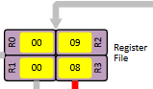

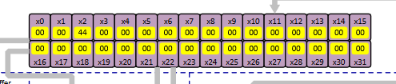

The decision to include all of these registers (a significant change to the animation) was made for two main reasons:

- Firstly, it gives the user far more freedom when writing their own RISC-V programs in the animation’s instruction cache. Greater register availability saves the user from thinking two much about register use when writing more complex programs, perhaps involving subroutines.
- Secondly, and more importantly, the register file was expanded to include all 32 registers in order for the animation in order to allow the user to accurately use the RISC-V calling convention as specified in the official RISC-V documentation. In the calling convention each register has a specific purpose, and some of those registers are crucial components of the stack animation (discussed in detail later in this section). Below is a table of all 32 RISC-V registers and their roles as specified by the calling convention.

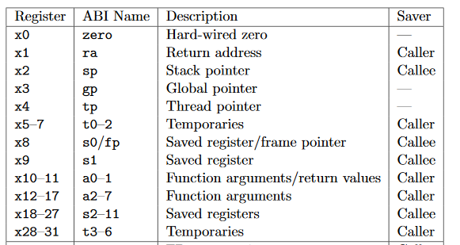

    - Branch Prediction

    - The M Register and the Branch Delay Slot

In the previous section about the RISC-V conditional branch instructions included in the animation, it is discussed how these instructions differ in one key way from both the MIPS and ARM conditional branch instructions.
Whereas in both the MIPS and ARM instruction sets a conditional branch instruction is determined by prior instructions, in the RISC-V instruction set the arithmetic operation determining whether or not a branch should be taken is included in the branch instruction itself.
While the RISC-V conditional branch instructions are similar to those in the ARM9, this key difference makes it very difficult to execute them in the same way, where flags in the CPU’s CPSR (Current Program Status Register) are checked. The ARM9 has the benefit of preceding a conditional branch with an arithmetic operation (to set/clear the flags) and CMP instruction to check the flags. The RISC-V does not have this luxury, forcing a slight reimagining of the pipeline.
It was decided to keep much of how the MIPS animation already executed conditional branching. While the zero check was no longer necessary, the idea of having feedback from the ALU to the multiplexer in stage 2 of the pipeline determining what’s written to the PC was maintained.
The key change is the addition of a register in the second stage of the pipeline, called the M register. This M register’s sole purpose is to store the potential next value of the program counter if the conditional branch instruction is executed.
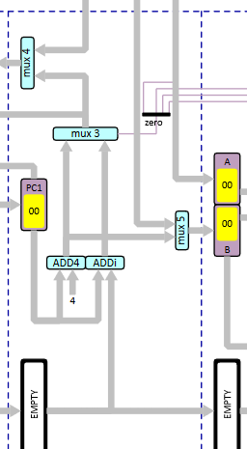
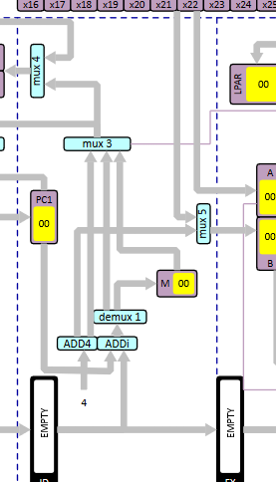

    - Stack Animation

In the MIPS animation the memory unit only has four memory locations. For the RISC-V animation, it was decided to replace this memory unit with a dynamic stack animation. This stack animation would contain 18 memory slots rather 4, and would be designed to complement the calling convention and emphasise the benefits of students adhering to it while programming.
The change was made for the following two reasons, similar to the reasons that stimulated the expansion of the register file.
- Like expanding the register file, giving the animation more memory space gives students far greater freedom. When writing more complex programs just having four memory locations would be incredibly limiting.
- More importantly, a dynamic stack visualisation with greater memory space was crucial in emphasising the benefits of the RISC-V calling convention. The stack animation keeps track of where both the stack pointer (x2) - labelled SP - and the frame pointer (x8) - labelled FP - are currently pointing. It also differentiates between stack frames using colour, and has enough space for several subroutines to save their contexts. The particulars of how the calling convention works is laid out in the Implementation section of this report.
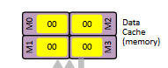
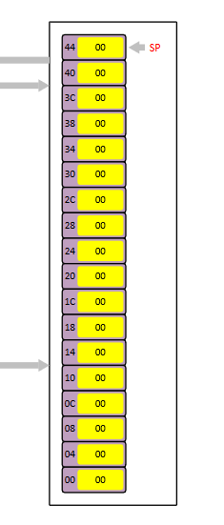
    - Parallel Hardware
As discussed in previous areas of this report, the decision was made to include instructions from the atomic extension of the RISC-V instruction set, in order for the animation to incorporate the concept of parallel computing. For this, hardware additions were required for the animation.

      - LPAR and LF
First, it must be explained what the LPAR (Lock Physical Address Register) and the LF (lock flag) are for. They are integral to the execution of both atomic instructions included in the animation (LR and SC).
In parallel computing, multiple CPUs could be running programs interacting with a shared memory space. The LR and SC instructions are designed specifically to ensure that each CPU is not using data from memory that doesn’t belong to that CPU.
While the LR instruction does indeed perform a load, it also “reserves” the memory location it loads from. In other words, it obtains a lock on that memory location. It does so by setting its lock flag (LF) and by putting that memory address in its LPAR. Note that more than one register can have a lock on the same memory address at the same time.
When it comes to the SC instruction, things get more complicated. If a CPU wants to perform an SC then it can only if its lock flag is set. Unless it has obtained a lock the store cannot be performed. If it is performed, then the instruction’s lock flag is cleared, and zero is written to the destination register of the instruction. However, if it’s not executed, a non-zero value is written to the destination register. This is useful because one can write a program where an SC is contained within a loop that only exits if the store is successful.
But an SC instruction can be unsuccessful even if it was preceded by an LR. Memory is connected to all CPUs via a shared memory bus, which each CPU “listens” to. If a CPU reads from the memory bus that another CPU has written to the memory location in its LPAR, then it’s lock flag is cleared. Another CPU got there first, so it must relinquish its lock on that address. If used correctly by the programmer then LR and SC ensure that he/she is never using values from memory that they don’t own. The concept of a memory bus and this locking mechanism is visualised in the below diagram.
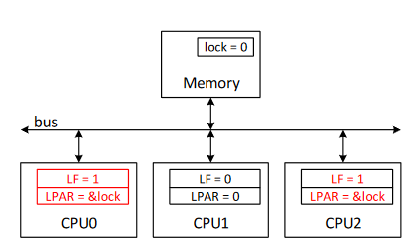

And below is the hardware implementation of the LPAR and lock flag in the animation.

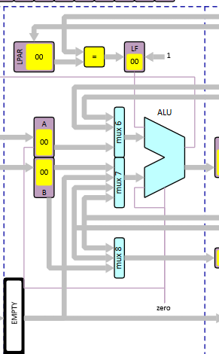

3.2.5.2. Memory Bus

