Sean Cavill

WEB701

Assignment 3 Documentation

# Relevance of Angular

Angular is a web framework owned by google that is written in type script and allows users to create single paged applications.

Web frameworks like angular are important and relevant as they allow for the repeatability of code, and they set a standard that coders can follow. It also improves the readability making it easier for other coders to understand your code or work on the same project with you.

As this web framework is owned by google, I believe it is going to have a continuing impact. There are alternatives such as few and react that are growing in popularity, but overall angular is still very popular amongst users. This means that there is a lot of support for angular and that there is going to be jobs and demand for angular.

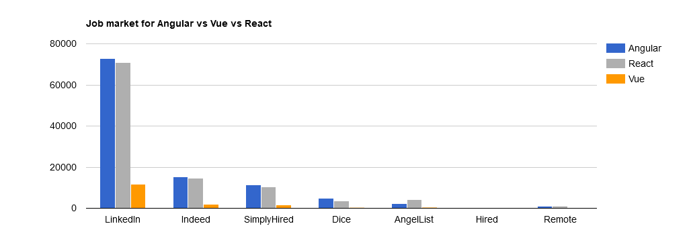

Going into the future with more and more web applications being made with frameworks, it means that the need to learn a web framework is becoming more and more important.

# My Implementation

For my project I had decided to go with the angular framework for the front end which uses an express and mongo db backend to store the data for my site.

To first install angular, I had to install the CLI using the npm install -g @angular/cli. And using the ng new command to create the general folder structure for the angular site.

With a simple ng serve command, angular already got me started with a basic webpage and it was hosted locally using the port 4200.

To use angular, you must install the components that your site is going to use in the form of modules. One of the useful modules that I installed that helped me connect to the back end was the HTTP Client module, which allowed me to make get and post requests to my server back end.

I also imported the Module which allows me to add bootstrap which makes structuring the page and forms a lot easier. This was useful in setting up an interactive carousel and aligning containers on the page.

To create a page on angular it was easy as I can use the ng generate to generate components that are going to be the pages for me site using ng g c <name of the component>. This links the component to the app module and provides me with the file structure including the html and type script files that I need to write logic for the component.

Angular is a single page application, meaning that a single page loads which is the app component page, and only the content inside that page is updated. This means that content is loaded faster, it gives a higher performance, and it made navigation very easy to set up with routes between the different components to display different content on the page.

A resource I used to get me started with authentication and authorization in angular using the express and mongo db backend was a tutorial by bezkoder (bezkoder, 2020). This helped me with the implementation of using the HttpInterceptor to send requests to my backend. It also helped setting up authorization and routing between the components in the angular app.

Going off his examples, and using the angular, bootstrap, and mongodb documentation online I was able to produce a working site that meets all the requirements. This including using angular materials, bootstrap, mongo db CRUD etc(MEAN stack)

The forms on the site are set up with frontend authentication for the text boxes, and back-end authentication for the roles and data before they are put into the database.

In general, I found angular quite easy to use and well laid out. However, I had some issues with it. Firstly, it is quite bulky, so pulling the files from git and running an ng serve took a lot more time than I feel like it should have for content on the page. Another problem I had was with the modules I needed in order to have things installed. If I looked at a tutorial, a lot of the times it is easy not to add the right module into the module file, and it caused a lot of errors in my code.

# Conclusion

Overall, this assignment has made me learn a lot about the web technology and creating a MEAN stack. If I was going to make a web application in the future, I would possibly go with VUE or React, as they seem to work better for smaller applications, but I think the relevancy of Angular is good for working on larger projects or as part of a development team for a job.

bezkoder. (2020, August 2). Angular 11 JWT Authentication example with Web Api. *BezKoder*. <https://bezkoder.com/angular-11-jwt-auth/>

Daityari, S. (2019, January 10). *Angular vs React vs Vue: Which Framework to Choose in 2021*. CodeinWP. <https://www.codeinwp.com/blog/angular-vs-vue-vs-react/>