Lab Homework Week2 Report

GROUP 66: 102403015程祥恩、102403016邱威穎、102403020曾子軒

Objective: To understanding how to write simple Assembly program and program structure.

* **Step 1:** Finish the code and edit “make.bat”, replace “%1” with “labw2”.

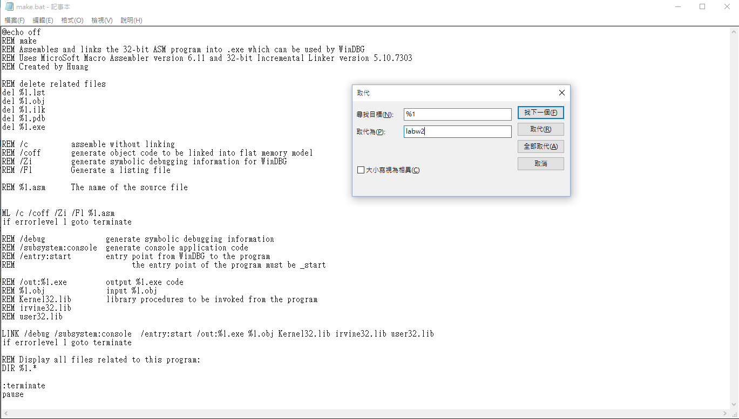

* **Step 2:** Run “make.bat”

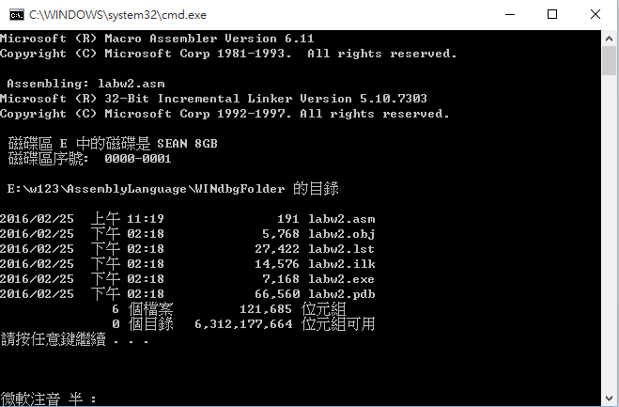

* **Step 3:** Run “windbg.exe”, open the source file (labw2.asm), and the executable (labw2.exe). Click “Watch” and “Registers” button to get ready.

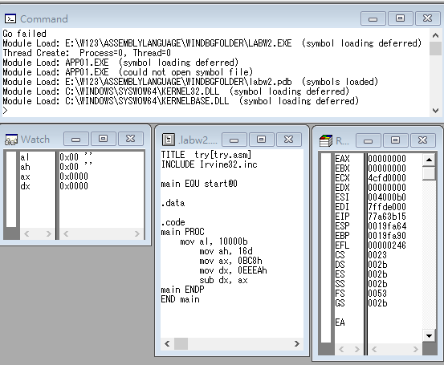

* **Step 4:** Click ”Start Over(F10)” to trace the code. “al” is successfully set to “0x10” and “EAX”, “EIP” changed. (The last two digits of student ID is 16)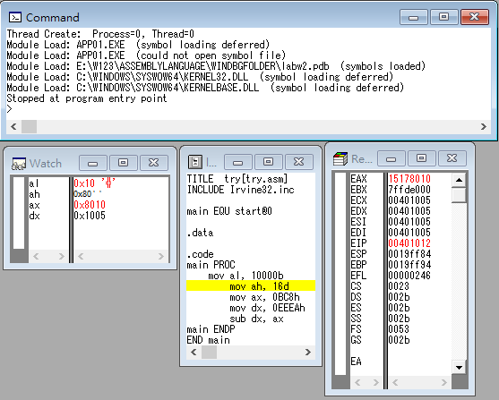
* **Step 5:** Keep clicking “Start Over”, “ah” is set to “0x10”, the value of ”EAX” and “EIP” changed.

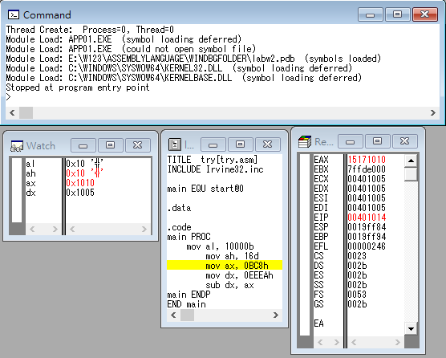

* **Step 6:** “ax” is set to “0x0bc8”

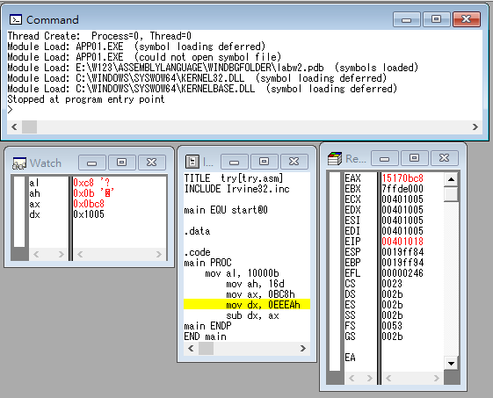

* **Step 7:** “dx” is set to “0xEEEA”, “EDX” is set to “0040eeea”.

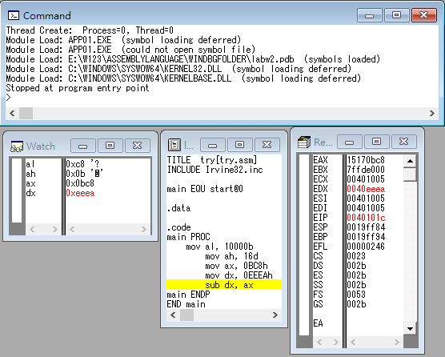

* **Step 8:** “dx” is set to “dx-ax”=0xe322, “EDX” and “EFL” changed.

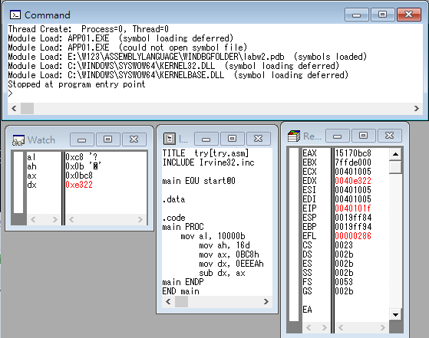

* **Reviews:** For us,it was difficult to understand the logic of Assembly Language, and we didn’t even know how to compile the program in the first 30 minutes of class. But eventually, we realized how it worked and finish this report. It was a good start for us and we will keep going.