SELECT STATEMENTS

Drinks containing rum

[SELECT](https://tools.engr.oregonstate.edu/phpMyAdmin/url.php?url=https://dev.mysql.com/doc/refman/5.5/en/select.html) DrinkName FROM Ingredients_List WHERE IngrName [LIKE](https://tools.engr.oregonstate.edu/phpMyAdmin/url.php?url=https://dev.mysql.com/doc/refman/5.5/en/string-comparison-functions.html#operator_like) '%%Rum'

GROUP BY DrinkName

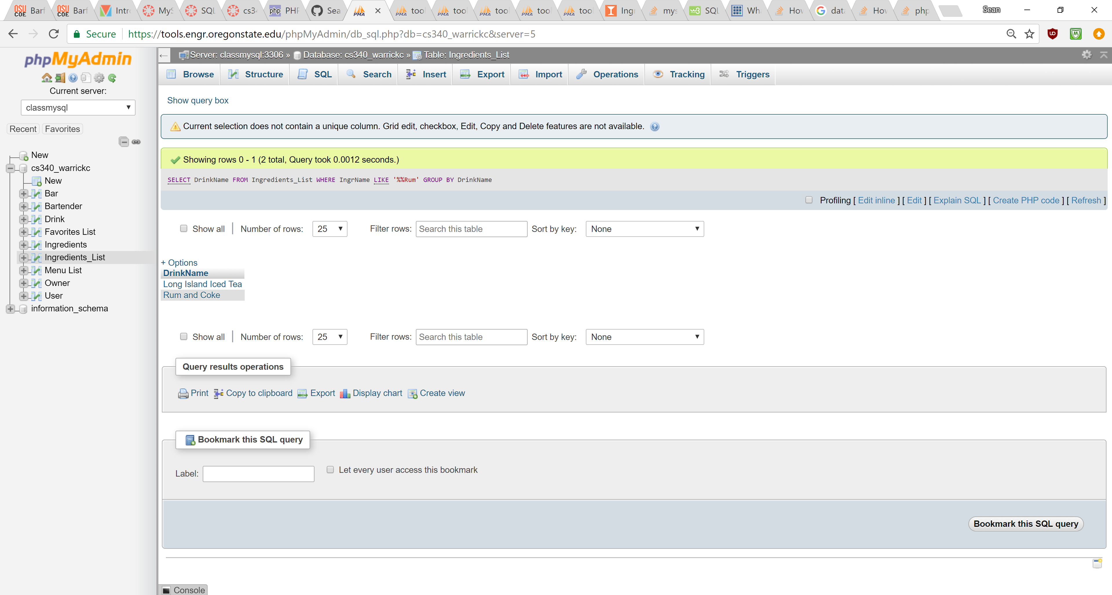

The owner of a bar that serves long islands

[SELECT](https://tools.engr.oregonstate.edu/phpMyAdmin/url.php?url=https://dev.mysql.com/doc/refman/5.5/en/select.html) Name FROM Owner, `Menu List` WHERE (Owner.BarName = `Menu List`.BarName) [AND](https://tools.engr.oregonstate.edu/phpMyAdmin/url.php?url=https://dev.mysql.com/doc/refman/5.5/en/logical-operators.html#operator_and) (`Menu List`.DrinkName [LIKE](https://tools.engr.oregonstate.edu/phpMyAdmin/url.php?url=https://dev.mysql.com/doc/refman/5.5/en/string-comparison-functions.html#operator_like) 'Long Island%%')

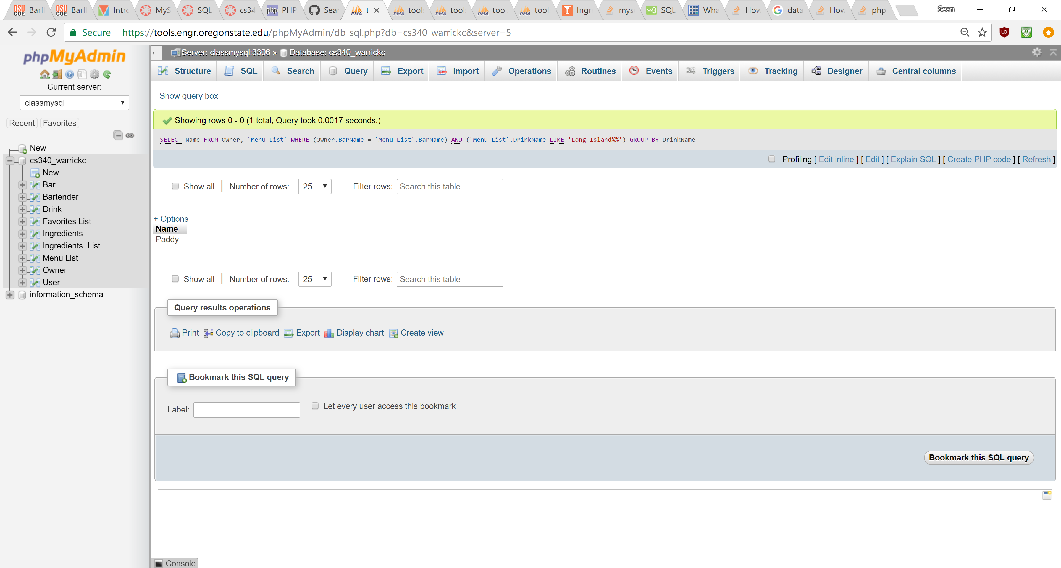

The Owner with the most liked bar.

[SELECT](https://tools.engr.oregonstate.edu/phpMyAdmin/url.php?url=https://dev.mysql.com/doc/refman/5.5/en/select.html) Name FROM Owner, `Favorites List` WHERE Owner.BarName = `Favorites List`.`Bar Name` GROUP BY `Favorites List`.`Bar Name` ORDER BY [COUNT](https://tools.engr.oregonstate.edu/phpMyAdmin/url.php?url=https://dev.mysql.com/doc/refman/5.5/en/group-by-functions.html#function_count)(`Favorites List`.`Bar Name`) DESC LIMIT 1

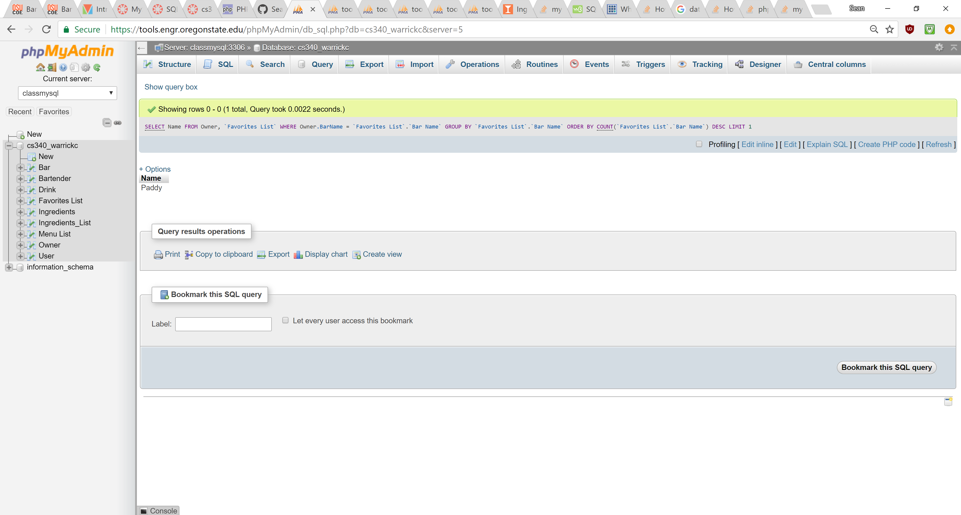

OTHER SQL STATEMENTS

Inserted a something into someones favorite’s list

INSERT INTO `Favorites List` (`Username`, `Bar Name`, `Drink Name`) VALUES ('PartyGrrl', 'Janky Jim\'s', 'Jack and Coke');

And an Update for the instructions of a drink

[UPDATE](https://tools.engr.oregonstate.edu/phpMyAdmin/url.php?url=https://dev.mysql.com/doc/refman/5.5/en/update.html) `Drink` [SET](https://tools.engr.oregonstate.edu/phpMyAdmin/url.php?url=https://dev.mysql.com/doc/refman/5.5/en/set.html) `Instructions` = 'Dont even try this drink, its to much work' WHERE `DrinkName`= 'Long Island Iced Tea'

TRIGGERS:

Both have been duplicated to handle instances where a registered or anonymous user decides to change their rating.

Trigger to update the average rating on a bar

CREATE TRIGGER `updateBarRating` AFTER INSERT ON `BarRatings`

FOR EACH ROW UPDATE Bar

SET Rating =

(SELECT AVG(BarRatings.Rating)

FROM BarRatings

WHERE Bar.`Bar Name` = BarRatings.BarName)

WHERE `Bar`.`Bar Name` = NEW.BarName

The Same for drinks

CREATE TRIGGER `updateDrinkRating` AFTER INSERT ON `DrinkRatings`

FOR EACH ROW UPDATE Drink

SET Rating =

(SELECT AVG(DrinkRatings.Rating)

FROM DrinkRatings

WHERE Drink.DrinkName = DrinkRatings.DrinkName)

WHERE Drink.DrinkName = NEW.DrinkName