What is the maximum number of processes? Where is it defined?
- Max number of processes: 100
- Defined in: conf.h

What does xinue define as an ’illegal PID’?
- PID < 0
- PID > Max number of processes in system
- Process table entry field ’prstate’ is unused

What is the default stack size Xinu assigns each process? Where is it defined?
- Default stack size: 65536 bytes
- Defined in: processes.h

Draw Xinu’s process state diagram:
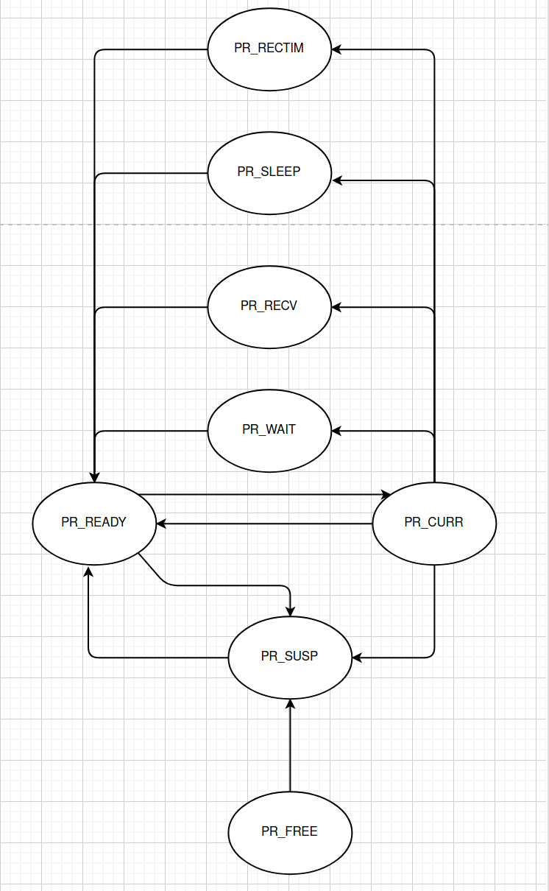

When is the shell process created?
- The shell process is created by the main process, which is created after the system is initialized

Draw Xinu’s process tree (including the name and identifier of each process) when the initialization is complete.
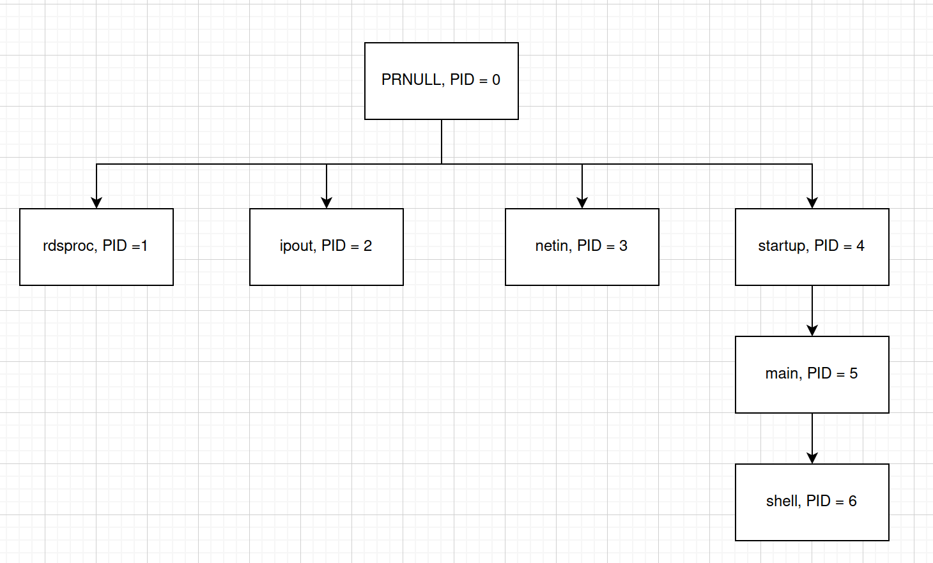

Coding Problem 1
- To report the timing of processes in the system, I created a new entry in the process table. Upon initialization, the entry in the process table is set to the current running time of the system. I added this in processes.h file. When ps() is called, the current running time of the system is computed, and that value is compared with the time saved in the process table entry, for each process. I also updated the output of the ps() call to print the result. These updates exist in the ~/shell/xshps.c file.

Coding Problem 2
- In order to accomplish the fork procedure, I followed three basic steps:
  - Copy the calling process’ stack:
    - I did this by passing the current EBP to a function called stackcopy(). ’stackcopy’ is a recursive function that searches for the base of the current stack. The function iterates through the base pointers that exist the current stack, all of which either point to stack magic or to another base pointer within the process stack. Upon reaching the base of the stack, the function returns the address of the base of the stack, and maintains a marker to pointer of the address of parent process’ closest base pointer. The function then copies all values up to the most recent base pointer. When reaching the most recent base pointer, a new pointer is added to the child stack, allowing the child stack to contain the appropriate pointers.
  - Initialize the new process registers:
    - This is accomplished in much the same way as the create() funciton. The only difference is that EAX is passed the value of NPROC
  - Insert the newly created process into the ready list, using the insert() function

what is the effect of the “receive()” call in the test cases provided? What would happen if that function call was not present? Hint: see receive.c and send.c files.
- Receive call sends the newly created process to the rescheduling funciton. The rescheduling function forces a context switch, the process sent to the rescheduling funciton is not the currently running function.

