REPUBLIC OF THE PHILIPPINES

POLYTECHNIC UNIVERSITY OF THE PHILIPPINES

COLLEGE OF COMPUTER AND INFORMATION SCIENCES

STA. MESA, MANILA

**Web-Based Furniture Shop Management System**

A System Study Presented to the Faculty of the College of Computer and Information Sciences Polytechnic University of the Philippines

In Partial Fulfillment of the Requirements for the Capstone Project

Submitted by:

Amarilla, Cyrene Jane B.

Coronado, Aira Marie B.

Efa, Sean Lester A.

Estores, Elissa Joy P.

Lozano, Mariano III S.

Publico, Mark Joseph B.

BSIT 4-2N

OCTOBER 2017

**APPROVAL SHEET**

Approved by the committee on Oral Examination with the grade of **_________**

Examiners:

__________________________

Prof. Monina D. Baretto

__________________________

Prof. Maria Esperanza H. Reyes

Accepted in partial requirements for the degree of Bachelor of Science in Information Technology.

_________________________________

Dr. Gisela May A. Albano

Dean, CCIS

**RECOMMENDATION SHEET**

The system entitled Furniture Shop Management System has been examined and is recommended for acceptance and approval to the committee for oral examination.

_______________________________

Prof. Alex B. Uy

Faculty-In-Charge

**TABLE OF CONTENTS**

**Abstract I**

**CHAPTER 1: PROJECT DEFINITION**

**1.1 Introduction**  1

**1.2 Business Case** 2

1.2.1 Background of the Organization 2

1.2.2 Project Overview 3

1.2.3 Project Constraint 3

1.2.4 Project Assumptions 4

**1.3. Scope and Limitation** 4

**1.4. Methods Used in the Study** 5

**CHAPTER 2: FUNCTIONAL SPECIFICATION REPORT**

**2.1 Data Requirements 7**

2.1.1 Forms 7

2.1.1.1 List of Forms 7

2.1.1.2 Sample of Forms 8

2.1.2 Reports 11

2.1.2.1 List of Reports 11

2.1.2.2 Sample Reports 12

**2.2 Policies and Procedures**

2.2.1 Procedures 13

2.2.1.1 Context Diagram 13

2.2.1.2 Level 1 DFD 14

2.2.2 Policies

2.2.2.1 Business Requirements 15

2.2.2.2 Business Policies 16

**2.3 Problem Analysis 17**

2.3.1 Fishbone 17

2.3.2 Problems and Requirements 18

2.3.3 Conclusion 19

2.3.4 Recommendation 19

**CHAPTER 3: PROPOSED SYSTEM DEFINITION**  
 **3.1 Requirements-Features Matrix 21**

**3.2 Functional Specification 23**

3.2.1 System Boundaries 23

3.2.2 System Use Case Diagram 23

3.2.3 Detailed Use Case Diagram 24

3.3.4 Use Case Description 29

**3.3 Technical Specification**

3.3.1. Class Diagram 43

3.3.1.1 Data Dictionary of Classes 43

3.3.1.2 Class Diagrams (per Use Case by System) 48  
 3.3.2. Activity Diagram 54

3.3.3. Database Design

3.3.3.1 Database Schema 59

3.3.3.2 Data Dictionary (Landscape orientation) 60

**3.4 Architectural Design**

3.4.1 Information system architecture 121

3.4.2 Web Architecture 122

3.4.3 Client-Server Architecture 123

3.4.4 Network Architecture 124

**CHAPTER 4: IMPLEMENTATION PLAN**

4.1 Testing Plan 125

4.1.1 Test Design Process 125

4.1.2 Test Execution Process 125

4.2. Requirements Plan 126

4.2.1 Hardware Requirements 126

4.2.1.1 Server

4.2.1.2 Workstation

4.2.2 Software Requirements 126

4.2.2.1 Operating Systems

4.2.2.2 DBMS

4.2.2.3 Pre-requisite Software

4.2.3 Peopleware (End Users, Systems Administration, Etc) 127

4.3 Quality Plan 127

4.4 Security Plan 127

4.5 System Maintenance and Support Plan 128

4.5.1 Preventive Measure Plan

4.5.2 Corrective Measure Plan

4.5.3. Backup and Recovery Plan 129

**CHAPTER 5: RECOMMENDATION 130**

**APPENDICES**

Data Gathering Instruments

Client Forms & Reports

List of Tables

List of Figures

Resume

**ABSTRACT**

The Furniture Shop Management System is a web-based application created based on a furniture shop that offers high quality furniture that goes from simple and classic to one very luxurious design. The shop offers furniture generously made of narra and of high quality fabrics imported from other countries. The shop creates furniture for display and for walk-in customers to see and purchase. They accept orders with designs picked from their brochures or customized designs specified or brought by the customer.

The Furniture Shop Management System helps the admin manage orders, monitor materials inventory and track furniture production. At the same time it will help them promote their products and reach customers on a farther vicinity. In this light, the furniture shop’s customers can create an account for website access so they can easily order furniture, track the production progress of their order as well as the delivery. The project has three (3) subsystems namely; Order Management, Billing and Collections and Production Tracking System.

**CHAPTER 1**

**PROJECT DEFINITION**

* 1. **INTRODUCTION**

The Furniture Shop now stands on it’s 36th year with two stores found in Bacoor and Silang, Cavite. The shop offers high quality furniture that goes from simple and classic to one very luxurious design.

The business is owned and managed by a family, but mostly by the parents who still list and writes the orders made per day and the receipts and bill per transaction. It’s difficult processing the transaction due to unorganized stack of charts and voluminous brochures. The shop also uses the forms improperly which leads to difficult retrieval of order records.

The proponents aim to provide a Web-Based Management system entitled, Furniture Shop Management System. This system will help the family in making faster transactions.

It will help them in storing and retrieving information, enhancing the security of their records. The customers will also find it more convenient to choose a furniture by sending their desired design with the customization feature. With this system, the furniture shop that is running for 36 years now, will keep up with the rapidly changing society and developing technology.

* 1. **BUSINESS CASE**
     1. **BACKGROUND OF THE ORGANIZATION**

The Furniture Shop makes high quality furniture made of narra wood with designs that goes from simple and classic to a very luxurious one. They offer furniture generously made of narra and of high quality fabrics imported from other countries. The shop creates furniture for display and for walk-in customers to see and purchase. They accept orders with designs picked from their brochures or customized designs specified or brought by the customer.

The 36 year old running business now has two stores; both stores are managed by the family members themselves. Josephine Bonayon Baraquiel, one of the owners, proposed the idea of making furniture shop to her husband because she herself is a daughter of a furniture maker. Josephine used to help her parents way back when she was in their care, her parents influenced her in every way and together with her husband they build the Furniture shop together.

This business is the reason they got to where they are now, from a small shop at vicinity in Albay, Bicol to owning two stores located nearby the capital city of the country. The Furniture Shop is also the reason how they manage to send their six children to decent universities and now their children are working at great companies and is helping them from time to time.

The Furniture shop’s number one priority in furniture making is ensuring that the furniture they make is of high quality and can be considered world class. They also wanted to join the bandwagon of online shops in the country to be part of this rapidly changing society.

* + 1. **PROJECT OVERVIEW**

The project aims to help the said Furniture Shop in making their transactions faster, easier and help them keep pace with the rapidly changing society by providing them a web-based system. This web-based system will have a website and an admin interface. The admin interface is where the manager can update their featured furniture, add and remove furniture and manage orders made personally or through the website. The website will display all furniture the shop can offer. The customer can easily order furniture just by browsing through the website and the manager will find it easy to manage orders and produce the customers’ bills and receipts.

It will also help the customers choose design on their perspective by sending their own design in our customization feature. With the system the manager can easily store and retrieve information, thus minimizing the time for looking upon the client’s record every time they deliver.

* + 1. **PROJECT CONSTRAINTS**

The constraints considered by the proponents are the following:

* Time frame given for the project is 10 months, limited amount of time to build the system.
* The scope of the project covers maintainance and transaction processes of the business.
* The proponents are currently students with limited source of income. It is certain that they cannot invest financially.
  + 1. **PROJECT ASSUMPTIONS**
* **The Project will be finished on time.**

The fully-functional system project will be finished on time with no errors and bugs.

* **The project team will able to acquire all the information and documents needed.**

The client will be able to provide all necessary documents and information for the Project Team to comply with the requirements of the project and be able to provide them a running system that functions accurately.

* **User Acceptance**

The client will be satisfied with the final outcome of the project. The project will lighten the works of the users, their transaction will be faster and provide a better service to their customers.

**1.3. SCOPE AND LIMITATION**

The business processes of the furniture shop that will be featured in the system includes managing of orders, creation of bills, issuance of receipts, collecting payment, tracking of production and monitoring materials.

The project also includes point of sales and delivery tracking. The system will have a customization feature which allows the customers to send their own design of the furniture. Maintenance of the fields needed for the transactions will be covered. The project also produces queries and reports.

The system will not cover the purchasing of materials in monitoring the inventory of raw materials.

**1.4. METHODS USED IN THE STUDY**

**1.4.1 DATA GATHERING TECHNIQUES**

* **Observation**

The proponents observed the business environment and how they do things thus making it easier for us to know their problems.

* **Personal Interview**

The proponents conducted an interview to gather data needed for this project. This serves as the way to obtain useful information to the people who know the business very well.

* **Document Analysis**

The forms we gathered will be analyzed to understand the business and know what data are needed for the transactions.

**1.4.2 Software Process Model**

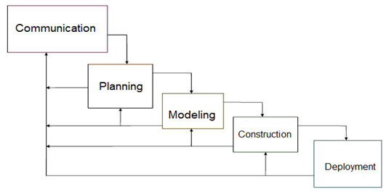

***Figure 1. Waterfall Model with Feedback***

The proponents used the Waterfall Model with Feedback as a model used in visualizing the step by step process the group is going to take to finish the project on the scheduled time. The Waterfall Model with Feedback is a simple and easy to use model because of it’s rigidity. Each phases has a specific deliverable and a review process therefore after making progress on the project we can go back to the client and ask if what we produce is accurate according to their business rules and processes.

**CHAPTER 2**

**FUNCTIONAL SPECIFICATION REPORT**

**2.1 DATA REQUIREMENTS**

**2.1.1 FORMS**

**2.1.1.1 LIST OF FORMS**

|  |  |  |  |
| --- | --- | --- | --- |
| **Form #** | **Form Name** | **Description** | **User** |
| F1 | Sales Invoice | This contains the customer information, order information, order specification and payment information. This serves as the contract and the bill. | Manager, Customer |
| F2 | Job Order | This contains the details of the ordered furniture the manufacturer should follow. | Manager, Manufacturer |
| F3 | Delivery Receipt | It contains delivery information, order information and payment information. This is given to the delivery man and later on passed to the customer as final receipt. | Manager, Customer, Delivery Man, |
| F4 | Official Receipt | This contains the payment details of the customer. This is given to the customer every payment made. | Manager, Customer |

***Table 1. List of Forms***

**2.1.1.2 SAMPLE OF FORMS**

**SALES INVOICE**

**Sold to**: Rosario Hernandez **DATE:** December 12, 2016

**Address:** Baco**or,** Cavite **CONTACT NO.:** 09163737052

|  |  |  |
| --- | --- | --- |
| QUANTITY | PARTICULAR ITEM | AMOUNT |
| 1 SALA SET | MANILENIA  FABRIC GOLD RANI  COLOR 19C  1 PC. LOVE SEAT  1 PC. CENTER TABLE  2 PCS SIDE TABLE  1 SET DINING SET | TOTAL AMOUNT  170,000   * 100,100   BALANCE 70,000 |

PREPARED BY: JOSEPHINE BARAQUEL

SIGNATURE OVER PRINTED NAME

***Figure 2. Sample Sales Invoice Format***

**JOB ORDER**

**SI #123 ROSARIO HERNANDEZ**

1 SET SALA SET – MANILENIA

FABIC: GOLD RANI

COLOR: 19C

1 PC. LOVE SEAT

1 PC CENTER TABLE 22 X 42’

2 PCS SIDE TABLE 18 X 22”

1 SET DINING SET W/ 8 CHAIRS

***Figure 3. Sample Job Order Format***

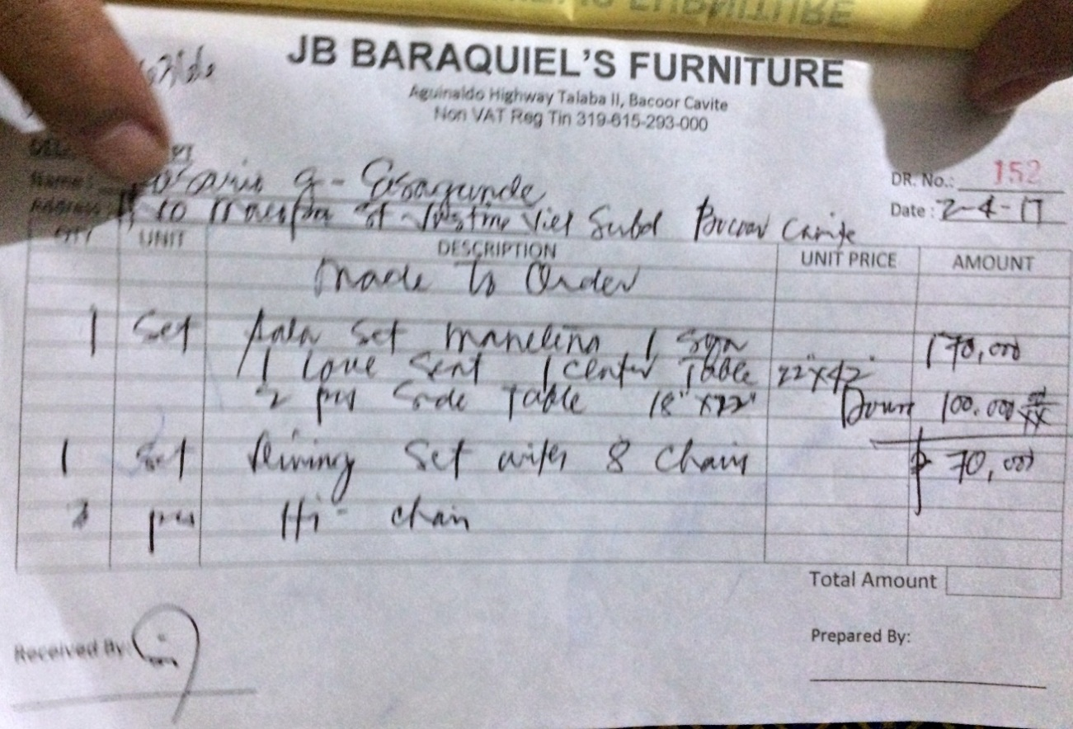

***Figure 4. Sample Delivery Receipt***

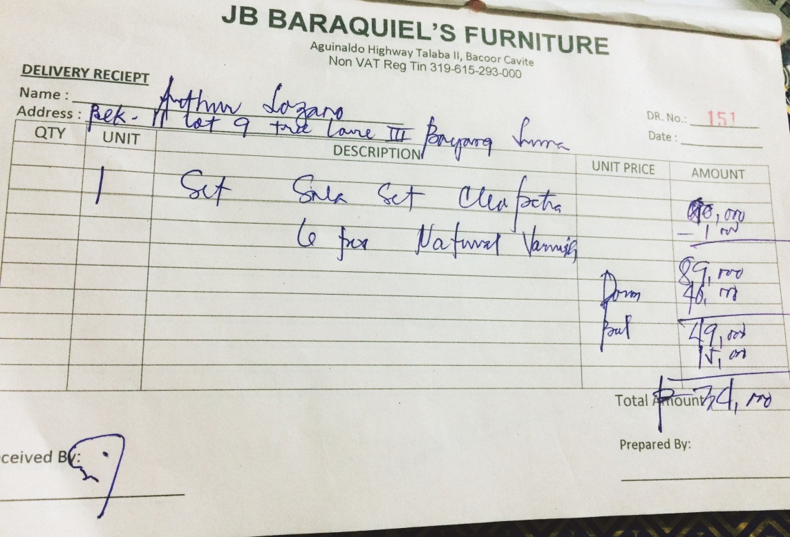

***Figure 4.1 Sample Delivery Receipt***

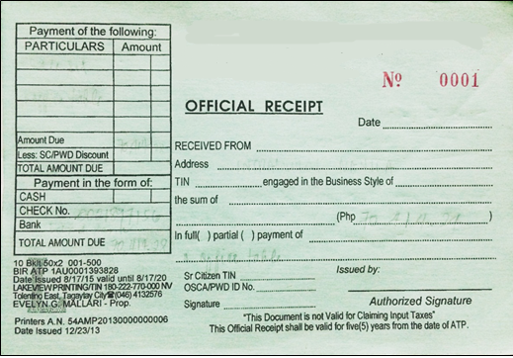

***Figure 5. Sample Official Receipt***

**2.1.2 REPORTS**

**2.1.2.1 LIST OF REPORTS**

|  |  |  |  |
| --- | --- | --- | --- |
| **Report #** | **Report Name** | **Description** | **Frequency** |
| R1 | Sales Report | Contains the daily record of the furniture sold to customers. | Daily, Monthly, Annually |

***Table 2 List of Reports***

**2.1.2.2 SAMPLE REPORTS**

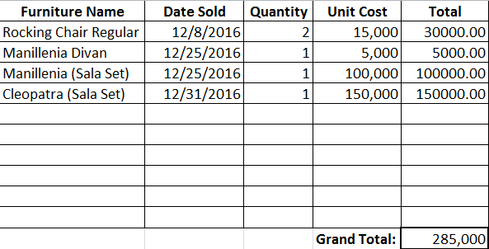

***Figure 6. Sample Sales Report Format***

**2.2 POLICIES AND PROCEDURES**

**2.2.1 PROCEDURES**

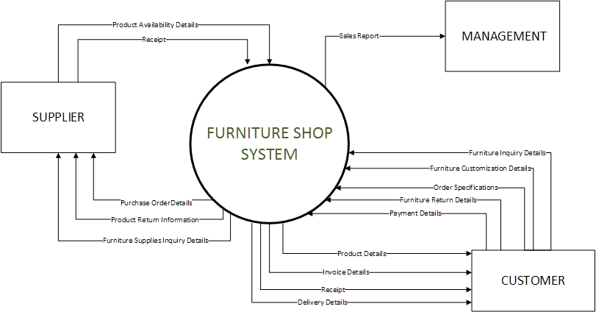**2.2.1.1 CONTEXT DIAGRAM**

***Figure 7. Context Diagram***

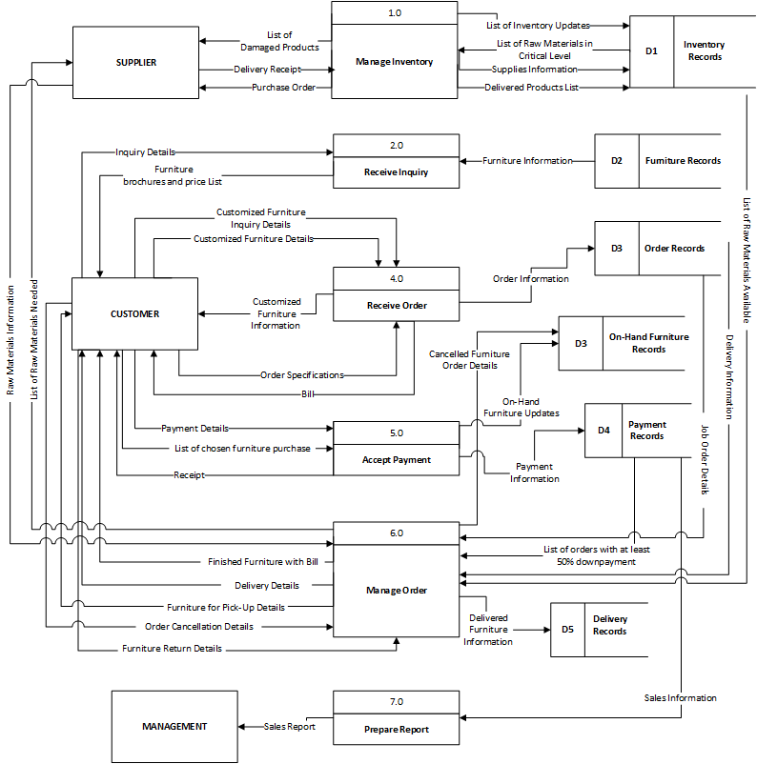**2.2.1.2 LEVEL 1 DFD**

***Figure 8. Level 1 Data Flow Diagram***

**2.2.2 POLICIES**

|  |  |
| --- | --- |
| **BR NO.** | **BUSINESS REQUIREMENT** |
| **BR001** | The production of furniture will begin once the customer paid a down payment of at least 50% of the total amount of the ordered furniture. |
| **BR002** | A minimum storage fee of PHP 500 pesos will be added to the total balance if furniture is not claimed or is fully paid on or before the day the contract will end. |
| **BR003** | A detailed description and specification is needed for customized furniture. |
| **BR004** | Damage on furniture caused by natural disaster and by improper use or maintenance is not covered on the warranty. |
| **BR006** | Official receipt must be presented to acquire warranty. |
| **BR007** | A minimum fee of PHP 500 is needed to cancel an order that is already undergoing production. |

**2.2.2.1 BUSINESS REQUIREMENTS**

***Table 3 Business Requirement***

|  |  |
| --- | --- |
| **BP NO.** | **BUSINESS POLICIES** |
| **BP01** | The customer must pay at least 50% of the total price of the furniture ordered for the production of furniture to begin. |
| **BP02** | On-hand furniture must be fully paid upon acquisition. |
| **BP03** | Furniture must be claimed, paid or delivered on or before the end of the contract. |
| **BP04** | A customer must pay a cancellation fee if he/she cancels his order that is already undergoing production. Cancellation fee varies. |
| **BP05** | If ordered furniture is not claimed and fully paid within 1 month (30 days) and 1 week (7 days) after the contract’s expiration the management has the right to resell the furniture. |
| **BP06** | The price of a customized furniture will be decided by the management |
| **BP07** | The furniture will be replaced or repaired if found broken upon delivery. |
| **BP08** | Six months warranty is given to all furniture. |

**2.2.2.2 BUSINESS POLICIES**

***Table 4 Business Policies***

**2.3 PROBLEM ANALYSIS**

**2.3.1 FISHBONE**

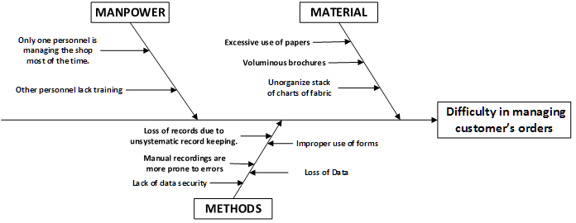

***Figure 9. Fishbone Diagram of the Furniture Shop***

**2.3.2 PROBLEMS AND REQUIREMENTS**

|  |  |  |  |
| --- | --- | --- | --- |
| **Ref. Page** | **No.** | **Problem** | **Requirements** |
| 16 | 1 | Only one personnel is managing the shop most of the time. | Capability to efficiently manage orders with the resources available. |
| 16 | 2 | Loss of records due to unsystematic record keeping. | Secure records in a database to manage records systematically. |
| 16 | 3 | Lack of data security. | Ability to keep the gathered data secure and control the user access. |
| 16 | 4 | Excessive use of papers. | Capability to minimize,if not eliminate the use of paper. |
| 16 | 5 | Voluminous brochures. | Provides categorized products for display. |
| 16 | 6 | Improper use of forms. | Capability to identify the form/s to be used in the given transactions. |
| 16 | 7 | Loss of data. | Ability to keep data for every transactions made. |

***Table 5 Problems and Requirements***

**2.3.3 CONCLUSIONS**

The Furniture Shop offers high quality furniture made of narra wood. They aim to provide high quality furniture that goes from simple and classic to one very luxurious design, not just to citizens of Cavite but as much as possible, to the whole country.

As of now, the said Furniture shop uses the manual process of recording data, the manager will write the customer information, order information, billing information, and they allow the client to customize their own designs of furniture. A lot of data is being stored so the shop uses excessive papers, papers that are being stored on the file cabinets around their small office. They also use their forms improperly providing confusing records that leads to difficulty in managing customer’s orders.

**2.3.3 RECOMMENDATIONS**

In order to help the business resolve the problems stated above, the proponents recommend the Furniture Shop to have a Web-Based system that will help them manage order and the information that is going in and out of the shop, at the same time will help them promote their products and reach customers on a farther vicinity. The Furniture Shop Management System will have the following sub-systems:

The Furniture Ordering Management System, this sub-system will help the manager in managing the orders. The customer will be able to order furniture easily. Additionally, this sub-system also has a customization feature where the customer can customize furniture to their own liking. In this sub-system, all on-hand furniture and furniture available for pre-order will be displayed per category for the customer to easily choose. Once, the customer is done ordering he can just check-out and proceed to billing. The customer information will be needed for verification.

The Billing and Collection System, this sub-system will compute the total amount of furniture in the customer’s orders. After checking-out the customer will receive an email from the furniture shop containing his bill and where and how the customer can pay. If the ordered furniture is on-hand and the customer has paid for it the furniture will be delivered. If it’s pre-order, the production of the ordered furniture will begin once the customer has paid 50% of the total amount. However, the order will be considered null and void if the customer fails to pay within seven days. This sub-system will help in producing receipt easily, lessening the time needed for writing.

The Production Tracking System, this sub-system will track the production of an order. After the transaction is settled, the manager will issue job order form for the manufacturers, this job order form contains the specifications and descriptions of the furniture to be made. This sub-system will enable the manager to view and update production progress information, which includes status of the production, the handler who will make the furniture, and the production progress percentage of the furniture.

**CHAPTER 3**

**PROPOSED SYSTEM DEFINITION**

**3.1 REQUIREMENTS-FEATURES MATRIX**

|  |  |  |  |  |  |  |  |
| --- | --- | --- | --- | --- | --- | --- | --- |
| **Features/ Requirements** | **REQ1.**  *Capability to efficiently manage orders with the resource available.* | **REQ2.**  *Secure records in a database to manage systematically..* | **REQ3.**  *Ability to keep the gathered data and control the user access.* | **REQ4.**  *Capability to minimize, if not eliminate the use of paper.* | **REQ5.**  *Provides categorized products for display.* | **REQ6.**  *Capability to identify the form/s to be used in the given transactions* | **REQ7.**  *Ability to keep data for every transactions made.* |
| **FEAT1.** *Web-based ordering transaction.* | **✔** | **✔** | **✔** | **✔** | **✔** | **✔** | **✔** |
| **FEAT2.**  *Tracking of production.* | **✔** | **✔** | **✔** | **✔** |  | **✔** | **✔** |
| **FEAT3.**  *Tracking of delivery.* | **✔** | **✔** | **✔** | **✔** |  | **✔** | **✔** |
| **FEAT4.**  *Inventory of Raw Materials.* | **✔** | **✔** | **✔** | **✔** |  |  | **✔** |
| **FEAT5.** *Customiza-*  *tion of designs.* | **✔** | **✔** |  | **✔** | **✔** | **✔** | **✔** |
| **FEAT6.**  *Ability to produce reports.* |  | **✔** | **✔** | **✔** |  |  | **✔** |

***Table 6. Feature-Requirements Matrix***

**3.2 FUNCTIONAL SPECIFICATION**

**3.2.1 SYSTEM BOUNDARIES**

**3.2.2 SYSTEM USE CASE DIAGRAM**

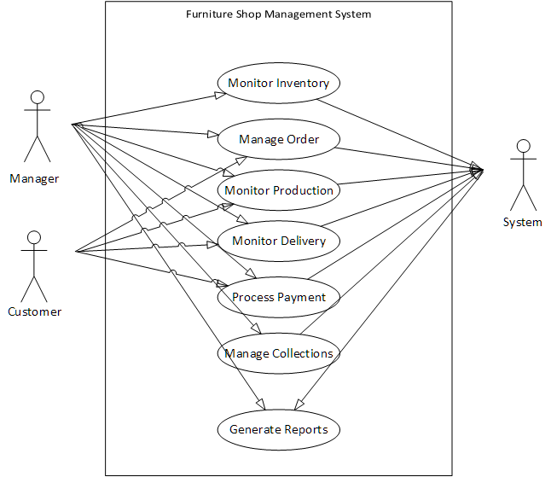

***Figure 10. Top level Use case***

**3.2.3 DETAILED PER USE CASE**

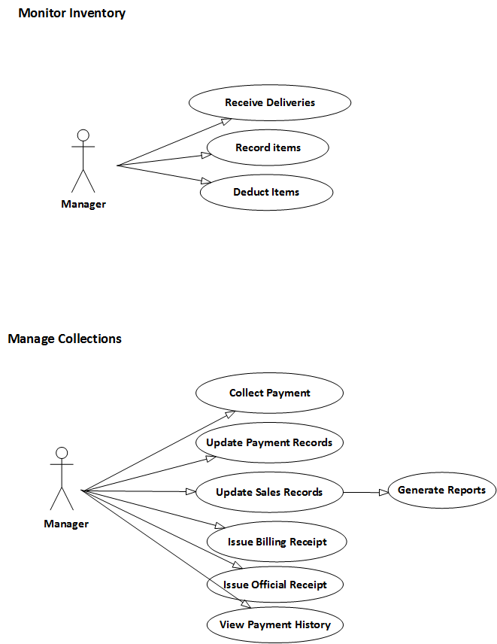

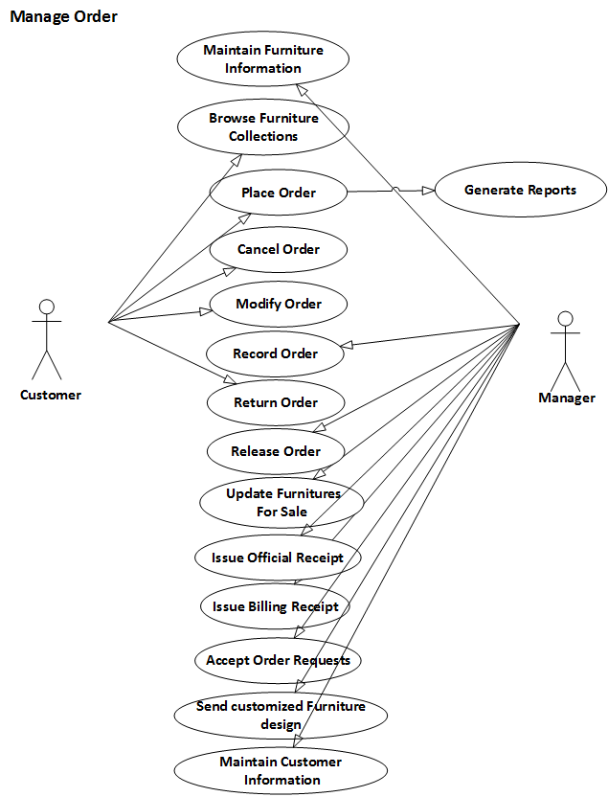

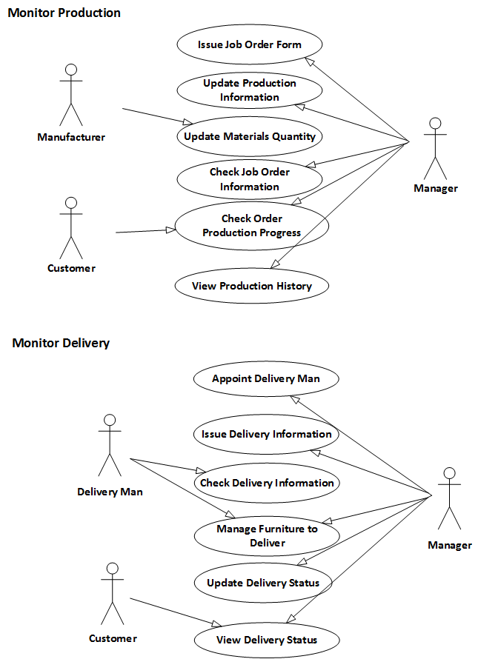

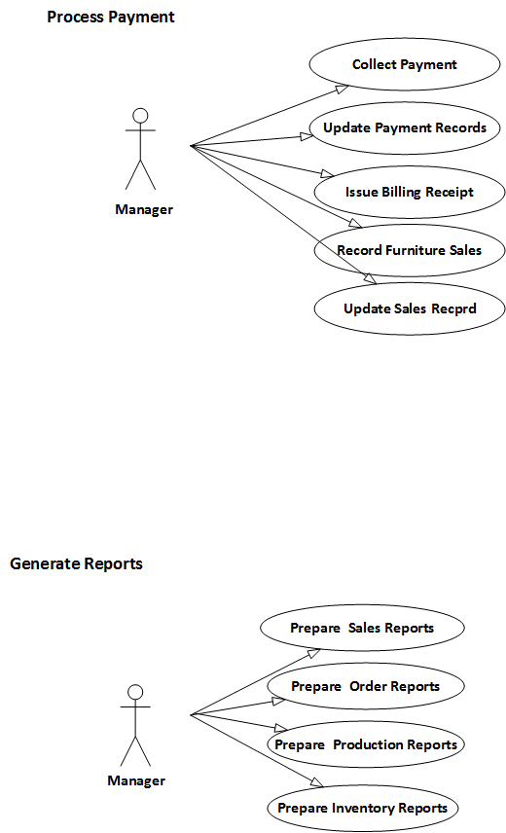







**3.3.4 USE CASE DESCRIPTION**

Use case: **Monitor Inventory**

Actor/s: Manager

Purpose: This use case enables the management to record the raw materials they have used for their production.

Brief Description: Monitoring of the inventory of raw materials used in the business.

Pre-condition: Must be an authenticated user.

Post-condition: An item must be deducted or restocked.

|  |  |  |
| --- | --- | --- |
| **BASIC FLOW** | | |
| ACTION EVENT | | SYSTEM RESPONSE |
| **Receive Deliveries** | | |
| 1. Admin accesses Raw Materials Management. | | 1. Displays all materials' status and materials' information. |
| 1. Click Receive Deliveries Button | | 1. Displays Delivery Information from the suppliers. |
| 1. Enables admin to accept a delivery from the supplier. Adding the raw materials to the raw materials storage. |
| **Record Items** | | |
| 1. Click Restock button | 1. Enables user to update the quantity of a certain item. | |
| **Deduct Items** | | |
| 1. Click Deduct button | | 1. Allows user to deduct the quantity of a certain item. |

Use case: **Manage Orders**

Actor/s: Manager/Customer

Purpose: Allows the management and the customer to keep the transacted orders made in the business.

Brief Description:This use case is capable of processing the main function of the business.

Pre-condition: Must be an authenticated user.

Post-condition: An order must be saved.

|  |  |
| --- | --- |
| **BASIC FLOW:** | |
| ACTION EVENT | SYSTEM RESPONSE |
| **Maintain Furniture Information** | |
| 1. Admin accesses products. | 1. Displays furniture details. |
| 1. Click update button. | 1. Enables admin to edit furniture information. |
| 1. Click Save button | 1. Save information to database. |
| 1. Click View button | 1. Allows user to see the information of a certain furniture. |
| 1. Click Deactivate button | 1. Deactivates the existence of a furniture. |
| **Browse Furniture Collections** | |
| 1. Admin accesses Order Management | 1. Displays the products being sold. |
| 1. Click view button. | 1. Displays all the information about a particular product. |
| **Place Order** | |
| 1. Admin or Customer accesses products. | 2. Displays the products being sold. |
| 3. Click cart button. | 4. Add the selected product to cart. |
| 5. Click proceed to checkout button. | 6. Enables user to put information such as the delivery information, payment information, customer information, and remarks about the order information. |
| 7. Click Save & Print | 8. Saves the order to Orders. |
| **Cancel Order** | |
| 1. Admin or Customer accesses orders. | 2. Displays all the user's orders. |
| 3. Click Update button. | 4. Enables the user to modify his orders. |
| 5. Click cancel order button. | 6. Enables the user to cite out the reason for cancelling. |
| 7. Click cancel order button | 8. Deletes the order from Orders. |
| **Modify Order** | |
| 1. Admin or Customer accesses orders. | 2. Displays all the user's orders. |
| 3. Click Update button. | 4. Enables the user to modify his orders. |
| 5. Click Save button | 6. Saves the new order information. |
| **Record Order** | |
| 1. Admin accesses orders. | 2. Displays all the user's orders. |
| 3. Click accept button. | 4. Accepts an order. |
| **Return Order** | |
| 1. Admin click Return orders from transaction. | 1. Display list of return orders and its status. |
| 1. Click Update button | 1. Enables user to update the status of the returned product. |
| **Release Order** | |
| 1. Admin accesses Releasing of orders in transaction. | 1. List of orders to be delivered must be displayed. |
| 1. Click New button | 1. Enables user to modify an order to be released. |
| 1. Click Delivery Receipt | 1. Must output a receipt to be printed. |
| **Update Furniture Sales** | |
| 1. Admin accesses orders. | 1. Displays all the furnitures for sale. |
| 1. Click Update button. | 1. Enables the admin to modify furniture information. |
| 1. Click Save button | 1. Saves the updated furniture information. |
| **Issue Billing Receipt** | |
| 1. Admin access Orders | 1. List of orders withing bills must be displayed. |
| 1. Click Bill button | 1. Billing receipt must be produced |
| **Issue Official Receipt** | |
| 1. Admin access Ordering in transactions | 1. Enables user to order from brochures displayed. |
| 1. Click save button | 1. Saves information to the database. |
| 1. Click Print button | 1. Official receipt must be produced. |
| **Accept Order Requests** | |
| 1. Click Order Request from Orders | 1. Displays list of order requests from the website. |
| 1. Click Accept button | 1. Accepts the order requests and transfer to Orders. |
| **Send Customized Furniture Design** | |
| 1. Admin access Dashboard. |  |
| 1. Click Customization Request | 1. List of customer request must be displayed. |
| 1. Click Accept | 1. Accepts the request made by the customer. |
| **Maintain Customer Information** | |
| 1. Admin access Customer information tab. | 1. Displays list of customers’ information that can be modified. |

Use case: **Monitor Production**

Actor/s: Manager/Customer

Purpose: Enables the management and the customer to track the production made per order.

Brief Description: Monitoring of the production per furniture ordered.

Pre-condition: Must be an authenticated user.

Post-condition: A production must be updated per phase finished.

|  |  |  |  |  |  |
| --- | --- | --- | --- | --- | --- |
| **BASIC FLOW** | | | | | |
| ACTION EVENT | SYSTEM RESPONSE | | | | |
| **Issue Job Order Form** | | | | | |
| 1. Click ‘Update’ on any production phase displayed. | 1. Enables the user to update Production Information of furniture depending on what phase the production has gone to. | | | | |
|  | 1. Display’s list of materials needed. | | | | |
| 1. Click ‘Print Job Order’ | 1. Job Order Form must be issued | | | | |
| **Update Production Information** | | | | | |
| 1. Admin accesses Production Tracking in Transactions. | 1. Orders that are undergoing or pending for production is displayed. | | | | |
| 1. Click View Details | 1. Display the ordered furniture and it’s production details. | | | | |
| 1. Click ‘Start’ on any production phase displayed. | 1. Display the materials needed and the form for saving the information of when the production started and who handles that phase of production | | | | |
| 1. Click ‘Update’ on any production phase displayed. | 1. Enables the user to update Production Information of furniture depending on what phase the production has gone to. | | | | |
| **Update Materials Quantity** | | | | | |
| 1. Click an on-going production | | 1. Displays information about the production. | | | |
|  | | 1. Enables user to deduct or add a material quantity per phase. | | | |
| **Check job order information** | | | | | |
| 1. Click an order production finished. | | | 1. Job order must be produced. | | |
| **Check production Progress** | | | | | |
| 1. Click Production Tracking | | | | 1. Displays list of production and its information. | |
| **View Production History** | | | | | |
| 1. Click any order production icon. | | | | | 1. Displays progress for each phase. |
| 1. Click production history button. | | | | | 1. Displays Production History. |

Use case: **Monitor Delivery**

Actor/s: Manager/Customer

Purpose: Enables the management and the customer to track the delivery made per order.

Brief Description: Monitoring of the delivery for every order made.

Pre-condition: Order must be finished and paid.

Post-condition: Delivery information must be updated.

|  |  |  |  |
| --- | --- | --- | --- |
| **BASIC FLOW** | | | |
| ACTION EVENT | | SYSTEM RESPONSE | |
| **Appoint Delivery Man** | | | |
| * 1. Click ‘Update’ on any production phase displayed. | | * 1. Enables the user to update Production Information of furniture depending on what phase the production has gone to. | |
|  | | * 1. Display’s list of materials needed. | |
| * 1. Click ‘Print Job Order’ | | * 1. Job Order Form must be issued | |
| **Issue Delivery Information** | | | |
| 1. Admin click the ‘Releasing of Order’ under Order Management | | 1. Displays Delivery information per order. | |
| **Check Delivery Information** | | | |
| 1. User clicks ‘Releasing of Orders’ under Order Management | 1. Displays Order’s information and status. | | |
| **Manage Furniture to Deliver** | | | |
| 1. Click New button | 1. Displays form about the order and delivery details to be fill up by the user. | | |
| 1. Choose order number or name to whom the delivery will address. | 1. Displays orders to be delivered. | | |
|  | 1. Release information to be fill up by the user must display. | | |
| **Update Delivery Status** | | | |
| 1. Click an order to be updated. | | 1. Shows form that must be fill up by the user to be able to update a delivery status. | |
| 1. Click the check box for finish delivery. | | 1. Date to be modified must appear. | |
| 1. Click Save button | | 1. Delivery status must change depending on the updated information inputted. | |
| **View Delivery Status** | | | |
| 1. User clicks ‘Releasing of Orders’ under Order Management | | | 1. Displays Order’s information and delivery status. |

Use case: **Process Payment**

Actor/s: Manager

Purpose: Record every process made per payment transacted in the business.

Brief Description: Keeps the information needed for every payment made by the customer to the Furniture shop.

Pre-condition: An order must be made.

Post-condition: Official Receipt and Billing is produced.

|  |  |  |  |
| --- | --- | --- | --- |
| **BASIC FLOW** | | | |
| ACTION EVENT | SYSTEM RESPONSE | | |
| **Collect Payment** | | | |
| 1. Admin inputted the payment details from the customer. | | 1. Computes change for the remaining balance. | |
| 1. User clicks Save button | | 1. Official Receipt must be produced. | |
|  | | 1. Official Receipt should be printed. | |
| **Issue Billing Receipt** | | | |
| 1. Click Bill button from the Collections transaction. | | | 1. Billing receipt is produced. |

Use case: **Manage Collections**

Actor/s: Manager

Purpose: To keep track of the billing payments made by the customers.

Brief Description: Manage payments made from billing transactions per every product sold.

Pre-condition: Successful order record must be existing.

Post-condition: Official and Billing receipt is produced.

|  |  |  |  |
| --- | --- | --- | --- |
| **BASIC FLOW** | | | |
| ACTION EVENT | | | SYSTEM RESPONSE |
| **Collect Payment** | | | |
| 1. Admin inputted the payment details from the customer. | 1. Computes change for the remaining balance. | | |
| 1. User clicks Save button | 1. Official Receipt must be produced. | | |
|  | 1. Official Receipt should be printed. | | |
| **Issue Billing Receipt** | | | |
| 1. Click Bill button from the Collections transaction. | 1. Billing receipt is produced. | | |
| **Issue Official Receipt** | | | |
| 1. Click Payment button | |  | |
| 1. Fill up Payment form and input the amount paid. | |  | |
| 1. Click Save button | | 1. Official receipt must be produced and ready to be printed. | |
| **View Payment History** | | | |
| 1. Click ‘Payment’ button. | | 1. Displays payment transaction to be fill up. | |
| 1. Click ‘View Payment History’ button | | 1. Customer’s past records of payments is displayed. | |

Use case: **Generate Reports**

Actor/s: Manager

Purpose: To keep track of the records gathered from the transactions made by the business.

Brief Description: Official documents that gives summarized information about a particular transaction.

Pre-condition: There must be a daily/monthly/annually data from the records.

Post-condition: Reports for a particular transaction is produced.

|  |  |  |
| --- | --- | --- |
| **BASIC FLOW** | | |
| ACTION EVENT | SYSTEM RESPONSE | |
| **Prepare Sales Report** | | |
| 1. Admin accesses Sales Report in Reports. | 1. Displays list of sales depending on the frequency selected. | |
| 1. Choose daily in frequency | 1. Displays list of sales records within the day. | |
| 1. Choose monthly in frequency | 1. Display list of sales records within the month. | |
| 1. Choose annual in frequency | 1. Display list of sales records within the year. | |
| 1. Click Print button. | 1. Must print sales report of within the chosen frequency. | |
| **Prepare Order Report** | | |
| 1. Admin accesses Order Report in Reports. | 1. Displays list of Order records depending on the frequency selected. | |
| 1. Choose daily in frequency | 1. Displays list of Order records within the day. | |
| 1. Choose monthly in frequency | 1. Display list of Order records within the month. | |
| 1. Choose annual in frequency | 1. Display list of Order records within the year. | |
| 1. Click Print button. | 1. Must print Order report of within the chosen frequency. | |
| **Prepare Production Report** | | |
| 1. Admin accesses Production Report in Reports. | | 1. Displays list of Production records depending on the frequency selected. |
| 1. Choose daily in frequency | | 1. Displays list of Production records within the day. |
| 1. Choose monthly in frequency | | 1. Display list of Production records within the month. |
| 1. Choose annual in frequency | | 1. Display list of Production records within the year. |
| 1. Click Print button. | | 1. Must print Production report of within the chosen frequency. |
| **Prepare Inventory Report** | | |
| 1. Admin accesses Inventory Report in Reports. | | 1. Displays list of Inventory records depending on the frequency selected. |
| 1. Choose daily in frequency | | 1. Displays list of Inventory records within the day. |
| 1. Choose monthly in frequency | | 1. Display list of Inventory records within the month. |
| 1. Choose annual in frequency | | 1. Display list of Inventory records within the year. |
| 1. Click Print button. | | 1. Must print sales report of within the chosen frequency. |

**3.3 TECHNICAL SPECIFICATION**

**3.3.1. CLASS DIAGRAM**

**3.3.1.1 DATA DICTIONARY OF CLASSES**

|  |  |
| --- | --- |
| Tables | Description |
| ATTRIBMEASURE | Contains the measurements needed for an attribute. |
| ATTRIBUTES | Contains the attributes that a material may have. |
| BANK ACCOUNTS | Contains the bank account information provided by the management. If the customer chooses to pay via bank the information of the bank account will be coming from here. |
| BRANCHES | Contains the bank account information provided by the management. If the customer chooses to pay via bank the information of the bank account will be coming from here. |
| CHECK DETAILS | Contains the bank account information provided by the management. If the customer chooses to pay via bank the information of the bank account will be coming from here. |
| COMPANY INFORMATION | Table contains the company information. This information is displayed on the website. |
| CUSTOMER REQ IMAGES | Contains the images of the customization request from the customer. |
| CUSTOMER | Contains the information of the customer. |
| CUSTOMIZE REQUEST | Contains the information of the customer’s customization request. |
| DELIVERY | Contains the delivery information of the order to be delivered. |
| DELIVERY DETAILS | Contains the information of the delivery. |
| DELIVERY RATES | Contains delivery rates information. |
| DESIGN PHASE | Contains the phases that a certain furniture design must undergo |
| DOWNPAYMENT |  |
| EMPLOYEE JOB | Contains the jobs of the employee |
| EMPLOYEE | Contains the employee information |
| FABRIC PATTERN | Contains the patterns or designs of a fabric. It is used to define the fabrics properly. |
| FABRIC TEXTURE | Contains the texture. It is used to define the fabric type properly. |
| FABRIC TYPE | Contains the fabric types. It is used to define the fabrics properly. |
| FABRICS | Contains the fabrics. It is used to define the products |
| FRAME DESIGN | Contains the frame design. It is used to define the frameworks. |
| FRAME MATERIAL | Contains the frame design. It is used to define the frameworks. |
| FRAMEWORKS | Contains the frameworks. It is used to define the products. |
| FURNITURE CATEGORY | Contains the category of the products |
| FURNITURE DESIGN | Contains the possible design of the product |
| FURNITURE YPE | Contains the furniture type |
| INVOICE DETAILS | Table contains the invoice information of the customer’s order |
| JOBS | Contains the jobs in the company |
| LOGS | Contains the actions or changes that a certain user did in the system |
| MATERIALS ACTIONS | Contains the actions done in the raw materials management |
| MATERIALS DELIVERIES | Contains the deliveries of materials received from the supplier. |
| MATERIALS DELIVERYDETAILS | Contains the details of the deliveries. |
| MATERIALS INVENTORY | Contains the quantity of materials. |
| MATERIALS TYPE | Contains the types of material. It is use to define a material. |
| MATERIALS VAR | Contains the variants of a material. |
| MATERIALS | Contains the materials used in making furniture. |
| MODE OF PAYMENT | Contains the mode of payments. |
| ONHAND | Contains the record of the on hand products. |
| ORDER ACTIONS | Contains the action that the user made on the orders. |
| ORDER CUSTOMIZATION | Contains the action customizations or special request the customer has made on every ordered furniture |
| ORDER REQUEST | Contains the details of every order |
| ORDER RETURN | Contains the record of orders that have been returned |
| ORDER RETURN DETAILS | Contains the details of the return record |
| ORDERS | Contains the orders made by the customers |
| PACKAGE INCLUSIONS | Contains the products included in every packages. |
| PACKAGE | Contains the packages available in the shop. |
| PAYMENT DETAILS | Contains the payments made by the customer |
| PENALTY | Contains the penalties of the shop |
| PHASES | Contains the phases a furniture must undergo under the production |
| PRODUCT IMAGES | Contains the other images of the product |
| PROD INFO | Contains the production information of a product according to phase |
| PRODUCT MATERIALS | Contains the materials needed in every production phase of the product |
| PRODUCTS ON PROMO | Contains the materials needed in every production phase of the product |
| PRODUCT | Contains the furniture that the shop can make. |
| PRODUCTION | Contains the production information of every ordered furniture |
| PRODUCTION PHASE | Contains the information of production per phases of production. |
| PROMO CONDITION | Contains the condition of a promo |
| PROMO PROMOTION | Contains the promotion or the incentive of a promo. |
| PROMO | This table contains the promos. |
| SUPPLIER | This table contains the suppliers |
| UNIT CATEGORY | Contains the category in which the unit of measurement falls. |
| UNIT OF MEASUREMENT | Contains the unit of measurements |
| UNIT OF MEASUREMENT CATEGORY | Contains the categories of unit of measurements |
| USER | Contains the information of the users of the system. |
| VARIANT DETAILS | Contains the details of the variants |

***Table 7. List of Classes***

**3.3.1.2 CLASS DIAGRAMS (PER USE CASE BY SYSTEM)**

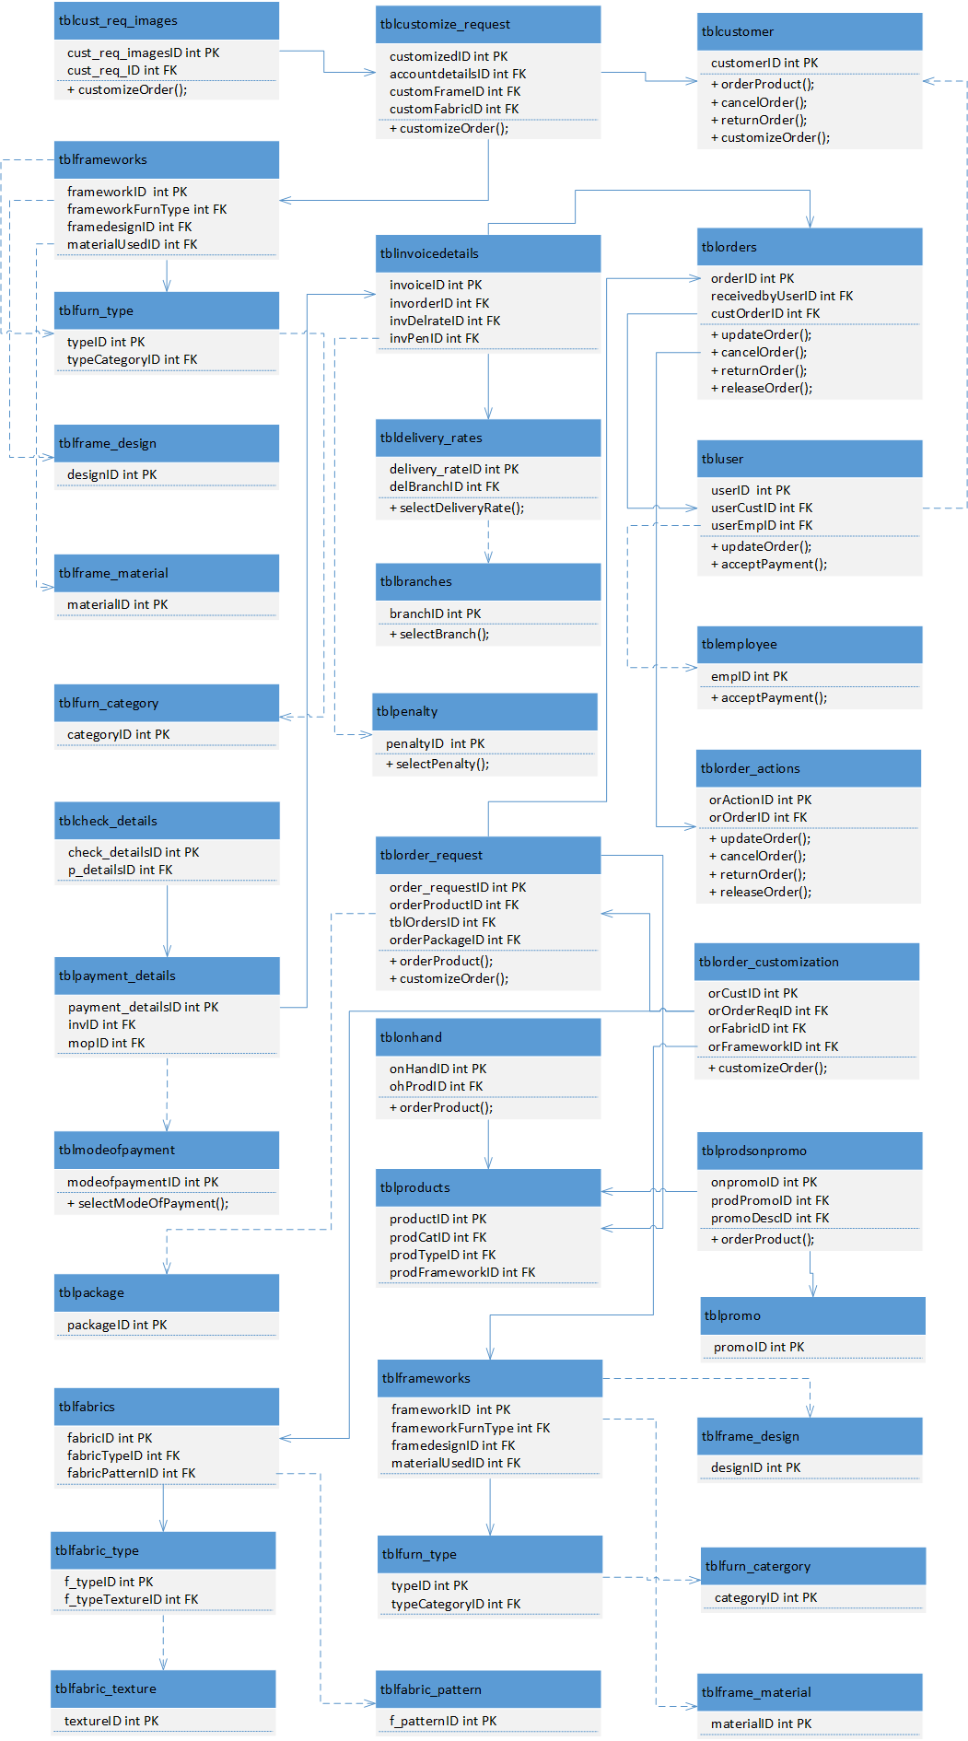

***Figure 11 Manage Orders Class Diagram***

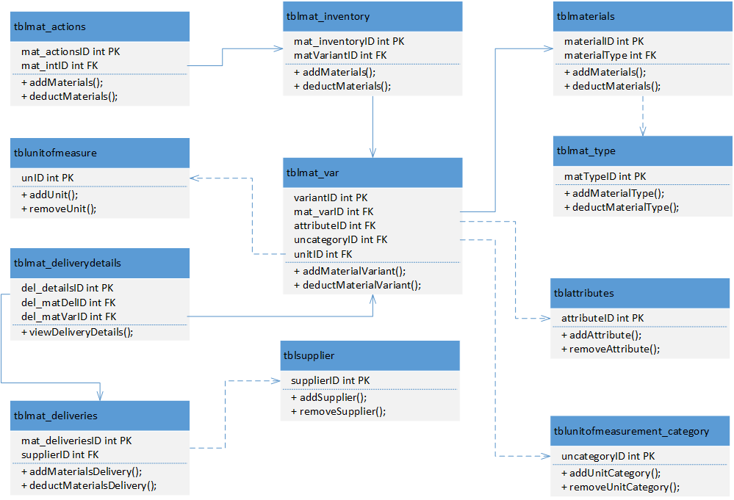

***Figure 11.1 Monitor Inventory Class Diagram***

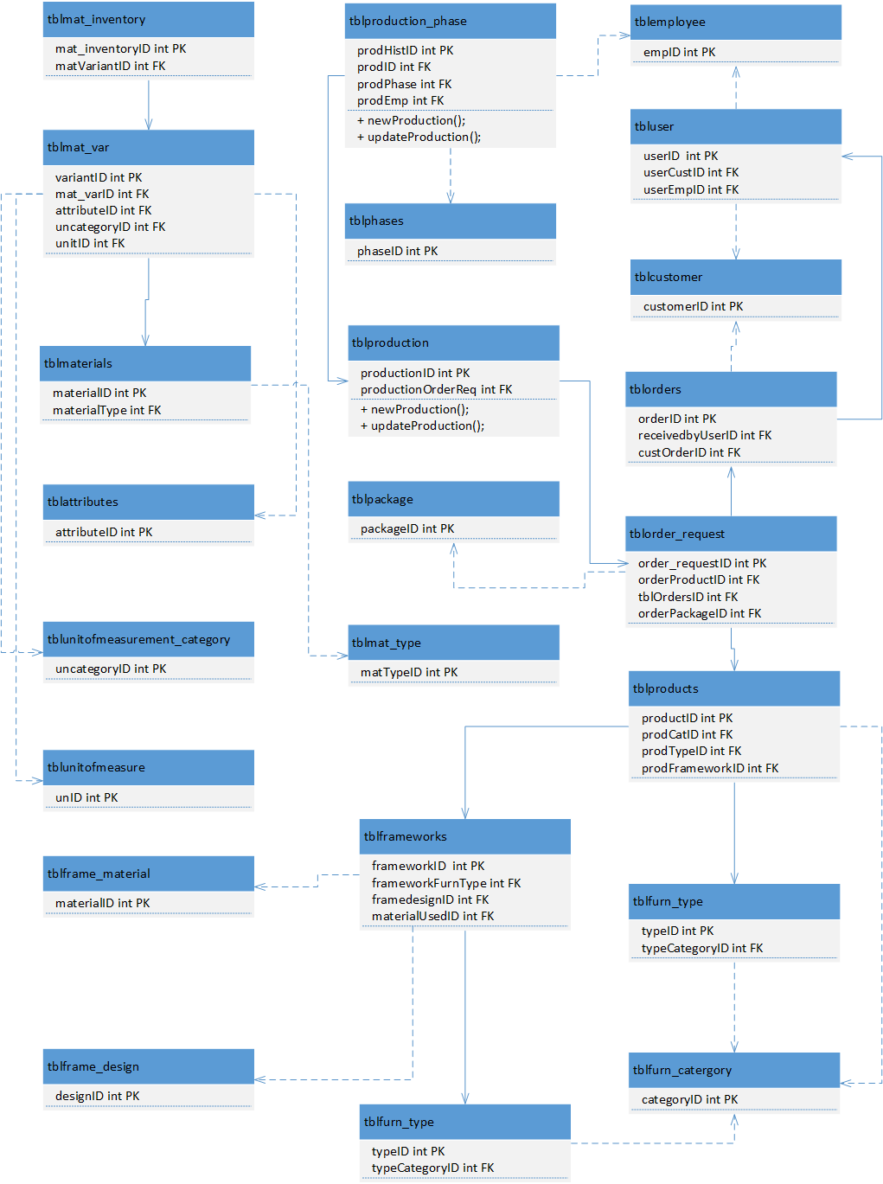

***Figure 11.2 Monitor Production Class Diagram***

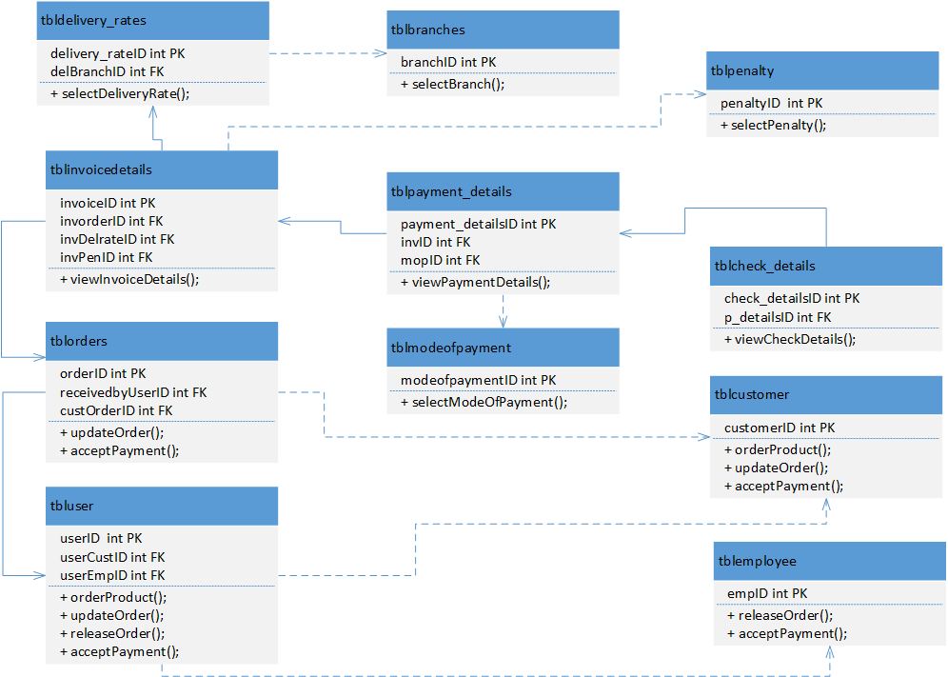***Figure 11.3 Process Payment Class Diagram***

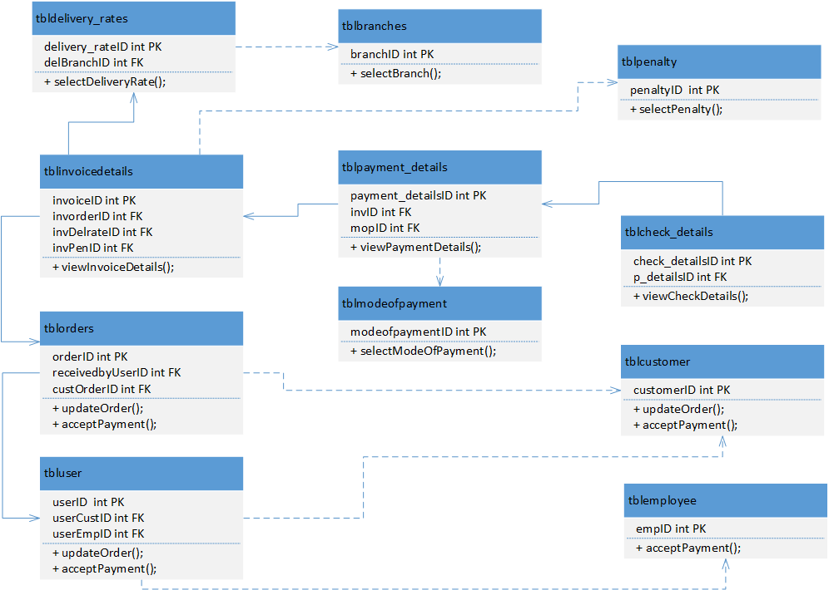

***Figure 11.4 Manage Collections Class Diagram***

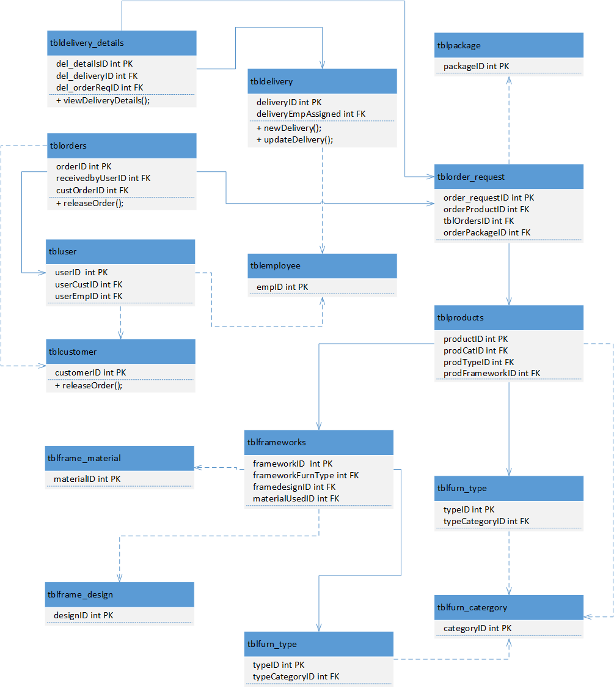

***Figure 11.5 Monitor Delivery Class Diagram***

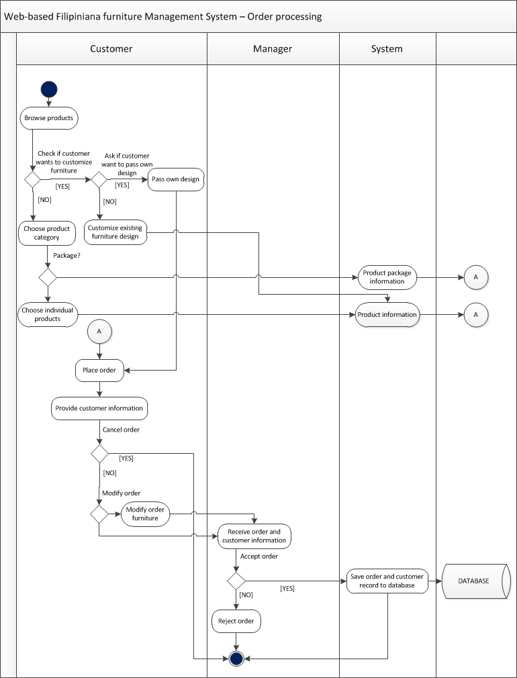**3.3.2. ACTIVITY DIAGRAM**

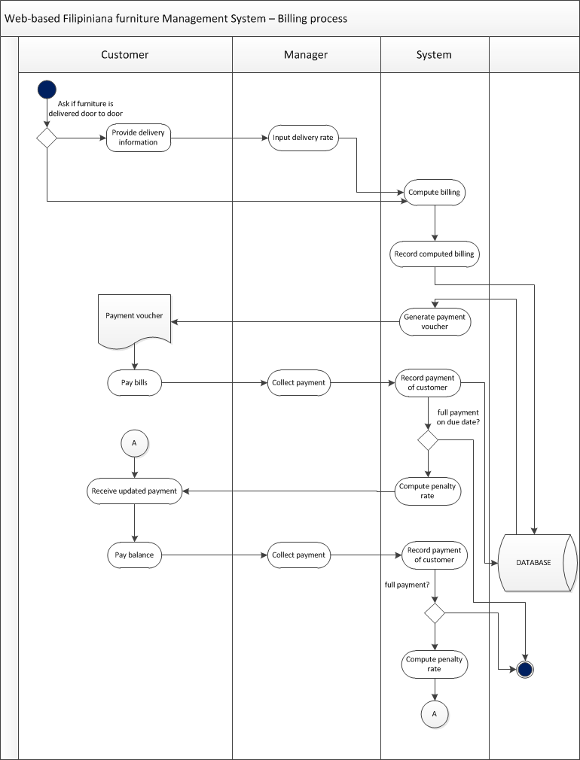





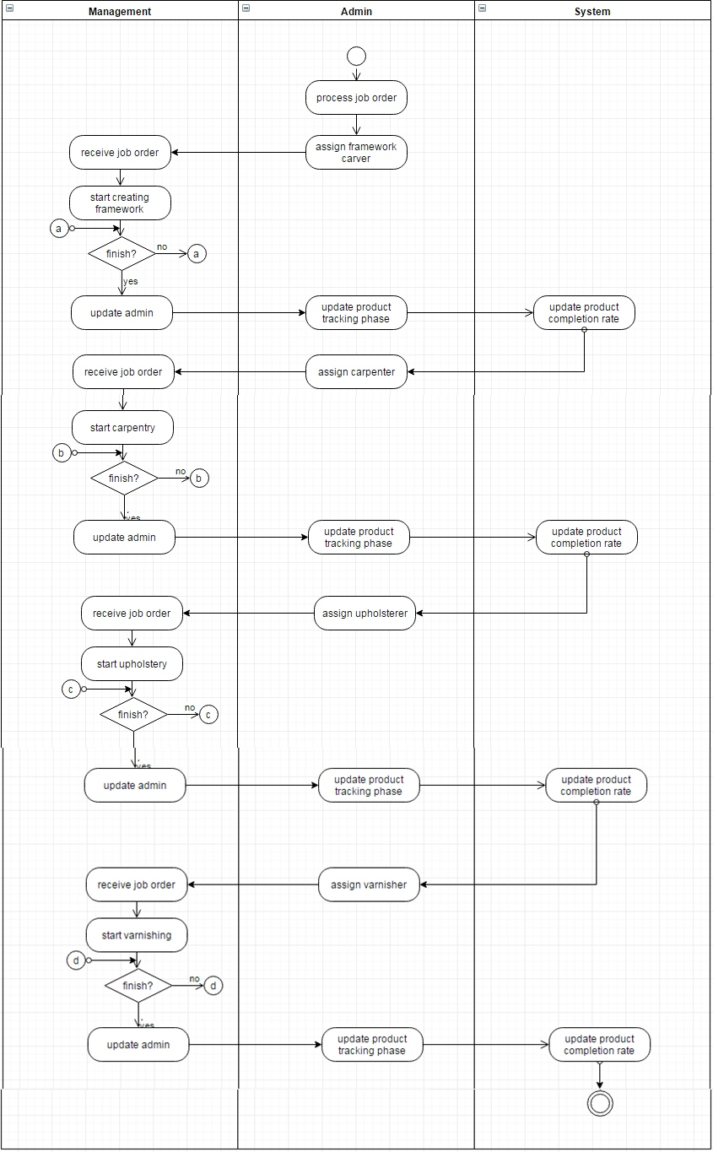**Production Tracking**

***Figure 12. Activity Diagram***

**3.3.3. DATABASE DESIGN**

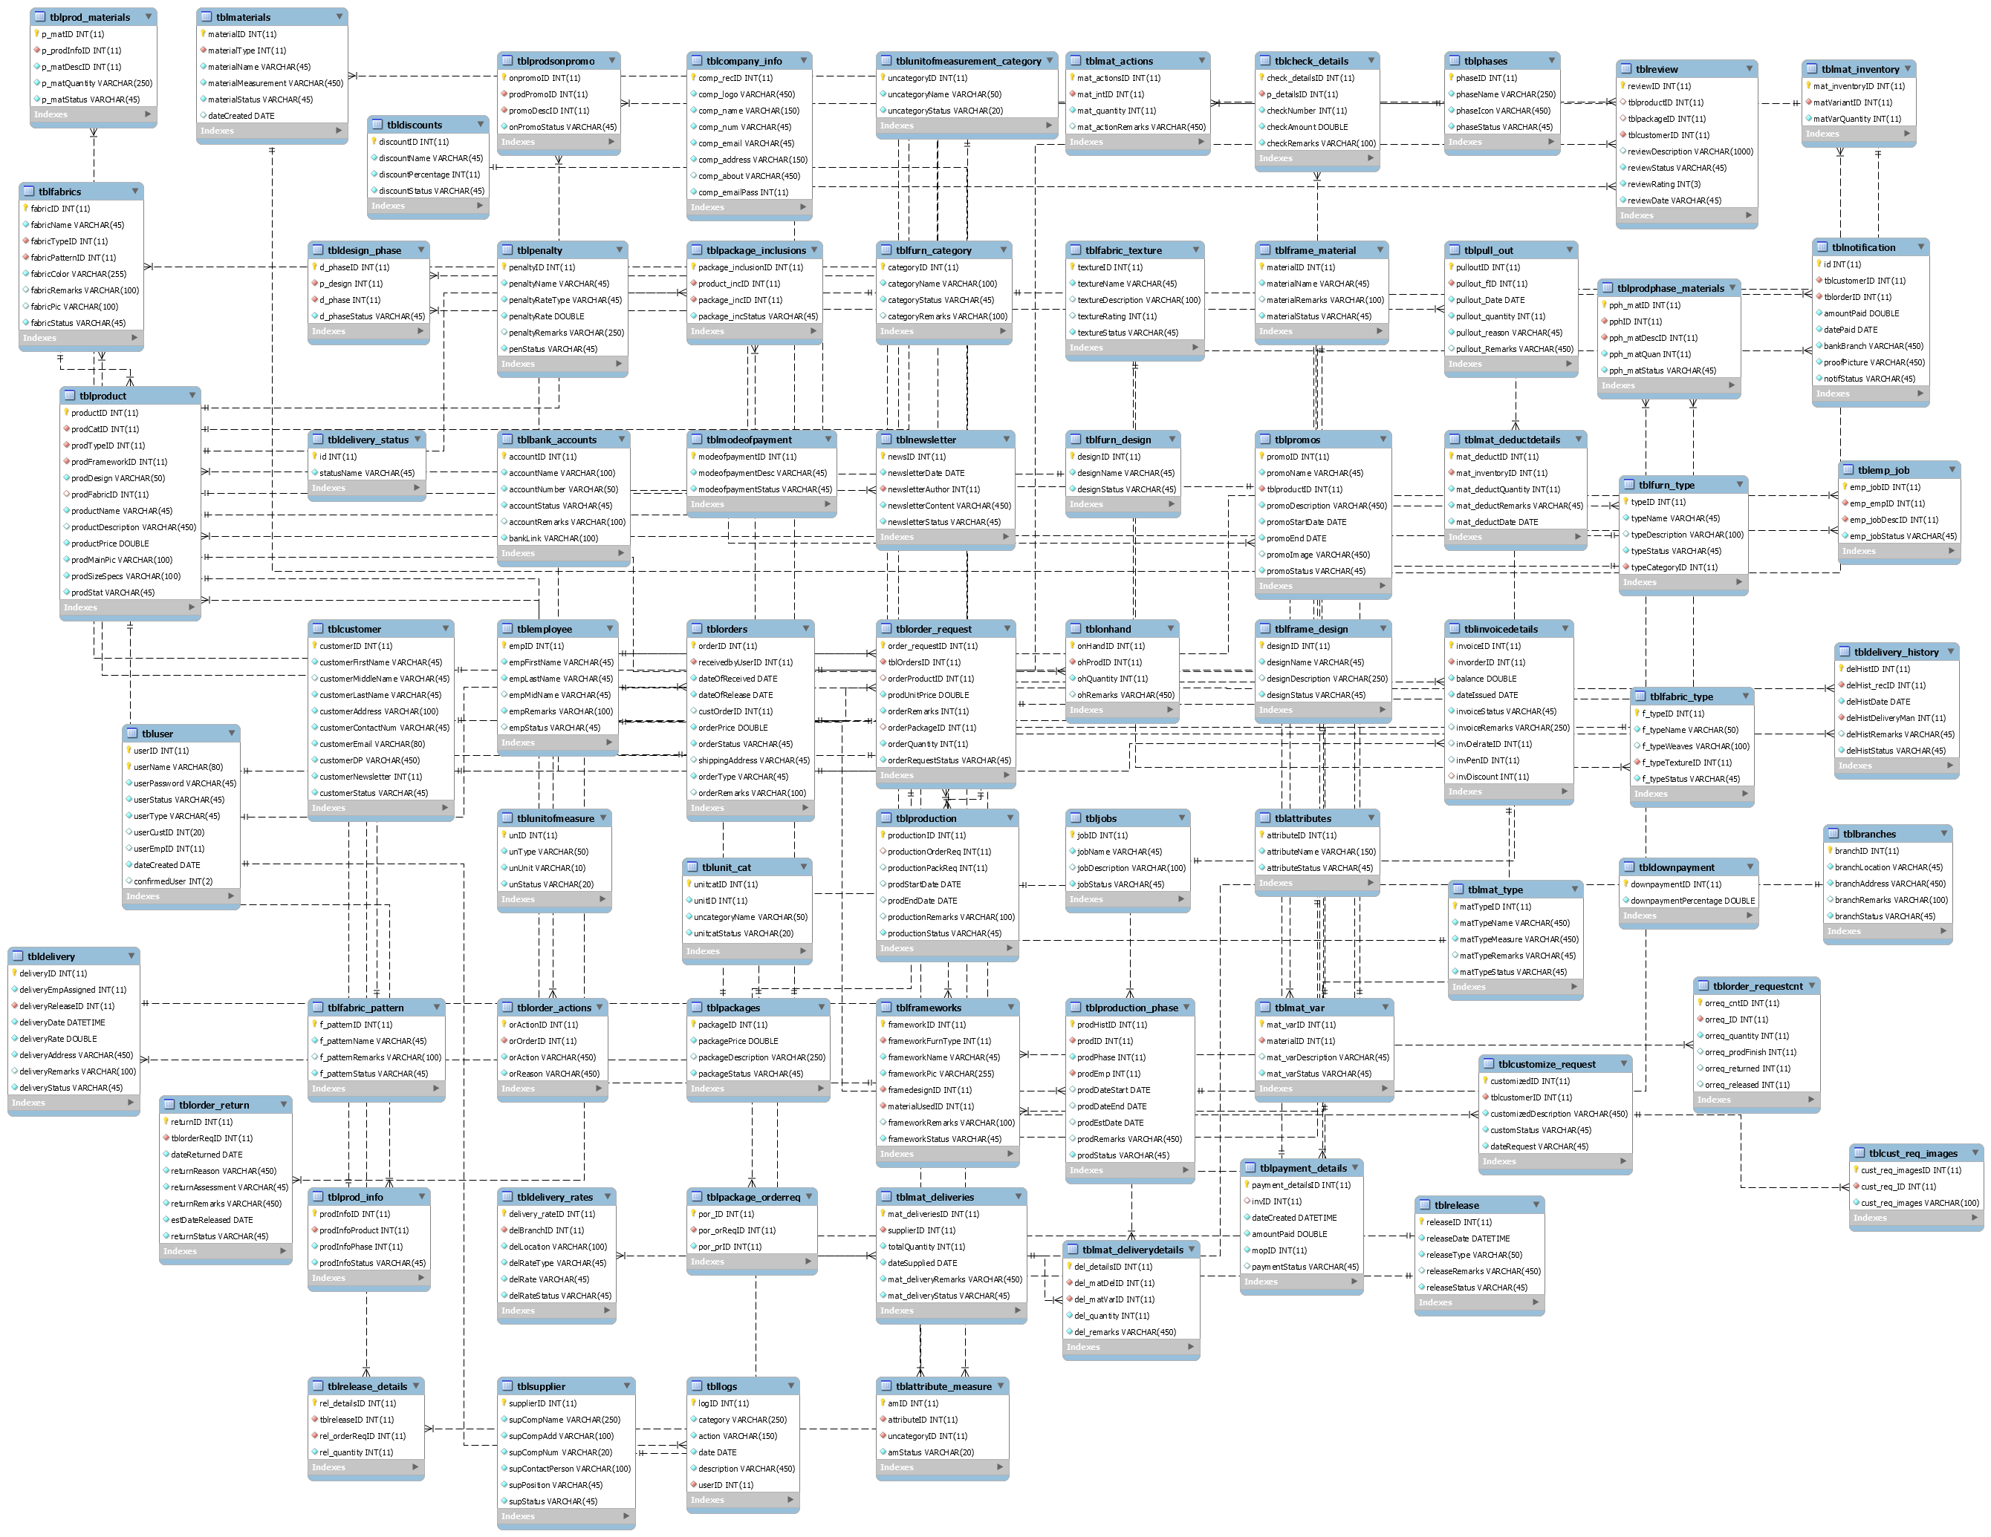**3.3.3.1 DATABASE SCHEMAinfor**

**3.3.3.2 DATA DICTIONARY**

**Table Name: tblattribute_measure**

**Related Table: tblattributes, tblunitofmeasurement_category**

**Description: This table contains the measurements needed for an attribute.**

|  |  |  |  |  |  |  |  |  |  |
| --- | --- | --- | --- | --- | --- | --- | --- | --- | --- |
| **Key** | **Field Name** | **Description** | **Data Type** | **Min** | **Max** | **Default** | **Required** | **Sample Data** | **Validation** |
| PK | amID | Attribute measure ID | INT (11) | N/A | N/A | 1 | Yes | 1 | N/A |
| FK | attributeID | ID of attribute from tblattributes | INT (11) | N/A | N/A | N/A | Yes | 1 | ID must exist in tblattributes |
| FK | uncategoryID | Description of the Project | INT(11) | N/A | N/A | N/A | Yes | 1 | ID must exist in tblunitofmeasurement_category |
|  | amStatus | Status of attribute measure record | VARCHAR(20) | N/A | N/A | N/A | Yes | Active | N/A |

**Table Name: tblattributes**

**Related Table:**

**Description: This table contains the attributes that a material may have.**

|  |  |  |  |  |  |  |  |  |  |
| --- | --- | --- | --- | --- | --- | --- | --- | --- | --- |
| **Key** | **Field Name** | **Description** | **Data Type** | **Min** | **Max** | **Default** | **Required** | **Sample Data** | **Validation** |
| PK | attributeID | ID’s of attributes | INT(11) | N/A | N/A | 1 | Yes | 1 | N/A |
|  | attributeName | Name of attributes | VARCHAR(150) | N/A | N/A | N/A | Yes | Color | N/A |
|  | attributeStatus | Status of attributes record | VARCHAR(45) | N/A | N/A | N/A | Yes | Active | N/A |

**Table Name: tblbank_accounts**

**Related Table:**

**Description: This table contains the bank account information provided by the management. If the customer chooses to pay via bank the information of the bank account will be coming from here.**

|  |  |  |  |  |  |  |  |  |  |
| --- | --- | --- | --- | --- | --- | --- | --- | --- | --- |
| **Key** | **Field Name** | **Description** | **Data Type** | **Min** | **Max** | **Default** | **Required** | **Sample Data** | **Validation** |
| PK | accountID | ID’s of bank accounts record | INT(11) | N/A | N/A | 1 | Yes | 1 | N/A |
|  | accountName | Name of the account holder | VARCHAR(100) | N/A | N/A | N/A | Yes | Aira B. Coronado | N/A |
|  | accountNumber | Number of account | INT(11) | N/A | N/A | N/A | Yes | 201402207MN0 | N/A |
|  | accountStatus | Status of bank account record | VARCHAR(45) | N/A | N/A | N/A | Yes | Active | N/A |
|  | accountRemarks | Remarks on the bank account | VARCHAR(100) | N/A | N/A | N/A | No | A bank account | N/A |

**Table Name: tblbranches**

**Related Table:**

**Description: This table contains the bank account information provided by the management. If the customer chooses to pay via bank the information of the bank account will be coming from here.**

|  |  |  |  |  |  |  |  |  |  |
| --- | --- | --- | --- | --- | --- | --- | --- | --- | --- |
| **Key** | **Field Name** | **Description** | **Data Type** | **Min** | **Max** | **Default** | **Required** | **Sample Data** | **Validation** |
| PK | branchID | ID’s of the branch record | INT(11) | N/A | N/A | 1 | Yes | 1 | N/A |
|  | branchLocation | Location of the branch | VARCHAR(45) | N/A | N/A | N/A | Yes | Bacoor | N/A |
|  | branchAddress | Specific address of the branch | VARCHAR(450) | N/A | N/A | N/A | Yes | #23 Talaba II Aguinaldo Hi-way Bacoor City | N/A |
|  | branchRemarks | Remarks about the branch | VARCHAR(100) | N/A | N/A | N/A | Yes | The main branch | N/A |
|  | branchStatus | Remarks on the bank account | VARCHAR(45) | N/A | N/A | N/A | No | Active | N/A |

**Table Name: tblcheck_details**

**Related Table: tblpayment_details**

**Description: This table contains the bank account information provided by the management. If the customer chooses to pay via bank the information of the bank account will be coming from here.**

|  |  |  |  |  |  |  |  |  |  |
| --- | --- | --- | --- | --- | --- | --- | --- | --- | --- |
| **Key** | **Field Name** | **Description** | **Data Type** | **Min** | **Max** | **Default** | **Required** | **Sample Data** | **Validation** |
| PK | check_detailsID | ID’s of the check details record | INT(11) | N/A | N/A | 1 | Yes | 1 | N/A |
| FK | p_detailsID | ID of tblpayment_details record | INT(11) | N/A | N/A | N/A | Yes | 2 | Must exist in tblpayment_details |
|  | checkNumber | Number of the check | INT(11) | N/A | N/A | N/A | Yes | 0000001 | N/A |
|  | checkAmount | Remarks about the branch | DOUBLE | N/A | N/A | N/A | Yes | 1000.00 | N/A |
|  | checkRemarks | Remarks on the bank account | VARCHAR(100) | N/A | N/A | N/A | No | Payment for an order | N/A |

**Table Name: tblcompany_info**

**Related Table:**

**Description: This table contains the company information. This information is displayed on the website.**

|  |  |  |  |  |  |  |  |  |  |
| --- | --- | --- | --- | --- | --- | --- | --- | --- | --- |
| **Key** | **Field Name** | **Description** | **Data Type** | **Min** | **Max** | **Default** | **Required** | **Sample Data** | **Validation** |
| PK | comp_recID | ID of the company information record | INT(11) | N/A | N/A | 1 | Yes | 1 | N/A |
|  | comp_logo | Filename of the company logo | VARCHAR(450) | N/A | N/A | N/A | Yes | Logo.png | N/A |
|  | comp_name | The name of the company | VARCHAR(150) | N/A | N/A | N/A | Yes | Filipiniana Furniture Shop | N/A |
|  | comp_num | The company’s contact information | INT(11) | N/A | N/A | N/A | Yes | 765-4321 | N/A |
|  | comp_email | The company’s email address | VARCHAR(45) | N/A | N/A | N/A | Yes | filfurniture@gmail.com | N/A |
|  | comp_emailPass | The company’s email password | VARCHAR(45) | N/A | N/A | N/A | Yes | Password | N/A |
|  | comp_address | The company’s address | VARCHAR(150) | N/A | N/A | N/A | Yes | Talaba II, Bacoor City | N/A |
|  | comp_about | The company’s about | VARCHAR(450) | N/A | N/A | N/A | Yes | A furniture shop. | N/A |

**Table Name: tblcust_req_images**

**Related Table:**

**Description: This table contains the images of the customization request from the customer.**

|  |  |  |  |  |  |  |  |  |  |
| --- | --- | --- | --- | --- | --- | --- | --- | --- | --- |
| **Key** | **Field Name** | **Description** | **Data Type** | **Min** | **Max** | **Default** | **Required** | **Sample Data** | **Validation** |
| PK | cust_req_imagesID | ID of the company information record | INT(11) | N/A | N/A | 1 | Yes | 1 | N/A |
| FK | cust_req_ID | Filename of the company logo | INT(11) | N/A | N/A | N/A | Yes | 2 | Must exist in tblcustomize_request |
|  | cust_req_images | The name of the company | VARCHAR(100) | N/A | N/A | N/A | Yes | Image.jpeg | N/A |
|  | cust_req_imageStat | The company’s contact information | VARCHAR(45) | N/A | N/A | N/A | Yes | Active | N/A |

**Table Name: tblcustomer**

**Related Table:**

**Description: This table contains the information of the customer.**

|  |  |  |  |  |  |  |  |  |  |
| --- | --- | --- | --- | --- | --- | --- | --- | --- | --- |
| **Key** | **Field Name** | **Description** | **Data Type** | **Min** | **Max** | **Default** | **Required** | **Sample Data** | **Validation** |
| PK | customerID | ID of the customer record | INT(11) | N/A | N/A | 1 | Yes | 1 | N/A |
|  | customerFirstName | Firstname of the customer | VARCHAR(45) | N/A | N/A | N/A | Yes | Rhodora | N/A |
|  | customerMiddleName | Middlename of the customer | VARCHAR(45) | N/A | N/A | N/A | No | Barrameda | N/A |
|  | customerLastName | Lastname of the customer | VARCHAR(45) | N/A | N/A | N/A | Yes | Coronado | N/A |
|  | customerAddress | Address of the customer | VARCHAR(100) | N/A | N/A | N/A | Yes | #123 Brgy. Batasan Hills Quezon City | N/A |
|  | customerContactNum | The customer’s contact number | VARCHAR(45) | N/A | N/A | N/A | Yes | 09216982449 | N/A |
|  | customerEmail | The customer’s email | VARCHAR(80) | N/A | N/A | N/A | Yes | rhodorabbcc@yahoo.com | N/A |
|  | customerStatus | The status of the customer | VARCHAR(45) | N/A | N/A | N/A | Yes |  |  |

**Table Name: tblcustomize_request**

**Related Table: tblcustomer, tblframeworks, tblfabrics**

**Description: This table contains the information of the customer’s customization request.**

|  |  |  |  |  |  |  |  |  |  |
| --- | --- | --- | --- | --- | --- | --- | --- | --- | --- |
| **Key** | **Field Name** | **Description** | **Data Type** | **Min** | **Max** | **Default** | **Required** | **Sample Data** | **Validation** |
| PK | customizedID | ID of the customization record | INT(11) | N/A | N/A | 1 | Yes | 1 | N/A |
| FK | accountdetailsID | ID of the customer who request the customization | INT(11) | N/A | N/A | N/A | Yes | 2 | Must exist in the tblcustomer |
|  | customizedPic | Filename of the customization image | VARCHAR(45) | N/A | N/A | N/A | No | Cust.jpeg | N/A |
|  | customizedDescription | Description of the customization | VARCHAR(250) | N/A | N/A | N/A | Yes | Coronado | N/A |
| FK | customFrameID | ID of the chosen framework | INT(11) | N/A | N/A | N/A | No | 2 | Must exist in the tblframeworks |
| FK | customFabricID | ID of the chosen fabric | INT(11) | N/A | N/A | N/A | No | 4 | Must exist in the tblfabrics |
|  | customStatus | Status of the customization | VARCHAR(45) | N/A | N/A | N/A | Yes | Pending | N/A |

**Table Name: tbldelivery**

**Related Table: tblemployee**

**Description: This table contains the delivery information of the order to be delivered**

|  |  |  |  |  |  |  |  |  |  |
| --- | --- | --- | --- | --- | --- | --- | --- | --- | --- |
| **Key** | **Field Name** | **Description** | **Data Type** | **Min** | **Max** | **Default** | **Required** | **Sample Data** | **Validation** |
| PK | deliveryID | ID of the delivery record | INT(11) | N/A | N/A | 1 | Yes | 1 | N/A |
| FK | deliveryEmpAssigned | ID of the employee assigned in the delivery | INT(11) | N/A | N/A | N/A | Yes | 2 | Must exist in the tblemployee |
|  | deliveryDate | Date of delivery | DATETIME | N/A | N/A | N/A | Yes | 2017-08-25 | N/A |
|  | deliveryRate | Rate of delivery | DOUBLE | N/A | N/A | N/A | Yes | 1000.00 | N/A |
|  | deliveryAddress | Address of delivery | VARCHAR(450) | N/A | N/A | N/A | Yes | #123 Kagawad Street Batasan Hills Quezon City | N/A |
|  | deliveryRemarks | Remarks on the delivery | VARCHAR(100) | N/A | N/A | N/A | No | A delivery | N/A |
|  | deliveryStatus | Status of the delivery | VARCHAR(45) | N/A | N/A | N/A | Yes | Pending | N/A |

**Table Name: tbldelivery_details**

**Related Table: tbldelivery,tblorder_request**

**Description: This table contains the information of the delivery.**

|  |  |  |  |  |  |  |  |  |  |
| --- | --- | --- | --- | --- | --- | --- | --- | --- | --- |
| **Key** | **Field Name** | **Description** | **Data Type** | **Min** | **Max** | **Default** | **Required** | **Sample Data** | **Validation** |
| PK | del_detailsID | ID of the delivery details record | INT(11) | N/A | N/A | 1 | Yes | 1 | N/A |
| FK | del_deliveryID | ID of the delivery record | INT(11) | N/A | N/A | N/A | Yes | 2 | Must exist in the tbldelivery |
| FK | del_orderReqID | ID of the order request | INT(11) | N/A | N/A | N/A | Yes | 3 | Must exist in the tblorder_request |
|  | del_quantity | Quantity of the deliver order request to be delivered | INT(11) | N/A | N/A | N/A | Yes | 5 | N/A |
|  | del_status | Status of the delivery details table | VARCHAR(45) | N/A | N/A | N/A | Yes | Pending | N/A |

**Table Name: tbldelivery_rates**

**Related Table: tblbranches**

**Description: This table contains delivery rates information.**

|  |  |  |  |  |  |  |  |  |  |
| --- | --- | --- | --- | --- | --- | --- | --- | --- | --- |
| **Key** | **Field Name** | **Description** | **Data Type** | **Min** | **Max** | **Default** | **Required** | **Sample Data** | **Validation** |
| PK | delivery_rateID | ID of the delivery details record | INT(11) | N/A | N/A | 1 | Yes | 1 | N/A |
| FK | delBranchID | ID of the branch record | INT(11) | N/A | N/A | N/A | Yes | 2 | Must exist in the tblbranches |
|  | delLocation | Location of the delivery | VARCHAR(100) | N/A | N/A | N/A | Yes | Bacoor | Must exist in the tblorder_request |
|  | delRateType | Rate Type can either be percentage or a fixed amount. Percentage pertaining to the percentage of the total price. | VARCHAR(45) | N/A | N/A | N/A | Yes | Amount | N/A |
|  | delRate | Rate of the delivery | VARCHAR(45) | N/A | N/A | N/A | Yes | 1000.00 | N/A |
|  | delRateStatus | Status of the delivery rate | VARCHAR(45) | N/A | N/A | N/A | Yes | Active | N/A |

**Table Name: tbldesign_phase**

**Related Table: tblphases, tblfurn_design**

**Description: This table contains the phases that a certain furniture design must undergo.**

|  |  |  |  |  |  |  |  |  |  |
| --- | --- | --- | --- | --- | --- | --- | --- | --- | --- |
| **Key** | **Field Name** | **Description** | **Data Type** | **Min** | **Max** | **Default** | **Required** | **Sample Data** | **Validation** |
| PK | d_phaseID | ID of the delivery details record | INT(11) | N/A | N/A | 1 | Yes | 1 | N/A |
| FK | p_design | ID of the furniture design | INT(11) | N/A | N/A | N/A | Yes | 2 | Must exist in the tblfurn_design |
| FK | d_phase | ID of the production phase | INT(11) | N/A | N/A | N/A | Yes | 3 | Must exist in the tblphases |
|  | d_phaseStatus | Status of the record | VARCHAR(45) | N/A | N/A | N/A | Yes | Active | N/A |

**Table Name: tbldelivery_status**

**Related Table:**

**Description: Status of deliveries**

|  |  |  |  |  |  |  |  |  |  |
| --- | --- | --- | --- | --- | --- | --- | --- | --- | --- |
| **Key** | **Field Name** | **Description** | **Data Type** | **Min** | **Max** | **Default** | **Required** | **Sample Data** | **Validation** |
| **PK** | **id** | **ID of the delivery details** | **Int(11)** | **N/A** | **N/A** |  | **Yes** | **1** | **N/A** |
|  | **statusName** | **Name of the delivery status.** | **Varchar(45)** | **N/A** | **N/A** |  | **Yes** | **Pending** | **N/A** |

**Table Name: tbldiscounts**

**Related Table:**

**Description: This table contains discount information**

|  |  |  |  |  |  |  |  |  |  |
| --- | --- | --- | --- | --- | --- | --- | --- | --- | --- |
| **Key** | **Field Name** | **Description** | **Data type** | **min** | **max** | **default** | **required** | **sample** | **Validation** |
| **pk** | **discountID** | **ID of the discounts** | **Int(11)** | **n/a** | **n/a** |  | **yes** | **1** | **n/a** |
|  | **discountName** | **Name of discounts** | **varchar(45)** | **n/a** | **n/a** |  | **yes** | **Friendly Discount** | **n/a** |
|  | **discountPercentage** | **Percentage of the discounts** | **Int(11)** | **n/a** | **n/a** |  | **yes** | **50** | **n/a** |
|  | **discountStatus** | **Status of the discount** | **Varchar(45)** | **n/a** | **n/a** |  | **yes** | **active** | **n/a** |

**Table Name: tbldownpayment**

**Related Table:**

**Description: This table contains the downpayment information**

|  |  |  |  |  |  |  |  |  |  |
| --- | --- | --- | --- | --- | --- | --- | --- | --- | --- |
| **Key** | **Field Name** | **Description** | **Data Type** | **Min** | **Max** | **Default** | **Required** | **Sample Data** | **Validation** |
| PK | downpaymentID | ID of the delivery details record | INT(11) | N/A | N/A | 1 | Yes | 1 | N/A |
|  | downpaymentPercentage | The percentage of the required downpayment to be paid | DOUBLE | N/A | N/A | N/A | Yes | .50 | N/A |

**Table Name: tblemp_job**

**Related Table: tblemployee,tbljobs**

**Description: An employee can have multiple jobs. This table contains the jobs of the employee.**

|  |  |  |  |  |  |  |  |  |  |
| --- | --- | --- | --- | --- | --- | --- | --- | --- | --- |
| **Key** | **Field Name** | **Description** | **Data Type** | **Min** | **Max** | **Default** | **Required** | **Sample Data** | **Validation** |
| PK | emp_jobID | ID of the delivery details record | INT(11) | N/A | N/A | 1 | Yes | 1 | N/A |
| FK | emp_empID | ID of the employee | INT(11) | N/A | N/A | N/A | Yes | 1 | N/A |
| FK | emp_jobDescID | ID of the job | INT(11) | N/A | N/A | N/A | Yes | 1 | N/A |
|  | emp_jobStatus | Status of the record | VARCHAR(45) | N/A | N/A | N/A | Yes | Active | N/A |

**Table Name: tblemployee**

**Related Table:**

**Description: This table contains the employee information**

|  |  |  |  |  |  |  |  |  |  |
| --- | --- | --- | --- | --- | --- | --- | --- | --- | --- |
| **Key** | **Field Name** | **Description** | **Data Type** | **Min** | **Max** | **Default** | **Required** | **Sample Data** | **Validation** |
| PK | empID | ID of the employee | INT(11) | N/A | N/A | 1 | Yes | 1 | N/A |
|  | empFirstName | First Name of the employee | VARCHAR(45) | N/A | N/A | N/A | Yes | Rhodora | N/A |
|  | empLastName | Last Name of the employee | VARCHAR(45) | N/A | N/A | N/A | Yes | Cooronado | N/A |
|  | empMidName | Middle Name of the employee | VARCHAR(45) | N/A | N/A | N/A | Yes | Barrameda | N/A |
|  | empRemarks | Remarks | VARCHAR(100) | N/A | N/A | N/A | No | An employee |  |
|  | empStatus | Status of the employee | VARCHAR(45) | N/A | N/A | N/A | Yes | Active |  |

**Table Name: tblfabric_pattern**

**Related Table:**

**Description: This table contains the patterns or designs of a fabric. It is used to define the fabrics properly.**

|  |  |  |  |  |  |  |  |  |  |
| --- | --- | --- | --- | --- | --- | --- | --- | --- | --- |
| **Key** | **Field Name** | **Description** | **Data Type** | **Min** | **Max** | **Default** | **Required** | **Sample Data** | **Validation** |
| PK | f_patternID | ID of the pattern | INT(11) | N/A | N/A | 1 | Yes | 1 | N/A |
|  | f_patternName | Name of the pattern | VARCHAR(45) | N/A | N/A | N/A | Yes | Floral | N/A |
|  | f_patternRemarks | Remarks of the pattern | VARCHAR(100) | N/A | N/A | N/A | No | A combination of multiple flowers | N/A |
|  | f_patternStatus | Status of the pattern record | VARCHAR(45) | N/A | N/A | N/A | Yes | Active | N/A |

**Table Name: tblfabric_texture**

**Related Table:**

**Description: This table contains the texture. It is used to define the fabric type properly.**

|  |  |  |  |  |  |  |  |  |  |
| --- | --- | --- | --- | --- | --- | --- | --- | --- | --- |
| **Key** | **Field Name** | **Description** | **Data Type** | **Min** | **Max** | **Default** | **Required** | **Sample Data** | **Validation** |
| PK | textureID | ID of the texture | INT(11) | N/A | N/A | 1 | Yes | 1 | N/A |
|  | textureName | Name of thetexture | VARCHAR(45) | N/A | N/A | N/A | Yes | Very smooth | N/A |
|  | textureDescription | Description of the texture | VARCHAR(100) | N/A | N/A | N/A | No | A very smooth texture | N/A |
|  | textureRating | Rating defines the level of the texture’s quality | INT(11) | N/A | N/A | N/A | Yes | 5 | N/A |
|  | textureStatus | Status of the record | VARCHAR(45) | N/A | N/A | N/A | Yes | Active | N/A |

**Table Name: tblfabric_type**

**Related Table: tblfabric_texture**

**Description: This table contains the fabric types. It is used to define the fabrics properly.**

|  |  |  |  |  |  |  |  |  |  |
| --- | --- | --- | --- | --- | --- | --- | --- | --- | --- |
| **Key** | **Field Name** | **Description** | **Data Type** | **Min** | **Max** | **Default** | **Required** | **Sample Data** | **Validation** |
| PK | f_typeID | ID of the fabric type | INT(11) | N/A | N/A | 1 | Yes | 1 | N/A |
|  | f_typeName | Name of the fabric type | VARCHAR(50) | N/A | N/A | N/A | Yes | Leather | N/A |
|  | f_typeWeaves | Description fabric type’s weaves. | VARCHAR(100) | N/A | N/A | N/A | No | Compactly weaved | N/A |
| FK | f_typeTextureID | ID of the texture of the fabric type | INT(11) | N/A | N/A | N/A | Yes | 5 | Must exist in the tblfabric_texture. |
|  | f_typeStatus | Status of the record | VARCHAR(45) | N/A | N/A | N/A | Yes | Active | N/A |

**Table Name: tblfabrics**

**Related Table: tblfabric_type, tblfabric_pattern**

**Description: This table contains the fabrics. It is used to define the products.**

|  |  |  |  |  |  |  |  |  |  |
| --- | --- | --- | --- | --- | --- | --- | --- | --- | --- |
| **Key** | **Field Name** | **Description** | **Data Type** | **Min** | **Max** | **Default** | **Required** | **Sample Data** | **Validation** |
| PK | fabricID | ID of the fabric | INT(11) | N/A | N/A | 1 | Yes | 1 | N/A |
|  | fabricName | Name of the fabric | VARCHAR(45) | N/A | N/A | N/A | Yes | Gold Rani | N/A |
| FK | fabricTypeID | ID of the fabric type | INT(11) | N/A | N/A | N/A | Yes | 4 | Must exist in the tblfabric_type |
| FK | fabricPatternID | ID of the fabric pattern | INT(11) | N/A | N/A | N/A | Yes | 5 | Must exist in the tblfabric_pattern |
|  | fabricColor | Color description of the fabric | VARCHAR(255) | N/A | N/A | N/A | Yes | Black and Yellow | N/A |
|  | fabricRemarks | Remarks about the fabric | VARCHAR(100) | N/A | N/A | N/A | No |  | N/A |
|  | fabricPic | The filename of the fabric’s image. | VARCHAR(100) | N/A | N/A | N/A | Yes | 201708251047.jpeg | N/A |
|  | fabricStatus | Status of the record | VARCHAR(45) | N/A | N/A | N/A | Yes | Active | N/A |

**Table Name: tblframe_design**

**Related Table:**

**Description: This table contains the frame design. It is used to define the frameworks.**

|  |  |  |  |  |  |  |  |  |  |
| --- | --- | --- | --- | --- | --- | --- | --- | --- | --- |
| **Key** | **Field Name** | **Description** | **Data Type** | **Min** | **Max** | **Default** | **Required** | **Sample Data** | **Validation** |
| PK | designID | ID of the frame design | INT(11) | N/A | N/A | 1 | Yes | 1 | N/A |
|  | designName | Frame design name | VARCHAR(45) | N/A | N/A | N/A | Yes | Classic | N/A |
|  | designDescription | Design description | VARCHAR(250) | N/A | N/A | N/A | No | A classical design | N/A |
|  | designStatus | Status of the record | VARCHAR(45) | N/A | N/A | N/A | Yes | Active | N/A |

**Table Name: tblframe_material**

**Related Table:**

**Description: This table contains the material used to create the frame. It is used to define the frameworks.**

|  |  |  |  |  |  |  |  |  |  |
| --- | --- | --- | --- | --- | --- | --- | --- | --- | --- |
| **Key** | **Field Name** | **Description** | **Data Type** | **Min** | **Max** | **Default** | **Required** | **Sample Data** | **Validation** |
| PK | materialID | ID of the frame material | INT(11) | N/A | N/A | 1 | Yes | 1 | N/A |
|  | materialName | Frame material name | VARCHAR(45) | N/A | N/A | N/A | Yes | Narra Wood | N/A |
|  | materialRemarks | Frame material remarks | VARCHAR(100) | N/A | N/A | N/A | No | A material | N/A |
|  | materialStatus | Status of the record | VARCHAR(45) | N/A | N/A | N/A | Yes | Active | N/A |

**Table Name: tblframeworks**

**Related Table: tblframe_design, tblfurn_type, tblframe_material**

**Description: This table contains the frameworks. It is used to define the products.**

|  |  |  |  |  |  |  |  |  |  |
| --- | --- | --- | --- | --- | --- | --- | --- | --- | --- |
| **Key** | **Field Name** | **Description** | **Data Type** | **Min** | **Max** | **Default** | **Required** | **Sample Data** | **Validation** |
| PK | frameworkID | ID of the framework | INT(11) | N/A | N/A | 1 | Yes | 1 | N/A |
| FK | frameworkFurnType | Frame material name | INT(11) | N/A | N/A | N/A | Yes | 2 | Must exist in tblfurn_type |
|  | frameworkName | Frame material remarks | VARCHAR(45) | N/A | N/A | N/A | Yes | Jolly | N/A |
|  | frameworkPic | The filename of the framework’s image. | VARCHAR(255) | N/A | N/A | N/A | Yes | 2016085129.jpeg | N/A |
| FK | framedesignID | ID of the frame design | INT(11) | N/A | N/A | N/A | Yes | 2 | Must exist in tblframe_design |
| FK | materialUsedID | ID of the material used | INT(11) | N/A | N/A | N/A | Yes | 2 | Must exist in tblframe_material |
|  | frameworkRemarks | Remarks | VARCHAR(100) | N/A | N/A | N/A | No | Remark | N/A |
|  | frameworkStatus | Status of the record | VARCHAR(45) | N/A | N/A | N/A | Yes | Active | N/A |

**Table Name: tblfurn_category**

**Related Table:**

**Description: This table contains the category of the products**

|  |  |  |  |  |  |  |  |  |  |
| --- | --- | --- | --- | --- | --- | --- | --- | --- | --- |
| **Key** | **Field Name** | **Description** | **Data Type** | **Min** | **Max** | **Default** | **Required** | **Sample Data** | **Validation** |
| PK | categoryID | ID of the framework | INT(11) | N/A | N/A | 1 | Yes | 1 | N/A |
|  | categoryName | Category name | VARCHAR(100) | N/A | N/A | N/A | Yes | Living Area | N/A |
|  | categoryStatus | Status of the record | VARCHAR(45) | N/A | N/A | N/A | Yes | Active | N/A |
|  | categoryRemarks | Remarks | VARCHAR(100) | N/A | N/A | N/A | No | A category | N/A |

**Table Name: tblfurn_design**

**Related Table:**

**Description: This table contains the possible design of the product. These designs are Pure, Weaved, Upholstered.**

|  |  |  |  |  |  |  |  |  |  |
| --- | --- | --- | --- | --- | --- | --- | --- | --- | --- |
| **Key** | **Field Name** | **Description** | **Data Type** | **Min** | **Max** | **Default** | **Required** | **Sample Data** | **Validation** |
| PK | designID | ID of the framework | INT(11) | N/A | N/A | 1 | Yes | 1 | N/A |
|  | designName | Category name | VARCHAR(100) | N/A | N/A | N/A | Yes | Pure | N/A |
|  | designStatus | Status of the record | VARCHAR(45) | N/A | N/A | N/A | Yes | Active | N/A |

**Table Name: tblfurn_type**

**Related Table: tblfurn_category**

**Description: This table contains the furniture type. It is based on the furniture category and is used to define the products.**

|  |  |  |  |  |  |  |  |  |  |
| --- | --- | --- | --- | --- | --- | --- | --- | --- | --- |
| **Key** | **Field Name** | **Description** | **Data Type** | **Min** | **Max** | **Default** | **Required** | **Sample Data** | **Validation** |
| PK | typeID | ID of the furniture type | INT(11) | N/A | N/A | 1 | Yes | 1 | N/A |
|  | typeName | Furniture type name | VARCHAR(45) | N/A | N/A | N/A | Yes | Sofa | N/A |
|  | typeDescription | Furniture type description | VARCHAR(100) | N/A | N/A | N/A | No | Found in the living area | N/A |
|  | typeStatus | Status of record | VARCHAR(45) | N/A | N/A | N/A | Yes | Active | N/A |
| FK | typeCategoryID | ID of furniture category | INT(11) | N/A | N/A | N/A | Yes | 2 | Must exist in the tblfurn_category |

**Table Name: tblinvoicedetails**

**Related Table: tblorders**

**Description: This table contains the invoice information of the customer’s order.**

|  |  |  |  |  |  |  |  |  |  |
| --- | --- | --- | --- | --- | --- | --- | --- | --- | --- |
| **Key** | **Field Name** | **Description** | **Data Type** | **Min** | **Max** | **Default** | **Required** | **Sample Data** | **Validation** |
| PK | invoiceID | ID of the invoice | INT(11) | N/A | N/A | 1 | Yes | 1 | N/A |
| FK | invorderID | ID of the order | INT(11) | N/A | N/A | N/A | Yes | Sofa | Must exist in the tblorders |
|  | balance | Remaining balance | DOUBLE | N/A | N/A | N/A | Yes | Found in the living area | N/A |
|  | dateIssued | Date the invoice was issued | DATE | N/A | N/A | N/A | Yes | 2017-08-25 | N/A |
|  | invoiceStatus | Status of invoice | VARCHAR(45) | N/A | N/A | N/A | Yes | Paid | N/A |
|  | invoiceRemarks | A remarks. | VARCHAR(250) | N/A | N/A | N/A | Yes | An invoice | N/A |
|  | invDelrateID | Delivery ID | INT(11) | N/A | N/A | N/A | No | 1 | N/A |
|  | invPenID | Penalty ID | INT(11) | N/A | N/A | N/A | No | 1 | N/A |

**Table Name: tbljobs**

**Related Table:**

**Description: This table contains the jobs in the company.**

|  |  |  |  |  |  |  |  |  |  |
| --- | --- | --- | --- | --- | --- | --- | --- | --- | --- |
| **Key** | **Field Name** | **Description** | **Data Type** | **Min** | **Max** | **Default** | **Required** | **Sample Data** | **Validation** |
| PK | jobID | ID of the job | INT(11) | N/A | N/A | 1 | Yes | 1 | N/A |
|  | jobName | Job name | VARCHAR(45) | N/A | N/A | N/A | Yes | Carpentry | N/A |
|  | jobDescription | Job description | VARCHAR(100) | N/A | N/A | N/A | Yes | Builds the frame | N/A |
|  | jobStatus | Status of the job record | VARCHAR(45) | N/A | N/A | N/A | Yes | Active | N/A |

**Table Name: tbllogs**

**Related Table: tbluser**

**Description: This table contains the actions or changes that a certain user did in the system**

|  |  |  |  |  |  |  |  |  |  |
| --- | --- | --- | --- | --- | --- | --- | --- | --- | --- |
| **Key** | **Field Name** | **Description** | **Data Type** | **Min** | **Max** | **Default** | **Required** | **Sample Data** | **Validation** |
| PK | logID | ID of the log | INT(11) | N/A | N/A | 1 | Yes | 1 | N/A |
|  | category | Category of the action | VARCHAR(250) | N/A | N/A | N/A | Yes | Supplier | N/A |
|  | action | Action description | VARCHAR(150) | N/A | N/A | N/A | Yes | New | N/A |
|  | date | Date the action is done | DATE | N/A | N/A | N/A | Yes | 2017-08-25 | N/A |
|  | description | Action description | VARCHAR(450) | N/A | N/A | N/A | Yes | Created new supplier | N/A |
| FK | userID | ID of the user who did the action | INT(11) | N/A | N/A | N/A | Yes | 1 | Must exist in the tbluser |

**Table Name: tblmat_actions**

**Related Table: tblmat_inventory**

**Description: This table contains the actions done in the raw materials management**

|  |  |  |  |  |  |  |  |  |  |
| --- | --- | --- | --- | --- | --- | --- | --- | --- | --- |
| **Key** | **Field Name** | **Description** | **Data Type** | **Min** | **Max** | **Default** | **Required** | **Sample Data** | **Validation** |
| PK | mat_actionsID | ID of the record | INT(11) | N/A | N/A | 1 | Yes | 1 | N/A |
| FK | mat_intID | ID of the material inventory | INT(11) | N/A | N/A | N/A | Yes | 2 | Must exist in the tblmat_inventory |
|  | mat_quantity | Quantity of material added or deducted | INT(11) | N/A | N/A | N/A | Yes | New | N/A |
|  | mat_actionRemarks | Remarks | VARCHAR(450) | N/A | N/A | N/A | Yes | 2017-08-25 | N/A |

**Table Name: tblmat_deductdetails**

**Related Table: tblmat_var**

**Description: This table contains the materials deducted from the product upon production process.**

|  |  |  |  |  |  |  |  |  |  |
| --- | --- | --- | --- | --- | --- | --- | --- | --- | --- |
| **key** | **Field name** | **description** | **Data type** | **min** | **max** | **default** | **required** | **Sample data** | **validation** |
| pk | mat_deduct | Id of the deducted materials | Int(11) | n/a | n/a | n/a | yes | 1 | n/a |
| fk | mat_inventoryID | Id of material inventory records | Int(11) | n/a | n/a | n/a | yes | 1 | n/a |
|  | mat_deductQuantity | Quantity of deducted materials | Int(11) | n/a | n/a | n/a | yes | 50 | n/a |
|  | mat_deductRemarks | Information about the deduction | Varchar(45) | n/a | n/a | n/a | no | deducted | n/a |

**Table Name: tblmat_deliveries**

**Related Table: tblsupplier**

**Description: This table contains the deliveries of materials received from the supplier.**

|  |  |  |  |  |  |  |  |  |  |
| --- | --- | --- | --- | --- | --- | --- | --- | --- | --- |
| **Key** | **Field Name** | **Description** | **Data Type** | **Min** | **Max** | **Default** | **Required** | **Sample Data** | **Validation** |
| PK | mat_deliveriesID | ID of the record | INT(11) | N/A | N/A | 1 | Yes | 1 | N/A |
| FK | supplierID | ID of supplier | INT(11) | N/A | N/A | N/A | Yes | 2 | Must exist in tblsupplier |
|  | totalQuantity | Total quantity of delivery | INT(11) | N/A | N/A | N/A | Yes | 1 | N/A |
|  | mat_deliveryRemarks | Remark on the record | VARCHAR(450) | N/A | N/A | N/A | No | A remark | N/A |
|  | mat_deliveryStatus | Status of record | VARCHAR(45) | N/A | N/A | N/A | Yes | Active | N/A |

**Table Name: tblmat_deliverydetails**

**Related Table: tblmat_deliveries, tblmat_var**

**Description: This table contains the details of the deliveries.**

|  |  |  |  |  |  |  |  |  |  |
| --- | --- | --- | --- | --- | --- | --- | --- | --- | --- |
| **Key** | **Field Name** | **Description** | **Data Type** | **Min** | **Max** | **Default** | **Required** | **Sample Data** | **Validation** |
| PK | del_detailsID | ID of the record | INT(11) | N/A | N/A | 1 | Yes | 1 | N/A |
| FK | del_matDelID | ID of delivery record | INT(11) | N/A | N/A | N/A | Yes | 2 | Must exist in tblmat_deliveries |
| FK | del_matVarID | ID of material variant delivered | INT(11) | N/A | N/A | N/A | Yes | 1 | Must exist in tblmat_var |
|  | del_quantity | Quantity delivered | INT(11) | N/A | N/A | N/A | Yes | 100 | N/A |
|  | del_remarks | Remarks | VARCHAR(450) | N/A | N/A | N/A | No | Active | N/A |

**Table Name: tblmat_inventory**

**Related Table: tblmat_var**

**Description: This table contains the quantity of materials.**

|  |  |  |  |  |  |  |  |  |  |
| --- | --- | --- | --- | --- | --- | --- | --- | --- | --- |
| **Key** | **Field Name** | **Description** | **Data Type** | **Min** | **Max** | **Default** | **Required** | **Sample Data** | **Validation** |
| PK | mat_inventoryID | ID of the record | INT(11) | N/A | N/A | 1 | Yes | 1 | N/A |
| FK | matVariantID | ID of material variant | INT(11) | N/A | N/A | N/A | Yes | 2 | Must exist in tblmat_var |
|  | matVarQuantity | ID of material variant delivered | INT(11) | N/A | N/A | N/A | Yes | 100 | N/A |

**Table Name: tblmat_type**

**Related Table: tblmat_var**

**Description: This table contains the types of material. It is use to define a material.**

|  |  |  |  |  |  |  |  |  |  |
| --- | --- | --- | --- | --- | --- | --- | --- | --- | --- |
| **Key** | **Field Name** | **Description** | **Data Type** | **Min** | **Max** | **Default** | **Required** | **Sample Data** | **Validation** |
| PK | matTypeID | ID of the record | INT(11) | N/A | N/A | 1 | Yes | 1 | N/A |
|  | matTypeName | Name of material type | VARCHAR(450) | N/A | N/A | N/A | Yes | Paint | Must exist in tblmat_var |
|  | matTypeMeasure | Measures of the material type | VARCHAR(450) | N/A | N/A | N/A | Yes | Liters | N/A |
|  | matTypeRemarks | Remarks | VARCHAR(45) | N/A | N/A | N/A | Yes | A remark | N/A |
|  | matTypeStatus | Status of record | VARCHAR(45) | N/A | N/A | N/A | Yes | Active | N/A |

**Table Name: tblmat_var**

**Related Table: tblmaterials, tblunitofmeasurement_category, tblunitofmeasure,tblattribute**

**Description: This table contains the variants of a material.**

|  |  |  |  |  |  |  |  |  |  |
| --- | --- | --- | --- | --- | --- | --- | --- | --- | --- |
| **Key** | **Field Name** | **Description** | **Data Type** | **Min** | **Max** | **Default** | **Required** | **Sample Data** | **Validation** |
| PK | variantID | ID of the record | INT(11) | N/A | N/A | 1 | Yes | 1 | N/A |
| FK | mat_varID | ID of material | INT(11) | N/A | N/A | N/A | Yes | 2 | Must exist in tblmaterials |
| FK | attributeID | ID of selected attribute | INT(11) | N/A | N/A | N/A | Yes | 1 | N/A |
|  | mat_varDescription | Description of the variant attribute | VARCHAR(150) | N/A | N/A | N/A | Yes |  | N/A |
| FK | uncategoryID | ID of selected unit of measurement category | INT(11) | N/A | N/A | N/A | No | 1 | Must exist in tblunitofmeasurement_category |
|  | unitValue | Value if inputted unit | INT(45) | N/A | N/A | N/A | No | 5 | N/A |
| FK | unitID | ID of selected unit | INT(11) | N/A | N/A | N/A | No | 1 | Must exist in tblmaterials |
|  | attribCounter | Counter of attributes | INT(11) | N/A | N/A | N/A | Yes | 3 | N/A |
|  | mat_varStatus | Status of record | VARCHAR(45) | N/A | N/A | N/A | Yes | Active | N/A |

**Table Name: tblmaterials**

**Related Table: tblmat_type**

**Description: This table contains the materials used in making furniture.**

|  |  |  |  |  |  |  |  |  |  |
| --- | --- | --- | --- | --- | --- | --- | --- | --- | --- |
| **Key** | **Field Name** | **Description** | **Data Type** | **Min** | **Max** | **Default** | **Required** | **Sample Data** | **Validation** |
| PK | materialID | ID of the record | INT(11) | N/A | N/A | 1 | Yes | 1 | N/A |
| FK | materialType | ID of material type | INT(11) | N/A | N/A | N/A | Yes | 2 | Must exist in tblmat_type |
|  | materialName | Material Name | VARCHAR(45) | N/A | N/A | N/A | Yes | Paint | N/A |
|  | materialMeasurement | Measurement | VARCHAR(450) | N/A | N/A | N/A | Yes |  | N/A |
|  | materialStatus | Status of recordd | VARCHAR(45) | N/A | N/A | N/A | No | A remark | N/A |

**Table Name: tblmodeofpayment**

**Related Table: tblmat_type**

**Description: This table contains the mode of payments.**

|  |  |  |  |  |  |  |  |  |  |
| --- | --- | --- | --- | --- | --- | --- | --- | --- | --- |
| **Key** | **Field Name** | **Description** | **Data Type** | **Min** | **Max** | **Default** | **Required** | **Sample Data** | **Validation** |
| PK | modeofpaymentID | ID of the record | INT(11) | N/A | N/A | 1 | Yes | 1 | N/A |
|  | modeofpaymentDesc | Mode of payment description | VARCHAR(45) | N/A | N/A | N/A | Yes | Cash | N/A |
|  | modeofpaymentStatus | Status of record | VARCHAR(45) | N/A | N/A | N/A | Yes | Active | N/A |

**Table Name: tblonhand**

**Related Table: tblproduct**

**Description: This table contains the record of the on hand products.**

|  |  |  |  |  |  |  |  |  |  |
| --- | --- | --- | --- | --- | --- | --- | --- | --- | --- |
| **Key** | **Field Name** | **Description** | **Data Type** | **Min** | **Max** | **Default** | **Required** | **Sample Data** | **Validation** |
| PK | onHandID | ID of the record | INT(11) | N/A | N/A | 1 | Yes | 1 | N/A |
| FK | ohProdID | ID of the product | INT(11) | N/A | N/A | N/A | Yes | 1 | Must exist in tblproduct |
|  | ohQuantity | Quantity on hand | INT(11) | N/A | N/A | N/A | Yes | 10 | N/A |
|  | ohRemarks | Status of record | VARCHAR(450) | N/A | N/A | N/A | Yes | Active | N/A |

**Table name: tblnewsletter**

**Related tables: tbluser**

**Description: this contains the newsletters sent to subscribed customers**

|  |  |  |  |  |  |  |  |  |  |
| --- | --- | --- | --- | --- | --- | --- | --- | --- | --- |
| **key** | **Field name** | **description** | **Data type** | **min** | **max** | **default** | **required** | **Sample data** | **validation** |
| pk | newsletterID | Id of the newsletter | Int(11) | n/a | n/a | n/a | yes | 1 | n/a |
|  | newsletterDate | date the newsletter is composed | date | n/a | n/a | n/a | yes | 2017-10-14 | Must not be earlier than today |
| fk | newletterAuthor | The id of the user who composed the newsletter | Int(11) | n/a | n/a | n/a | yes | 3 | Must exist in tbluser |
|  | newsletterContent | The content of the newsletter | Varchar(25000) | n/a | n/a | n/a | yes | "this is an announcement..." | n/a |

**Table Name: tblnotifications**

**related tables:**

**description: contains the notifications of customer payment.**

|  |  |  |  |  |  |  |  |  |  |
| --- | --- | --- | --- | --- | --- | --- | --- | --- | --- |
| **Key** | **Field name** | **description** | **Data type** | **min** | **max** | **default** | **required** | **sample data** | **Validation** |
| pk | id | Id of notification | Int(11) | n/a | n/a | n/a | yes | 1 | n/a |
| Fk | tblcustomerID | Id of the customer who executed the action. | Int(11) | n/a | n/a | n/a | yes | 1 | n/a |
| Fk | tblorderID | Order information of the customer | Int(11) | n/a | n/a | n/a | yes | 1 | n/a |
|  | amountPaid | The amount paid for the order | double | n/a | n/a | n/a | yes | 250.00 | n/a |
|  | datePaid | The date when the customer paid | date | n/a | n/a | n/a | yes | 2017-14-10 | n/a |
|  | bankBranch | The bank branch where the customer paid | Varchar(45) | n/a | n/a | n/a | yes | BNORPHMM | Must be an existing bank branch. |
|  | proofPicture | The photo which provides evidence of payment | Varchar(450) | n/a | n/a | n/a | yes | Proofofpayment.jpg | must be an image. |
|  | notifStatus | Status of the notification | Varchar(45) | n/a | n/a | n/a | Yes | Pending | n/a |

**Table Name: tblorder_actions**

**Related Table: tblorders**

**Description: This table contains the action that the user made on the orders.**

|  |  |  |  |  |  |  |  |  |  |
| --- | --- | --- | --- | --- | --- | --- | --- | --- | --- |
| **Key** | **Field Name** | **Description** | **Data Type** | **Min** | **Max** | **Default** | **Required** | **Sample Data** | **Validation** |
| PK | orActionID | ID of the record | INT(11) | N/A | N/A | 1 | Yes | 1 | N/A |
| FK | orOrderID | ID of the order | INT(11) | N/A | N/A | N/A | Yes | 1 | Must exist in tblorders |
|  | orAction | Quantity on hand | INT(11) | N/A | N/A | N/A | Yes | Reject | N/A |
|  | orReason | Status of record | VARCHAR(450) | N/A | N/A | N/A | Yes | Not enough materials | N/A |

**Table Name: tblorder_customization**

**Related Table: tblorder_request, tblfabric, tblframeworks**

**Description: This table contains the action customizations or special request the customer has made on every ordered furniture**

|  |  |  |  |  |  |  |  |  |  |
| --- | --- | --- | --- | --- | --- | --- | --- | --- | --- |
| **Key** | **Field Name** | **Description** | **Data Type** | **Min** | **Max** | **Default** | **Required** | **Sample Data** | **Validation** |
| PK | orCustID | ID of the record | INT(11) | N/A | N/A | 1 | Yes | 1 | N/A |
| FK | orOrderReqID | ID of the order | INT(11) | N/A | N/A | N/A | Yes | 1 | Must exist in tblorder_request |
| FK | orFabricID | ID of fabric | INT(11) | N/A | N/A | N/A | No | 1 | Must exist in tblfabrics |
| FK | orFrameworkID | ID of framework | INT(11) | N/A | N/A | N/A | No | 1 | Must exist in tblframeworks |
|  | orSizeSpecs | Description of specified size | VARCHAR(150) | N/A | N/A | N/A | No | 187 cm lenght | N/A |
|  | orDescription | Description of customization | VARCHAR(250) | N/A | N/A | N/A | No | Gold plating on the carvings | N/A |

**Table Name: tblorder_request**

**Related Table: tblorders, tblproducts, tblpackages**

**Description: This table contains the details of every order.**

|  |  |  |  |  |  |  |  |  |  |
| --- | --- | --- | --- | --- | --- | --- | --- | --- | --- |
| **Key** | **Field Name** | **Description** | **Data Type** | **Min** | **Max** | **Default** | **Required** | **Sample Data** | **Validation** |
| PK | order_requestID | ID of the record | INT(11) | N/A | N/A | 1 | Yes | 1 | N/A |
| FK | orderProductID | ID of the  product | INT(11) | N/A | N/A | N/A | No | 1 | Must exist in tblproducts |
|  | productUnitPrice | Price of the furniture | DOUBLE | N/A | N/A | N/A | Yes | 50000 | N/A |
| FK | tblOrdersID | ID of order | INT(11) | N/A | N/A | N/A | Yes | 1 | Must exist in tblfabrics |
|  | orderRemarks | Remarks | INT(11) | N/A | N/A | N/A | No | 1 | Must exist in tblframeworks |
| FK | orderPackageID | ID of the  package | INT(11) | N/A | N/A | N/A | No | 1 | Must exist in tblpackage |
|  | orderQuantity | Quantity | INT(11) | N/A | N/A | N/A | No | 100 | N/A |
|  | orderRequestStatus | Status of order request | VARCHAR(45) | N/A | N/A | N/A | Yes | Pending | N/A |

**Table name: tblorder_requestcnt**

|  |  |  |  |  |  |  |  |  |  |
| --- | --- | --- | --- | --- | --- | --- | --- | --- | --- |
| **key** | **Field name** | **description** | **Data type** | **min** | **max** | **default** | **required** | **Sample data** | **Validation** |
| pk | Orreq_cntID | The id of the order request count. | Int(11) | n/a | n/a | n/a | yes | 1 | n/a |
| fk | Orreq_ID | The id of the order request | Int(11) | n/a | n/a | n/a | yes | 1 | n/a |
|  | Orreq_quantity | The quantity of the order requests. | Int(11) | n/a | n/a | n/a | yes | 1 | n/a |
|  | Orreq_prodFinish | The quantity of order requests that are finished | Int(11) | n/a | n/a | n/a | no | 35 | Must not be more than the total quantity of order requests |
|  | Orreq_returned | Quantity of returned products under warranty | Int(11) | n/a | n/a | n/a | no | 100 | Must not be more than the products that are delivered to the user. |
|  | Orreq_released | Quantity of order requests that are released | Int(11) | n/a | n/a | n/a | no | 45 | Must not be more than the requested products. |

**Table Name: tblorder_return**

**Related Table:**

**Description: This table contains the record of orders that have been returned**

|  |  |  |  |  |  |  |  |  |  |
| --- | --- | --- | --- | --- | --- | --- | --- | --- | --- |
| **Key** | **Field Name** | **Description** | **Data Type** | **Min** | **Max** | **Default** | **Required** | **Sample Data** | **Validation** |
| PK | returnID | ID of the record | INT(11) | N/A | N/A | 1 | Yes | 1 | N/A |
|  | dateReturned | Date the furniture is returned | DATE | N/A | N/A | N/A | Yes | 2017-08-28 | N/A |
|  | returnRemarks | Remarks about the return | VARCHAR(450) | N/A | N/A | N/A | No | A remark | N/A |
|  | returnStatus | Status of the transaction | VARCHAR(45) | N/A | N/A | N/A | Yes | Pending | N/A |

**Table Name: tblorders**

**Related Table: tbluser, tblcustomer**

**Description: This table contains the orders made by the customers**

|  |  |  |  |  |  |  |  |  |  |
| --- | --- | --- | --- | --- | --- | --- | --- | --- | --- |
| **Key** | **Field Name** | **Description** | **Data Type** | **Min** | **Max** | **Default** | **Required** | **Sample Data** | **Validation** |
| PK | orderID | ID of the record | INT(11) | N/A | N/A | 1 | Yes | 1 | N/A |
| FK | receivedbyUserID | ID of user who accepted the order | INT(11) | N/A | N/A | N/A | Yes | Pending | N/A |
|  | dateOfReceived | Date the order was received | DATE | N/A | N/A | N/A | Yes | 2018-08-24 | N/A |
|  | dateOfRelease | Date the order was released | DATE | N/A | N/A | N/A | Yes | 2018-08-30 | Must exist in tblproducts |
| FK | custOrderID | ID of customer who ordered | INT(11) | N/A | N/A | N/A | Yes | 1 | Must exist in tblcustomer |
|  | orderPrice | Price of the order | DOUBLE | N/A | N/A | N/A | Yes | 1 | N/A |
|  | orderStatus | Status of the order | VARCHAR(45) | N/A | N/A | N/A | Yes | 1 | N/A |
|  | shippingAddress | Shipping Address of the order | VARCHAR(45) | N/A | N/A | N/A | No | 100 | N/A |
|  | orderType | Type of the order | VARCHAR(45) | N/A | N/A | N/A | Yes | Pending | N/A |
|  | orderRemarks | Remarks | VARCHAR(100) | N/A | N/A | N/A | No | Pending | N/A |

**Table Name: tblpackage_inclusions**

**Related Table: tblpackage,tblproduct**

**Description: This table contains the products included in every packages.**

|  |  |  |  |  |  |  |  |  |  |
| --- | --- | --- | --- | --- | --- | --- | --- | --- | --- |
| **Key** | **Field Name** | **Description** | **Data Type** | **Min** | **Max** | **Default** | **Required** | **Sample Data** | **Validation** |
| PK | package_inclusionID | ID of the record | INT(11) | N/A | N/A | 1 | Yes | 1 | N/A |
| FK | product_incID | ID of product | INT(11) | N/A | N/A | N/A | Yes | 1 | Must exist in tblproducts |
| FK | package_incID | ID of package this record is included | INT(11) | N/A | N/A | N/A | Yes | 1 | Must exist in tblpackage |
|  | package_incStatus | Status of record | VARCHAR(45) | N/A | N/A | N/A | Yes | Active | N/A |

**Table name: tblpackage_orderreq**

**Related table:**

**Description: here lies the requests for packages.**

|  |  |  |  |  |  |  |  |  |  |
| --- | --- | --- | --- | --- | --- | --- | --- | --- | --- |
| **key** | **Field name** | **description** | **Data type** | **min** | **max** | **default** | **required** | **Sample data** | **Validation** |
| pk | Por_ID | Id for requested packages | Int(11) | n/a | n/a | n/a | yes | 1 | n/a |
| Fk | Por_orReqID | Id of the orderRequest |  |  |  |  |  |  |  |

**Table Name: tblpackage**

**Related Table:**

**Description: This table contains the packages available in the shop.**

|  |  |  |  |  |  |  |  |  |  |
| --- | --- | --- | --- | --- | --- | --- | --- | --- | --- |
| **Key** | **Field Name** | **Description** | **Data Type** | **Min** | **Max** | **Default** | **Required** | **Sample Data** | **Validation** |
| PK | packageID | ID of the record | INT(11) | N/A | N/A | 1 | Yes | 1 | N/A |
|  | packagePrice | Price of the package | DOUBLE | N/A | N/A | N/A | Yes | 10000 | Must exist in tblproducts |
|  | packageDescription | Description or name of the package | VARCHAR(250) | N/A | N/A | N/A | Yes | Winter Package | Must exist in tblpackage |
|  | packageStatus | Status of record | VARCHAR(45) | N/A | N/A | N/A | Yes | Active | N/A |

**Table Name: tblpayment_details**

**Related Table: tblinvoicedetails, tblmodeofpayment**

**Description: This table contains the payments made by the customer**

|  |  |  |  |  |  |  |  |  |  |
| --- | --- | --- | --- | --- | --- | --- | --- | --- | --- |
| **Key** | **Field Name** | **Description** | **Data Type** | **Min** | **Max** | **Default** | **Required** | **Sample Data** | **Validation** |
| PK | payment_detailsID | ID of the record | INT(11) | N/A | N/A | 1 | Yes | 1 | N/A |
| FK | invID | ID of the invoice | INT(11) | N/A | N/A | N/A | Yes | 1 | Must exist in tblinvoicedetails |
|  | dateCreated | Date of payment | DATETIME | N/A | N/A | N/A | Yes | 2017-08-25 | N/A |
|  | amountPaid | Amount Paid | DOUBLE | N/A | N/A | N/A | Yes | 5000 | N/A |
| FK | mopID | ID of mode of payment | INT(11) | N/A | N/A | N/A | Yes | 1 | Must exist in tblmodeofpayment |
|  | paymentStatus | Status of payment | VARCHAR(45) | N/A | N/A | N/A | Yes | Paid | N/A |

**Table Name: tblpenalty**

**Related Table:**

**Description: This table contains the penalties of the shop.**

|  |  |  |  |  |  |  |  |  |  |
| --- | --- | --- | --- | --- | --- | --- | --- | --- | --- |
| **Key** | **Field Name** | **Description** | **Data Type** | **Min** | **Max** | **Default** | **Required** | **Sample Data** | **Validation** |
| PK | penaltyID | ID of the record | INT(11) | N/A | N/A | 1 | Yes | 1 | N/A |
|  | penaltyName | Penalty name | VARCHAR(45) | N/A | N/A | N/A | Yes | 1 | N/A |
|  | penaltyRateType | Rate type | VARCHAR(45) | N/A | N/A | N/A | Yes | Amount | N/A |
|  | penaltyRate | Rate | DOUBLE | N/A | N/A | N/A | Yes | 5000 | N/A |
|  | penaltyRemarks | Remarks | VARCHAR(250) | N/A | N/A | N/A | No | A remark | N/A |
|  | penStatus | Status of record | VARCHAR(45) | N/A | N/A | N/A | Yes | Active | N/A |

**Table Name: tblphases**

**Related Table:**

**Description: This table contains the phases a furniture must undergo under the production**

|  |  |  |  |  |  |  |  |  |  |
| --- | --- | --- | --- | --- | --- | --- | --- | --- | --- |
| **Key** | **Field Name** | **Description** | **Data Type** | **Min** | **Max** | **Default** | **Required** | **Sample Data** | **Validation** |
| PK | phaseID | ID of the record | INT(11) | N/A | N/A | 1 | Yes | 1 | N/A |
|  | phaseName | Phase name | VARCHAR(250) | N/A | N/A | N/A | Yes | Carpentry | N/A |
|  | phaseIcon | The filename of the phase’s icon | VARCHAR(450) | N/A | N/A | N/A | Yes | Carpentry.png | N/A |
|  | phaseStatus | Status of record | VARCHAR(45) | N/A | N/A | N/A | Yes | Active | N/A |

**Table Name: tblprod_images**

**Related Table: tblproduct**

**Description: This table contains the other images of the product**

|  |  |  |  |  |  |  |  |  |  |
| --- | --- | --- | --- | --- | --- | --- | --- | --- | --- |
| **Key** | **Field Name** | **Description** | **Data Type** | **Min** | **Max** | **Default** | **Required** | **Sample Data** | **Validation** |
| PK | prodImageID | ID of the record | INT(11) | N/A | N/A | 1 | Yes | 1 | N/A |
| FK | prodImgID | ID of the product | INT(11) | N/A | N/A | N/A | Yes | 1 | Must exist in the tblproduct |
|  | prodImageName | The filename of the image | VARCHAR(100) | N/A | N/A | N/A | Yes | Carpentry.png | N/A |
|  | prodImgStatus | Status of record | VARCHAR(45) | N/A | N/A | N/A | Yes | Active | N/A |

**Table Name: tblprod_info**

**Related Table: tblproduct,tblphases**

**Description: This table contains the production information of a product according to phase.**

|  |  |  |  |  |  |  |  |  |  |
| --- | --- | --- | --- | --- | --- | --- | --- | --- | --- |
| **Key** | **Field Name** | **Description** | **Data Type** | **Min** | **Max** | **Default** | **Required** | **Sample Data** | **Validation** |
| PK | prodInfoID *(Primary)* | ID of the record | INT(11) | N/A | N/A | 1 | Yes | 1 | N/A |
| FK | prodInfoProduct | ID of the product | INT(11) | N/A | N/A | N/A | Yes | 1 | Must exist in the tblproduct |
| FK | prodInfoPhase | ID of phase | INT(11) | N/A | N/A | N/A | Yes | 1 | Must exist in the tblphases |
|  | prodInfoStatus | Status of record | VARCHAR(45) | N/A | N/A | N/A | Yes | Active | N/A |

**Table Name: tblprod_materials**

**Related Table: tblprod_info,tblmaterials,tblmat_var**

**Description: This table contains the materials needed in every production phase of the product**

|  |  |  |  |  |  |  |  |  |  |
| --- | --- | --- | --- | --- | --- | --- | --- | --- | --- |
| **Key** | **Field Name** | **Description** | **Data Type** | **Min** | **Max** | **Default** | **Required** | **Sample Data** | **Validation** |
| PK | p_matID | ID of the record | INT(11) | N/A | N/A | 1 | Yes | 1 | N/A |
| FK | p_prodInfoID | ID of the product | INT(11) | N/A | N/A | N/A | Yes | 1 | Must exist in the tblprod_info |
| FK | p_matMaterialID | ID of the material | INT(11) | N/A | N/A | N/A | Yes | 1 | Must exist in the tblmaterials |
| FK | p_matDescID | ID of material variant | INT(11) | N/A | N/A | N/A | Yes | 1 | Must exist in the tblmat_var |
|  | p_matQuantity | Quantity needed | VARCHAR(250) | N/A | N/A | N/A | Yes | 10 | N/A |
|  | p_matUnit | ID of phase | VARCHAR(45) | N/A | N/A | N/A | Yes | pcs | N/A |
|  | p_matStatus | Status of record | VARCHAR(45) | N/A | N/A | N/A | Yes | Active | N/A |

**Table Name: tblprodsonpromo**

**Related Table: tblprod_info,tblmaterials,tblmat_var**

**Description: This table contains the materials needed in every production phase of the product**

|  |  |  |  |  |  |  |  |  |  |
| --- | --- | --- | --- | --- | --- | --- | --- | --- | --- |
| **Key** | **Field Name** | **Description** | **Data Type** | **Min** | **Max** | **Default** | **Required** | **Sample Data** | **Validation** |
| PK | onpromoID *(Primary)* | ID of the record | INT(11) | N/A | N/A | 1 | Yes | 1 | N/A |
| FK | prodPromoID | ID of the product | INT(11) | N/A | N/A | N/A | Yes | 1 | Must exist in the tblproduct |
| FK | promoDescID | ID of the promo | INT(11) | N/A | N/A | N/A | Yes | 1 | Must exist in the tblpromo |
|  | onPromoStatus | Status of record | INT(11) | N/A | N/A | N/A | Yes | Active | Must exist in the tblmat_var |

**Table Name: tblproduct**

**Related Table: tblfurn_category,tblfurn_type,tblframeworks**

**Description: This table contains the furniture that the shop can make.**

|  |  |  |  |  |  |  |  |  |  |
| --- | --- | --- | --- | --- | --- | --- | --- | --- | --- |
| **Key** | **Field Name** | **Description** | **Data Type** | **Min** | **Max** | **Default** | **Required** | **Sample Data** | **Validation** |
| PK | productID | ID of the record | INT(11) | N/A | N/A | 1 | Yes | 1 | N/A |
| FK | prodCatID | ID of category | INT(11) | N/A | N/A | N/A | Yes | 1 | Must exist in the tblfurn_category |
| FK | prodTypeID | ID of type | INT(11) | N/A | N/A | N/A | Yes | 2 | Must exist in the tblfurn_type |
| FK | prodFrameworkID | ID of framework | INT(11) | N/A | N/A | N/A | Yes | 4 | Must exist in the tblframework |
|  | prodDesign | ID of design | VARCHAR(50) | N/A | N/A | N/A | Yes | 5 | N/A |
|  | prodFabricID | ID of fabric | INT(11) | N/A | N/A | N/A | No | 6 | N/A |
|  | productName | Product Name | VARCHAR(45) | N/A | N/A | N/A | Yes | 1 | N/A |
|  | productDescription | Product Description | VARCHAR(450) | N/A | N/A | N/A | No | 1 | N/A |
|  | productPrice | Product Price | DOUBLE | N/A | N/A | N/A | Yes | 50000 | N/A |
|  | prodMainPic | Product Main Pic | VARCHAR(100) | N/A | N/A | N/A | Yes | IMAGE.JPEG | N/A |
|  | prodSizeSpecs | Size Specification | VARCHAR(100) | N/A | N/A | N/A | Yes | 34,56,78 | N/A |
|  | prodStat | Status of record | VARCHAR(45) | N/A | N/A | N/A | Yes | Active | N/A |

**Table Name: tblproduction**

**Related Table: tblorder_request**

**Description: This table contains the production information of every ordered furniture**

|  |  |  |  |  |  |  |  |  |  |
| --- | --- | --- | --- | --- | --- | --- | --- | --- | --- |
| **Key** | **Field Name** | **Description** | **Data Type** | **Min** | **Max** | **Default** | **Required** | **Sample Data** | **Validation** |
| PK | productionID | ID of the record | INT(11) | N/A | N/A | 1 | Yes | 1 | N/A |
| FK | productionOrderReq | ID of order_request | INT(11) | N/A | N/A | N/A | Yes | 1 | Must exist in the tblorder_request |
|  | prodStartDate | Date start | INT(11) | N/A | N/A | N/A | Yes | 2017-08-25 | N/A |
|  | prodEndDate | Date start | INT(11) | N/A | N/A | N/A | Yes | 2017-08-26 | N/A |
|  | productionRemarks | Remarks | VARCHAR(50) | N/A | N/A | N/A | Yes | A remark. | N/A |
|  | productionStatus | Status of production | INT(11) | N/A | N/A | N/A | No | Ongoing | N/A |

**Table Name: tblproduction_phase**

**Related Table: tblproduction, tblemployee**

**Description: This table contains the information of production per phases of production.**

|  |  |  |  |  |  |  |  |  |  |
| --- | --- | --- | --- | --- | --- | --- | --- | --- | --- |
| **Key** | **Field Name** | **Description** | **Data Type** | **Min** | **Max** | **Default** | **Required** | **Sample Data** | **Validation** |
| PK | prodHistID | ID of the record | INT(11) | N/A | N/A | 1 | Yes | 1 | N/A |
| FK | prodID | ID of production | INT(11) | N/A | N/A | N/A | Yes | 1 | Must exist in the tblrproduction |
| FK | prodPhase | ID of phase | INT(11) | N/A | N/A | N/A | Yes | 1 | Must exist in the tblphases |
| FK | prodEmp | ID of employee | INT(11) | N/A | N/A | N/A | Yes | 1 | Must exist in the tblemployee |
|  | prodDateStart | Date start | DATE | N/A | N/A | N/A | Yes | 2017-08-25 | N/A |
|  | prodDateEnd | Date end | DATE | N/A | N/A | N/A | Yes | 2017-08-26 | N/A |
|  | prodRemarks | Remarks on production | VARCHAR(450) | N/A | N/A | N/A | Yes | A remark. | N/A |
|  | prodStatus | Status of production | VARCHAR(45) | N/A | N/A | N/A | No | Ongoing | N/A |

**Table Name: tblpromo**

**Related Table:**

**Description: This table contains the promos.**

|  |  |  |  |  |  |  |  |  |  |
| --- | --- | --- | --- | --- | --- | --- | --- | --- | --- |
| **Key** | **Field Name** | **Description** | **Data Type** | **Min** | **Max** | **Default** | **Required** | **Sample Data** | **Validation** |
| PK | promoID | ID of the record | INT(11) | N/A | N/A | 1 | Yes | 1 | N/A |
|  | promoName | Promo name | VARCHAR(45) | N/A | N/A | N/A | Yes | Grand Opening Promo | N/A |
|  | promoDescription | Promo description | VARCHAR(450) | N/A | N/A | N/A | Yes | Buy 1 free 1 table | N/A |
|  | promoStartDate | Promo start date | DATE | N/A | N/A | N/A | Yes | 2017-08-25 | N/A |
|  | promoEnd | Promo End | VARCHAR(450) | N/A | N/A | N/A | Yes | 2017-08-25 | N/A |
|  | promoImage | Promo image display | VARCHAR(450) | N/A | N/A | N/A | Yes | Promo1.png | N/A |
|  | promoStatus | Status of record | VARCHAR(45) | N/A | N/A | N/A | Yes | Free 1 table | N/A |

**Table Name: tblsupplier**

**Related Table:**

**Description: This table contains the suppliers**

|  |  |  |  |  |  |  |  |  |  |
| --- | --- | --- | --- | --- | --- | --- | --- | --- | --- |
| **Key** | **Field Name** | **Description** | **Data Type** | **Min** | **Max** | **Default** | **Required** | **Sample Data** | **Validation** |
| PK | supplierID | ID of the record | INT(11) | N/A | N/A | 1 | Yes | 1 | N/A |
|  | supCompName | Supplier company name | VARCHAR(250) | N/A | N/A | N/A | Yes | FNC | N/A |
|  | supCompAdd | Supplier company address | VARCHAR(100) | N/A | N/A | N/A | Yes | #111 Gangnam SOUKOR | N/A |
|  | supCompNum | Supplier contact number | VARCHAR(20) | N/A | N/A | N/A | Yes | 786-9072 | N/A |
|  | supContactPerson | Supplier contact person | VARCHAR(100) | N/A | N/A | N/A | Yes | Mr.Lee | N/A |
|  | supPosition | Supplier contact postiion | VARCHAR(45) | N/A | N/A | N/A | Yes | Manager | N/A |
|  | supStatus | Status of record | VARCHAR(45) | N/A | N/A | N/A | Yes | Active | N/A |

**Table Name: tblunit_cat**

**Related Table: tblunitofmeasure,tblunitofmeasurement_category**

**Description: This table contains the category in which the unit of measurement falls.**

|  |  |  |  |  |  |  |  |  |  |
| --- | --- | --- | --- | --- | --- | --- | --- | --- | --- |
| **Key** | **Field Name** | **Description** | **Data Type** | **Min** | **Max** | **Default** | **Required** | **Sample Data** | **Validation** |
| PK | unitcatID | ID of the record | INT(11) | N/A | N/A | 1 | Yes | 1 | N/A |
| FK | unitID | ID of unit of measurement | INT(11) | N/A | N/A | N/A | Yes | 1 | Must exist in tblunitofmeasure |
| FK | uncategoryID | ID of unit of measurement category | INT(11) | N/A | N/A | N/A | Yes | 1 | Must exist in tblunitofmeasurement_category |
|  | unitcatStatus | Supplier contact number | VARCHAR(20) | N/A | N/A | N/A | Yes | Active | N/A |

**Table Name: tblunitofmeasure**

**Related Table:**

**Description: This table contains the unit of measurements**

|  |  |  |  |  |  |  |  |  |  |
| --- | --- | --- | --- | --- | --- | --- | --- | --- | --- |
| **Key** | **Field Name** | **Description** | **Data Type** | **Min** | **Max** | **Default** | **Required** | **Sample Data** | **Validation** |
| PK | unID | ID of the record | INT(11) | N/A | N/A | 1 | Yes | 1 | N/A |
|  | unType | Type of unit of measurement | VARCHAR(50) | N/A | N/A | N/A | Yes | Feet | N/A |
|  | unUnit | Unit of unit of measurement | VARCHAR(10) | N/A | N/A | N/A | Yes | ft | N/A |
|  | unStatus | Status of record | VARCHAR(20) | N/A | N/A | N/A | Yes | Active | N/A |

**Table Name: tblunitofmeasurement_category**

**Related Table:**

**Description: This table contains the categories of unit of measurements**

|  |  |  |  |  |  |  |  |  |  |
| --- | --- | --- | --- | --- | --- | --- | --- | --- | --- |
| **Key** | **Field Name** | **Description** | **Data Type** | **Min** | **Max** | **Default** | **Required** | **Sample Data** | **Validation** |
| PK | uncategoryID | ID of the record | INT(11) | N/A | N/A | 1 | Yes | 1 | N/A |
|  | uncategoryName | Category name | VARCHAR(50) | N/A | N/A | N/A | Yes | Length | N/A |
|  | uncategoryDescription | Category description | VARCHAR(50) | N/A | N/A | N/A | No | A measure | N/A |
|  | uncategoryStatus | Status of record | VARCHAR(20) | N/A | N/A | N/A | Yes | Active | N/A |

**Table Name: tbluser**

**Related Table: tblcustomer,tblemployee**

**Description: This table contains the information of the users of the system**

|  |  |  |  |  |  |  |  |  |  |
| --- | --- | --- | --- | --- | --- | --- | --- | --- | --- |
| **Key** | **Field Name** | **Description** | **Data Type** | **Min** | **Max** | **Default** | **Required** | **Sample Data** | **Validation** |
| PK | userID | ID of the record | INT(11) | N/A | N/A | 1 | Yes | 1 | N/A |
| PK | userName | User name | VARCHAR(80) | N/A | N/A | N/A | Yes | 1 | N/A |
|  | userPassword | User password | VARCHAR(45) | N/A | N/A | N/A | Yes | 1 | N/A |
|  | userStatus | Status of record | VARCHAR(45) | N/A | N/A | N/A | Yes | Active | N/A |
|  | userType | Type of user | VARCHAR(45) | N/A | N/A | N/A | Yes | admin |  |
| FK | userCustID | ID of customer | INT(20) | N/A | N/A | N/A | Yes | null | Must be existing in tblcustomer |
| FK | userEmpID | ID of employee | INT(11) | N/A | N/A | N/A | Yes | 1 | Must be existing in tblemployee |
|  | dateCreated | Date created the user account | DATE | N/A | N/A | N/A | Yes | 2017-08-25 | N/A |

**Table Name: tblvariant_detail**

**Related Table: tblmaterial,tblmat_var**

**Description: This table contains the details of the material variants**

|  |  |  |  |  |  |  |  |  |  |
| --- | --- | --- | --- | --- | --- | --- | --- | --- | --- |
| **Key** | **Field Name** | **Description** | **Data Type** | **Min** | **Max** | **Default** | **Required** | **Sample Data** | **Validation** |
| PK | variantDetailID | ID of the record | INT(11) | N/A | N/A | 1 | Yes | 1 | N/A |
| FK | materialID | ID of material | INT(11) | N/A | N/A | N/A | Yes | 1 | Must exist in tblmaterials |
|  | variantCounter | Count of variant | INT(11) | N/A | N/A | N/A | Yes | 1 | N/A |
| FK | mat_varID | ID of material variant | INT(11) | N/A | N/A | N/A | Yes | Active | Must exist in tblmat_var |
|  | variantDetailStatus | Status of record | VARCHAR(45) | N/A | N/A | N/A | Yes | admin | N/A |

**3.4 ARCHITECTURAL DESIGN**

* + 1. **INFORMATION SYSTEM ARCHITECTURE**

**INPUT**

**(Data)**

* Customer Information
* Order Information
* Customized Design
* Payment Information
* Delivery Details of Raw Materials

**OUTPUT**

**(Reports/Output)**

* Official Receipt
* Billing Receipt
* Delivery Receipt
* Job Order Form
* Order Report
* Sales Report
* Inventory Report
* Production Report

**PROCESS**

**(Operation)**

* Monitor Inventory
* Manage Orders
* Monitor Production
* Monitor Delivery
* Process Payment
* Manage Collections
* Generate Reports

DATABASE

**(Furniture Shop Management System**)

***Figure 13. Information System Architecture***

* + 1. **WEB ARCHITECTURE**

OWNER/MANAGER, CUSTOMER

BROWSER (Google Chrome, Mozilla Firefox, Microsoft Edge, Mobile Browser)

ORDER MANAGEMENT, BILLING AND COLLECTIONS, PRODUCTION TRACKING SYSTEM

DATABASE

(FURNITURE SHOP MANAGEMENT SYSTEM)

***Figure 14. Web Architecture***

The system will be accessible to the owner/manager of the Furniture Shop and the customers through the browsers as mentioned, Google Chrome, Mozilla Firefox, Microsoft Edge and mobile browsers. It’s processes includes order management, billing and collections and production tracking. All the records gathered through this transactions will be saved in the database.

* + 1. **CLIENT/SERVER ARCHITECTURE**

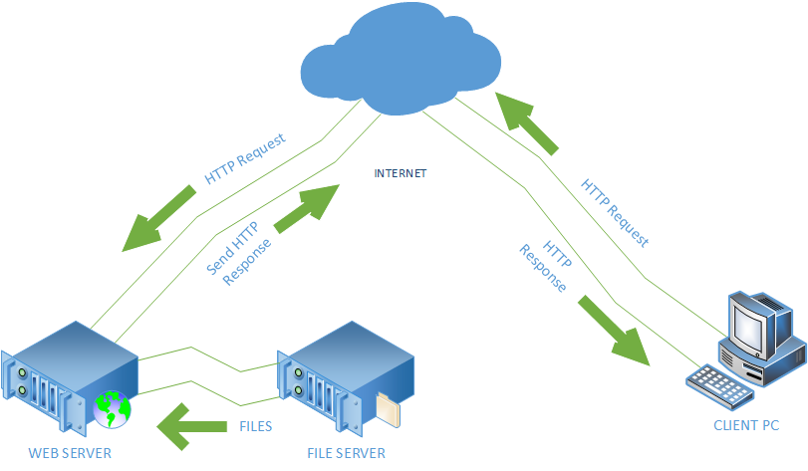

***Figure 15. Client/Server Architecture***

The File Server will store the files needed for the system. Web Server serves as the middle man wherein it processes requests via HTTP and distribute information on the internet. This information will be displayed as web pages to for the clients to interact.

* + 1. **NETWORK ARCHITECTURE**

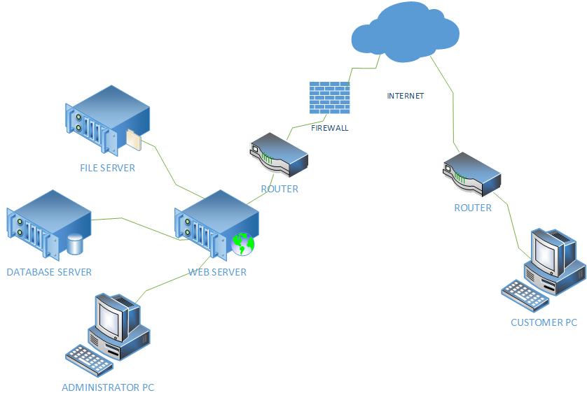

***Figure 16. Network Architecture***

Having a Web Application requires a quality network performance that will ensure the security of data and information of the project. Smooth transaction process will also be experienced. The diagram shows that the firewall will secure the safety of the server and avoid malwares. The files and database used in this system will come from the file server and database server and send to the web server, which serves the customer the web pages they will interact.

**CHAPTER 4**

**IMPLEMENTATION PLAN**

* 1. **TESTING PLAN**

4.1.1 TEST DESIGN PROCESS

After analyzing the developed system, to be able to detect the defects before deployment and implementation, the proponents choose to conduct four types of testing. It includes the following;

* **Unit Testing**

Under the unit testing, testing of modules and components are done by the programmers themselves. The programmers validated the modules that they made.

* **System Testing**

The system testing, the entire system should be tested as per the requirement and must cover all the parts of the system. A person other than the programmers tested the system to identify other errors and bugs.

* **Security Testing**

The security testing, security is vital when it comes to e-commerce websites because it stores sensitive customer information that's why we require to conduct a security testing.

* + 1. TEST EXECUTION PROCESS

Execute the test cases, report bugs, and capture information about the tests continuously, taking into account previous test results for each subsequent test. Capture and report information about the test just executed.

**4.2. REQUIREMENTS PLAN**

**4.2.1 HARDWARE REQUIREMENTS**

**4.2.1.1 SERVER**

|  |  |
| --- | --- |
| **Hardware Component** | **Specification** |
| Processor | 4 GHz, Intel Core i7 |
| Installed Memory (RAM) | 8.00GB or higher |
| Network | 5Mbps |
| Hard Disk Drive | 1TB or higher |
| Operating System | Windows 7 or higher |

* + - 1. **WORKSTATION**

|  |  |
| --- | --- |
| **COMPONENT** | **SPECIFICATION** |
| Operating System | Windows 7 or higher |
| Web Browser | Google Chrome, Mozilla Firefox, Microsoft Edge, Mobile Browser |

**4.2.2 SOFTWARE REQUIREMENTS**

|  |  |
| --- | --- |
| **COMPONENT** | **SPECIFICATION** |
| Language | PHP 7, HTML 5, CSS 3 |
| Browser | Google Chrome, Mozilla Firefox, Microsoft Edge, Mobile Browser |

* + - 1. **OPERATING SYSTEMS**

|  |  |
| --- | --- |
| **COMPONENT** | **SPECIFICATION** |
| Operating System | Windows 7 or higher |

* + - 1. **DBMS**

|  |  |
| --- | --- |
| **COMPONENT** | **SPECIFICATION** |
| Database | MySQL |

* + 1. **PEOPLEWARE (End Users, Systems Administration, Etc)**

|  |  |
| --- | --- |
| **ACTOR** | **RESPONSIBILITIES** |
| Furniture Shop Owner/Manager | Administrator of the Furniture Shop Management System. Head of the Furniture Shop. Manages transactions of the system. |
| Customer | Orders a furniture, can be from the brochures or sent customize design. Monitors production and delivery of his/her purchased order. |

* 1. **QUALITY PLAN**

Quality plays a big role in considering a project successfully finished. To ensure the system’s great performance, accuracy, reliability and usability, here are the plan followed:

* The system undergone series of test in order to ensure it is running smoothly and produces valid and reliable outputs
* People other than the proponents tried using the system to ensure the user friendliness of the system.
* The team conducted daily to weekly meetings in order for everyone to be updated on the project’s status.
* The team communicates with each other and tells everyone the updates that they have done so far as well as the concerns and other ideas they have to ensure the project’s quality.
  1. **SECURITY PLAN**

|  |  |
| --- | --- |
| **SECURITY POLICIES** | **SECURITY FEATURES** |
| * User Policies | Users allowed to access the system will only be the owner/manager and any user that has confirmed his registration through the email confirmation feature. |
| * Password Policies | Restriction of access of records for files containing confidential information. The system secures restriction of access from authenticated users only. |
| * Internet Policies | The website has a feature of CAPTCHA that  prevents bot from registering on the website. |

* 1. **SYSTEM MAINTENANCE AND SUPPORT PLAN**

**4.5.1 PREVENTIVE MEASURE PLAN**

In order to attain a smooth transaction process of the system and avoid unnecessary errors, the proponents have acquired preventive measure plan that will help the users of the system, these are the following:

* Critical data and vital records should be backed up and sent off-site for storage.
* A necessarily proper training on how to use the system will be conducted for the users.
* The work areas are comfortable and safe.
* Back up files every night, to multiple locations.
* Install anti-virus, anti-malware and a firewall software.
* Do not click suspicious ads or emails.
* Read and apply instruction from the User Manual.
  + 1. **CORRECTIVE MEASURE PLAN**

On the assumption of errors and failures, there are corrective measure to be executed upon the circumstances:

* Scan for viruses with the malware software installed on your PC.
* Retrieve files from the synced data from the trusted host server.
* Contact a professional regarding the failure of the hard drive.

**4.5.3. BACKUP AND RECOVERY PLAN**

To secure the files and maintain the functionality of the system, it must have a backup plan. The proponents think of the following as backup and recovery plan:

* **Virus/Malware**

In case of an attack of a malware, the system has installed anti-virus software that will avoid the virus to spread.

* **File Corruption**

To secure files on the system, the proponents determine to have File Server Backup Software installed. To keep files from the transactions made in the system.

* **Database Backup**

Nightly back up of database is stored in the system files. Furthermore, it is also being back up in the Database Server.

**CHAPTER 5**

**RECOMMENDATION**

Upon determining and evaluating every problems encountered by the business, the proponents affirm that the Furniture Shop Management System will be effective in helping the furniture shop from its tedious business process of managing orders and monitoring its production and delivery operation.

The system will be able to lessen the excessive use of papers, and the voluminous brochures. Charts of fabric are organized and stored in the system, wherein the customers can choose from the list of it. It also uses the proper forms needed for every transaction made that will decrease the possible rate of losing a data.

With the Furniture Shop Management System, the shop will have increase in sales because of the reachable way of ordering, through the website. Monitoring of the production and delivery will be easier for both the customer and the management. Queries and Reports will be automatically generated wherein they can track the progress of the business.

**APPENDICES**

**DATA GATHERING INSTRUMENTS**

The proponents used the following instruments in gathering data from the client to support the development of the project:

1. UNSTRUCTURED INTERVIEW

* The proponents initially conducted an unstructured interview on the day we found our client. This is the part where we asked them if they are alright with sharing information with us regarding out study and also where they introduced us to the basic in and outs of the business and what problems they encounter at times.

2. OBSERVATION

* We, the proponents observed the shop situation every interview. We observe how they organize their brochures, their forms and how they interact with the client to further identify what problems they encounter and what solution we can provide them.

3. TRANSCRIBING

The proponents were given some documents and forms to study. We transcribe those documents and filter what data or information is needed the most. We got out form fields from these documents and forms.

**CLIENT FORMS & REPORTS**

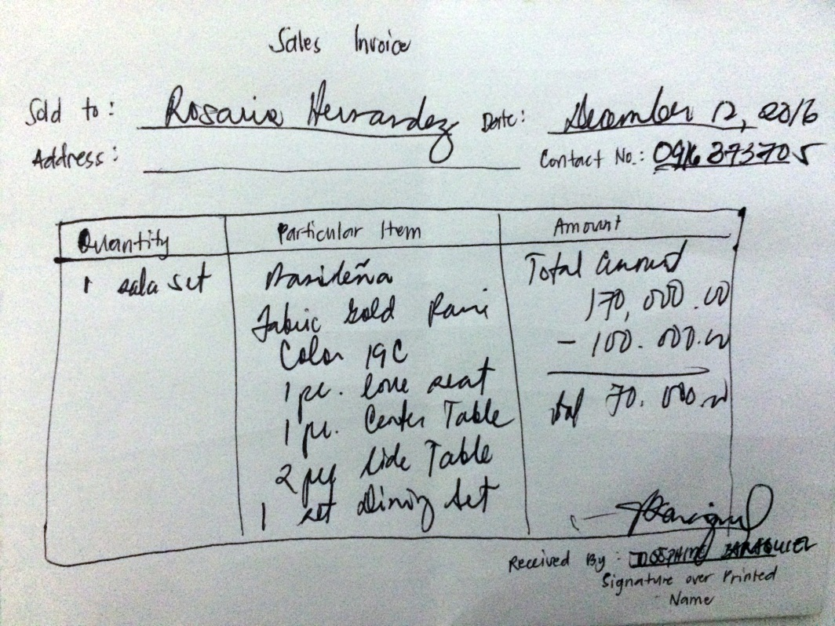

***Sales Invoice Format***

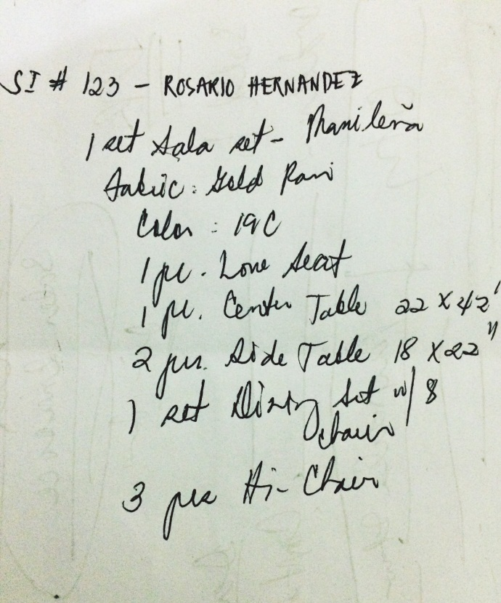

***Job Order Format***



***Delivery Receipt***



***Delivery Receipt***

***Official Receipt***



***Sales Report***

**LIST OF TABLES**

|  |  |
| --- | --- |
| Table 1 List of Forms | 7 |
| Table 2 List of Reports | 12 |
| Table 3 Business Requirement | 15 |
| Table 4 Business Policies | 16 |
| Table 5 Problems and Requirements | 18 |
| Table 6 Feature-Requirements Matrix | 22 |
| Table 7 List of Classes | 47 |

**LIST OF FIGURES**

|  |  |
| --- | --- |
| Figure 1 Waterfall Model with Feedback | 5 |
| Figure 2 Sample Sales Invoice Format | 8 |
| Figure 3 Sample Job Order Format | 9 |
| Figure 4 Sample Delivery Receipt | 10 |
| Figure 4.1 Sample Delivery Receipt | 10 |
| Figure 5 Sample Official Receipt | 11 |
| Figure 6 Sample Sales Report Format | 12 |
| Figure 7 Context Diagram | 13 |
| Figure 8 Level 1 Data Flow Diagram | 14 |
| Figure 9 Fishbone Diagram | 17 |
| Figure 10 Top Level Use Case | 23 |
| Figure 11 Manage Order Class Diagram | 48 |
| Figure 11.1 Monitor Inventory Class Diagram | 49 |
| Figure 11.2 Monitor Production Class Diagram | 50 |
| Figure 11.3 Process Payment Class Diagram | 51 |
| Figure 11.4 Manage Collections Class Diagram | 52 |
| Figure 11.5 Monitor Delivery Class Diagram | 53 |
| Figure 12 Activity Diagram | 58 |
| Figure 13 Information System Architecture | 104 |
| Figure 14 Web Architecture | 105 |
| Figure 15 Client/Server Architecture | 106 |
| Figure 16 Network Architecture | 107 |

**AIRA MARIE BARRAMEDA CORONADO**

**Address:** #62 Resolution Street, Batasan Hills Quezon City

**Email Address:** hongkaira@gmail.com

**Contact Number**: (+63) 919 5436 694

(+63) 936 6728 549

**EDUCATIONAL BACKGROUND**

2014 – Present **Bachelor of Science in Information Technology**

Polytechnic University of the Philippines

Sta. Mesa, Manila

2010 – 2014 **Batasan Hills National High School**

Batasan Hills, Quezon City

2004 – 2010 **Batasan Hills Elementary School**

Batasan Hills, Quezon City

**CORE QUALIFICATIONS**

* Knowledgeable with the following:
  + PHP, Java Script, CSS, HTML, jQuery, Bootstrap
  + Database Administration (MySQL Workbench, MS SQL Server, PHPMyAdmin)
* Basic knowledge with the following:
  + COBOL, C, C#, Java SE, Java EE
  + Adobe Photoshop
  + Adobe Flash
* Proficient in Microsoft Office Tools (MS Word, MS Excel, MS PowerPoint).
* Possesses good communication skills.
* Dedicated and hardworking in accomplishing tasks given.
* Flexible in working with a team.
* Adaptable and eager to learn.

**CERTIFICATES AND ACHIEVEMENTS**

* Dean’s Lister – 2nd Year 1st Semester – **June 2015**
* Proxor Rating 3 SDE – Java Certification– **September 2016**
* DOST-SEI JLSS Scholar **– Year 2016**

**AFFILIATION**

* **PUP Institute of Bachelors in Information Technology Studies** (IBITS)

2014 – Present

Member

**SEMINARS ATTENDED**

* **5th IT Research Forum**

Polytechnic University of the Philippines

2017

* **iBITS Mid-Year Seminar 2017**

Polytechnic University of the Philippines

2017

**CHARACTER REFERENCE**

**Prof. Rachel A. Nayre**

Chairperson, Department of Information Technology

PUP-CCIS

(+63) 921 4084 612

[ranayre@pup.edu.ph](mailto:ranayre@pup.edu.ph)

**Mr. Alex Uy**

Information Systems Analyst / ICT Instructor

PUP-CCIS

(+63) 998 5528 261

[uyalexb@gmail.com](mailto:uyalexb@gmail.com)

**Ms. Eurrance Mancio**

Physical Therapist / Choreographer

(+63) 936 9307 073

[barbie_ace25@yahoo.com](mailto:barbie_ace25@yahoo.com)

**ELISSA JOY PANGANIBAN ESTORES**

Address: B4 L40 Portobello Homes, GB-1, San Mateo, Rizal

Email Address: [elissaestores@gmail.com](mailto:elissaestores@gmail.com)

Contact Number: 09984711662

**EDUCATIONAL BACKGROUND**

2014 – Present **Bachelor of Science in Information Technology**

Polytechnic University of the Philippines

Sta. Mesa, Manila

2010 – 2014 **San Jose National High School**

San Jose, Rodriguez, Rizal

2004 – 2010 **San Mateo Elementary School**

Sta. Ana, San Mateo, Rizal

**CORE QUALIFICATIONS**

* Basic knowledge with the following:
* C, Java, C#, COBOL
* Web Design
* Database (MS Access, MySQL Workbench, PHPMyAdmin)
* Adobe Photoshop and Adobe Premiere
* Proficient in MS Office Applications.
* Experienced in Technical Documentation.
* Experienced in Quality Testing.
* Possesses good communication and analytical skills.
* Dedicated and hardworking in accomplishing tasks given.
* Flexible in working with a team.
* Adaptable and eager to learn.
* Self-motivated, resourceful and efficient.

**ORGANIZATION**

* **PUP Institute of Bachelors in Information Technology Studies** (IBITS)

2014 – Present

Member

**SEMINARS ATTENDED**

* **5th IT Research Forum**

Polytechnic University of the Philippines

2017

* **iBITS Mid-Year Seminar 2017**

Polytechnic University of the Philippines

2017

**CHARACTER REFERENCES**

**Prof. Rachel A. Nayre**

Chairperson, Department of Information Technology

PUP-CCIS

09214084612

ranayre@pup.edu.ph

**Aaron Jose Apigo**

Senior Software Development Lead

AS White, Net Lima Bldg.

BGC, Taguig City

09178157360

**Katherine Kimpo**

Group Leader, Risk and Compliance

Concentrix

09499928842

**SEAN LESTER AUSTERO EFA**

Road 18, Lot 31, Phase III COGEO Village,

Brgy. Bagong Nayon, Antipolo City, Rizal

Mobile No. 0926-7564307(+63)

E-mail Address: [efasean06@gmail.com](mailto:efasean06@gmail.com)

**EDUCATIONAL BACKGROUND**

2014 – Present **Bachelor of Science in Information Technology**

Polytechnic University of the Philippines

Sta. Mesa, Manila

2010 – 2014 **Don Antonio de Zuzuarregui Sr. Memorial Academy**

Brgy. Inarawan, Antipolo City, Rizal

2004 – 2010 **Sto. Niño de Antipolo School**

Road 18, COGEO Village, Antipolo City, Rizal

**CORE QUALIFICATIONS**

* Good computer skills
* Good communication skills
* Ability to multitask
* Efficiency and Attention to details
* Willing to serve others
* Ability to adapt to different environments and situation
* **Web Development**

Skills and Tools**:** HTML, CSS, JavaScript, JQuery, PHP, Laravel Framework, and MySQL

* **Desktop Development**

Skills and Tools**:** C, COBOL, Java, C#, and Microsoft SQL Server

* **Mobile Development**

Skills and Tools: Android Studio

* + Basic knowledge about ROM porting and ROM modification.
* **Others**
  + Strong knowledge about Hardware and Software configuration and troubleshooting.
  + Proficient in Adobe Photoshop and Microsoft Office.
  + Average knowledge about operating systems and networking.

**CERTIFICATES AND ACHIEVEMENTS**

* iSeminar Event Organizer
* Proxor Rating 3 – SDE-JAVA (Gurango Software Corporation)
* 2015 - 2016 College Scholar (Dean’s Lister)
* iBITS iVote Online Election Assistant
* College Academic Contest Participant
* Experiencing ICT in Web Development 1

**ORGANIZATION**

* **PUP Institute of Bachelors in Information Technology Studies** (IBITS)

2014 – Present

Member

**SEMINARS ATTENDED**

* **iSeminar: Laravel and The Future of Digital Forensics**

Bulwagang Balagtas, NALLRC

PUP, Sta. Mesa, Manila

September 16, 2017

* **Career Talk 2017**

Bulwagang Balagtas, NALLRC

PUP, Sta. Mesa, Manila

September 12, 2017

* **5th IT Research Forum**

Bulwagang Bonifacio, NALLRC

PUP, Sta. Mesa, Manila

March 6, 2017

* ***4th IT Research Forum***

Claro M. Recto Hall

PUP, Sta. Mesa, Manila

March 7, 2016

* **The Present and Future of COBOL**

5th Floor, South Wing, Main Bldg.

PUP, Sta. Mesa, Manila

October 16, 2015

**REFERENCES**

* Prof. Rachel A. Nayre : Chairperson, DIT

PUP-CCIS

09214084612

ranayre@pup.edu.ph

* Mr. Alex B. Uy : Systems Analyst

Court of Appeals

09985528261



**MARIANO S LOZANO III**

**Block-4, Lot 32. Phase-3D, Tawilis St.**

**Kaunlaran Village, Caloocan City**

**09452566031**

[**lozanomarianosapico@gmail.com**](mailto:lozanomarianosapico@gmail.com)

**EDUCATIONAL BACKGROUND**

2014 – Present **Bachelor of Science in Information Technology**

Polytechnic University of the Philippines

Sta. Mesa, Manila

2010 – 2014 **Jose Panganiban National High School**

2004 – 2010 **Jose Panganiban Elementary School**

**SUMMARY OF QUALIFICATIONS**

* Proficient in HTML, CSS, PHP, javaScript, jQuery, Ajax, Android Programming and MySQL,
* Knowledgeable in C,C++,C# and JAVA,
* Beginner in PHP Laravel Framework, basic Ruby and Phyton
* Computer Literate; Microsoft Office (Word, Excel, Powerpoint)

**ORGANIZATION**

* **PUP Institute of Bachelors in Information Technology Studies** (IBITS)

2014 – Present

Member

**SEMINARS ATTENDED**

* **5th IT Research Forum**

Polytechnic University of the Philippines

2017

* **iBITS Mid-Year Seminar 2017**

Polytechnic University of the Philippines

2017

**CHARACTER REFERENCES**

**Prof. Rachel A. Nayre**

Chairperson, Department of Information Technology

PUP-CCIS

09214084612

ranayre@pup.edu.ph



**MARK JOSEPH B. PUBLICO**

**Blk. 1, Lt. 6, UCV Village, Sapang Viejo,**

**Ligid-Tipas, Taguig City**

**+63 919 7464 382**

**+63 948 9455 156**

[**mjoseph.publico@gmail.com**](mailto:mjoseph.publico@gmail.com)

**EDUCATIONAL BACKGROUND**

2014 – Present **Bachelor of Science in Information Technology**

Polytechnic University of the Philippines

Sta. Mesa, Manila

2010 – 2014 **Parang High School**

2004 – 2010 **Saint Mary Elem. School**

**SUMMARY OF QUALIFICATIONS**

* Can communicate using English and Filipino.
* Can work under pressure.
* Willing to learn.
* Familiar with programming languages such as PHP, Java, JavaScript, C++, and C#.
* Familiar in web development tools such as HTML, CSS, and Bootstrap.
* Familiar with MySQL.
* Knowledgeable in Microsoft Office Suites (Word, PowerPoint, Excel, etc.).
* Knowledgeable in Multimedia tools such as Adobe Photoshop and Sony Vegas Pro.

**ORGANIZATION**

* **PUP Institute of Bachelors in Information Technology Studies** (IBITS)

2014 – Present

Member

**SEMINARS ATTENDED**

* **5th IT Research Forum**

Polytechnic University of the Philippines

2017

* **iBITS Mid-Year Seminar 2017**

Polytechnic University of the Philippines

2017

**CHARACTER REFERENCES**

**Prof. Rachel A. Nayre**

Chairperson, Department of Information Technology

PUP-CCIS

09214084612

[ranayre@pup.edu.ph](mailto:ranayre@pup.edu.ph)

**John Mark C. Silvestre**

* + Analyst Programmer
  + H2 Software

**Hasmen Grace V. Cuachin**

* Client Service Associate
* BDO Rizal Montalban
* +63 977 4574 007



**CYRENE JANE B. AMARILLA**

Blk 203 Lot 28 Tañaquin St., Pembo, Makati City

[cyrene.amarilla@yahoo.com](mailto:cyrene.amarilla@yahoo.com)  
09305161647

**EDUCATIONAL BACKGROUND**

2014 – Present **Bachelor of Science in Information Technology**

Polytechnic University of the Philippines

Sta. Mesa, Manila

2010 – 2014 **Benigno “Ninoy” S. Aquino High School**

Comembo, Makati City

2004 – 2010 **Pembo Elementary School**

Pembo, Makati City

**CORE QUALIFICATIONS**

* **TECHNICAL SKILLS**
* Programming (PHP, CSS, Javascript, C#, COBOL)
* SQL Scripting
* System Analyst
* System Test
* Project Management
* Business Analyst Skills
* Graphics designing(Adobe Photoshop, Adobe Flash)
* **PROFESSIONAL STRENGTH**
* NC II Passer – Computer Hardware Servicing (March 2014)
* Proxor Rating 3 – SDE-Java (September 2016)
* Ability to work in a team
* Leadership Skills
* Communication Skills
* Critical thinking

**ORGANIZATION**

* **PUP Institute of Bachelors in Information Technology Studies** (IBITS)

2014 – Present

Member

**SEMINARS ATTENDED**

* **CCIS@29: The Journey to Success**  
  (Typography and Adobe Lightroom)  
  February 10, 2015
* **Block the Hack**  
  (Association for Computer Intelligence Integration Cyber Security Seminar)  
  January 29, 2016
* **4th University-Wide IT Research Forum**  
  (Thesis Project Exhibition)  
  March 7, 2016
* **5th University-Wide IT Research Forum**  
  (Thesis Project Exhibition)  
  March 6, 2017

**CHARACTER REFERENCES**

**Rachel P. Nayre**

Department of Information Technology Chairperson, PUP Sta,Mesa

09214084612

**Rhoner Rendon**  
DPWH Employee, Engineering Department  
09491145621

**Tam Albert Ondevilla**  
 Genesys, Computer Engineer  
 09059018088