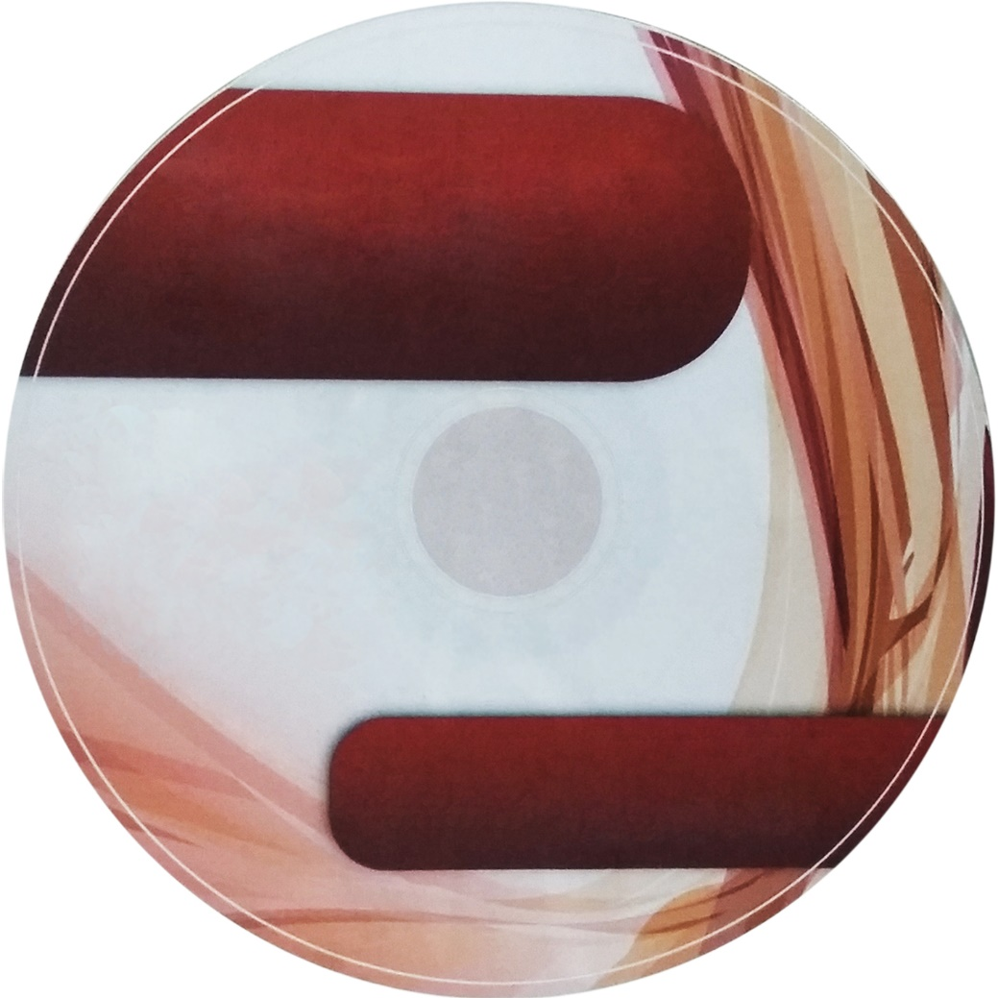

***AUTHORS:***

***AMARILLA, CYRENE JANE B.  
CORONADO, AIRA MARIE B.***

***EFA, SEAN LESTER A.  
ESTORES, ELISSA JOY P.  
LOZANO, MARIANO III S.  
PUBLICO, MARK JOSEPH B.***

**WEB-BASED FURNITURE SHOP MANAGEMENT SYSTEM**

****

****

**SOFTWARE  
USER’S MANUAL**



***AUTHORS:***

***AMARILLA, CYRENE JANE B.  
CORONADO, AIRA MARIE B.***

***EFA, SEAN LESTER A.  
ESTORES, ELISSA JOY P.  
LOZANO, MARIANO III S.  
PUBLICO, MARK JOSEPH B.***

**WEB-BASED FURNITURE SHOP MANAGEMENT SYSTEM**

****

****

**SOFTWARE  
USER’S MANUAL**