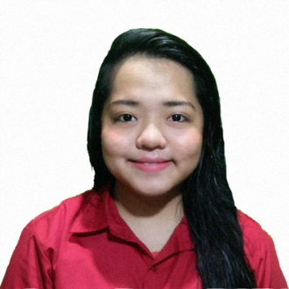**AIRA MARIE BARRAMEDA CORONADO**

**Address:** #62 Resolution Street, Batasan Hills Quezon City

**Email Address:** hongkaira@gmail.com

**Contact Number**: (+63) 919 5436 694

(+63) 936 6728 549

**OBJECTIVES**

To learn new knowledge that will further enhance my skills in different areas of Information Technology and to experience Information Technology related work in an actual business as an intern.

**EDUCATIONAL BACKGROUND**

2014 – Present **Bachelor of Science in Information Technology**

Polytechnic University of the Philippines

Sta. Mesa, Manila

2010 – 2014 **Batasan Hills National High School**

Batasan Hills, Quezon City

2004 – 2010 **Batasan Hills Elementary School**

Batasan Hills, Quezon City

**CORE QUALIFICATIONS**

* Knowledgeable with the following:
  + PHP, Java Script, CSS, HTML, jQuery, Bootstrap
  + Database Administration (MySQL Workbench, MS SQL Server, PHPMyAdmin)
* Basic knowledge with the following:
  + COBOL, C, C#, Java SE, Java EE
  + Adobe Photoshop
  + Adobe Flash
* Proficient in Microsoft Office Tools (MS Word, MS Excel, MS PowerPoint).
* Possesses good communication skills.
* Dedicated and hardworking in accomplishing tasks given.
* Flexible in working with a team.
* Adaptable and eager to learn.

**CERTIFICATES AND ACHIEVEMENTS**

* Dean’s Lister – 2nd Year 1st Semester – **June 2015**
* Proxor Rating 3 SDE – Java Certification– **September 2016**
* DOST-SEI JLSS Scholar **– Year 2016**

**AFFILIATION**

* **PUP Institute of Bachelors in Information Technology Studies** (IBITS)

2014 – Present

Member

**SEMINARS ATTENDED**

* **5th IT Research Forum**

Polytechnic University of the Philippines

2017

* **iBITS Mid-Year Seminar 2017**

Polytechnic University of the Philippines

2017

**CHARACTER REFERENCE**

**Prof. Rachel A. Nayre**

Chairperson, Department of Information Technology

PUP-CCIS

(+63) 921 4084 612

[ranayre@pup.edu.ph](mailto:ranayre@pup.edu.ph)

**Mr. Alex Uy**

Information Systems Analyst / ICT Instructor

PUP-CCIS

(+63) 998 5528 261

[uyalexb@gmail.com](mailto:uyalexb@gmail.com)

**Ms. Eurrance Mancio**

Physical Therapist / Choreographer

(+63) 936 9307 073

[barbie_ace25@yahoo.com](mailto:barbie_ace25@yahoo.com)