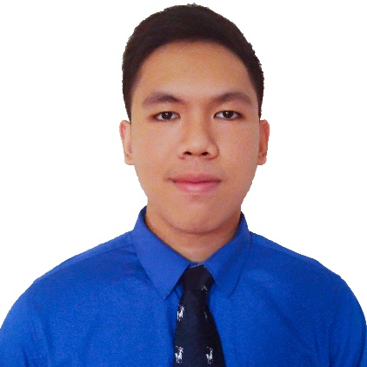



**SEAN LESTER AUSTERO EFA**

Road 18, Lot 31, Phase III COGEO Village,

Brgy. Bagong Nayon, Antipolo City, Rizal

Mobile No. 0926-7564307(+63)

E-mail Address: [efasean06@gmail.com](mailto:efasean06@gmail.com)



**OBJECTIVE**

To join an organization that provides me an opportunity for professional development and at the same time allowing me to utilize my knowledge, skills and initiative in the IT industry.



**KEY SKILLS**

* Good computer skills
* Good communication skills
* Ability to multitask
* Efficiency and Attention to details
* Willing to serve others
* Ability to adapt to different environments and situation



**PERSONAL INFORMATION**

**Date of Birth** : November 6, 1997 **Weight** : 68 kg

**Place of Birth** : Manila **Religion** : Roman Catholic

**Age** : 20 **Civil Status** : Single

**Height** : 5’8 **Nationality** : Filipino



**EDUCATIONAL BACKGROUND**

Tertiary 2014 - Present : **Polytechnic University of the Philippines**

Sta. Mesa, Manila

Bachelor of Science in Information Technology

Secondary 2010 - 2014 : **Don Antonio de Zuzuarregui Sr. Memorial Academy**

Brgy. Inarawan, Antipolo City, Rizal

Elementary 2004 - 2010 : **Sto. Niño de Antipolo School**

Road 18, COGEO Village, Antipolo City, Rizal



**TECHNICAL SKILLS**

* **Web Development**

Skills and Tools**:** HTML, CSS, JavaScript, JQuery, PHP, Laravel Framework, and MySQL

* **Desktop Development**

Skills and Tools**:** C, COBOL, Java, C#, and Microsoft SQL Server

* **Mobile Development**

Skills and Tools: Android Studio

* + Basic knowledge about ROM porting and ROM modification.
* **Others**
  + Strong knowledge about Hardware and Software configuration and troubleshooting.
  + Proficient in Adobe Photoshop and Microsoft Office.
  + Average knowledge about operating systems and networking.



**THESIS PROJECTS**

* **Furniture Shop Management System**(HTML, CSS, JavaScript, JQuery, PHP)

(Front End Developer)

November 2016 – October 2017

* **PUP Physical Planning and Development Office: Project Monitoring System** (C#)

(Quality Assurance)

July 2016 – October 2016



**ACHIEVEMENTS**

* iSeminar Event Organizer
* Proxor Rating 3 – SDE-JAVA (Gurango Software Corporation)
* 2015 - 2016 College Scholar (Dean’s Lister)
* iBITS iVote Online Election Assistant
* College Academic Contest Participant
* Experiencing ICT in Web Development 1



**AFFILIATIONS**

* 2014 – Present Member, Institute of Bachelors in Information Technology Students (iBITS)



**SEMINARS ATTENDED**

* **iSeminar: Laravel and The Future of Digital Forensics**

Bulwagang Balagtas, NALLRC

PUP, Sta. Mesa, Manila

September 16, 2017

* **Career Talk 2017**

Bulwagang Balagtas, NALLRC

PUP, Sta. Mesa, Manila

September 12, 2017

* **5th IT Research Forum**

Bulwagang Bonifacio, NALLRC

PUP, Sta. Mesa, Manila

March 6, 2017

* ***4th IT Research Forum***

Claro M. Recto Hall

PUP, Sta. Mesa, Manila

March 7, 2016

* **The Present and Future of COBOL**

5th Floor, South Wing, Main Bldg.

PUP, Sta. Mesa, Manila

October 16, 2015



**CHARACTER REFERENCES**

* Prof. Rachel A. Nayre : Chairperson, DIT

PUP-CCIS

09214084612

ranayre@pup.edu.ph

* Mr. Alex B. Uy : Systems Analyst

Court of Appeals

09985528261

*I hereby certify that the above information is true and correct.*

**SEAN LESTER AUSTERO EFA**

Applicant