Team Charlie

Members: Elijah Wilkinson, Gabriel Pedraza Torres, Sean Christman, Dan Maher

Module 11.1

02/26/2023

1.)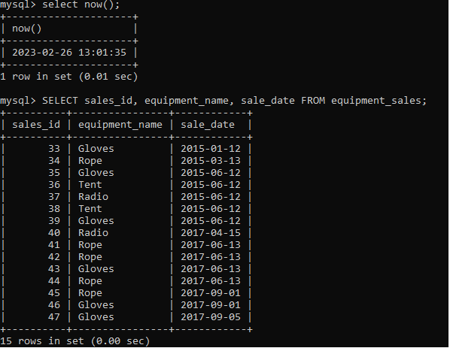

This report pulls several columns from the equipment_sales table in our Outland database. These records indicate the ID of the transaction, the name of the gear that was sold, and the date that the gear was sold to a customer. This report will help us answer the business question “Do enough customers buy equipment to keep equipment sales?”

2.)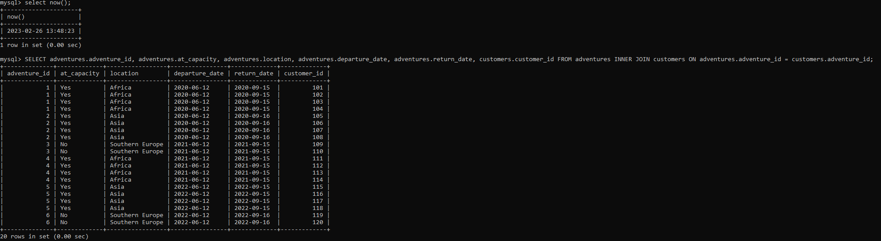

This report joins columns from two tables; our adventures table, as well as our customers table. While we don’t need customer information “such as their names, visa & inoculation status etc” to determine whether or not there’s a decrease in bookings, I did want to include customer_id to illustrate the relationship and why it’s important. We can use the columns drawn from our adventure table to determine what adventuring location is seeing a downtrend in bookings and customer interest. NOTE: in our assumptions, one guide can take up to 4 customers on an adventure, so any adventure scheduled with 4 customers is “at capacity.”

3.)

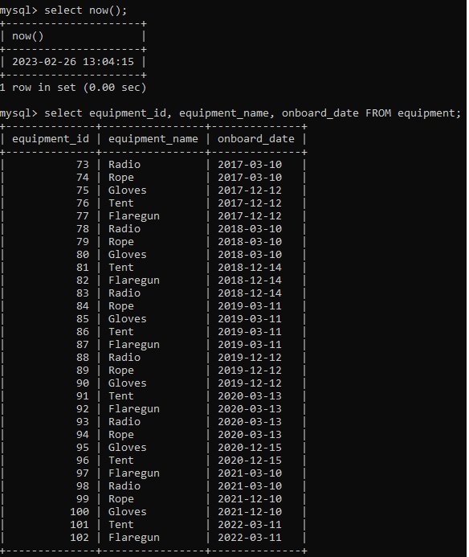

This report pulls columns from our equipment table to help identify what equipment_id is associated to what pieces of gear, as well as our onboard date of that equipment. This will allow us to determine which pieces of gear are 5 years old or older, as well as gear getting near that point that may need to be discarded for customer safety if not sold.