**Team Charlie**

**Members:**

* Elijah Wilkinson
* Sean Christman
* Gabriel Pedraza Torres
* Dan Maher

**Case Study:** Outland Adventures

**ERD**

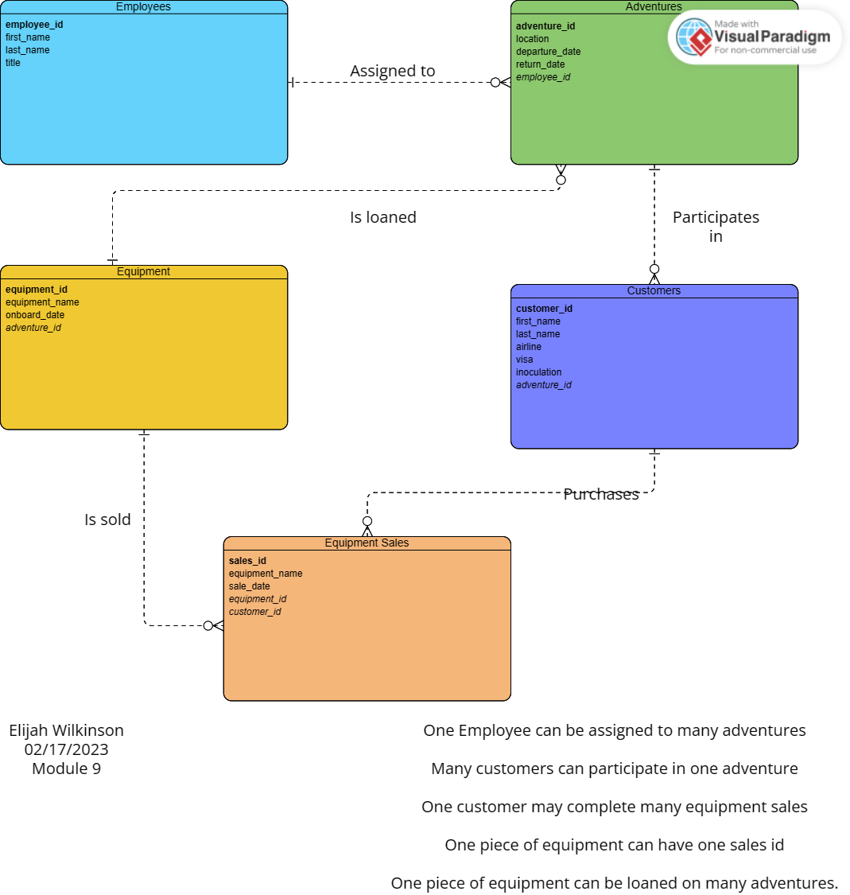

**Business Rules**

* An EMPLOYEE can be assigned to many ADVENTURES
* Many CUSTOMERS can participate in one ADVENTURES
* One CUSTOMER can purchase many pieces of EQUIPMENT(sales.)
* One piece of EQUIPMENT can have one SALES ID
* One piece of EQUIPMENT can be loaned on many ADVENTURES