**Screenshot of the HTML validation results:**

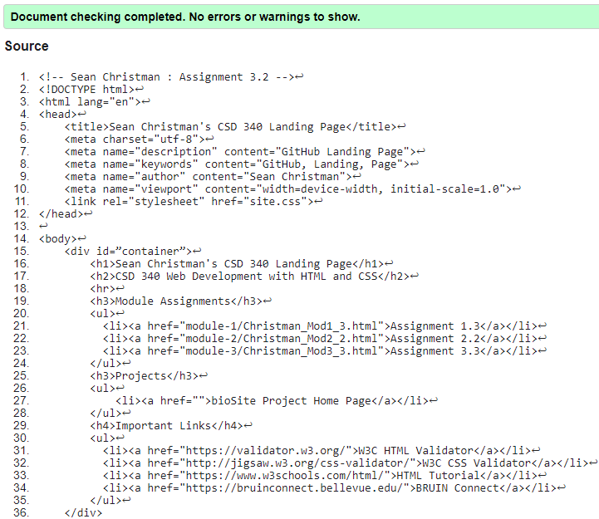

**Screenshot of the CSS validation results:**

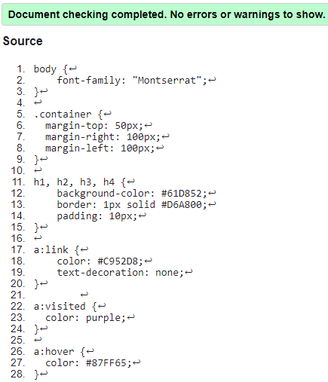

**Screenshot of the index page:**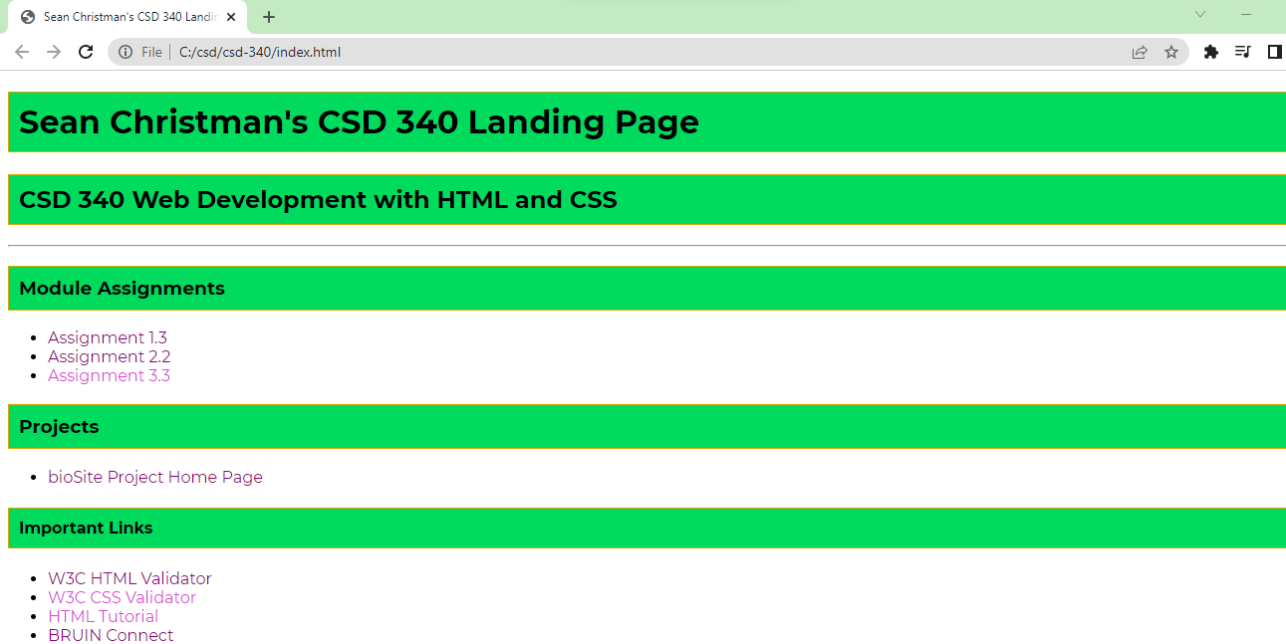

**Link to the GitHub pages landing page:**

<https://seanerobs4.github.io/csd-340/>

**Link to my GitHub repository:**

<https://github.com/SeanERobs4/csd-340.git>