# Lab2 deliverable

## Task2

Q1:

Q2:

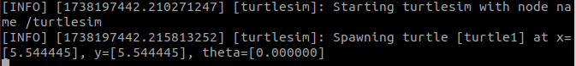

Q3:

It would blocked by the edge of the window

With warning “Oh I hit the wall”

Q4:

2 node

Q5:

The `/turtlesim` node is responsible for simulating the movement of the turtle.

- **Subscribed topics:**

- `/turtle1/cmd_vel` (message type: `geometry_msgs/msg/Twist`): Receives velocity commands to move the turtle.

- **Published topics:**

- `/turtle1/pose` (message type: `turtlesim/msg/Pose`): Publishes the turtle's current position (`x, y, theta`).

- `/turtle1/color_sensor` (message type: `turtlesim/msg/Color`): Publishes the color of the pixel under the turtle.

These topics allow the turtle to receive movement commands and provide feedback about its position and environment.

Q6：

The `/teleop_turtle` node is responsible for controlling the turtle's movement using keyboard inputs.

- **Subscribed topics:** None (it does not directly subscribe to any topics; instead, it takes user input from the keyboard).

- **Published topics:**

- `/turtle1/cmd_vel` (message type: `geometry_msgs/msg/Twist`): Sends velocity commands to move the turtle.

This means `/teleop_turtle` translates user keyboard input into velocity commands, which are then received by `/turtlesim` to move the turtle.

Q7:

Yes the arrows match the information before.

Q8:

List -t provide the type of the topic

Q9:

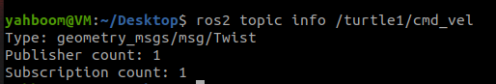

The command provides information about the **/turtle1/cmd_vel** topic, including:

* **Message type**: The type of message being used for this topic.
* **Publisher count**: The number of nodes currently publishing to this topic.
* **Subscriber count**: The number of nodes currently subscribed to this topic.

Q10&Q11:

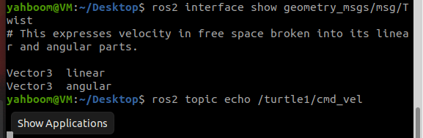

These commands display the **message structure** of Twist, and **subscribes to the /turtle1/cmd_vel topic** and prints all messages sent to this topic in real-time.

Q12:

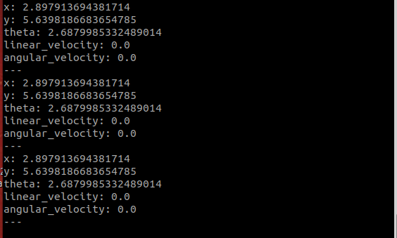

The average hz is 62.5

Q13:

It draws a curve while I add a 0.5 angular speed on x axis.

Use rate of 3, it continuously drew a circle

Q14:

Add -t option to ros2 service list

We then can see the type of the services.

The meaning of service type can be checked by using: ros2 interface show std_srvs/srv/Empty

This will output:

---

This means that:

The Empty service **does not take any request parameters**.

The response is also **empty**, meaning no data is returned.

Calling the /clear service **only triggers an action** (e.g., clearing the turtlesim screen), but **does not require input parameters**.

The response does **not** contain any data, so it only confirms that the request was received.

Q15:

The turtlesim has been cleared

Challenge:

Use interface show, we know there is 5 parameters for set_pen, they are “r” “g” “b” “width” and “off”

By setting r to 255, we get a red line.

Q17 & 18:

## Task3



