THOMAS FEENEY
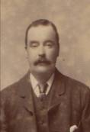
Thomas Feeney was born in Birmingham in 1849 he was the son of John Feeney

MARRIGES
Thomas first marriage was to Ann Guggiarie who was born in Birmingham in 1850. Ann was the daughter of Nathaniel Guggiarie born 1809 in Lazio Italy and Jemima Orme born 1811 from Birmingham
Thomas was 20 years old and worked as a bedstead fitter
They married in the parish church of St Thomas Birmingham in the presents of Ann’s sister Angelina
And Thomas’s friend Ambrose Roberts
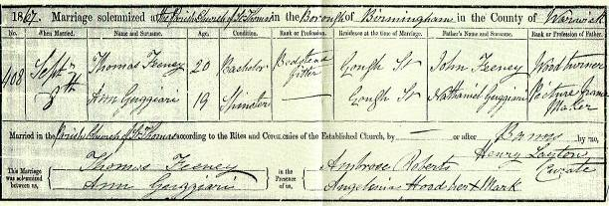
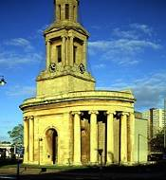

ANN’ S DEATH
Ann died in 1870 from acute bronchitis present at her death was her sister Mary address 3 court Gough Street

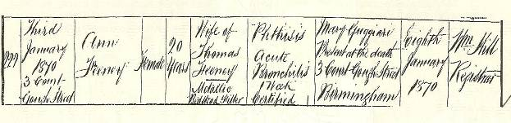

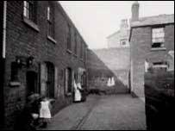 Living conditions at this time in Birmingham were poor and many people died young

AFTER ANN’S DEATH
When Ann died Thomas moved in with his brother Stephen and sister-in-law Sarah they lived at 26 Fisher Street
Birmingham

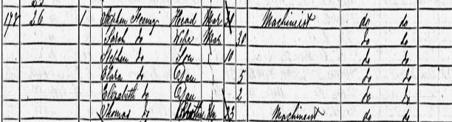
Census record from 1871

Thomas married Henrietta Onions in 1871
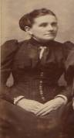
Henrietta was the daughter of William onions she was born in Dudley in 1852

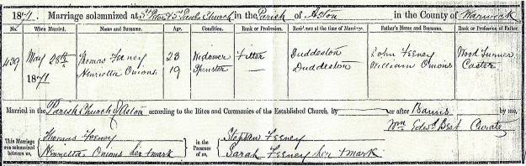

They married in St Peters and St Pauls church Birmingham witnesses at the wedding was Thomas’s brother Stephen and his sister-in-law Sarah

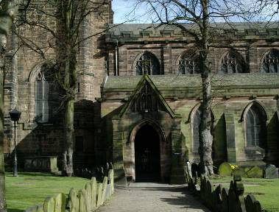

During the 1880s Thomas and Henrietta moved to Barrow in furnace from Birmingham probably to find work to support their family
Thomas being and engineer and their being major ship building going on in the area at the time

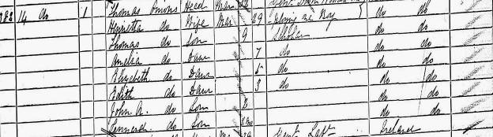
Census 1881 Barrow in furnace
The family are listed as Onions but should been Feeney

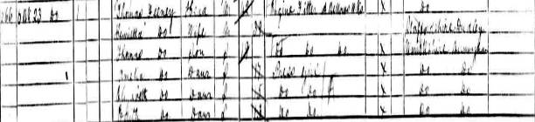
Census 1891 family living back in Birmingham, Vittoria Street

Thomas and Henrietta had nine children

Thomas Feeney

1872 –

Amelia Feeney

1874 –

Elizabeth Feeney

1875 – 1960

Edith Feeney

1878 –

John A Feeney

1879 –

Leonard Feeney

1881 – 1949

Henrietta Feeney

1884 –

Ernest Feeney

1887 –

William H Feeney

1890 –

HENRIETTA’S DEATH

Henrietta died in 1897 at home from Alcoholic paralysis in the presents of her daughter Amelia
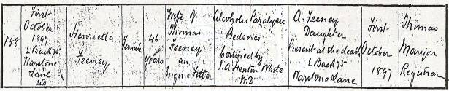

AFTER HENRIETTA DEATH

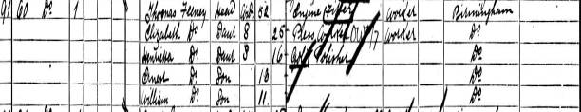
Census 1901 Thomas living with the children at 60 Carver Street, Birmingham

THOMAS THIRD MARRIAGE

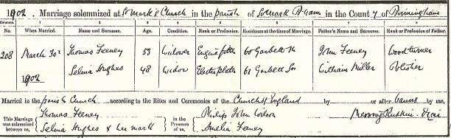

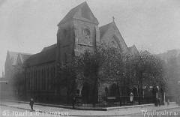
St Marks Church

Thomas married Selina Hughes in 1902 age 53 at St Marks church In the presents of daughter Amelia Feeney they were living in Garbett street Thomas at 60 and Selina at
61

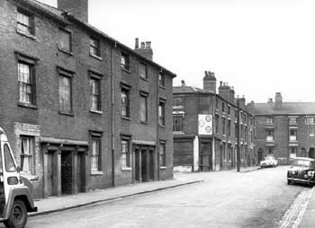
Garbett Street

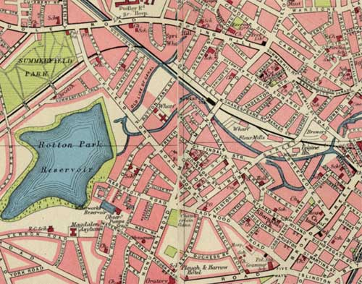
Map of Ladywood 1952

Regarding John Feeney

At this time I’ve been unable to find the Feeney before 1871
It is my assumption that either the records have not been up-dated
There a name change or misspelling in previous censuses
I know that john Feeney was a wood turner as it states this on all
Three of Thomas’s wedding certificates

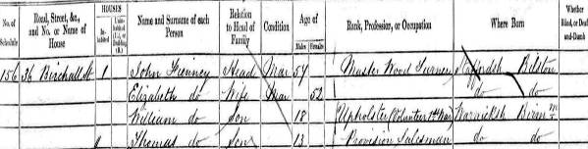
Census from 1861 living in Birchall Street, Birmingham

This census from 1861 states that John Fienney was a master wood turner and that
His son Thomas was born ruffle 1848/1849
If this is the same family then Thomas had another brother William and his mother
Was Elizabeth
Both name have been used by the family later my great grandmother was Elizabeth
Feeney her brother was called William

Leonard Feeney

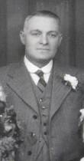

1881 – 1949
Leonard Feeney was born in Birmingham in 1881 at an early age his parent moved
To barrow in furnace to find work he spoke of his early life in barrow with fondness
Moving back to Birmingham sometime before 1891
Please see censuses for Thomas Feeney 1881,1891
Just after his mother Henrietta died Leonard join the army in 1901
Serving in the Scottish Rifles and then transferring to the Royal Warwickshire Regiment
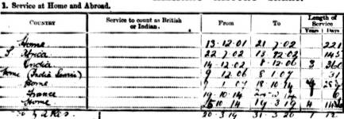

During Leonards service he served in Africa seeing action in the boar war
Then India then being stationed at home from 1907 to 1914
In 1914 when the Great War started Leonard being a seasoned veteran of previous conflicts Leonard was mobilised. The Royal Warwickshire Regiment, which landed at Zeebrugge on 6 October 1914 as part of Sir Harry Rawlinson's 7th Division. After successfully covering the retreat of the Belgium Army the Division began to fall back on 14th October before the overwhelming force of the enemy.
By the 16th the Battalion had formed part of a defensive line east of Ypres, capturing Menin under heavy fire two days later. The Germans reinforced and attacked resulting in three days of heavy fighting
On the 23rd the 2nd Warwick’s threw the enemy out of Polygon Wood in hard and close fighting in a still dense wood and advanced for one mile beyond the wood to recover lost ground.
The cost was over one hundred casualties including Leonard how had been wounded
Receiving a gun shot wound to the lower knee on the 24th October 1914 ending his war on returned home he stayed in the army until 1919 in the service corps.
LEONARD MARRIAGES

In 1909 Leonard married Sarah Jane Taylor
Born in Birmingham in 1888 Sarah was the daughter of Joseph Taylor born 1856
And Sarah Woodhall born 1857
Leonard and Sarah had six children
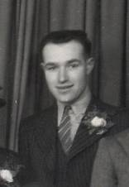Leonard Jr born 1910 married Kathleen Newton 1933 Plymouth
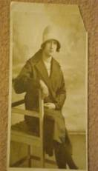Lillian - 1910 - 1938 Lillian never married
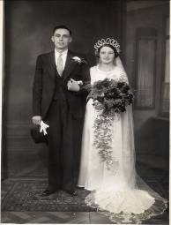 Gladys was born 1912 she married Les Wykes in 1935

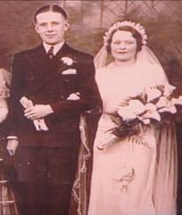Doris was born in 1914 she married Francis Beecham in 1938

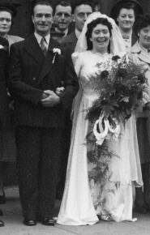 Charles was born 1916 he married Mary Liddane in 1948

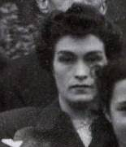Henrietta born 1919 she married Bertram Perkins 1941

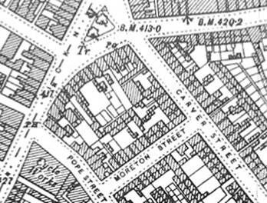

Leonard lived in Morton Street with Sarah at no5

Sadly on 9th January 1923 Sarah died in child birth
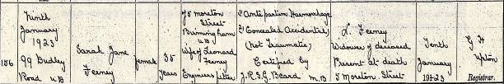

In February 1924 Leonard married Florence Clara Bowen
Florence born 1884 the daughter of John Bowen born 1841 a tailor by trade and Mary Bowen (Brookes) born 1843

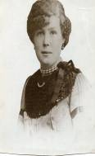

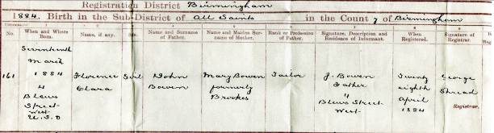
Copy of Florence birth 1884

Florence marriage to Thomas Feeney 1924
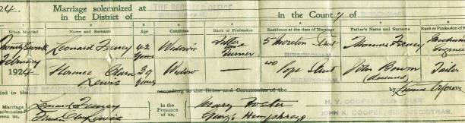

Florence had children from her first marriage to Thomas George Lewis born 1879
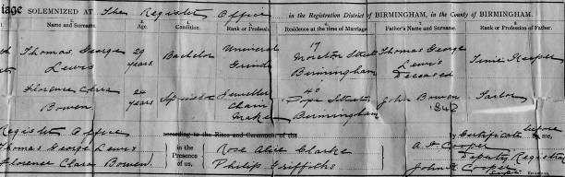
Copy of Thomas and Florence wedding 1908

Florence and Thomas Lewis children

Thomas George – 1916 - 1921
Clara M Lewis – 1911 - 19
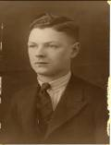
William Lewis – 1909 -

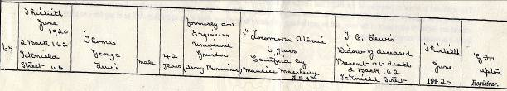
Thomas had died in 1920

Thomas Feeney and Florence
Had two children

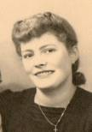
Mary Lewis – 1922 –

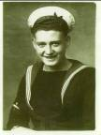
Thomas Feeney – 1924 – 1944
Thomas was killed in action at Anzio on-board Hospital ship St David

Mary Lewis married Alan Lesley Hickebottom
Alan was the son of Oliver Hickebottom born 1885 and Annie Parker born 1890

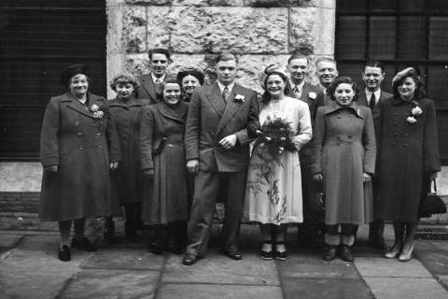
Annie Parker is on the left side of the picture with the hat

Mary and Alan or Bill as he was know had three children between them

My mother
Eileen Hickebottom born 1940
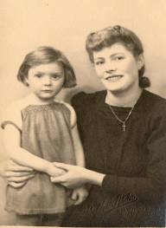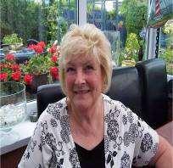

Mary Ann Hickebottom
Born 1950
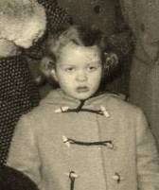

Timothy A Hickebottom
Born 1953
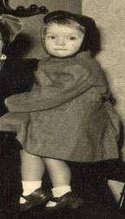
Tim and Ann have not had children
Eileen Married Malcolm Williams born 1931 in Bleanavon

Malcolm was the son of

Henrietta Walkley born 1905 in Birmingham Daughter of Edwin Walkley born 1880 and Elizabeth Feeney born 1875

Walter Williams born 1904 in Bleanavon was the son of Walter Williams born
1879 in Newport and Mary Ann Flower born 1879 in Bleanavon
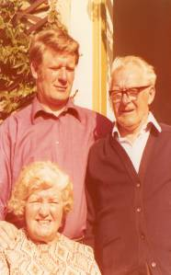
Picture of Walter, Henrietta and Malcolm Williams

Malcolm was an only child
And had two children with Eileen Hickebottom

Richard Thomas Williams born 1973



Jamie Charles Williams born 1979

Elizabeth Feeney

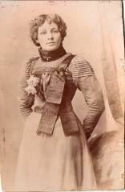

1875 – 1960
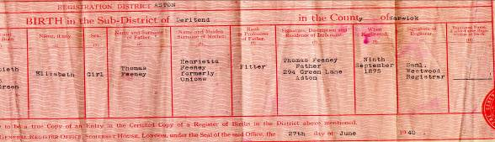
Elizabeth birth certificate 1875
Family address at the time 294 Green Lane

Elizabeth Feeney was born in Birmingham in 1875 as Leonard at an early age her parent moved to barrow in furnace to find work
Moving back to Birmingham sometime before 1891
Please see censuses for Thomas Feeney 1881,1891

Elizabeth Married Edwin Walkley born 1880 in Birmingham
Edwin was the son of Edwin Walkley born 1846 and Maria
Upston born 1847 in Northamptonshire
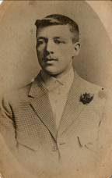

Elizabeth and Edwin had five Children

Edwin - 1903

Henrietta 1905 - 1998 my grandmother
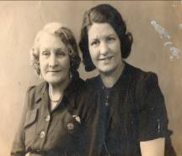
Henrietta and Elizabeth

Frank Henry - 1909

Clarence 1912- 1913

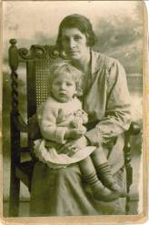 Roland Ernest - 1920 - 2008
Elizabeth with Roland

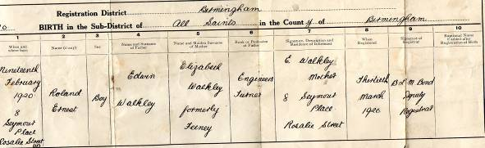
Roland birth Certificate 1920

Edwin died in 1949
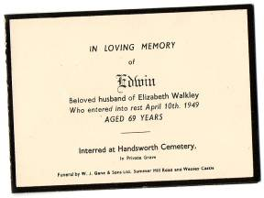

Elizabeth died in 1960

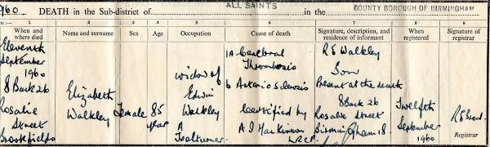
Elizabeth death certificate

