Table of Contents
ROS FUNDAMENTAL CONCEPTS 2
ROS2 making Packages 3
ROS2 Transforms 4
ROS2 URDF files 5
ROS2 Gazebo 6

ROS FUNDAMENTAL CONCEPTS

ROS graph: a network of ROS 2 elements processing data together at one time.
encompasses all executable and the connections between them if you were
to map them all out and visualize them

Node: Responsible for a single purpose.
Should send and receive data via topics, services, actions, or parameters
full robotic system uses many node in concert.
executable contains one or more

Topics: bus for nodes to exchange messages
Nodes may publish data to any number of topic
Node can simultaneously have subscriptions to any number of topics
One of the main ways data is moved between nodes

Services: call-and-response model/ service(server) only provides data when called by client
can be many clients
only one server

Parameter: configuration value of a node
can store as integers, floats, boolean, strings, and lists
nodes maintain own parameters
configure at startup and runtime
tied to lifetime of node

Actions: use a client-server model. "Action client" sends goal to "action server"
consist of goal, feedback, and a result
goal service begins action
feedback is sent to client until finished through feedback topic
once done, sends result through result service

result service begins feedback sending?
Long running tasks
can be canceled
built on topics and services

Launch files: used to run many objects at once (likely used towards end)
are made with python files

ROS2 making Packages

Package: A package can be considered a container for your ROS2 code
C++ Requires CMakeLists.txt and a package.xml
Python Requires setup.py, package.xml, resource/my_package
python vs cmake is ament_cmake vs ament_python
--create package:
ros2 pkg create --build-type ament_cmake [--node-name <node_name>] <package_name>
--build specific packages:
colcon build --packages-select <package_name>
--source ROS2 installation (needed for running newly build packages) (run in ws):
. install/local_setup.bash
--use package:
ros2 run my_package my_node

ROS2 Transforms

does broadcasting and listening instead of publishing and subscribing

static: doesn't changed overtime
--static tf publisher: publishes a static transform (translations first then rotations) (angles in radians)
ros2 run tf2_ros static_transform_publisher <x> <y> <z> <yaw> <pitch> <roll> <parent_frame> <child_frame>

dynamic: changes overtime
if the state publishes overtime, without a publisher, it will crash
--robot_state_publisher: publishes the state of the robot while giving an option to edit the transforms
ros2 run robot_state_publisher robot_state_publisher --ros-args -p robot description:="$( xacro <urdf file location>)"
use TF and RobotModel in RVIZ
RobotModel needs to be subscribed to robot_description
--robot joint control gui
ros2 run joint_state_publisher_gui joint_state_publisher_gui

RVIZ: used for modeling
--rviz: rviz2
tf and robot_model are used for visualization

ROS2 URDF files

links: separate components of the robot
if two parts move independently
if it makes sense (like removable components)
has a corresponding joint it is connected to
have only one parent
can have many parents

joints: how links relate to each other (joined)
determines each rotation in space
Joint types: revolute, continues, fixed, prismatic (linear)

urdf
xml declaration
contains root tag.
in root tags are link and joints

xacro [xml macro] (split files into multiple files and avoid repitition)
added through command <robot xmlns: xacro="http://www.ros.org/wiki/xacro">

one main file representing robot
can include other file
included files need a robot tag
main file should end as .urdf.xacro

Flow seen in screenshot

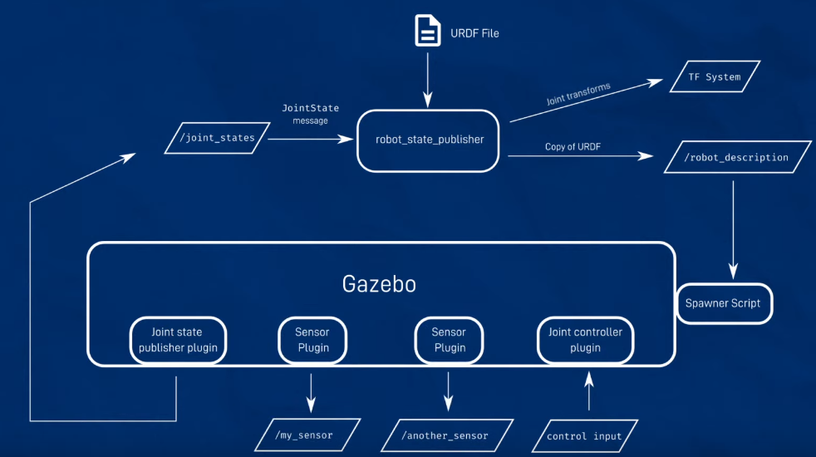

ROS2 Gazebo

Gazebo
--install:
sudo apt install ros-<ros_version>-gazebo-ros-pgks
--run without ROS:
gazebo <gazebo_file>
interacts with ros throught pluggins
--run with ros:
ros2 launch gazebo_ros gazebo_launch.py
--convert urdf to stf and spawn
ros2 run gazebo_ros spawn_entity.py -topic robot_desciption -entity <my_bot>
--publish joint states:

Note: Best way for control and publishing is Gazebo Ros2 control pluggin

Gazebo knows world links stay stationary

STF: format gazebo uses
stores the world AND the robots in the world
urdf only stores robot

Mischellaneous

the underlay is the setup.bash file

Quality of Service how fast it wants to output data
no agreement means nothing outputs

