CLINICAL CASE STUDY · THAILAND COHORT · CASE 1  Functional Recovery Following Bilateral Stroke with Structured Rehabilitation and Caregiver Support  Thailand · Stimel-03 | 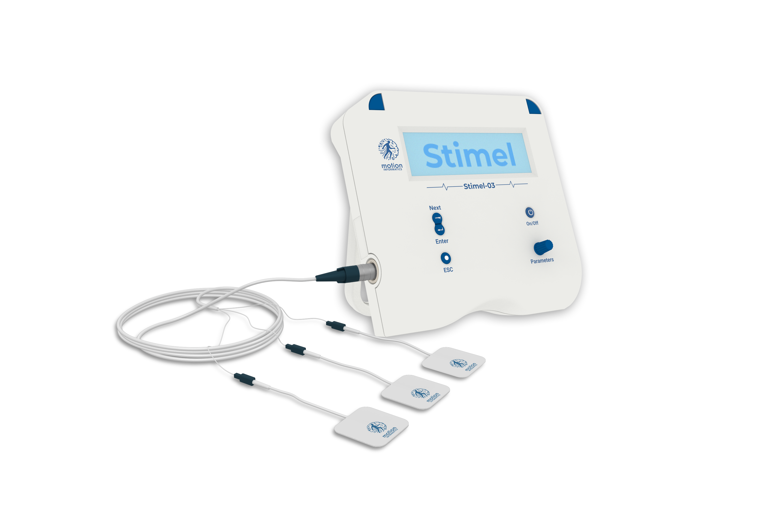

Patient & Treatment Snapshot
Region | Thailand
Patient profile | 52-year-old male
Clinical history | Left-side stroke (2020); right-side stroke (October 2025); bilateral paralysis
Device | Stimel-03
Treatment period | March 2026 · ~1 month
Sessions | 8 sessions, twice weekly (Mon/Wed)
Treated side | Right (more recent stroke)

Introduction
Upper-limb recovery after stroke depends on lesion timing, residual motor capacity, treatment intensity, repetition, task relevance, and continuity of activity outside formal sessions. Recovery improves when training is repetitive, meaningful, and sustained — particularly when therapy extends beyond isolated clinic encounters into supported daily practice. Family and caregiver participation is highly relevant in home-based or hybrid settings, especially when the patient has severe disability and depends on others for positioning, transfers, and repeated movement attempts.
This case presents structured device-based rehabilitation alongside a highly active caregiving environment. The value lies not only in observed motor changes but also in the broader context: family involvement created a high-exposure therapeutic environment in which formal sessions were reinforced by repeated activity outside the clinic. Because post-stroke recovery depends on cumulative practice and engagement, this context is clinically important.
Patient Information
52-year-old male. First stroke affecting the left side in 2020; second stroke affecting the right side in October 2025. According to the treating team, the cumulative effect resulted in bilateral paralysis. The more recent right-sided event was selected as the initial therapeutic focus.
The patient's family included healthcare professionals — specifically nurses — who played an active role in daily care. Their familiarity with clinical care appeared to influence the structure and consistency of supportive activity outside formal sessions.
Baseline Clinical Status
At the initiation of treatment in March 2026, the patient was unable to:
■ Voluntarily open or close the hand on the treated side.
■ Wrist movement was not observed.
■ Functional use of the upper limb was absent on the side selected for intervention.
Intervention
Rehabilitation was conducted using Stimel-03. Treatment focused on the right side (more recent stroke, October 2025). The patient completed 8 sessions over ~1 month, twice weekly on Mondays and Wednesdays.
Outside formal sessions, the family maintained additional rehabilitation-related activity. Two forms of support were specifically described: (1) a mechanical lifting system to assist with movement and handling; and (2) an electrical stimulation glove to support repetitive hand opening and closing practice. These adjunctive activities were not part of the Stimel-03 protocol itself but formed part of the patient's broader rehabilitation environment.

Formal sessions were embedded within a wider pattern of daily assistance and repeated activity at home — a high-exposure therapeutic environment built around the patient.

Clinical Course
The patient participated consistently in the scheduled program. During the initial phase, fatigue occurred after ~20 minutes in the first 3 sessions. Tolerance improved over time; by later sessions, the patient could continue ~45 minutes before fatigue.
The treating team described the patient as highly motivated and strongly committed to recovery — motivation specifically linked to a desire to return to normal functioning. The family was also described as highly proactive and engaged. Together, these conditions created a setting in which formal treatment sessions were embedded within a wider pattern of daily assistance and repeated activity.
Outcomes
After 8 sessions, the patient demonstrated the ability to open and close the hand, lift the wrist, and produce slight extension and retraction of the hand. These functions were reported as absent at baseline. Overall improvement was considered clearly noticeable after ~1 month of treatment.
In addition to motor change, endurance increased from ~20 minutes to ~45 minutes during sessions. Although not a formal outcome metric, this change may reflect improved tolerance for continued engagement in the rehabilitation process.
Discussion
Several aspects are clinically noteworthy. The patient had a complex history (2 strokes affecting opposite sides at different times), yet measurable improvement was observed in the treated limb after a short window. The change was not isolated from the rehabilitation environment — the case represents a combined-exposure model in which device-based stimulation, repeated movement attempts, caregiver-supported activity, and strong patient engagement coexisted.
Rehabilitation literature consistently supports repetitive, task-oriented, sufficiently intensive practice for upper-limb recovery. Repetition alone does not guarantee recovery, but repeated attempts to move — particularly when reinforced by structured therapy — are widely regarded as central to motor relearning. Here, scheduled sessions were supplemented by movement activity at home; even though intensity and dosage of that external activity were not quantified, its presence may be clinically relevant.
Caregiver involvement is another important factor. For survivors with substantial disability, family support determines whether meaningful activity continues between sessions. Here the family did not act as passive supporters — they actively created opportunities for movement and handling, likely increasing total therapeutic exposure and supporting adherence by integrating rehabilitation into daily routine.
Motivation is also relevant; rehabilitation research increasingly recognizes it as a determinant of participation and adherence. The patient's high commitment, matched by a supportive home structure, may have contributed to consistent participation and to his ability to tolerate longer sessions over time.
Conclusion
This case documents functional improvement in hand and wrist movement over 8 Stimel-03 sessions in a patient with bilateral post-stroke paralysis. The observed recovery occurred in a setting characterized by strong patient motivation, intensive family involvement, and repeated movement activity outside formal sessions. The case supports the practical importance of embedding device-based rehabilitation within a broader environment of sustained engagement and caregiver-supported repetition.
Case Video
Watch the case video: link

Stimel-03 by Motion Informatics — clinical-grade neuromuscular rehabilitation in a portable, patient-friendly device.

