Controlling Remote Machines
Welcome to the last concept taught in the automation starter pack. We have covered multithreading through data mining on an introductory level so now we can put all of these concepts together under one function! Controlling remote machines is useful when it comes to network maintenance, resource allocation and control and simulations, just to name a few. Essentially, it is enabling you to access another computer from a remote location! Of course, having a baseline knowledge on network architecture will take you a long way when it comes to remote control so take some time in brushing up on some.
https://en.wikipedia.org/wiki/Network_architecture

We are going to be taking the programs we have built in this series and run them through a Secure Shell (SSH). This allows us to access a computer in a secure way over an unsecured network. So we will be performing this on a network we have administrative rights over.

First off we are going to install openssh-server on the device we want to access from our base machine. I will be accessing my laptop from my desktop computer, so I will install openssh-server onto my laptop.
Sudo apt update
sudo apt install openssh-server.
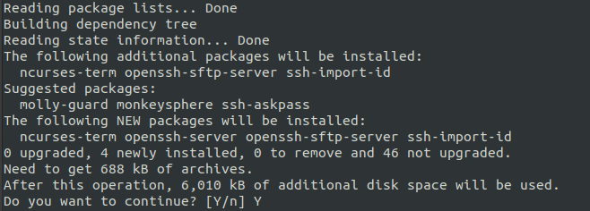

After thats installed lets check to see that its running
sudo systemctl status ssh

Enable your firewall to allows ssh
sudo ufw allow ssh

Next, we want to install nmap and scan using the command sudo nmap 192.168.1.0/24. When we add 1.0 to the end of 192.168. we are using a private IP address used by many routers to identify themselves. Hopefully this is the same for your router, but if it isn’t don’t be afraid to look up the self identifier online.

When we run the command we should see an assortment of devices on the network, their IP and Mac address and a short description of the device. We are interested in the IP address of the device that we enabled secure shell scripting on.
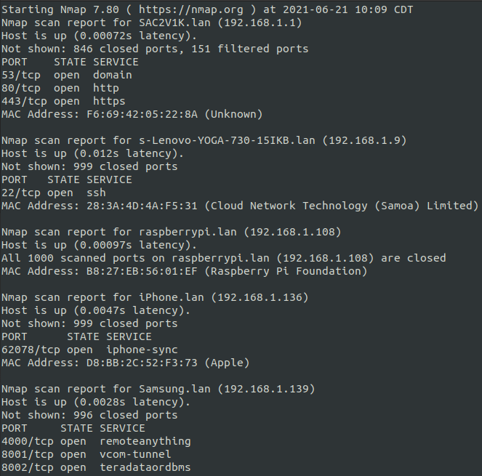

Cool, now we want to grab to IP address and device_username@device name of our laptop and try to connect from our base machine using:

sudo ssh device_username@IP_Address_Of_Device

It should give us a cryptographic SHA fingerprint and ask us if we with to continue. Type ‘yes’. And then Enter the password for the device
Fun fact, Bitcoin also uses SHA256.

Once you have connected to your laptop you should be able to navigate the computers directory using cd and ls -l

Cool, now we are going to automate this process in python, so lets start off with all of the functions we previously built in the series.

Python3.8

