Predicting Forest Fires

Lorem ipsum dolor sit amet, consectetuer adipiscing elit

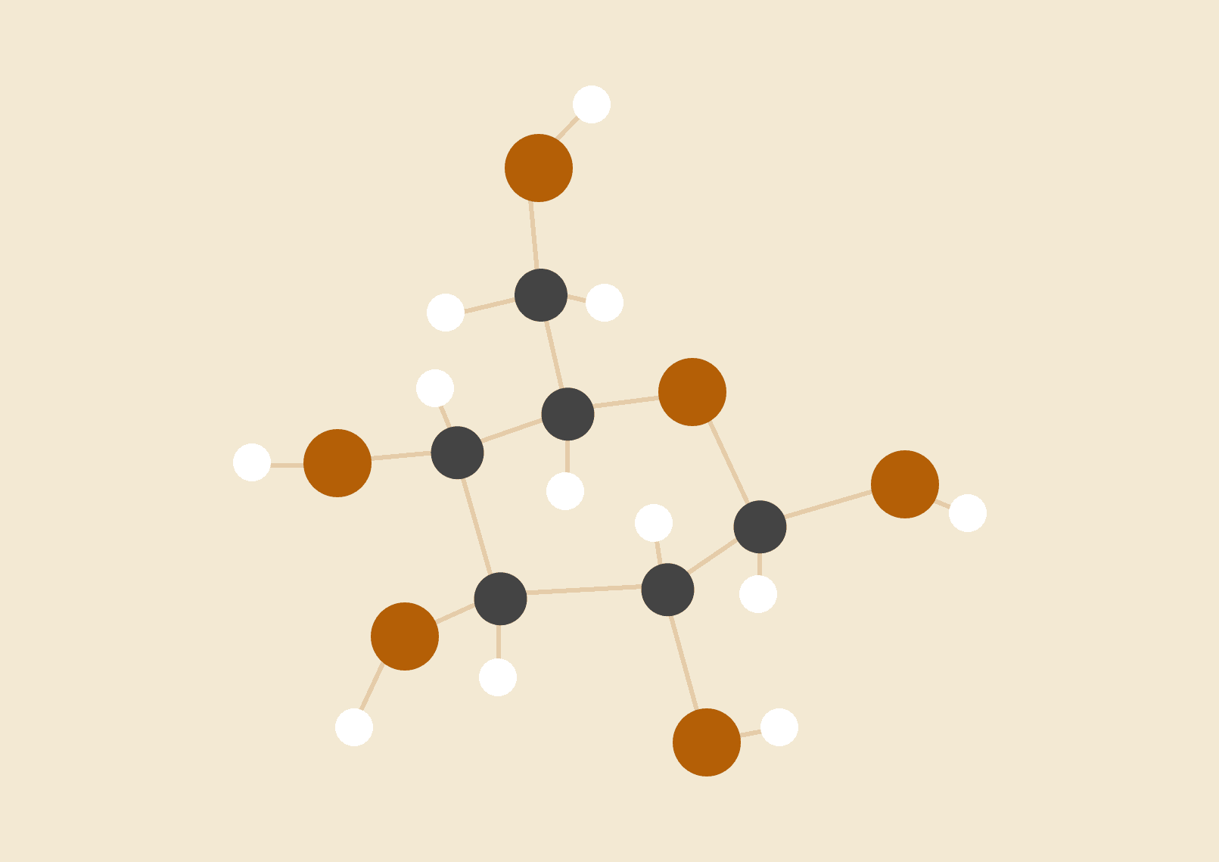

**Your Name**

09.04.20XX

8TH GRADE SCIENCE

# INTRODUCTION

This program is created in order to help predict the likelihood and severity of fire starting in a certain area in canada through the weather and physical data collected there. The program uses the FFMC to predict the possibility of forest fire starting based off of weather and fuel condition data. The initial spread index is the calculation of the FFMC taking into account the wind level which fuels the fire with oxygen. The BPI measures the ratio of between how dry or damp the fuel that the fire consumes is. Finally, based on the initial spread and the buildup of fuel, we measure the FWI, possible severity of the forest fire. Given equations are

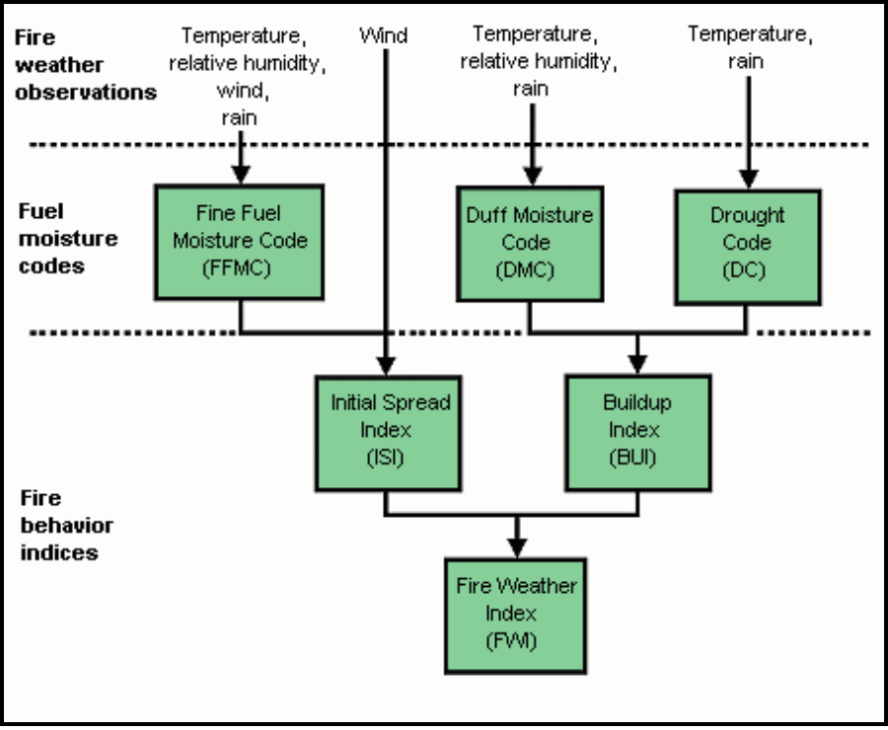

Introduction Forest fires are devastating, and can rage out of control. The 2017 forest fires in British Columbia, for example, compelled thousands to escape, burned 1.2 million hectares of forest, and caused more than CAD $500 million in damage. Moreover, pollution from the fires caused respiratory problems for people living hundreds of kilometers away. Predicting the source and spread of forest fires could have considerable benefits for human health and life, the economy and the environment. This could help identify areas with higher risk - for example, with limited resource, the authorities could choose to focus on monitoring specific areas. Many techniques have been developed, including approaches that use satellite (2.1) > > images, historical weather data and computational fluid dynamics. The advent of high-power, low-cost computing has heralded the use of machine learning and neural networks for predicting forest fires. Machine learning can see trends and patterns that humans often overlook; in fact, this approach is gaining recent media attention.

Team

Staffan Al-Kadhimi - python programmer

Hussam Shah -

Sean Lemoine - R shiny programmer

Robert Zhang -