**Manual**

IDE: Visual Studio 2017 Community in C++

# Menu

# Add a new contact

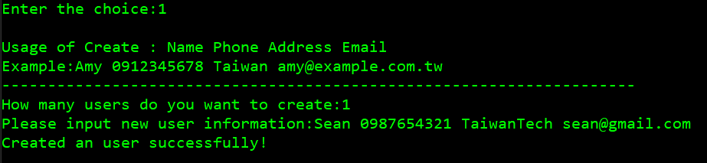(Enter the amount first)

# List all contacts

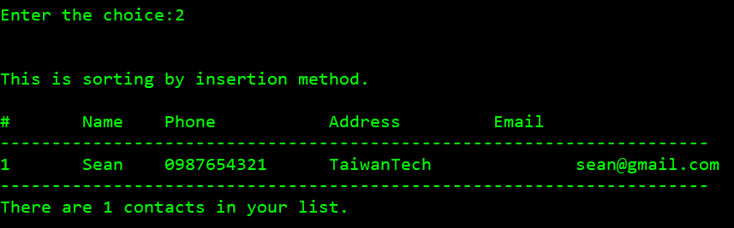(I provide the sorting method)

# Search for contact (no matter uppercase or lowercase)

(Also provide searching by phone)

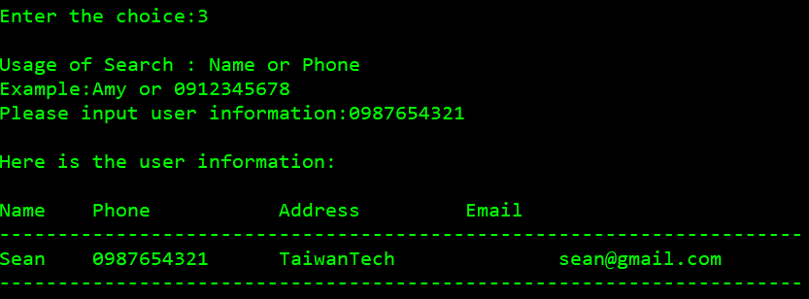

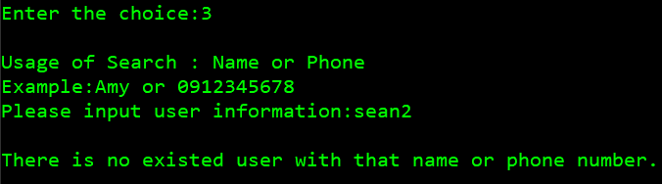(Show the message if not found)

# Edit a contact

(Name must be the same)

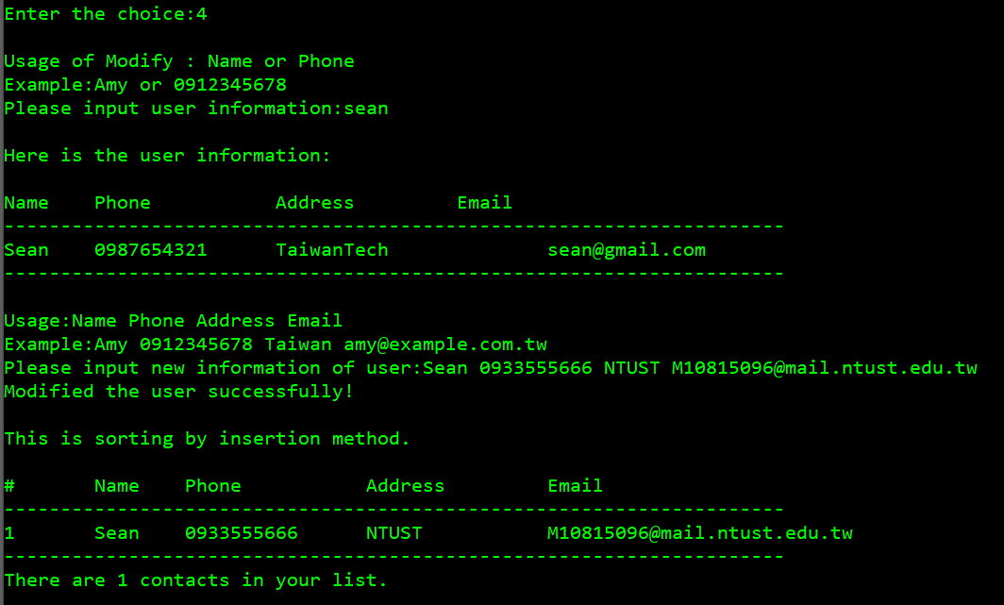

# Delete a contact

(Check if really want to delete again)

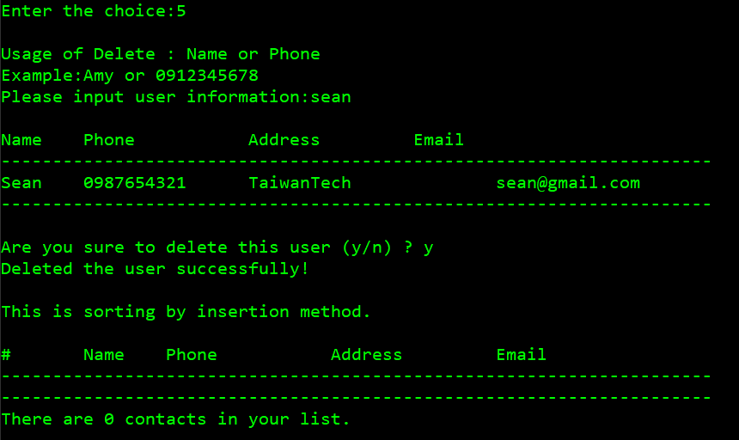

# Import from file

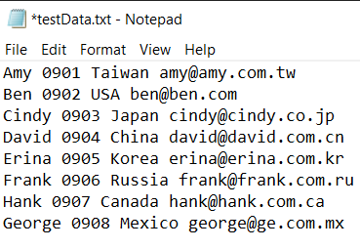

(add user information from specified file)

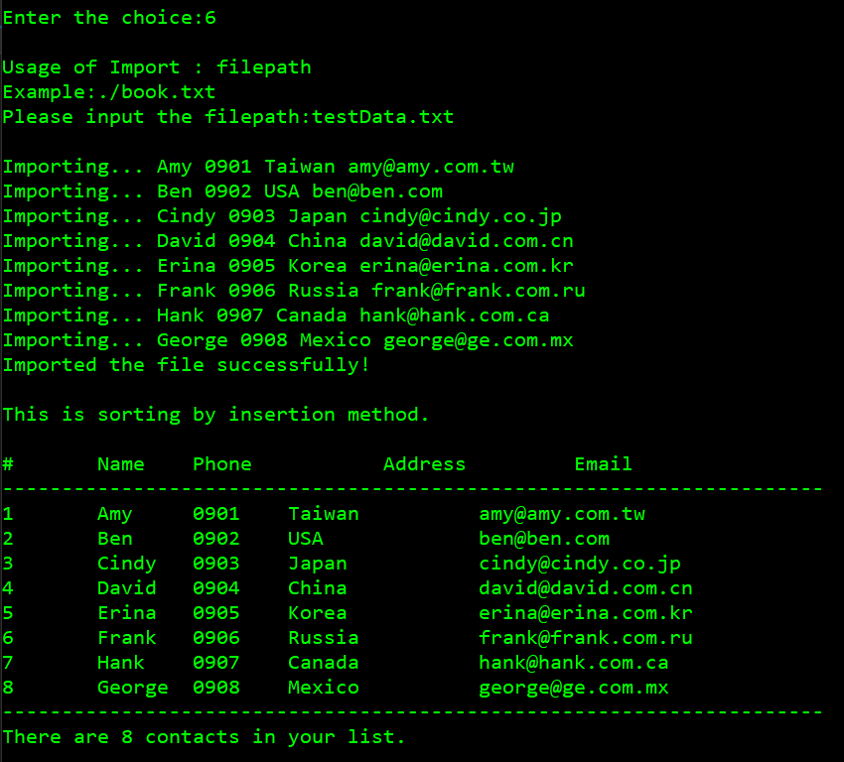

# Export to file

# Sorting

sorting by descending name method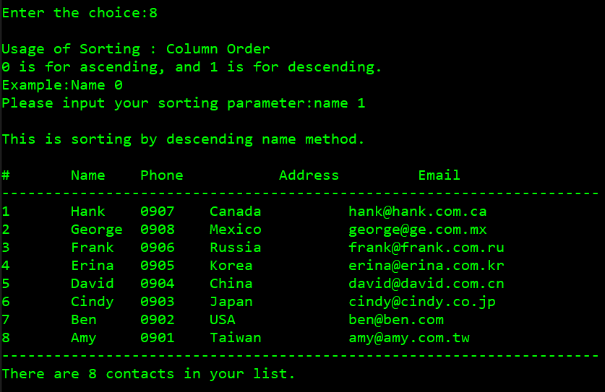

sorting by ascending name method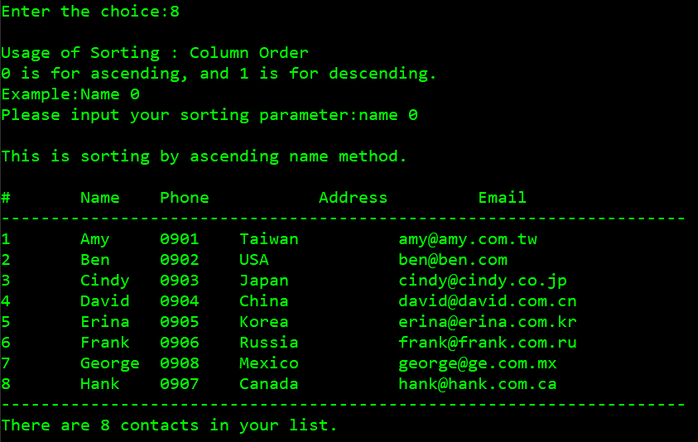

sorting by ascending phone method

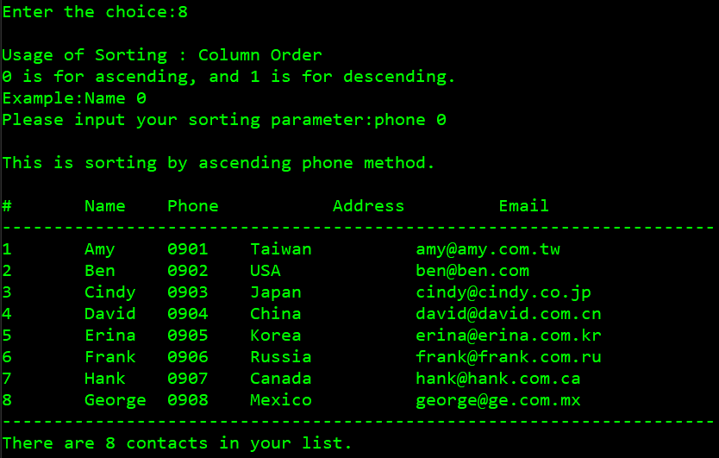

sorting by descending phone method

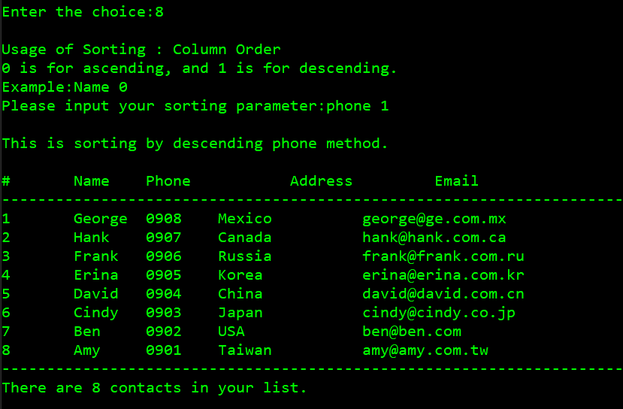

sorting by ascending address method

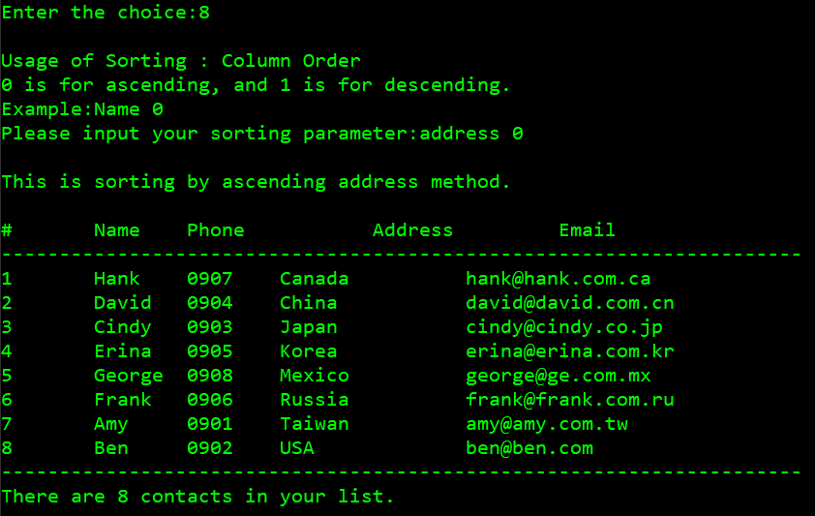

sorting by descending address method

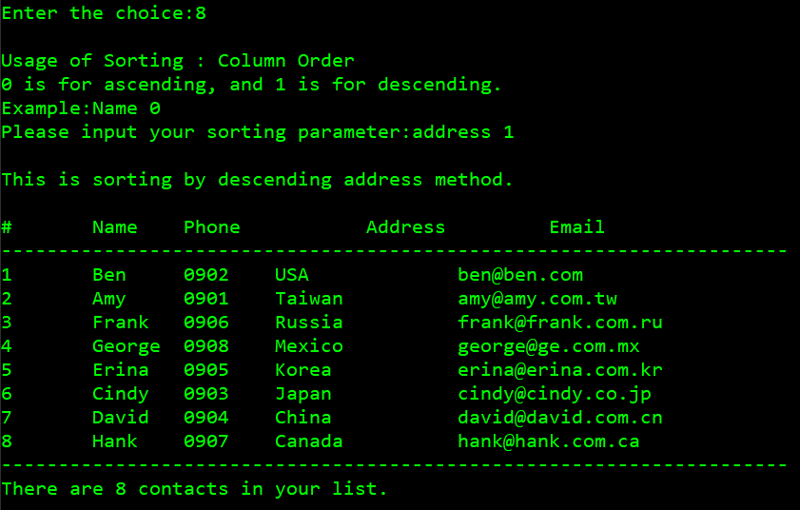

sorting by ascending email method

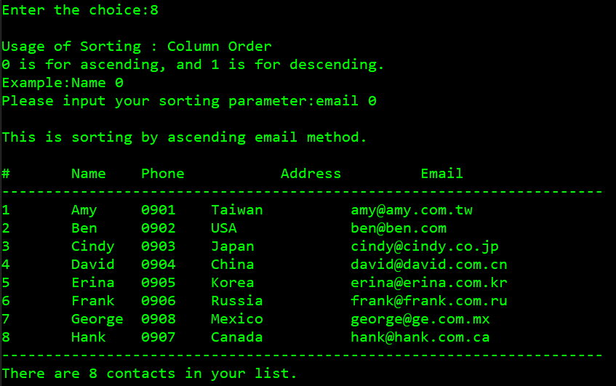

sorting by descending email method

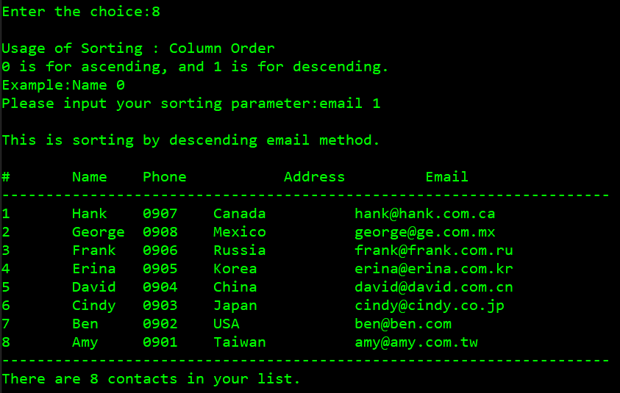

# Exit

