Vertices/nodes – finite set of edges

Complete graph – every pair of nodes is joined by an edge (n-1 * n / 2)
Connected graph – where every pair of vertices is connected by a path

Directed graph – has direction (with arrow), Arc
Undirected graph – no direction, it joins a pair of vertices, Edge
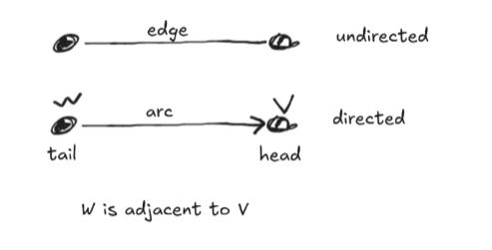
Path – sequence of vertices
Length – number of arcs, if path is 6 then length is 5

Simple path – if all vertices in a path are distinct
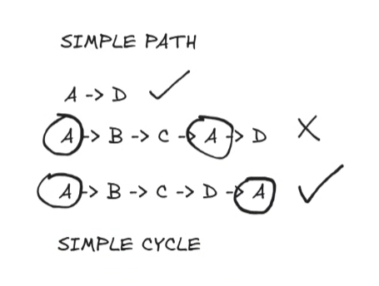
Simple cycles – is a simple path that begins and ends in the same vertex
Cyclic graph – when a graph contains a cycle
Acyclic graph – when a graph has no cycle

Incident – a node is incident to an arc if n(arc) is 1 of the two nodes in the ordered pair
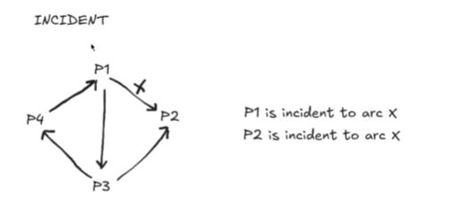
Degree – number of arcs incident to it (P2 – 2)
Indegree – number of arcs that have node as a head (P2 – 2 | P3 – 1)
Outdegree – number of arcs that have the node as a tail (P3 – 2 | P4 – 1)

Relation
Weighted Graph – the weight of each arc is the remainder of y % x or head % tail
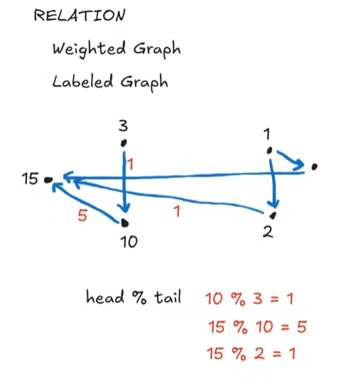
Labeled graph – is a di-graph in which arcs and or vertices have an associated label of any value

Representation
Adjacency Matrix
