Exploratory Data Analysis of the 2020/21 Premier League Season
Sean McEvilly

1. Introduction
Dataset and aim. The dataset contains results and match statistics for all 380 Premier League matches in the 2020/21 season, with 16 variables covering teams, goals, shots, shots on target, fouls, and cards. The data was sourced from football-data.co.uk. The main aim of this exploratory analysis was to investigate whether playing at home provided a noticeable advantage and, where patterns appeared, to explore them further.
Data integrity. The data was inspected using head(), str(), summary(), names() and dim(). Missing values were checked with is.na(); no missing values were found. The dataset contains character variables such as team names and dates, and integer variables for match statistics. Full-time result (FTR) is stored numerically but represents a categorical outcome.

2. Match results and home advantage
Home teams won 144 matches (37.89%), draws accounted for 83 matches (21.84%), and away teams won 153 matches (40.26%). Away wins were therefore slightly more common than home wins. Based on match results alone, there was no clear home advantage in this season.
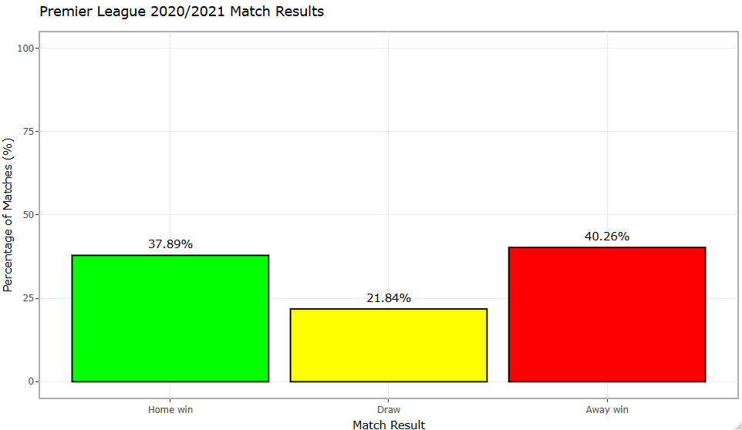
Figure 1. Percentage of matches ending in a home win, draw or away win.

3. Home and away goal scoring
Goal scoring statistics were very similar for home and away teams. Home teams averaged 1.35 goals per match compared with 1.34 for away teams. The median was 1 goal for both, and the IQR was 2 for both. Standard deviation was also similar (1.32 for home goals and 1.26 for away goals). The histograms and boxplots produced in R showed similar overall distributions, so there was little evidence of a meaningful scoring advantage for home teams.
Statistic | Home goals | Away goals
Mean | 1.35 | 1.34
Median | 1 | 1
Standard deviation | 1.32 | 1.26
IQR | 2 | 2

4. Attacking chances
Although goal scoring was almost identical, home teams created more attacking opportunities. Home teams averaged 12.82 shots compared to 11.36 for away teams. Home teams also averaged 4.54 shots on target compared to 4.08 for away teams. This suggests a small home advantage in chance creation, even though it did not translate into more wins or clearly more goals.
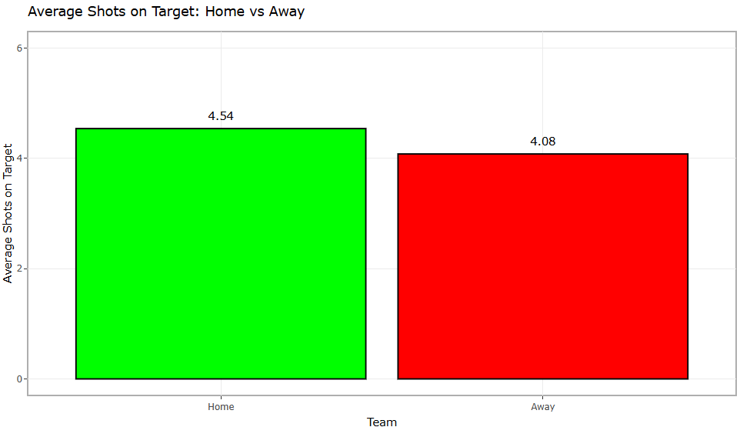
Figure 2. Average shots on target for home and away teams.

5. Shots on target and match result
The initial findings led to a further question: were shots on target associated with the match result? A clear pattern emerged. When the home teams won, they averaged 6.06 shots on target compared to 3.13 for the away teams. When the away teams won, the pattern reversed: the away side averaged 5.15 shots on target compared to 3.31 for the home side. Drawn matches showed the smallest difference, with averages of 4.21 for home teams and 3.77 for away teams. This indicates a strong association between producing more shots on target and winning, although the analysis does not establish causation.
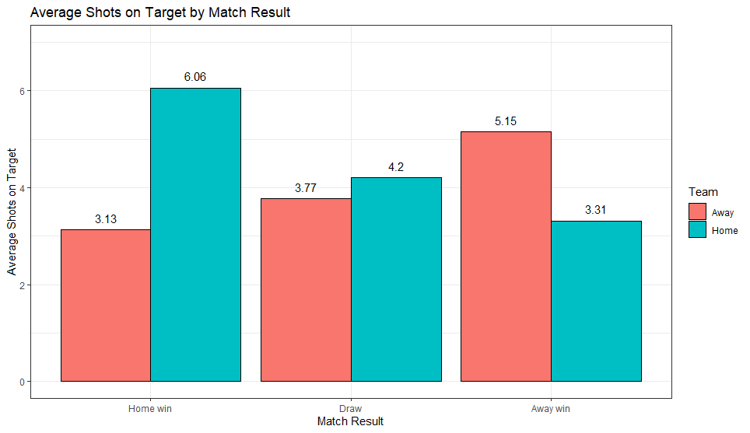
Figure 3. Average home and away shots on target by match result.

6. Conclusion
Overall, the 2020/21 data did not show a clear home advantage in match outcomes or goal scoring. Away wins were slightly more common than home wins, while average goals were almost identical. Home teams did, however, record more total shots and shots on target average. The most notable finding was the relationship between shots on target and the result: winning teams generally produced substantially more shots on target than their opponents. This iterative exploration therefore shifted the focus from home advantage alone toward attacking effectiveness as a potentially more informative feature of match outcomes.

