Keyword In Context implementation

Git URL: <https://bitbucket.org/CS3213a1/assignment-1>

|  |  |  |
| --- | --- | --- |
| Name: | Nguyen Trong Son | Han En Chou |
| Matriculation number: | A0088441B | A0081241U |

# Introduction

Key Word In Context (KWIC) index system produces a list of permutated text to enable the fast and effective searches based on the keywords. KWIC is widely used for various purposes, such as in searching for movie titles, food recipes and blogs. Due to this wide usage, our design priorities are primarily expandability followed by performance.

# Design Overview

As search engines are front-user facing, it is important to maintain an up-to-date User Interface to manage users expectations. Our implementation has an outline similar to Model-View-Controller, which allows for further enhancement on our implementation. Designers can further improve the User Interface and the model can be extended to implement a logging function for data analysis.

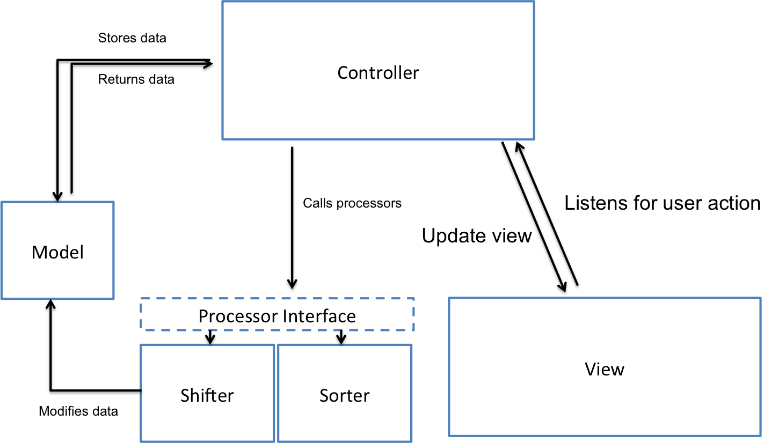

Due to the possible varied usage of KWIC, we have separated the actual processing through a Processor interface. For example, in a movie titles search engine, the sorting may be done using a heap tree based on the recency of the movie. Similarly, the shifting may be done in a randomised manner. This design decision will allow the different types of implementations to optimise the performance of the KWIC for different uses.

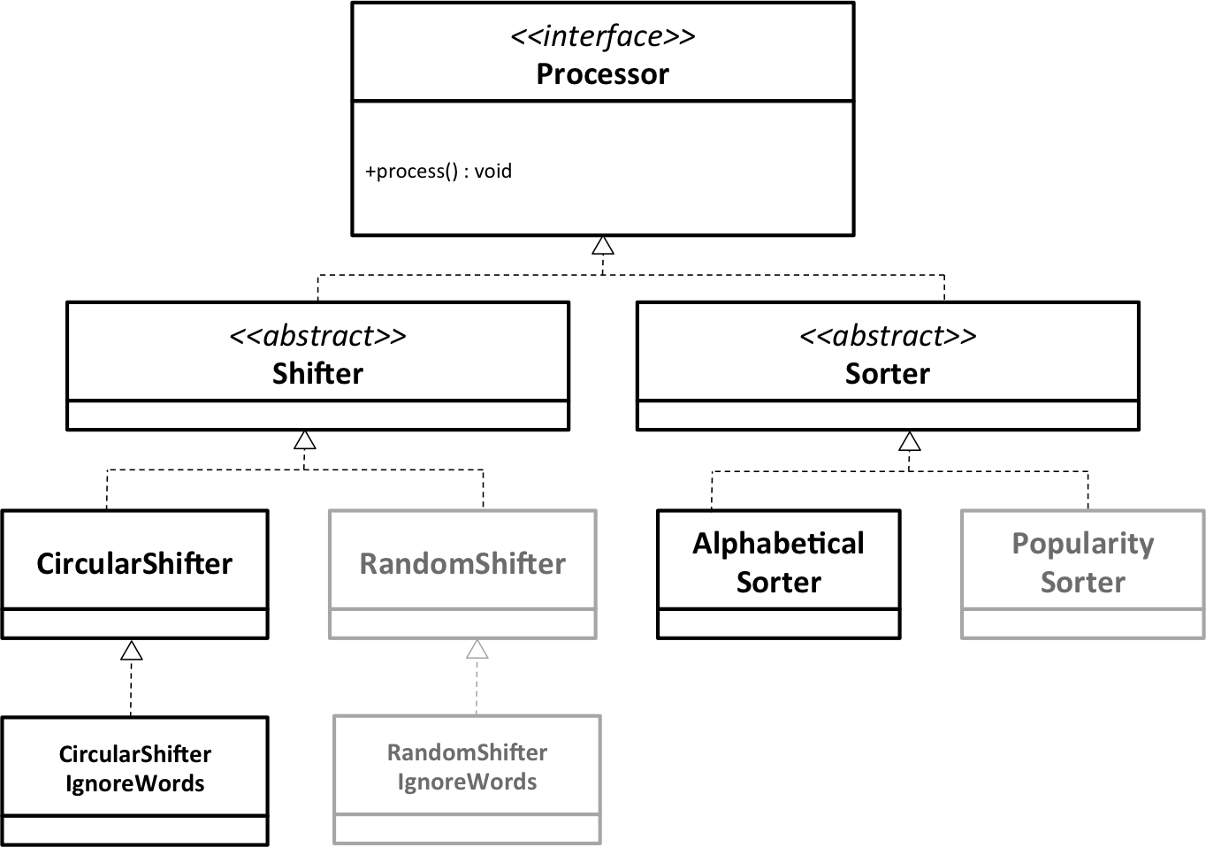

# Limitation & Benefits of Selected Design