**Weekly Status Report**

# Group

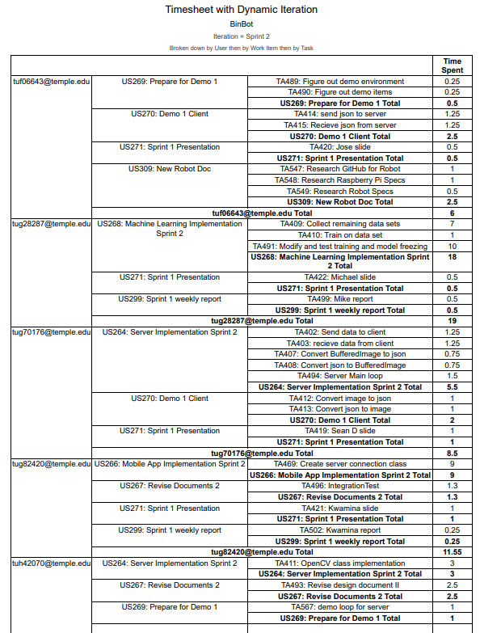

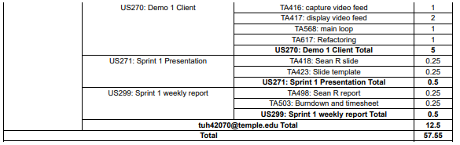

# Sean Reddington

# Overview

In the beginning of the week, I worked on our design document II revision. I manually put all of the generated Javadocs into a word document, adding a few updates and corrections. This took about 2 hours. The rest of the week I worked on preparing the client program for demo 1. This included using OpenCV’s video capturing library to capture video feed from a webcam and send it to the server program for processing. The server program would then send a modified image back to the client program to be displayed. This work on the demo 1 client took about 5 hours. I then worked on the OpenCV waste detection implementation in the server program which took another 3 hours. These tasks provided progress for showcasing the machine learning waste detection features for demo 1.

# Achievements in Last Week

* + User Story 261: tasks 493 (est: 2 hrs – act: 2 hrs)

Made revisions for design document II and resubmitted.

* + User Story 270: task 416, 417, 568, 617 (est: 5 hrs – act: 5 hrs)

Implemented capturing video feed from client and displaying the modified image from the server. This also included sending the captured buffered images between the client and server. The maturity level of these features are finished.

* + User Story 264: task 464 (est: 3 hrs – act: 3 hrs)

Implemented the OpenCV waste detection class for the processing server. This allowed the buffered images to be passed into OpenCV’s object detection and have bounding boxes drawn around any waste found in the image. The image is then sent back to the client program to be displayed. The maturity level of this feature still requires some better classification between the type of waste objects, but is finished enough for our first demo.

# Issues in Last Week

The only issue I had was having to reconfigure some of our Java projects with JDK 11 and getting the OpenCV dependencies to work correctly.

# Goals for Next Week

Now that we have received the hardware for BinBot; next week I will be focusing on building the robot kit and getting the Raspberry Pi set up. Since we had to switch from Arduino to Raspberry Pi with the new robot kit, I will also have to research more into using the Raspberry Pi. Then I will begin to work on writing some of the tread mechanism’s functionality.

# Sean Digirolamo

# Overview

* Created the baseline for a client which receives data from the server and sends data back
* Server tested, modified, and bug fixed to be able to successfully send and receive data to and from client
* Successfully implemented and tested packing images into json, sending that json over a socket, and extracting the image back out in both server and client

# Achievements in Last Week

* User story 270: Demo 1 Client
  + Task 412: Convert image to json EST 1.0, spent 1.0
  + Task 413: Convert json to image EST 1.0, spent 1.0
    - Since our first demo is a demonstration of sending images to the server, locating the trash, and then displaying it, that information needed to be transmitted from client to server. By embedding the image into json, that data could be transmitted over a network successfully.
    - Most of the work done for both of this was shared amongst the two tasks, and also two tasks listed under US264, so time spent has been shared and split amongst the tasks
* User story 264: Server Implementation Sprint 2
  + Task 402: Send data to client EST 1.25 spent 1.25
  + Task 403: Receive data from client EST 1.25 spent 1.25
    - In order to communicate between the server and client, a connection must be established and tested. Most of this code was written last week, but it was not able to be tested yet. Upon testing it, it failed and took much time debugging to work out, but eventually succeeded.
  + Task 407: Convert BufferedImage to json EST .75 spent .75
  + Task 408: Convert json to BufferedImage EST .75 spent .75
    - Again, this is useful for formatting data communicated between the server and client in a readable and meaningful way. The time spent on these are shared and split with the tasks in US270.
  + Task 494: Server Main loop EST 1.5 spent 1.5
    - The first version of the main loop of our final server code has been written. It has not been tested yet though because we do not have our robot completed yet.

# Issues in Last Week

* User Story 264: Server Implementation Sprint 2
  + Task 401: Send data to App
  + Task 402: Receive data from App
    - Neither of these tasks were completed, because my focus was shifted to modules more relevant to demo 1 due to its urgency. Since the mobile application is relatively immature and also irrelevant to demo 1, I did not get to testing the connection between the mobile application and server.

# Goals for Next Week

* User Story 314: Build Robot
  + Task 570: Attach raspberry PI
    - Attach and ensure the functionality of the raspberry PI in the robot
* User Story 317: Write Robot Software
  + Task 578: Write Transmission Class
  + Task 579: Write Transmission Tests
  + Task 580: Write Main Class
* User Story 323: Server Sprint 3
  + Task 584: New thread to connect to app
  + Task 585: Send images to app in new json string
  + Task 586: Test connection to app
* User Story 327: Weekly Status Report
  + Task 592: Sean D

# Michael Savitski

**Overview**

* Training software modified and completed for bounding box regression
* Entirety of first data set augmented with bounding boxes
* Trained convnet successfully on first data set
* 19.5 hours committed, versus the initial estimation of 11

**Achievements in Last Week**

* Tasks completed las Sprint:
  + User story 251, task 342: Documentation on machine learning tests complete in the expected 0.5 hours
  + User story 230, task 210: Train on first data set. Counting all other operations as separate (such as the implementation and data set augmentation), and not counting idle time while the software performed the training loop, about 1 hour was spent versus the proposed 2 hours.
  + User story 268, task 409: This task was originally allotted for taking photos of the remaining data sets, but was used to augment the first data set with the needed bounding boxes, which proved very time consuming. Took 7 hours versus the initial estimation of 4, and the remaining data sets still need to be collected.
  + User story 268, task 491: Was originally assigned as a small task involving the modification of model freezing functionality. Instead, much time was spent re-implementing the original machine learning functionality to allow for bounding box regression. Estimated as 2 hours, took 10.
  + User story 299, task 499: Created my weekly report for Sprint 1. Took the estimated 0.5 hours.

**Issues in Last Week**

* Several tasks had to be shifted in focus
  + Tasks 210, 409, and 491 were all modified to implement the needed changes for bounding box regression, as the original implementation would not meet our needs for the demo.

**Goals for Next Week**

* Complete the data set collection and augmentation
  + Will remain associated with User story 268, task 409.
* Complete training on the collected and fully augmented data sets.
  + Will remain associated with User story 230, task 210.

# Jose Silva

**Overview**

* Progresses in feature completion
  + This Sprint was able to complete research into new robot kit. Original robot kit had to be scraped due to shipping issues and new robot was found. Once robot kit was decided research had to be done to get a better understanding on future mobility feature and claw feature. Did work on client for Demo 1, was able to get server and client to receive and send images among one another. BinBot in the end will have to take images and send to server to analyze and return them to BinBot. Client was tested and worked on different machines(laptops).
* Total working hours committed vs total working hours actually spent on project
  + Commited a total of 9.5 hours vs 6 hours actually spend

**Achievements in Last Week**

* Tasks completed las Sprint:
  + User Story 309: Tasks 547/548/549 (hours estimated: 3 hrs vs actual hours spent: 3hrs)
    - This user story focused on the new robot, since we had to acquire a new robot kit research had to done on the specs of this one. The majority of time was researching the GitHub repo for this robot which is called RaspTank. Researching more in depth into the robot will help move along once work is started on the actual robot.
  + User Story 270: Tasks 414/415 (hours estimated 2hrs vs actual hours spent 2.5 hrs)
    - These tasks included sending json to the server and receiving json from server. For Demo 1 want to show the server is able to receive and send json, as BinBot will have to do this once assembled. The server and client are successfully able to send/receive images, was tested with a test case of sending an image that was on my desktop and sent/received the image.
  + User Story 269: Tasks 489/490 (hours estimated 2hrs vs actual hours spent .5hrs)
    - Figuring out the objects that would be used in demo 1 based on how far the machine learning aspect was so far.

**Issues in Last Week**

* + User Story 266: Mobile App Implementation Sprint 2
    - Task 467 Receive data from server using App & Task 468 Send data to server using App
      * As Sprint 2 was coming to an end, realized since the app would not be used in Demo 1 it would be better to focus attention to components that would actually come into use for Demo 1. App tasks would be worked on in future Sprints.

**Goals for Next Week**

* + User Story 314: Task 569 Assemble Robot
    - For Demo 2 BinBot’s movability feature will be demoed in order to do this the robot kit must be assembled.
  + User Story 317: Task 572 and Task 573 Write Camera class and Camera Tests
    - BinBot has a camera which will be used to identify waste objects. The camera class will be created in this Sprint.
  + User Story 317: Task 576 and Task 577 Write Arm class and Arm Tests
    - BinBot will use a mechanical claw to pick up waste objects. The arm class will be created in this Sprint.
  + User Story 326: Task 590 RaspTank API Research
    - Research RaspTank API to help with the development of BinBot
  + User Story 327: Task 591 Weekly Status Report
    - Complete Weekly status report on tasks completed/not completed in Sprint 3

# Kwamina Thompson

# Overview

* Sprints goal was to set up a server connection with app to a server
* Working on parsing byte strings to Images
* Total working hours committed was at 8 hours vs total working hours actually spent on project ended up being approximately 12 hours

# Achievements in Last Week

* Tasks completed last Sprint:
  + For my user story 9 hours estimated and 10 hours spent.
  + Being able to convert images to byte arrays then parsing it to a json string

# Issues in Last Week

* Tasks could not been complete last Sprint:
* The major problem faced was in debugging android activity issues. Since we wanted to work in just landscape mode. Android API’s will not allow us to be able to set up a solo activity without it being attached to the main activity. But I think this problem existed due my lack in more in depth android development.

# Goals for Next Week

* Tasks moved from Project Backlog to Sprint Backlog:
* Complete connection to the Server
  + Also create another user test case where by the images are converted into byte arrays to Base64 encoder
  + Display Images from Server.