**Weekly Status Report**

# Group

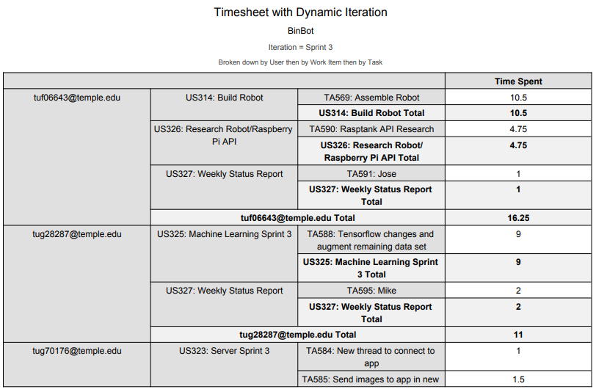

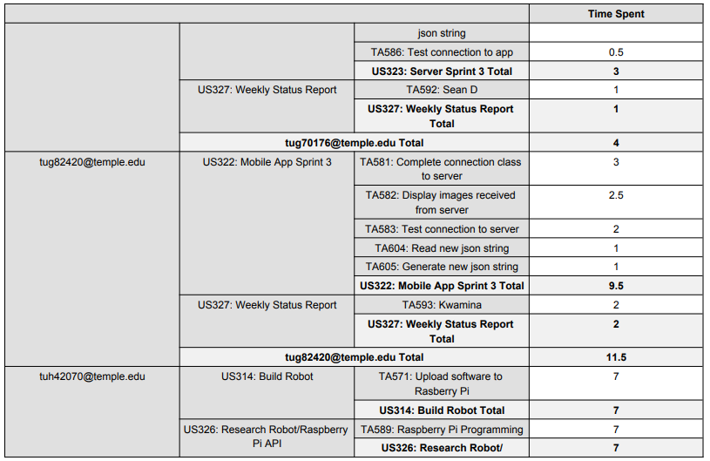

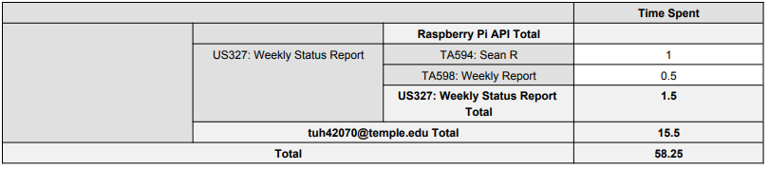

# Sean Reddington

# Overview

For sprint 3, I worked with Jose to build and set up our robot for BinBot. This included putting the robot kit together and configuring the Raspberry Pi with it. We were able to get the robot set up completely and working with the provided software, however, we were unable to connect the Raspberry Pi to the university’s network. Instead, we have it configured to Jose’s mobile hotspot. The robot also consisted of a lot of tiny pieces which took longer to put together than expected. Setting up the BinBot robot took about 14 hours total throughout the week. We were unable to begin programming our own software for the robot due to the unexpected time it took to build it, however, we will focus on that on this following sprint.

# Achievements in Last Week

* + User Story 314/326 (est: 6 hrs – act: 14 hrs)

- Built robot kit with Jose

- Set up Raspberry Pi

- Got Raspberry Pi working with robot kit

- Got provided client software to control robot over mobile hotspot

# Issues in Last Week

The robot kit took an unexpected amount of time to complete, with many road blocks early on. We had trouble getting the Raspberry Pi configured to Temple university’s Wi-Fi and had to resort to using a mobile hotspot. I also had to take home and sand one of the initial plastic pieces of the robot kit which added more delay as well.

# Goals for Next Week

Now that the robot kit is built, next week I will focus on implementing the BinBot software on the Raspberry Pi. This includes the tread and transmission classes. I will also be working to integrate the Raspberry Pi program with our data processing program on the server.

# Sean Digirolamo

# Overview

* Development of Raspberry Pi software in Python
* Connection and communication with mobile application
* Committed 12, spent 10.5

# Achievements in Last Week

* US363: Write Robot Software
  + TA578: Write Transmission Class - Spent 2.5 hours, Committed 2.5
    - Transmission class complete, which allows communication between server and robot
  + TA579: Write Transmission Tests - Spent 1 hour, Committed 1 hour
    - All tests passed, communication between server and robot is successful
  + TA580: Write Main class - Spent 1 hour, Committed 1 hour
    - Main class written, but not completed outside of comments because we are still missing classes for the arms treads and camera. This is important for the robot to run
* US314: Built Robot
  + TA570: Attach Raspberry Pi - Spent 0.5 hours, Committed 0.5 hours
    - Obviously the robot needs to be built to be used
* US323: Server Sprint 3
  + TA584: New thread to connect to app - Spent 2 hours, Committed 2 hours
    - Server now connects to app in separate thread, and allows app to turn server on and off - this functionality has not been implemented in the app yet
  + TA585: Send images to app in new json string - Spent 2 hours, Committed 3 hours
    - Did not finish, images are not sent, but json is sent, allowing meaningful communication between robot and app
  + TA586: Test connection to app - Spent .5 hours, Committed 1 hour
    - Successful connection to app test class in mobile project, however has not been implemented in actual mobile application yet.
* US327: Weekly Status Report
  + TA592: Weekly status report - Spent 1 hour, Committed 1 hour

# Issues in Last Week

* US323: Server Sprint 3
  + TA585: Send images to app in new json string
    - Sending images to the mobile application is slightly more complicated than anticipated because BufferedImages are not available on android, and BitMap (The android image representation) is not available in the regular jdk. This was ignored since this is irrelevant to our second demo

# Goals for Next Week

* US364: Weekly status reports
  + TA746: Complete status report, committed 1 hour
* US368: Processing server sprint 4
  + TA761: Create movement sequence for demo, committed 2 hours
  + TA762: Test mobile app thread functionality, committed 2 hours
  + TA763: Test entire system for demo, committed 2 hours
  + TA764: Togglable server operation based on mobile app message, committed 3 hours

# Michael Savitski

# Overview

* Completion of all data set image augmentation for training and preparation for SSD convnet model
* Ten working hours, equal to the ten committed hours

# Achievements in Last Week

* Tasks completed last Sprint:
  + User story 325, task 588: Augmented all remaining data set photos with bounding boxes, and shot new images of smaller aluminum cans to accommodate robot changes.
  + Researched “Single Shot Detection” variant of convnet machine learning for image detection, obtained existing data model files to train, and planned changes to training implementation for next sprint

# Issues in Last Week

* None

# Goals for Next Week

* Implement changes to training software and OpenCV implementation in server software for new “Single Shot Detection” model
* Commit additional hours to assist other members on any tasks needed to prepare for demo 2

# Jose Silva

**Overview**

* This week’s goals were to start and complete the assembly of the robot kit. Without the robot kit the project could not move forward as the next feature(s) we plan to demo have to do with the mobility of the robot and function of the claw/arm. This took longer than anticipated as we came across issues with tiny pieces having to be assemble and issues working with the raspberry pi connecting it to the school wifi (we couldn’t get this part so we used a hot spot for now). At the end the robot was assemble successfully. Research was also done into the Rasptank source code, the code provided to us that controls different components of the robot.
* Total working hours committed – 7 vs total working hours actually spent on project – 16.5

**Achievements in Last Week**

* Tasks completed las Sprint:
  + User Story 314: task 569 (hours estimated - 2 vs actual hours spent – 10.5)
    - A major task that had to be completed was the assembly of the robot. Sean and I spent a total of 10.5 hours assembling this robot. It had a lot of components that had to be assembled carefully. The robot was assembled successfully. With this task complete the project can move forward with mobility and claw features.
  + User Story 326: task Rasptank API Research (hours estimated – 4 vs hours spent – 4.75)
    - Research had to be done with the Rasptank API which has the methods and source code that control the different aspects of the robot such as treads, camera, mobility, and etc.
  + User Story 327: Weekly Status Report
    - Completed my individual status report

**Issues in Last Week**

* Tasks could not been complete last Sprint:
  + Once the robot was assembled, some of the functionality of the robot was not working as expected. Some of the components were not moving in the manner that was expected. Robot will have to be examined further to see where bugs/issues are coming from. Either from misassembling or the code could be buggy.
  + Connecting the Raspberry Pi to the university’s WIFI was also giving us issues and needed to be set aside in order to make progress with the sprint.

**Goals for Next Week**

* Tasks moved from Project Backlog to Sprint Backlog:
* Main goal for next week is to debug issues with BinBot treads/mobility.
  + User Story 366: Robot Mobility using Adeept GUI
    - Task 760: Arm/Claw movement using Adeept GUI
  + User Story 317: Write Robot Software
    - Task 572: Write Camera class
    - Task 573: Write Camera test
    - Task 576: Write Arm class
    - Task 577: Write Arm test
  + User Story: 364:
    - Task 751: Jose weekly status report

# Kwamina Thompson

# Overview

* Prepping robot parts for assembly
* A total of 11 working hours was estimated but ended up working a total of 11 hours and 30 minutes on the project

# Achievements in Last Week

* Tasks completed las Sprint:
  + User Story 322 tasks 581 had 2.5 hours estimated and ended up spending 3 hours on the user story.
  + Progress in feature development as a result of those task completion is at 45 percent. I now have to conduct another sprint building up on my feature development to be able to fully have my development integrated in the feature being developed.

# Issues in Last Week

* Tasks could not been complete last Sprint:
  + User Story 322: task 583 All task where able to be completed even though some of them where duplicated work since there was a lapse in communications. Some team members ended up working on some user stories, just to find other members had taken care of it.

# Goals for Next Week

* + The main goal is to start the robot and end turn it of with the command of the mobile app.