**Weekly Status Report**

# Group

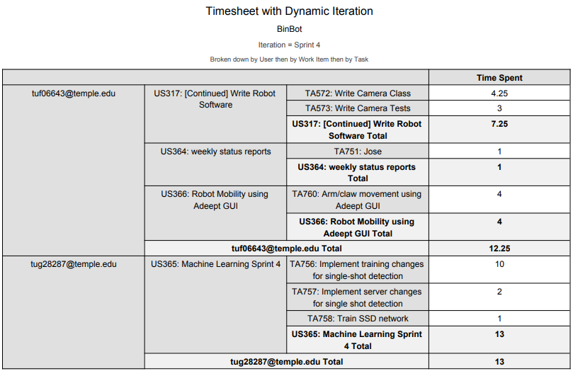

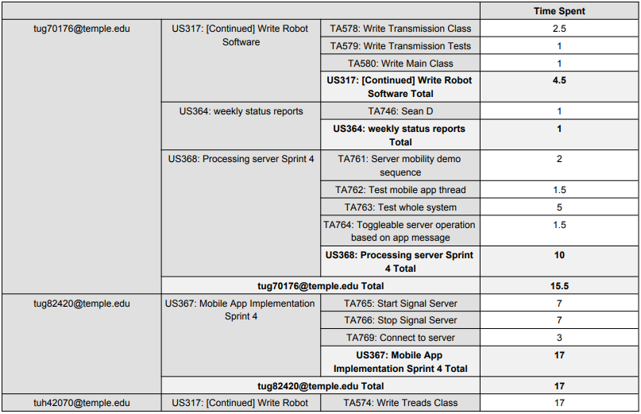

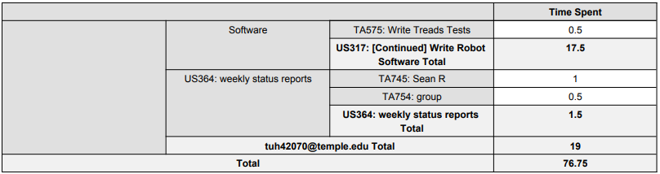

# Sean Reddington

# Overview

For sprint 4, I worked on implementing the tread movement functionality. This included writing the Tread module and tests for the robot’s Python program. This required research into how the Raspberry Pi controls the motors, via the RPi.GPIO library. After implementing, I spent a lot of time trying to fine tune and calibrate the movements of the treads. I worked on several mock instructions for testing as well as an instruction set that we will use to display the robot’s mobility in demo 2. While I estimated these tasks would take about 3-4 hours, I ended up working on it for about 17 hours throughout the week.

# Achievements in Last Week

* + User Story 317: TA574 (est: 3 hrs – act: 15 hrs)

- Implemented Tread module on python program

- included some fine tuning and calibration

* + User Story 317: TA575 (est: 0.5 hrs – act: 2 hrs)

- Wrote unit test for Treads module

- Wrote tests for Treads functionality

- Wrote mock instructions to test tread movement

# Issues in Last Week

I found that the treads move differently based on the friction of the floor it lays on. This is an issue because the movements must be calibrated for each type of terrain. For example, a 45 degree turn instruction does not make the full 45 degrees on carpet, while the same instruction will overshoot 45 degrees on a smooth table. Jose and I also ran into a slight roadblock with getting our robot program’s environment set up and running it on the Raspberry Pi which added an extra 1-1:30 hours of configurations.

# Goals for Next Week

Next week I plan to finish up only remaining calibration for the tread functionality then work with Jose to get the robot’s camera and arm modules implemented. Depending on the accuracy, we may also work on implementing functionality for the robot’s proximity sensors.

# Sean Digirolamo

# Overview

* Mobility demonstration sequence completed for demo 2.
* Robot operation is now toggleable via mobile application control
* Bug fixes on communication between robot and server. Connection no longer stops based on race bug.
* Committed 11.5 hours, spent 11.5 hours

# Achievements in Last Week

* US354: weekly status reports
  + TA746: Sean D - 1.0 estimated, 1.0 spent
* US368: Processing server Sprint 4
  + TA761: Server mobility demo sequence - 2.0 estimated, 2.0 spent
    - Designed movements for robot to execute during demo 2
  + TA762: Test mobile app thread - 2.0 estimated, 2.0 spent
    - Ensure that server thread for mobile app communication and operations executes correctly. Also fixed any errors found, now that the mobile app has been implemented and communication implemented. This is necessary for the mobile app to interact with the server, so that images can be displayed in the app and that the app can toggle operation
  + TA763: Test whole system - 5.0 estimated, 5.0 spent
    - Test communication between robot and server, and server and app, and ensure everything works as it should. Fixed any communication bugs. Everything works now/for now.
  + TA764: Toggleable server operation based on app message - 1.5 estimated, 1.5 spent
    - Server now toggles operation based on input from the mobile app, stopping and starting the robot.

# Issues in Last Week

* None

# Goals for Next Week

* US433: Weekly status report Sprint 5
  + TA950: Sean D - 1.0 est
* US434: Server Impl Sprint 5
  + TA955: Tread movement calculations - 4.0 est
    - Calculate movements robot treads should take based on image recognition
  + TA956: Arm movement calculations - 5.0 est
    - Calculate movement robot arms should take based on image recognition

# Michael Savitski

# Overview

* Progress towards “Single-shot Detection” model for machine learning
* 13 hours committed to work, versus 14 spent

# Achievements in Last Week

* Tasks completed las Sprint:
  + User Story 365, task 756 to implement changes to neural network model and training for Single Shot detection – 8 hours committed, 10 spent.
  + User Story 365, task 757 to implement server-side changes for SSD – 2 hours committed, 2 spent
  + User Story 365, task 758 to train SSD neural network model – 2 hours committed, 1 spent (does not include passive time spent by software performing training without input)
  + User Story 327, task 595 for weekly reports – 1 hour committed, 1 spent
  + Overall progress in single-shot detection development is good, but training was not fully successful due to set-up errors. Some further progress needed to resolve errors.

# Issues in Last Week

* Tasks could not been complete last Sprint:
  + Trained model was not fully successful due to errors with label map file and problems working on GPU system.
  + Some compatibility issues using chosen model in Java OpenCV implementation

# Goals for Next Week

* Tasks moved from Project Backlog to Sprint Backlog:
  + User story 436, task 961: Complete server-side OpenCV (Java) changes
  + User story 436, task 962: Complete training of SSD model
  + User story 436, task 963: Thoroughly test completely trained model

# Jose Silva

# Overview

* This week I was able to work on the Camera aspect of BinBot, using a raspberry pi camera BinBot can now take photos of what it is infront of it. Some time was taken to research more into the raspberry pi camera and seeing what would be the best approach to take. Some of the week was also spent using the Adeept GUI to test out the functionality of some of the components of the RaspTank. I was also able to work with Sean in testing the treads of the robot to make sure it had the correct speed for the motors.
* Total working hours committed – 10 vs total working hours actually spent on project - 12

# Achievements in Last Week

* Tasks completed las Sprint:
  + User Story 317: task Write Camera Class (hours estimated - 2 vs actual hours spent - 4).
    - Progress in feature development as a result of those task completion. You must associate your progress in assigned task(s) to the feature(s) specified in your project. You will get a lower grade if you only list all the tasks assigned to you in the last Sprint.
  + User Story 317: task Write Camera Tests (hours estimated - .5 vs actual hours spent – 3)
    - Wrote unit test to test the functionality of the take_photo method. Once that was completed went on to testing on the raspberry pi camera to get a better idea on how it functions. There are many different built in functions within the camera so had to test out a few to see which one would work best for our project.
  + User Story 366 Robot Mobility using Adeept GUI: task Arm/claw movement using Adeept GUI
    - (hours estimated – 4 vs actual hours spent – 4)
    - Tested movement using the already built in GUI provided to test out functions as well as test out battery life of BinBot
  + Worked with Sean on treads testing (hours estimated – 1 vs actual hours spent 3 hours)

# Issues in Last Week

* Tasks could not been complete last Sprint:
  + User Story 317: Write Robot software
    - Task Write Arm Class and Arm Tests
    - Since arm movement would not be used in our next demo, we moved working with the arm/claw to the next sprint
  + Wanted to created a GUI to present photos taken from raspberry pi camera but the raspberry pi was giving issues and decided it would not be needed

# Goals for Next Week

* Tasks moved from Project Backlog to Sprint Backlog:
  + User Story 435: Robot Pi Sprint 5
    - Task: Write Arm Class,
      * Arm class tests,
      * Arm class implementation
        + Will begin to work with the Arm/claw functionality of BinBot such as moving forward, down, opening claw, closing claw etc
    - Task: Sensor class implementation
      * Implement the sensor on BinBot so it can be able to stop the right amount of space before the object

# Kwamina Thompson

**Overview**

* Completed task to help improve the feature development.
* Total working hours estimated is 10 vs total working hours actually spent on project 17.

**Achievements in Last Week**

* Tasks completed last Sprint:
  + User Story 367: tasks 765, 3 hours estimated and 7 hours actual hours spent
  + For the feature development my task was to create a switch on a mobile up that transmit to a server. Since I got that completed the features demo success lies in the hands of teammates.
  + User Story 367: tasks 766, 3 hours estimated and 7 hours actual hours spent
  + User Story 367: tasks 769, 3 hours estimated and 3 hours actual hours spent

**Issues in Last Week**

* Tasks were all completed

**Goals for Next Week**

* Help with the automation of the robot.