**Weekly Status Report**

# Group

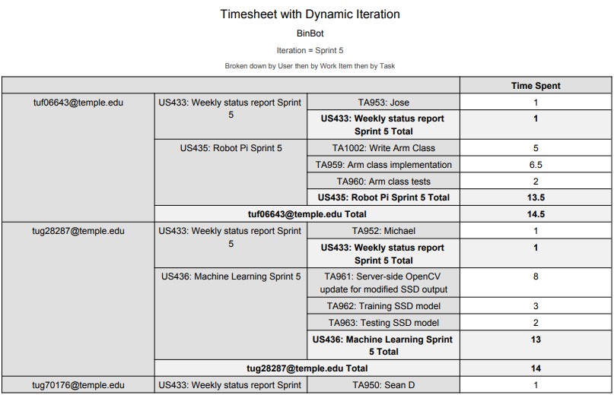

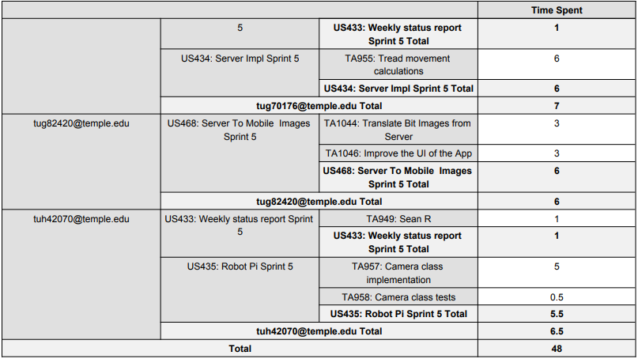

# Sean Reddington

# Overview

For sprint 5 I worked on interfacing the robot kit’s camera with the server. While I was able to retrieve pictures from the camera using the Picamera library, I ran into some issues with format/protocol conversion so that the image can be read by the OpenCV class on the server program. The image can be sent to the server via the connection socket, but the structure still needs to be determined. I was only able to work on the camera implementations for about 5 and a half hours, due to being busy.

# Achievements in Last Week

* + User Story 435: TA957 (est: 8 hrs – act: 5 hrs)

- Implemented some of the robot kit’s camera interfacing, still work in progress

- Capture image from the Raspberry Pi’s camera

- Send it to the processing server over the socket

- Able to retrieve the image as an encoded .jpg or Numpy array

* + User Story 435: TA958 (est: 0.5 hrs – act: 0.5 hrs)

- Wrote unit test for Camera module

- Wrote tests for camera functionality

# Issues in Last Week

As mentioned in the overview, I ran into a roadblock trying to figure out the proper encoding required for the image to be processable by the Java OpenCV library. Because I had a busy week, I was also not able to dedicate as much time as expected this week.

# Goals for Next Week

Next week I plan to finish up the camera module then begin working on the integration for Demo 3. This includes testing the treads for navigating to the waste objects via server instructions and implementing the proximity sensor on the robot if necessary.

# Sean Digirolamo

# Overview

* Devised and wrote algorithm to calculate movements and navigate to trash based on trash x, y, height, width, and image Field of View
* Committed 10, spent 7

# Achievements in Last Week

* US433: Weekly status report Sprint 5
  + TA950: Sean D - Committed 1.0, Spent 1.0
* US434: Server Impl Sprint 5
  + TA955: Tread movement calculations - Committed 6.0, Spent 6.0
    - Devise algorithm, implement algorithm
    - Needed so that binbot can autonomously retrieve trash

# Issues in Last Week

* US434: Server Impl Sprint 5
  + TA956: Arm movement calculations
    - Arm movement calculations will no longer be performed by the server, and arm movements will be a set movement programmed in the robot, so this was not necessary to complete
    - This decision was made because we decided to use the sensor to calculate distance, and also because of the size of our robot

# Goals for Next Week

* US486: Robot Sprint 6
  + TA1113: Status code handling
* US487: Server Sprint 6
  + TA1109: Test Robot tread angling
  + TA1114: Bugfix json length getting cut off when sent to python

# Michael Savitski

# Overview

* Server-side implementation of intended SSD model completed for processing images sent by BinBot
* 14 actual hours spent versus 17 committed

# Achievements in Last Week

* Tasks completed las Sprint:
  + User story 433, task 952: Weekly status report. 1 hours committed, 1 hour spent.
  + User story 426, task 961: Server-side OpenCV update for modified SSD output. 8 hours committed, 8 hours spent.
  + User story 426, task 962: Training SSD model: 4 hours committed, 3 spent.
  + User story 426, task 963: Testing SSD model: 4 hours committed, 2 spent.
  + Server ready to use trained “Faster R-CNN” SSD model to identify trash objects in images sent by BinBot

# Issues in Last Week

* Tasks could not been complete last Sprint:
  + User Story 426, tasks 962 and 963. Current data set trash object images deemed insufficient for scope of project. New data set of more distinct trash objects with more diverse “contexts” (backgrounds / lighting environments) must be prepared

# Goals for Next Week

* Tasks moved from Project Backlog to Sprint Backlog:
  + User Story 488: task 1105, Create and augment new data set and prepare integration of COCO data set
  + User Story 488: task 1106, train Faster R-CNN model using completed new data set.
  + User Story 488: task 1107, continuously test output model checkpoints during and after training for object identification success

# Jose Silva

**Overview**

* For this week sprint I spent the majority of time working with the arm aspect of BinBot. BinBot will be able to pick up objects infront of it using its claw. The arm is controlled by four servos, I had to spend some time looking up how the servos were being controlled using the Adafruit library. I was able to complete the Arm class which will allow us to control the movements of the arm as well as the claw allowing it to open and close. More tests need to be done with the arm as to find the specific inputs for set_pwm() method which controls the servos and the amount of power needed to get a specific movement from the arm. At the moment we can get the arm to come out, close and open the claw, and then bring it back.
* Total working hours committed – 16 vs total working hours actually spent on project – 14.5

**Achievements in Last Week**

* Tasks completed las Sprint:
  + User Story 435: Robot Sprint (hours estimated: 3 vs actual hours spent: 5).
    - Task: Write Arm class
      * Was able to complete the arm class which controls the movements of the arm, claw, and moving it back into this place. This will allow BinBot to pick up objects in front of it.
  + Did some tests on the arm by inputting units and seeing how BinBot’s arm moved based on those units. Sometimes units were too much and arm moved faster than expected and vise-versa some units were too small and had little to no effect on the arm movement. (estimated hours .5 vs actual hours 2)

**Issues in Last Week**

* Tasks could not been complete last Sprint:
  + User Story 435: Robot Pi Sprint 5
    - Sensor class implementation task was not able to be completed time was spent working on the arm class
  + Raspberry Pi would disconnect from the hotspot and would pause work, this seemed to be a battery issue
  + Could not get the right parameters for pwm_set(channel, on, off) during this sprint thus the servos did not move as expected

**Goals for Next Week**

* Tasks moved from Project Backlog to Sprint Backlog:
  + User Story 486: Robot Sprint 6
    - Pick up object via server instructions
  + User Story 486: Robot Sprint 6
    - Send continuous image feed to server
  + Work on the Sensor class
  + Finish Arm implementation
  + Finish Arm tests

# Kwamina Thompson

# Overview

* Progresses in App User Interface
* Total working hours estimated was 9 hours and 9 hours was spent working

# Achievements in Last Week

* Tasks completed las Sprint:
  + User Story 468: tasks 1044 and 3 hours estimated vs 3 actual hours spent.
  + Development of feature is to make the app more easy for the user to use.

# Issues in Last Week

* Tasks could not been complete last Sprint:
  + User Story 468: task 1044 No Issue

# Goals for Next Week

* Tasks moved from Project Backlog to Sprint Backlog:
  + Helping in module set up for Machine Learning