Sean Reddington

CIS4331 Project

Phase 1:

a) E-R Diagram

b) Challenges

I had some trouble thinking of the best way to represent the admin/senior user monitoring. I also struggled a bit with the relationship cardinalities.

Phase 2:

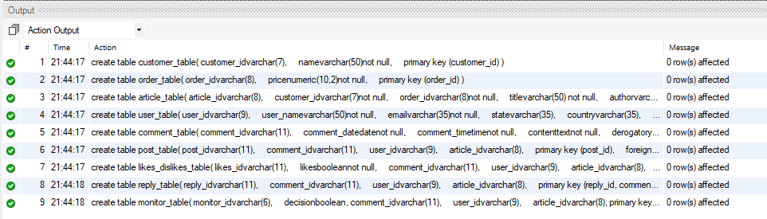

I had issues getting Microsoft SQL server to run on my desktop. I had to create the tables using CIS-Linux2’s MySQL server.