Hello Professor,

For my application, I chose a cookbook that can either add, read, update, or delete ingredients. As you will see below, in my index.html file, you will click the ‘select an option’ button, and you can choose between the options of create new ingredient, show all ingredients, update an ingredient, or delete an ingredient.

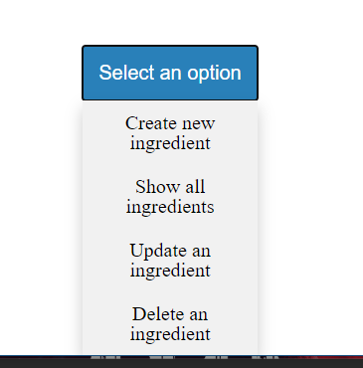

You can also create a new user with my username.html file. I have a simple HTML form that you can insert your username into.

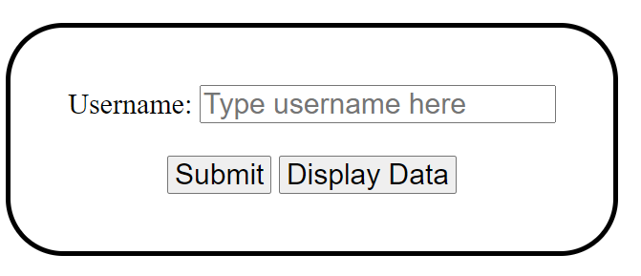

When you do these things, these changes will be added into my mongoDB. I will show in the following screenshots:

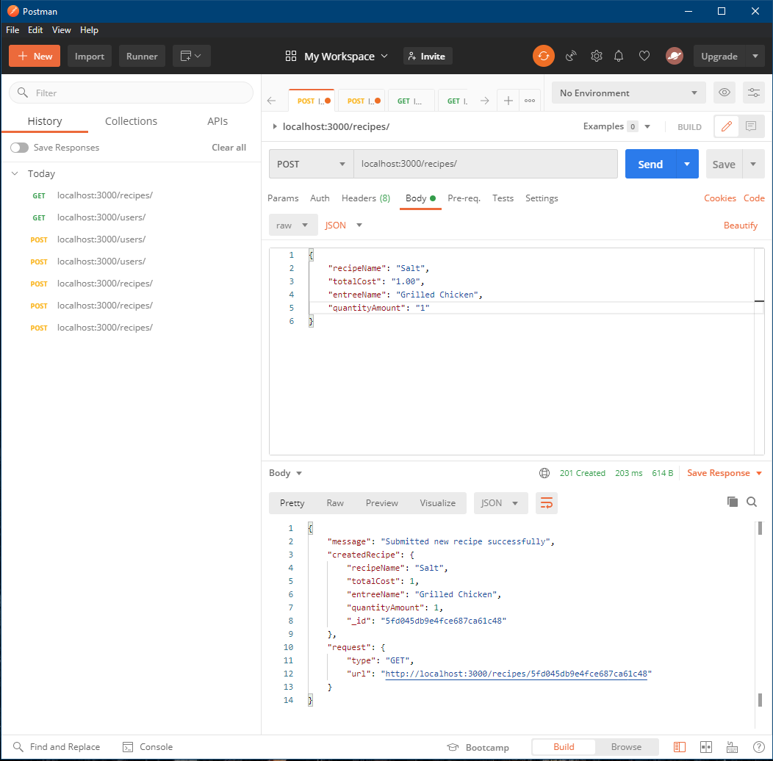

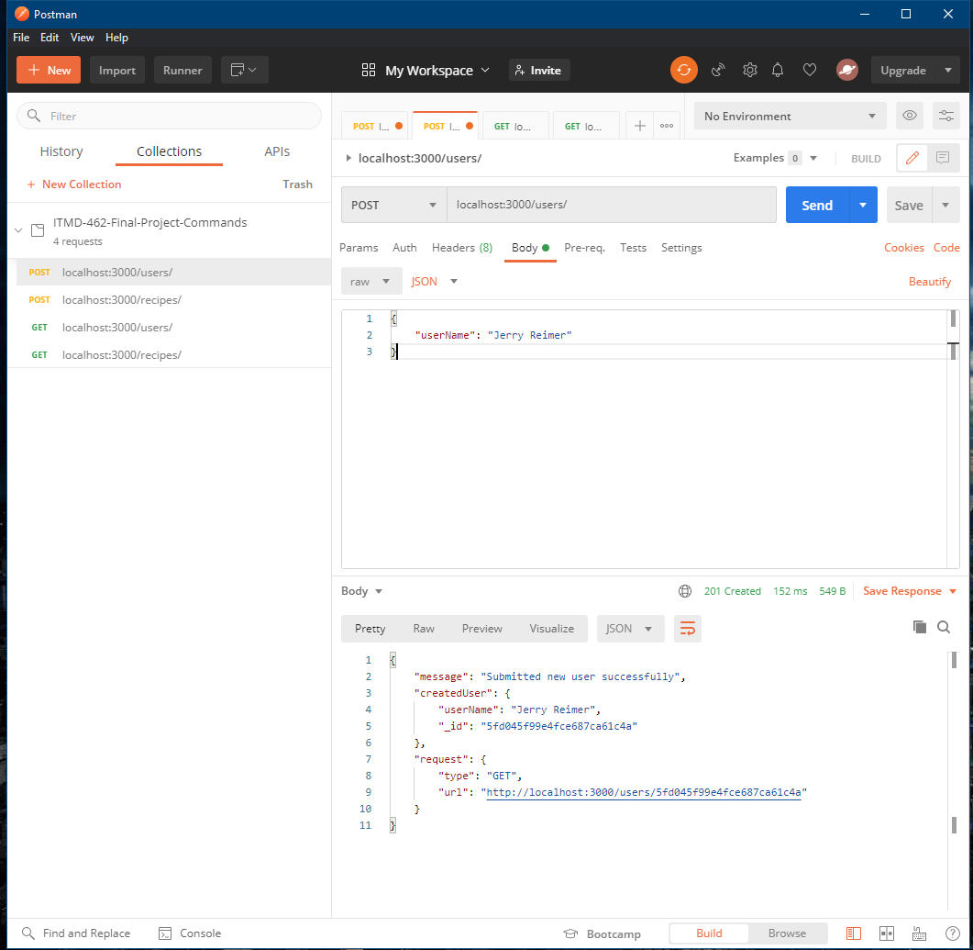

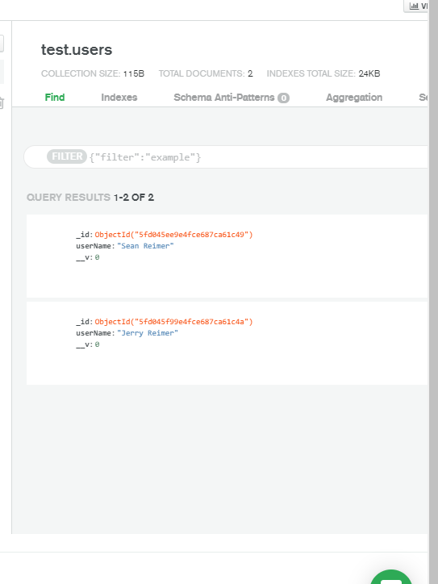

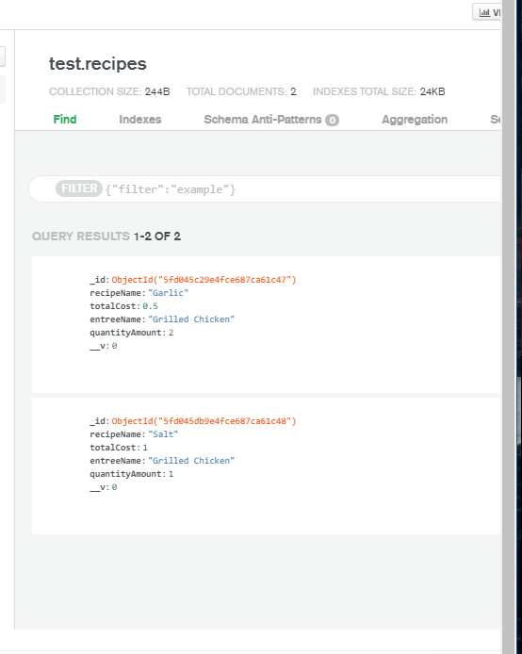

Here are examples of showing that inputting the wrong data will display an error prompt:

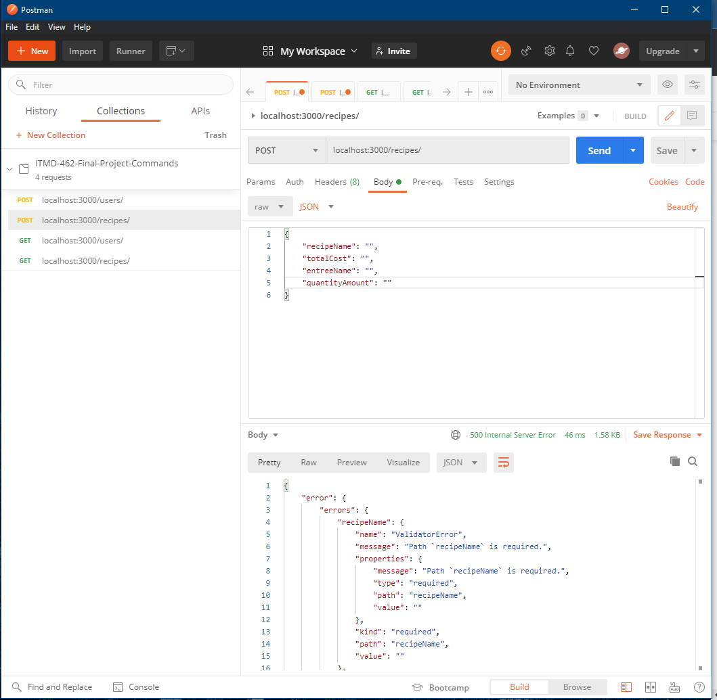

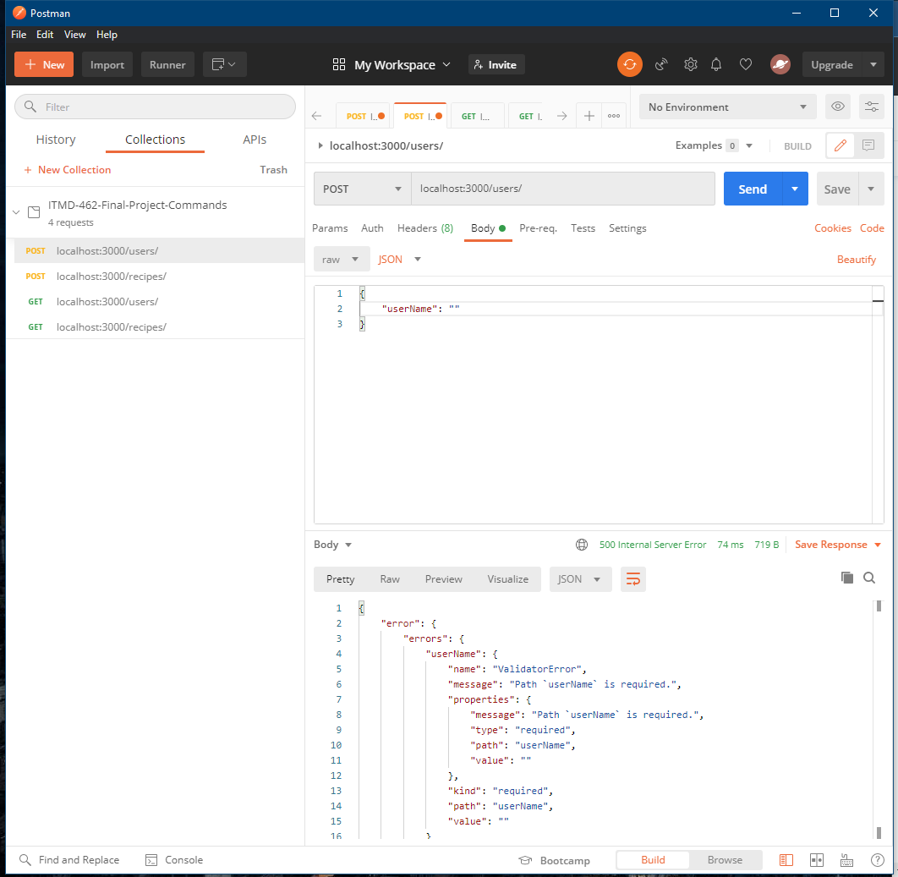

I hope this is a good brief summary of what my application does. I forgot what commands to use in postman for deleting and updating recipes/users, but the files are very similar to what we did in class, so I know they work 😊 Have a great winter break, professor!