**Statistical Thinking**

The formulation of a good research question is essential ***before*** beginning any research and associated data sourcing. It is a systematic process which needs to be carried out meticulously as any results could guide clinical decision making or business actions toward the larger customer base.

We can categorise research questions as:

**1.)** **Comparative** - comparing differences between two or more groups

*"Is there a difference in 0-3 year survival between elec-only customers who joined the Rewards Club at sign-up and those who never joined it?"*

Dependent variable: customer survival

Groups: elec-only customers that joined the Rewards Club at sign-up, elec-only customers who never joined the Rewards Club.

*"Is there a difference in first cycle 12-month contract renewal rates between Dublin-based Rewards Club customers that received complimentary theatre tickets along with the standard renewal call and those that received the renewal call only?"*

Dependent variable: 12-month contract renewal rate

Groups: First cycle 12-month dual-fuel contract customers in Rewards based in Dublin with complimentary tickets, first cycle 12-month dual-fuel contract customers in Rewards based in Dublin without complimentary tickets.

**2.)** **Causal** - investigating if a variable causes one or more outcomes; cause-and-effect inference; relationship research

*"What is the relationship between take-on channel and new customer survival to Q4 of tenure?"*

Dependent variable: customer survival

Independent variable: time

Strata: take-on channels

Groups: new customers from each take-on channel

**3.)** **Descriptive -** describing something

*"What is the average customer lifetime value for elec-only customers that signed up through the Bonkers channel?"*

Variable: customer lifetime value

Group: elec-only customers via Bonkers

*"How much energy, on average, do residential gas BGE customers consume annually?"*

Variable: annual gas consumption (kWh)

Group: all BGE residential gas customers

*"What factors increase the risk of churn in BGE twin-fuel customers?"*

Dependent variable: risk of churn (e.g. a hazard ratio or odds ratio)

Independent variable(s): this is what we want to know

Group: all BGE twin-fuel customers

***Once we have a well formulated research question, an appropriate statistical analysis can be conducted***.

Examples of poor research questions:

*"Having a free boiler service stops churn."* - This is too broad because tenure has a large impact on churn. Also, *"stops"* is far too strong an effect to hope to uncover as some customers who receive boiler services will no doubt churn anyway.

*"GAA engagement in 2017 will reduce churn by 3,000 SAs."* - This is so broad that is impossible to measure and ignores the time-to-event nature of BGE customer survival data. Does it refer to Q4 renewals, Q8 renewals, churn at any point in tenure, contract renewals, or all of them? Is there a control? If not, no controls no conclusions.

Better versions of these research questions, that could be tested empirically, would be:

*"A free boiler service in Q4 of tenure reduces the risk of churn in BGE residential gas customers over a two-year study period."*

*"Over a 1-year study period, is there a difference in survival between rural Rewards Club customers who engaged with GAA in 2017 and those that did not, controlling for all other factors?"*

**Sampling methods**

***A sample is a subset of data that should reasonably mimic the population from which it was drawn***. In most cases, we cannot obtain data on the entire population of interest (e.g. smokers under 18 in the entire world).

In BGE, however, we can potentially calculate descriptive statistics for the entire population of interest (e.g. all BGE residential electricity customers). Remember that this population itself only makes up a sample of the wider population of electricity customers in the country of Ireland.

Obtaining a representative sample is an essential step in statistical research. It must be objective, and bias cannot be introduced. Common types of bias are:

* selection bias (convenience sampling)
* confirmation bias (sampler wants to prove they are correct)
* response-driven bias (response, non-response)

So how do we ensure an objective unbiased sample is taken? ***Randomisation and replication***. With these two Rs, you will not go far wrong. Randomisation reduces bias as each subject has an equal probability of being randomised into treatment/control groups. Replication increases reliability.

Another very important concept is that of ***initial conditions***. When conducting comparative research, for example, the only systematic difference between groups should be the treatment(s) of interest. Randomisation ensures this.

**Simple random Sampling**

An example would be randomly assigning 100 Dublin-based Rewards Club customers into a treatment group and 100 Dublin-based Rewards Club customers into a control group to trial a new loyalty offering and its effect on churn (i.e. customer survival).

**Stratified Sampling**

An example would be splitting new customer data by take-on channel and then performing simple random sampling on each split to obtain 500 customers from each channel. We could then carry out descriptive research on average lifetime value by channel with representative samples.

**Cluster sampling**

An example would be using each county in Ireland as a cluster and within each cluster randomly sampling customers.

Sample size is important and can impact *p*-values (i.e. statistical significance). Power testing determines an adequate sample size and should always be carried out if sample size is a concern.

**Correlation and Linear Regression**

Correlation

Correlation is used to measure ***the degree of association between two variables***. However, note that correlation does not imply causation. For causality to be inferred, a controlled experiment is required.

There are two measures of correlation.

Pearson’s and Spearman’s Rank Correlation Coefficients

Both measure the strength of association between two variables. Pearson’s is ***parametric*** whereas Spearman’s Rank is ***non-parametric***.

Both Pearson’s and Spearman’s give values between -1 (strong negative association) and +1 (strong positive association). Thresholds for weak, moderate and strong associations are somewhat arbitrary.

There are a few important differences you need to be aware of before you decide which, if any, is best for your data:

1. Pearson’s uses the actual observed values to calculate the correlation, but Spearman’s ranks the values and then calculates the coefficient using the ranks;
2. Pearson’s measures ***the strength of a linear association*** between two variables, whereas Spearman’s is not quite as restrictive and measures if there is an association ***assuming only a monotonic relationship***.
3. Pearson’s requires that both variables are continuous, whereas Spearman’s can be used for continuous and ordinal variables.
4. Pearson’s requires that both variables are approximately normally distributed in the population, whereas Spearman’s makes no such distributional assumptions. Both require that observations are a random sample from the population of interest.

A word of warning

Remember to always examine your data in a *scatterplot* before calculating a correlation. Not only will it allow you to assess the assumptions, but it also helps you spot outliers and discontinuities in the data.

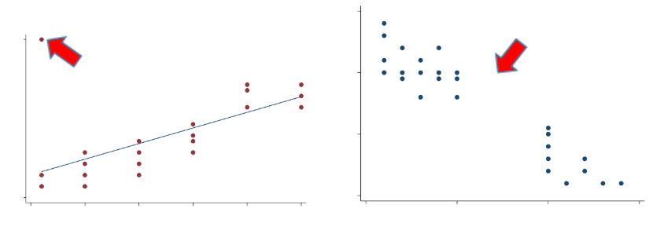

It does not matter which variable goes on the x- or y-axis when analysing correlation but it does matter when using linear regression (dependent vs. independent variable(s)).

Linear regression

Correlation tells you if you have a strong, moderate or weak association between two variables, but it doesn’t describe or quantify that relationship. If you want to quantify the impact of a change in one variable on another, you can use linear regression.

Previously, we looked at whether height was a predictor of lung function (the outcome or dependent variable). It’s natural to think of height as influencing lung function. It’s not always obvious when variables are measured at the same time-point which one is the outcome, and for these situations, it is something you will need to decide. Once you’re happy with your research question, you can proceed.

***Linear regression is simply a way of fitting an optimal straight line to your data***; it allows you to evaluate relationships and make predictions.

One way to fit an optimal straight line to the data is to minimise the sum of squared residuals, also referred to as the ***residual sum of squares*** (RSS).

– the value of the outcome variable

– the value of the predictor variable

– the intercept; the value of when the value of = 0

– the coefficient of the slope; the linear effect of the predictor on the outcome

– the error (i.e. residual) as the model is not expected to predict every *y* value exactly

Software such as R can be used to find *α* and *β*, such that ***the line minimises the squared distances between each observed value and the predicted regression line***. The units of the sum of squared errors (SSE) can be hard to interpret so the root mean squared error (RMSE) is used and is normalised to the units of the dependent variable.

Recall:

* *α* is the intercept of the straight line which is the value of the outcome where the line cuts the *y*-axis i.e. when the predictor equals 0;
* *β* is the slope, or the gradient, of the line and it quantifies the linear relationship between your two variables. ***It tells you how much, on average, your outcome variable increases for a one unit increase in your predictor***.

For the model to be valid, there are 3 key assumptions that need to be satisfied:

1. Linearity between outcome (*y*) and predictor (*x*) variables
2. The outcome variable is normally distributed across predictor values
3. The variance of outcome is the constant across predicted values

***If these assumptions hold, then your residuals are normally distributed with a mean of 0 and constant variance (i.e. homoscedasticity) across the predicted values.***

Residuals ~ Normal (0, *σ*2)

There are two useful plots that can help you assess model assumptions.

1. QQ plot (for assessing normally distributed residuals)

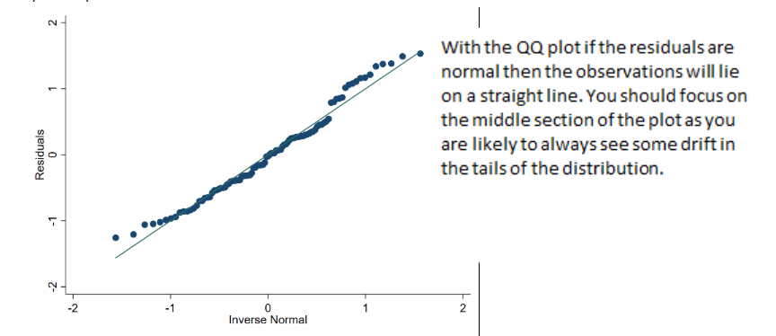

**2. Scatterplot of the residuals by the fitted regression values (for constant variance)**

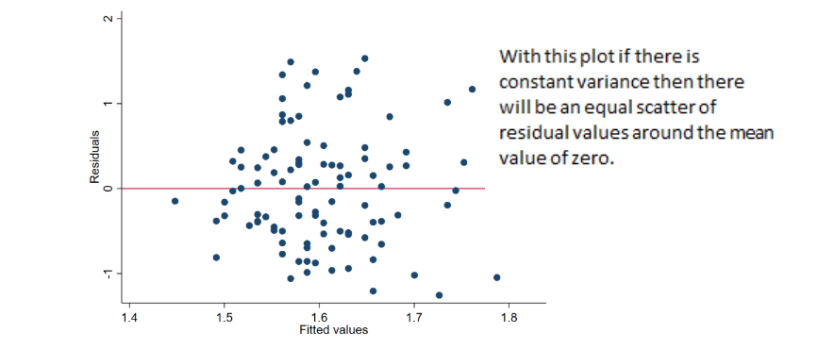

Multivariate linear regression (multiple linear regression)

The simple linear regression model can be extended to include multiple predictor variables:

*y* = *α* + *β*1*x*1 + *β*2*x*2 + ... + *β*p*x*p + *e*

Remember that this slightly alters your interpretation of the *α* and *β* coefficients.

* *β*1 is now the average change in *y* for every one unit increase in *x*1 keeping *x*2 held constant;
* *β*2 is the average change in *y* for every one unit increase in *x*2 keeping *x*1 held constant;
* And so on for *p* predictors.

You can investigate ***collinearity*** amongst the predictor variables, another important consideration in linear regression, by examining the correlations between pairs of independent variables or through ***variance inflation factors*** (VIFs).

Correlations are limited to only examining pairwise relationships. Correlations don’t allow you to identify dependence amongst three or more predictors. The variance inflation factor can help you identify the collinearity in this situation. ***The VIF quantifies how much the variances of coefficients are inflated by***, ***so each coefficient will have a VIF***. VIFs equal to 1 indicate no collinearity amongst the predictors in the model, values above 4 would prompt further investigation, and anything above 10 would indicate serious issues of collinearity. There are some situations in which you don’t need to worry about collinearity, but it is always important to check.

Good practice steps to develop a multivariate linear regression model are:

1.) ***Inspect your variables using summary statistics, histograms for continuous variables and frequency tables for categorical variables. Normal distributions and non-zero variance are important.***

This helps you identify and quantify the amount of missing information. It also helps you spot any strange or outlying observations. If you do spot any strange values, you will need to decide what to do with them before you move on.

2.**)** ***Examine the relationship between your candidate predictor variables using cross tabulations for categorical variables and pairwise correlations and scatterplot matrices for continuous variables.***

This helps you identify potential associations across your candidate predictor variables that could be problematic if included together in your multivariate model.

3.**)** ***Fit a simple linear regression model between the outcome and each of your candidate predictor variables.***

This allows you to assess the relationship between each of your candidate predictor variables and the outcome variable. Again, this helps to spot errors in either the data or the coding, and it also allows you to anticipate what you might expect to happen when you fit the multivariate model. Any lack of change in most of the coefficients between the simple models (save the coefficients for comparison) and the multivariate model should reassure you that collinearity is unlikely to be a problem in the multivariate model. This can also be explored by examining the VIFs.

Once you’ve taken these steps, you’re in a much better position to start thinking about building a multivariate regression model for production or reporting. Just like simple linear regression with one covariate, in multivariate regression the best coefficients are selected to minimise the SSE.

To summarise**, *it’s important that you get to know your data well before you start modelling***.

Below is an example analysis of VIFs.

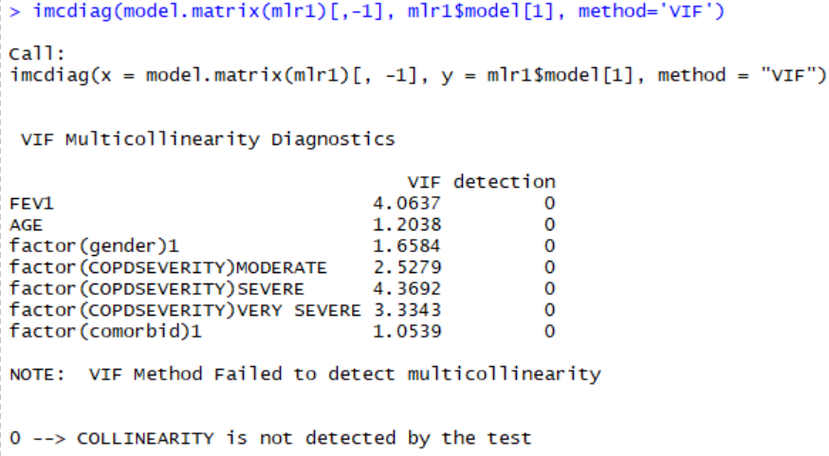

This suggests potential problems with FEV1 and COPDSEVERITY, and in fact it does not seem unreasonable that FEV1 (a measure of lung capacity) and COPDSEVERITY rating might be associated. A decision needs to be made about which covariate to keep in the model. It is important to check univariate coefficients and how they change in the multivariate model.

***Regression models don’t always have to assume that predictor effects are additive. Instead predictor effects can depend on each other (i.e. there can be interactions between predictors).***

As an example, we can look at the effect of an interaction between two binary predictor variables, atrial fibrillation and diabetes on walking distance:

MWT1best = *α* + *β*1∗Diabetic + *β*2∗AtrialFib + *β*3∗Diabetic∗AtrialFib

where:

Diabetic = 0 if diabetes not present, 1 if present; (it is always good to use 0 for the absence case)

AtrialFib = 0 if atrial fibrillation not present, 1 if present;

Diabetic*AtrialFib = 0 if diabetes or atrial fibrillation are not present, and 1 if diabetes and atrial fibrillation are present.

To fit this model in R you first need to create the Diabetic*AtrialFib variable.

Note: R will not be able to create this new variable if the Diabetes and AtrialFib variables are saved as factors. They therefore need to remain/be changed to integers. You can do this using the as.integer() function:

You can create the new variable using the R code:

DAF <- COPD$Diabetes * COPD$AtrialFib

You can then code for the regression, using the command:

r1 <- lm(MWT1Best ~ factor(Diabetes) + factor(AtrialFib) + factor(DAF), data = COPD)

You can view the regression using the function summary(r1) and the confidence intervals using the command confint(r1).

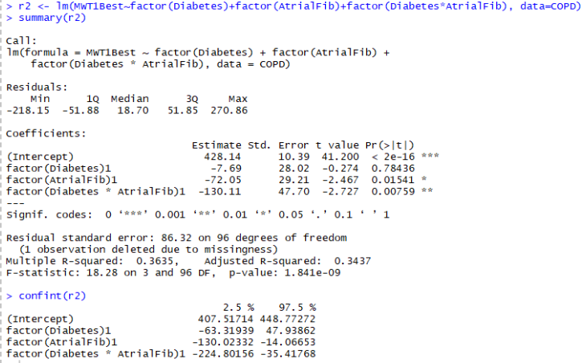

which equates to:

MWT1best = 428.1 − 7.7∗Diabetic −72.0∗AtrialFib − 130.1∗(Diabetic∗AtrialFib)

This can be interpreted as follows:

A person with diabetes and no atrial fibrillation has an estimated average walking distance of 420.4 metres.

MWT1best= 428.1 − 7.7∗Diabetic

= 428.1 − 7.7

= 420.4

A person with atrial fibrillation and no diabetes has an estimated average walking distance of 356.1 metres.

MWT1best = 428.1 − 72.0∗AtrialFib

= 428.1 − 72.0

= 356.1

A person with both diabetes and atrial fibrillation has an estimated average walking distance of 218.3 metres. ***Include all coefficients in the equation!***

MWT1best =

428.1 − 7.7∗Diabetic − 72.0∗AtrialFib − 130.1∗(Diabetic∗AtrialFib)

= 428.1 − 7.7 − 72.0 − 130.1 = 218.3

Now look at the model with the interaction effect of having IHD and diabetes. First, fit the model without the interaction effect: MWT1best = *α* + *β*1∗Diabetic + *β*2∗IHD

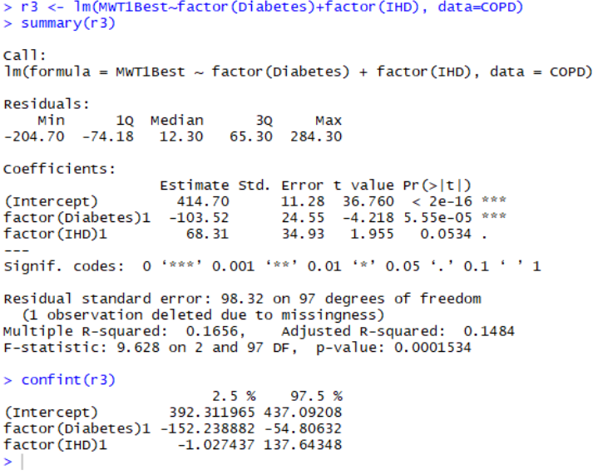

Now, you might suspect that the predictive effects of diabetes and IHD depend on each other. You can investigate this by including the interaction term:

MWT1best = *α* + *β*1∗Diabetic + *β*2∗IHD + *β*3∗Diabetic ∗ IHD

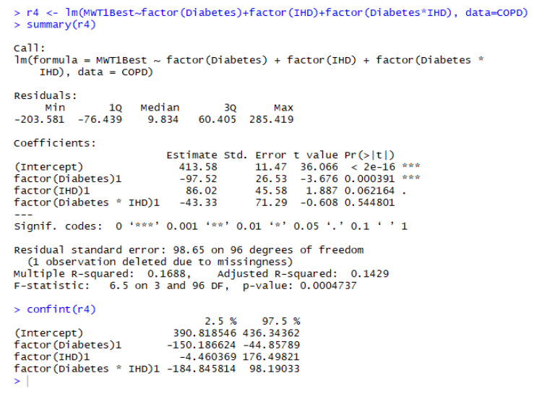

The effect of the interaction term in this model has been far less dramatic on the regression coefficients. This suggests the lack of an association between IHD and diabetes. In fact, there is no evidence of an interaction effect between IHD and diabetes.

Finally, a measure of model quality is *R*2. This represents the variance in *y* explained by the variance in *x*. It compares the fitted model to a baseline model where all values of the covariates equal zero (i.e. the line is horizontal through the plotted data at the mean of *y*). *R*2 is unitless and reveals the value that a model adds in reducing the squared errors. Adjusted *R*2 is better to use when the model is multivariate but be careful not to add too many covariates as this can lead to overfitting.

**Survival Analysis**

Our final chapter concerns models for the analysis of data which have three main characteristics: (1) the dependent variable or response is the waiting time until the occurrence of a well-defined event, (2) observations are censored, in the sense that for some units the event of interest has not occurred at the time the data are analysed, and (3) there are predictors or explanatory variables whose effect on the waiting time we wish to assess or control. We start with some basic definitions.

**KEY CONCEPTS**

* Define the branch of statistics known as survival analysis
* Explain when it is valid to use survival analysis
* Run the Kaplan-Meier plot and log-rank test in R and interpret the results

Survival analysis can be applied to studies that run over many months or years. The anatomy of a longitudinal study is comprised of a planning phase, a data collection (or enrolment) phase with a start and end date, a follow-up date (end of study; usually sometime after follow-up) and a data analysis phase.

We are mainly interested to know when a particular outcome has occurred over the study period. The **“if”** and the **“when”** rather than just the “if” as with logistic regression and classification techniques.

Examples of outcomes survival analysis deals with:

* Time to onset of speech from birth
* Time to cancer relapse
* Time to hospital discharge after a kidney transplant
* Time to customer churn
* Time to mechanical failure of an instrument

**Life tables: the basics**

Life tables are used to measure the probability of death (or the event occurring) at a given age (or time) and the life expectancy at varying ages/times. Actuarial science and of course life insurance companies need to know this in detail, but we in public health do too. There are two different kinds of life table:

* Cohort or generational life tables
* Current or period life tables

Cohort life tables take an actual set of people born at the same time, usually in the same year or even on the same day of the same year and follow them up for their whole lives. Several countries, including Norway, Denmark and the US, have these “birth cohorts” such as the Millennium Cohort Study in the UK that follows up people born in 2000. The mortality experience of such a cohort teaches us a lot and is great for history, but it’s unlikely to be completely relevant to people born at other time points.

Period life tables take a hypothetical cohort of people born at the same time and uses the assumption that they are subject to the age-specific mortality rates of a region or country. These rates are often calculated using census data as the base population and actual age-specific death rates during the census year (and typically also one year either side).

How are life tables constructed? In a common type of epidemiological study called **a cohort study**, a set or cohort of patients are enrolled at time zero and then followed up to see who gets the outcome of interest, such as death, and when they get it. The latter will often be measured in days since the study start, but not necessarily. In theory you could measure it in milliseconds, but that’s silly unless you’re looking at something like biochemical reactions. At time zero, a table of the numbers of people with and without the outcome at each time point will look like this. Let’s suppose that we start off with 100 patients.

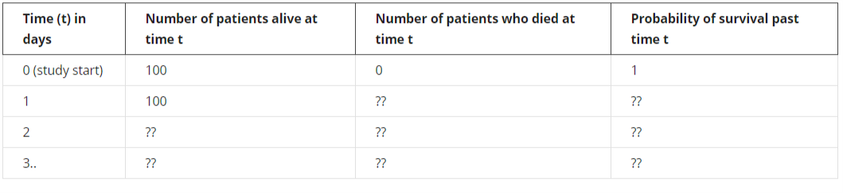Everybody makes it past time zero, so the probability of surviving at least to time *t* = 0 is 1, or 100%. This probability is technically known as the **survival function**, one of two core concepts in survival analysis. The survival function uses the cumulative survival probability.

Let’s now say that two people die the day after they are enrolled. The life table then looks like this:

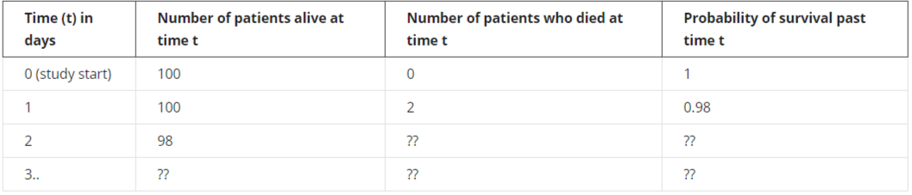

The calculations continue in that way. However, this assumes that everybody enters the study at the same time, *t* = 0, and no one leaves it except by death. It ignores the more realistic case when people drop out or are “lost to follow-up”. The technical term for this is that these people are **censored**. Censoring is an important concept in survival analysis. There are different forms, but the type due to people dropping out – or when people are still alive at the study end – is the most common (this is called right-censoring). The Kaplan-Meier table and associated plot is the simplest (but not the only) way of estimating the survival time when you have drop-outs.

**How to calculate a Kaplan-Meier table and plot by hand**

The plot of the survival function versus time is called the survival curve. The Kaplan-Meier method can be used to estimate this curve from the observed survival times without the assumption of an underlying probability distribution (it is, therefore, *non-parametric*). Other kinds of survival analysis such as Weibull do require estimating the underlying distribution for the survival times. One reason why the KM method is so popular is that it doesn’t make any such assumptions. **Whenever you make assumptions in statistics, you must test whether they are valid**.

To better understand the Kaplan-Meier method we’ll now use it to draw a survival curve. Let’s suppose we are monitoring patients after a treatment. After 5 days of follow-up we have the following information (example adapted from [https://www.ncbi.nlm.nih.gov/pmc/articles/PMC1065034](https://www.ncbi.nlm.nih.gov/pmc/articles/PMC1065034/)).

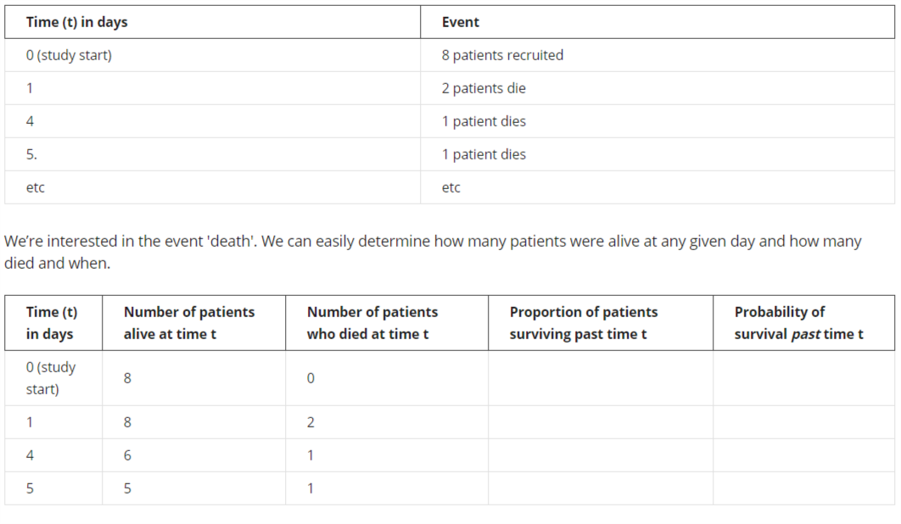

But how do we compute the probability of survival past time *t*? Start by computing the proportion of patients that survive day, i.e. of those alive at the beginning of day *t*, what proportion make it to the next day alive? On day 0, the day the study begins, there are no deaths. Everybody survives. Hence the proportion surviving is 1. On the following day, 2 out of 8 patients don't make it; in other words, 75% survive the day. The wording is thus “***the probability of surviving past 1 day is 75%***”.

Now we know the proportions, but what are the probabilities? With no deaths on day 0, the probability of surviving is 1. Computing the next probability is a bit trickier. The basic idea underlying Kaplan-Meier tables comes into play here: the probability of surviving past day *t* is simply the probability of surviving past day *t*-1 times the proportion of patients that survive on day *t*. Let's see it together:

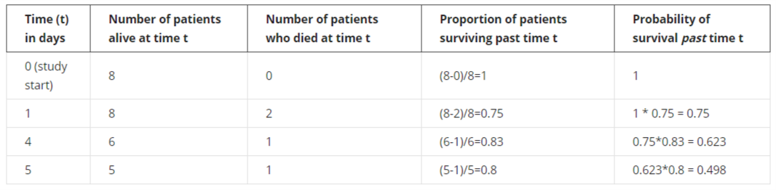

Adding more of the data, we now have some drop-outs, i.e. patients whose outcome we don't know exactly. These patients are censored and should be treated differently from patients that die. When a patient is censored at time *t*, we know the patient was alive at time *t*, but we don't know whether the patient has died or survived since then. For this reason, censored patients are classified neither as survived nor as died on any given day. We simply deduct them from the number of patients alive at the next time-point. When there are censored patients at the same time as patients that die, we deal first with patients that die. Then we add a new line, mark it with a little “+” right after the time count and denote the censored patient(s) by taking them off the count of patients alive at time *t*.

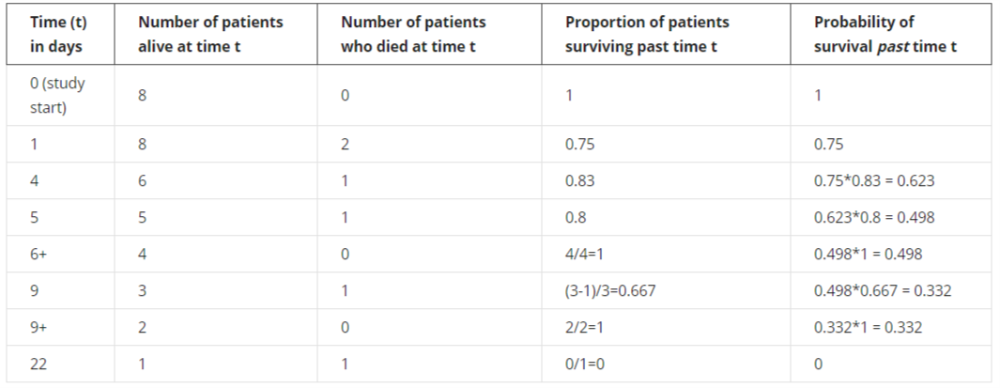

At time *t* = 6 and *t* = 9, we need to subtract one person from the risk set, the number of patients at risk of death. For *t* = 6, for instance, 4 people enter that time period, but one drops out, leaving 3 to go forward to *t* = 7, which means that at the time of the next death, *t* = 9, the proportion of patients surviving is (3 - 1) / 3.

At times when no one dies, the proportion surviving that time point is 1, or 100%, so the (cumulative) probability of survival past time *t* in the last column is unchanged.

At the last time point, *t* = 22, there's only one person left in the risk set, i.e. only one person who we're still following up, and they then die, giving a final probability of survival beyond *t* = 22 of zero.

**Results of the interpretation of log-rank test for gender**

The log-rank test compares the survival time by gender. It’s the most popular method of comparing the survival of patient groups that takes the whole follow-up period into account. Its big advantage is that you don’t need to know anything about the shape of the survival curve or the distribution of survival times. It’s based on a comparison of the observed numbers of deaths and the numbers of deaths expected if in fact there were no difference in the probability of death between the groups (genders in this case) and uses a chi-squared test.

If the resulting *p*-value is high, there’s no good evidence of a difference between the groups in their survival times.

**The Hazard and Survival Functions**

Let *T* be a non-negative random variable representing the waiting time until the occurrence of an event (i.e. the time to the event). For simplicity we will adopt the terminology of survival analysis, referring to the event of interest as “death” and to the waiting time as “survival” time, but the techniques to be studied have much wider applicability. They can be used, for example, to study age at marriage, the duration of marriage, the intervals between successive births to a woman, the duration of stay in a city (or in a job), or the length of life of any organism.

**The Survival Function**

We will assume for now that *T* is a continuous random variable with probability density function (p.d.f.)  and cumulative distribution function (c.d.f.) , giving the probability that the event has occurred by duration *t*.

It will often be convenient to work with the complement of the c.d.f, the **survival function**

which gives the probability of making it past time *t*, or more generally, the probability that the event of interest has not occurred by time *t*. A simpler equation for the survival function is

where is the number of events at time *t* and is the number of subjects at risk of experiencing the event at time *t*. is the survival probability at one time-step before time *t*. The survival function calculates the cumulative survival probability at any time.

**The Hazard Function**

An alternative characterisation of the distribution of *T* is given by the**hazard function**, or **instantaneous rate of occurrence of the event**, defined as

The numerator of this expression is the conditional probability that the event will occur in the interval [*t*, *t* + *dt*) given that it has not occurred before, and the denominator is the width of the interval. Dividing one by the other we obtain a rate of event occurrence per unit of time. Taking the limit as the width of the interval goes down to zero, we obtain an instantaneous rate of occurrence.

The conditional probability in the numerator may be written as the ratio of the joint probability that *T* is in the interval [*t*, *t* + *dt*) and *T* ≥ *t* (which is, of course, the same as the probability that *t* is in the interval), to the probability of the condition *T* ≥ *t*. The latter is *S*(*t*) by definition. Dividing by *dt* and passing to the limit gives the useful result

which some authors give as a definition of the hazard function. In words, the rate of occurrence of the event at time *t* equals the density of events at *t*, divided by the probability of surviving to that duration without experiencing the event.

These results show that the survival and hazard functions provide alternative but equivalent characterizations of the distribution of *T*. Given the survival function, we can always differentiate to obtain the density and then calculate the hazard. Given the hazard, we can always integrate to obtain the cumulative hazard and then exponentiate to obtain the survival function.

**Expectation of Life**

Let µ denote the mean or expected value of *T*. One would calculate µ multiplying *t* by the density  and integrating, so

Integrating by parts, and making use of the fact that *−f(t)* is the derivative of *S(t)*, which has limits or boundary conditions  and , one can show that

In words, the mean is simply the integral of the survival function. The median survival time is the point on the x-axis corresponding to a survival probability of 0.5. This is the time by which 50% of the subjects had experienced the event of interest.

**A Note on Improper Random Variables**

So far, we have assumed implicitly that the event of interest is bound to occur, so that . In words, given enough time the proportion surviving goes down to zero. This condition implies that the cumulative hazard must diverge, i.e. we must have Λ(∞) = ∞. Intuitively, the event will occur with certainty only if the cumulative risk over a long period is sufficiently high.

There are, however, many events of possible interest that are not bound to occur. Some men and women remain forever single, some birth intervals never close, and some people are happy enough at their jobs that they never leave. What can we do in these cases? There are two approaches one can take.

One approach is to note that we can still calculate the hazard and survival functions, which are well defined even if the event of interest is not bound to occur. For example, we can study marriage in the entire population, which includes people who will never marry, and calculate marriage rates and proportions single. In this example *S(t)* would represent the proportion still single at age *t* and *S(∞)* would represent the proportion who never marry.

One limitation of this approach is that if the event is not certain to occur, then the waiting time *T* could be undefined (or infinite) and thus not a proper random variable. Its density, which could be calculated from the hazard and survival, would be improper, i.e. it would fail to integrate to one. Obviously, the mean waiting time would not be defined. In terms of our example, we cannot calculate mean age at marriage for the entire population, simply because not everyone marries. But this limitation is of no great consequence if interest centres on the hazard and survival functions, rather than the waiting time. In the marriage example we can even calculate a median age at marriage, provided we define it as the age by which half the population has married.

**The Cox Proportional Hazards Regression Model**

Last week you calculated survival probabilities and worked through the steps involved in the Kaplan-Meier method. This week you’ll learn about the more flexible Cox proportional hazards model. With this method you will be able to compare the survival of multiple groups of patients at the same time. With the Kaplan-Meier estimator, only univariate analysis of survival can be carried out. However, as Cox PH is a regression model, we can explore the effect of multiple covariates on survival.

Like the name suggests, the model is formulated around the concept of hazards. You’ve already seen examples of the hazard function and the hazard can vary over time. The hazard function *h(t)* is the probability of the event happening at time *t*, given that it has not yet happened.**In other words, *h(t)* is the probability of dying at time *t* having survived up to time *t.*** While the concept sounds straightforward, there’s no easy formula to compute *h(t)* by hand. If you are comfortable with formulae, you can follow this link to an article explaining the hazard function <http://data.princeton.edu/wws509/notes/c7s1.html>

An important concept involved in the calculation of the hazard is the risk set. Just like the risk of dying (or experiencing some specific event) changes over time, so too does the number of patients that are subjected to that risk change over time as people die or drop out. **The risk set at time *t* is defined as the set of patients at time *t* that are at risk of experiencing the event.**You saw this in the earlier calculations for the Kaplan-Meier method when we made a risk set adjustment for patients who dropped out. Survival analysis consists of a family of methods, and one way that they differ is in their handling of drop-outs and other issues when they define the risk set.

Usually in survival analysis, we are interested in the difference between survival curves of different groups of patients. Earlier you saw the log-rank test, which gives a *p*-value for comparing the survival curves between different groups of patients with a Kaplan-Meier plot. The *p*-value tells you nothing about the size of the difference between the survival curves, however. This is done by dividing one hazard by another to give a hazard ratio. For example, dividing the hazard for females by the hazard for males gives you a hazard ratio for females compared with males. It tells you how much more likely female patients will die than male patients (i.e. a relative risk ratio).

I’ll now introduce you to the Cox model and explain how its hazard and hazard ratios work. This week you’ll get to know the most commonly used survival analysis method for incorporating not just one but multiple predictors of survival: Cox proportional hazards regression modelling. You’ll learn about the key concepts of hazards and the risk set. From now and until the end of this course, there’ll be plenty of chances to run Cox models on data simulated from real patient-level records for people admitted to hospital with heart failure. You’ll see why missing data and categorical variables can cause problems in regression models such as Cox.

**KEY CONCEPTS**

* Define a hazard in the context of survival analysis
* Run a simple Cox model in R and interpret the output
* Select and apply appropriate methods to formulate and examine statistical associations between variables within a data set in R

**Missing data in survival analysis**

Missing data are a common problem in research. The conclusions of analyses where the data are complete can be very different from analyses with incomplete data. How do you make sure your analysis yields the correct conclusion, even though the data are not complete?

First, **you need to understand why some data are missing**. This is important, because the techniques you decide to apply depend on the reason some data are missing. Be aware that there is no statistical test telling us why the data are missing. This is done by combining reason and knowledge on how the data were collected. Something I’ve emphasised throughout this course and the previous ones in the series is that **there is no substitute for getting to know your data**. Part of this is by tabulation and histograms etc., but another key part of it comes before any descriptive analysis – **knowing how the data were generated** and the potential for missing or invalid values in each data field. Let’s now recap patterns of missingness.

We say that data are “missing completely at random” (MCAR) when the complete cases (patients without any missing values for a given data item) are a random sample of the whole dataset (all patients). One patient is just as likely to have missing values as any other patient: males just as likely as females, older patients just as likely as younger ones, and so on. This can happen when a participant didn't have time to fill out the questionnaire or some information was lost or misplaced - and none of these things happened in a systematic way. This is the easiest situation to deal with, though sadly it’s often rather an unrealistic assumption.

More often, you’ll have to deal with data that are “missing at random” (MAR). In this case, missingness can be explained by other variables for which there is full information. For example, if people with a higher education are less likely to disclose their income, then income is MAR because the chance of income values being missing depends on the patient’s education. In this situation, which is common, you can predict the missing values on the basis of another variable, so if you know their education you can predict their income well. Statistical methods exist to deal with this that are beyond the scope of this course, though I’ll list them briefly below.

Finally, data that are “missing not at random” (MNAR) are neither MAR nor MCAR. For example, you could be missing medical information on the severity of diabetes when they are too ill to see a doctor and provide that information; missingness depends partly on the diabetes status, as is the case for MAR, but it also depends on the severity of illness, which can’t always be captured. In general, data are MNAR when the missingness is specifically related to what’s missing and so the probability of the value being missing depends on unobserved variables, i.e., variables not in your data set. This is generally the most problematic type.

Now that we know what we are talking about when we say missing data, we can have a look at different methods for dealing with incomplete data. Luckily, you only need to understand the general idea and pick the right tool, as the computer will do rest of the work. Here are some of the most used techniques for handling missing data.

**Complete case analysis**

In this approach, the cases with missing data are simply omitted from the analysis. **If the data are MCAR, this will produce unbiased estimates if the sample size is still sufficiently large**. If the data are MAR or MNAR, the estimates will be biased. That’s a good reason why you need to understand the reason for the missing values. It’s tempting to just hope they’re completely random, but you need to think through the problem, run some descriptive analyses and ask the data provider if necessary and possible.

**Mean/median substitution (or mean/median imputation)**

Replace (“impute”) the missing values of a variable with the mean or median of the available values of the same variable. For example, if some male patients are missing values, then just assign them the overall mean value for the male patients who do have values. **This has the advantage of not changing the overall mean for that variable**. However, **it artificially decreases the estimated variation**. It also makes it difficult to detect correlations between the imputed variable and other variables. Hence mean/median substitution always gives biased results and is not recommended.

**Multiple imputation**

Missing variables are assumed to be MAR (or MCAR) and are imputed by drawing from a distribution. This is done multiple times and yields multiple different completed datasets. Each of these datasets is analysed, and the results are combined into a single overall result. **Multiple imputation has been shown to yield unbiased results for MAR or MCAR data**. It can be done in R.

**Maximum likelihood**

**This approach also gives unbiased results for MAR (or MCAR) data**. Data are assumed to be normally distributed with a certain (multivariate) mean and variance. Observed data are used to compute the mean and variance, and missing data are drawn from the resulting normal distribution. We draw many times from the distribution **until the mean and variance of the completed data are as close as they can get to that of the observed data**. Fortunately, you don't have to do that yourself. There are many packages that can do that for you in R!

You may have noticed that I’ve not suggested any approach for MNAR data. This is because **MNAR data need to be handled on a case-by-case basis**.

<https://www.ncbi.nlm.nih.gov/pubmed/17538078>

<https://www.ncbi.nlm.nih.gov/pmc/articles/PMC3668100/>

Having run the Cox model with just one predictor and become acquainted with its code and output, you’ll want to move on to include multiple predictors in a multiple Cox regression model. As you saw with ethnic group, which had both missing values and some small categories, including one for “unknown”, leaping in and running the model without looking at the variables is hazardous.

You’ll extend the simple Cox model to the multiple Cox model. As preparation, you’ll run the essential descriptive statistics on your main variables. Then you’ll see what can happen with real-life public health data and learn some simple tricks to fix the problem.

**KEY CONCEPTS**

* Explain and run a multiple Cox model in R and interpret the output
* Assess the potential effect of correlated variables on modelling
* Describe a given data set from scratch, including data item features and data quality issues, using descriptive statistics and simple graphical methods as a necessary first step for more advanced analysis using R software
* Test for non-convergence in a regression model and fix the problem
* Recognise that approaches other than Cox PH exist for survival analysis

This next activity does essential preparation for running a multiple Cox regression model.

Earlier you loaded the data set for the course and ran Kaplan-Meier analysis and then simple Cox regression, but you only looked at the outcome variable – death – and a single predictor – age and then ethnic group. The latter had some missing values. Now we want to incorporate more variables into the Cox model, so we need to summarise each of them first, to see if they too have any hidden traps.

If you took the earlier courses in this specialisation on linear and logistic regression, you'll be familiar with the concept of a "multiple regression model" - it's just an extension of a simple regression model to incorporate multiple predictors. When you have a choice of predictors to include, things get complicated - later in this course, you'll look at why this can be a problem and what to do about it. For now, let's just say you want to fit a model with five predictors because **you have good prior knowledge that they're important**. Once you've decided which predictors to try, it's very easy in R to enter them into a model, whether that's Cox or any other kind of regression model.

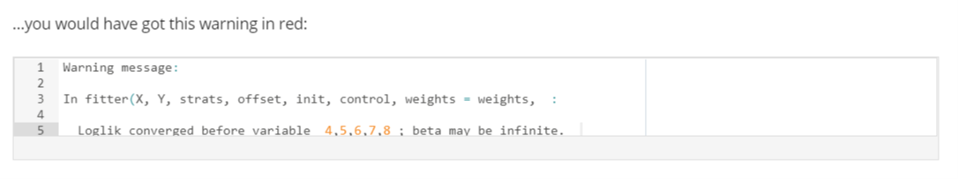

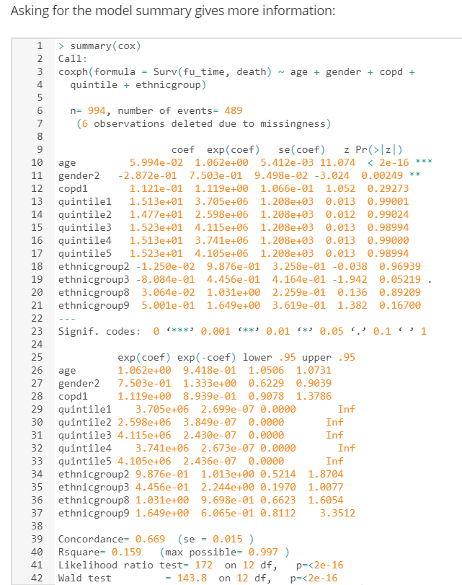

This is a disaster. The coefficients and particularly the standard errors for quintile are all huge. A couple of the standard errors for ethnic group are a bit high, but the main problem is quintile. It seems to have infinitely wide CIs. Why?

Only four patients have quintile zero. This means invalid quintile, for instance when the postcode (zip code) can’t be mapped to a small geographical area and therefore to a socio-economic status measure. Four patients in a category can sometimes be enough to get the model to work, but there’s another problem. Of those four patients with quintile zero, not one died. That itself might not be a problem, but we’ve let R choose the reference category by default, and it’s chosen quintile zero. All the other five hazard ratios are relative to this tiny group of patients in which no one died. It’s not surprising that the algorithm couldn’t come up with sensible HR estimates. Remember, R uses the lowest integer as the reference group if the covariate is encoded or discrete.

How can you fix this?

**1) Change the reference category**

By default, R sets the first (or lowest) category to be the reference. With quintile taking on values from 0 to 5 and 0 having very few patients in it, 0 is an awful choice of reference category. The first thing to try is to set the reference one to something else. As quintile measures socio-economic status or deprivation, and you're usually interested in the effect of lower status (or greater deprivation in UK terminology) compared with higher status, it makes sense to set higher status, quintile = 1, as the reference category.

**2) Combine categories**

If that doesn’t work, then consider combining categories if it makes sense to do so. Quintile zero is an artificial category meaning that the patient’s postcode (zip code) or other small geographical area identifier was missing or could not be linked to the national socio-economic status file, i.e. the patient’s status is unknown. These patients are often different from the others, e.g. they are from overseas or are homeless, and that’s why they have no postcode or geographical area. It doesn’t make too much sense to combine them with any of the other five categories. However, in this case, this quintile zero group is so small compared with the other categories that combining them will have a negligible impact on the results.

**3) Exclude the patients**

This is the best option if combining categories doesn’t make sense and there are only a few patients in the problematic category.

**4) Drop the offending variable**

This will be the best option if combining categories doesn’t make sense and if there are too many patients in the problematic category for us to be comfortable dropping them all.

In practice, you may have to trade off one of these concerns against another, for example having to choose between combining categories that don’t fit well together and dropping an important variable from the model. **How much information is being lost or potentially distorted with each option?**

**Remember that the problem of non-convergence can happen in any kind of regression and that these simple tricks can also work there.**

**Alternatives to Cox regression**

In this course, I’m covering the two most commonly used survival analysis methods, Kaplan-Meier and Cox regression. These are popular largely because they are easy to run in standard software but mainly because you don’t need to make any assumptions about the shape of the baseline hazard function, the specific way that risk changes over time. There are, however, several other important types of methods for analysing such data. The example you’ve been using in this course concerns trying to predict mortality following admission for heart failure. Cox doesn’t care about the distribution of survival times or what the baseline hazard function looks like. Therefore, it’s called “semi-parametric”: it has some parameters – those of the predictors – but it has no parameters to describe the hazard function for patients with a value of zero for the predictors (i.e. patients with age zero and all the reference categories for the categorical variables). For completeness, the simple proportion alive at a given time point and the Kaplan-Meier estimate are examples of non-parametric survival analysis.

However, making assumptions about the shape of the baseline hazard function – adding parameters to the model to describe the shape, making the model “fully parametric” – can lead to better prediction. More accurate prediction of a patient’s survival time or risk of death within a given timeframe is vital for enabling the patient and his or her doctor and clinical team to make decisions regarding treatment. Risk models can put patients into, for example, low-, medium- or high-risk in a process called risk stratification, and high-risk patients can be offered different treatment plans from low-risk ones. It may be that you can do better than the Cox model in terms of risk prediction for a given data set and patient outcome. **The Cox model was developed to look at the effect of covariates on the baseline hazard function rather than to estimate survival times**. A fully parametric model can help here, especially if the Cox model assumptions are violated.

There are several such fully parametric models such as Weibull, exponential, log-normal, and log-logistic models, where the baseline hazard function has to be specified. The Weibull distribution is used widely in medicine because of its flexibility: its hazard function can be increasing, decreasing, or constant over time. A special case of it is an exponential distribution, which is simple because it has only one parameter. This is because the hazard function is constant when the survival time is exponentially distributed. If you want a hazard that increases and then decreases over time, try either the log-logistic or the log-normal.

There are further extensions to the basic survival analysis approach, such as allowing for the fact that the values of some predictors change over time (Cox can deal with this) and handling multiple events (patient outcomes) in the same model. This is useful for disease recurrence, for example. Also, like so many statistical methods, survival analysis can be run in a Bayesian framework. Bayesian analysis is, in general, more complicated but very powerful. It involves mixing your data and your prior beliefs about what is related to what and deriving probabilities that something is true. What I’m teaching on this course and throughout this series of courses within the specialisation is called classical or “frequentist” statistics. In the classical framework, there’s no formal use of prior knowledge in the underlying maths. The answer you get is completely driven by the data. There’s a philosophical as well as a mathematical difference between the two, and much has been written about it – it’s a huge subject, way too big to go into here. It’s often claimed that there are two rival camps, but (happily) it’s also often claimed that there are no such camps and that many people, including me, use both methods (which often give similar results anyway in practice).

**The Proportionality Assumption**

In this final part of the course, you’ll learn how to assess the fit of the model and test the validity of the main assumptions involved in Cox regression such as proportional hazards. This will cover **three types of residuals**. Lastly, you’ll get to practice fitting a multiple Cox regression model and will have to decide which predictors to include and which to drop, a ubiquitous challenge for people fitting any type of regression model.

**KEY CONCEPTS**

* Evaluate the model assumptions for Cox regression in R
* Apply a simple way to fix the problem of proportionality assumption violation
* Apply and critique simple ways to deal with missing values in a predictor
* Describe and compare some common ways to choose a multiple regression model

The proportionality assumption can be checked informally by plotting the hazards. If the assumption is met then the hazard lines will be roughly parallel to each other - note that that's only true when they're plotted on the log scale, i.e. if you take the natural logarithm of the hazards or plot them on axes on the log scale.

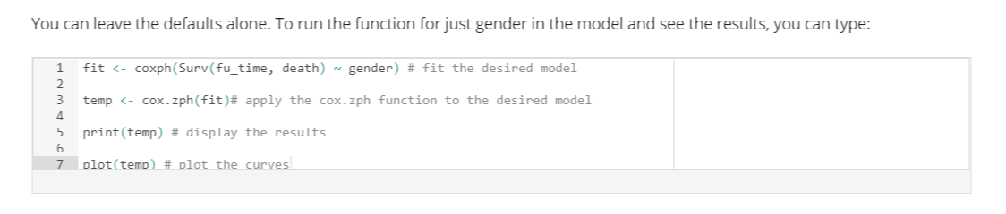

Technically speaking, the function cox.zph() correlates for each predictor the corresponding set of **scaled Schoenfeld residuals** with time, to test for independence between residuals and time. You don’t need to know what any of that means to do the test, but some people prefer to know the technical details of things. If you took the courses on linear and logistic regression in this series, you will have come across the term “residuals”. In those types of regression, they measured the difference between the model’s predicted values and the actual values from the data. Cox regression also generates residuals, and Schoenfeld are one type mentioned in the video.

A *p-*value greater than 0.05 from the cox.zph test confirms proportional hazards. **If the plotted line is relatively flat, the effect of the covariate changes little during the follow-up period**. That’s good news. Schoenfeld residual plots test proportionality of hazards.

**When you have a predictor with few categories, you can also use our old friend the Kaplan-Meier plot as an informal visual check**. If the predictor satisfies the proportional hazard assumption, then the graph of the survival functions versus the survival time should yield parallel curves. This method does not work well for continuous predictors or categorical ones with many levels because the graph becomes too “cluttered”.

**Deviance residuals** are transformations of Martingale residuals and help you look for **outliers or influential data points**. You can either examine the influence of each data point on the coefficients or plot the distribution of the residuals against the covariate:

res.cox <- coxph(Surv(fu_time, death) ~ age)

ggcoxdiagnostics(res.cox, type = "dfbeta", linear.predictions = FALSE, ggtheme = theme_bw())

It’s also possible to check outliers by visualizing the deviance residuals, which are normalised transformations of the Martingale residual and **should be roughly symmetrically distributed about zero with a standard deviation of 1**. If you remember the normal distribution, then 5% of observations are more than 1.96 standard deviations from the mean. If the SD is 1, then only 5% of observations should be bigger than 1.96 or more negative than -1.96. If you have more than that proportion, then **your model doesn’t fit the data as well as it should**, and some observations are a problem. This is just the same issue as with the other types of regression. The maths behind the calculation of the residuals is different, mostly because of the censoring, but we don’t need to worry about that.

* Positive values correspond to individuals that “died too soon” compared with expected survival times.
* Negative values correspond to individuals that “lived too long” compared with expected survival times.
* Very large or small values are outliers, which are poorly predicted by the model.

res.cox <- coxph(Surv(fu_time, death) ~ age)

ggcoxdiagnostics(res.cox, type = "deviance", linear.predictions = FALSE, ggtheme = theme_bw())

Another issue is whether any continuous variables that you assume to have a linear relation with the outcome do have a linear relation. If you fit age as a single term in the model, then that’s what you’re assuming. The **Martingale residual** is used to test this assumption:

ggcoxfunctional(Surv(fu_time, death) ~ age + log(age) + sqrt(age))

Martingale residuals may present any value between minus infinity and 1) and have a mean of zero:

* Martingale residuals near 1 represent individuals that “died too soon”
* Large negative values correspond to individuals that “lived too long”
* The plots should give you nice straight line if the assumption is valid

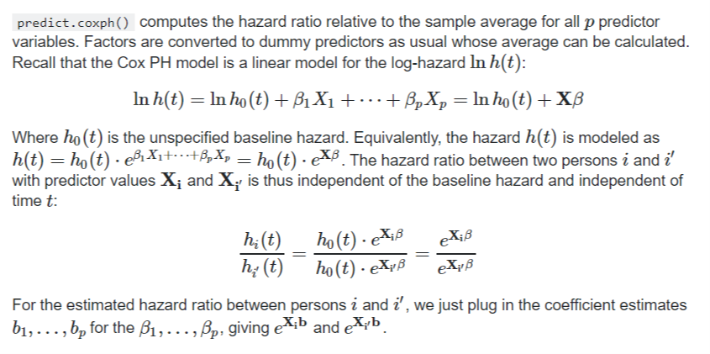

*If you have a stratified model, the comparison in predict.coxph() is against the strata-averages (means), this can be controlled via the reference option that is explained in the help page.*

*Very clear answer. Thank you. I have a question about using the mean of a skewed continuous covariate for the reference average hazard calculation (by strata or overall sample). Wouldn't an extreme positive skew on, for example, age make any reference mean age a poor measure of central tendency? A median would be a better statistic unless skewed covariates can be transformed to normal?*

**Suppose your test for proportional hazards gives you a clear suggestion that the assumption isn't met. What should you do?**

To answer this, you need to think about what having non-proportional hazards means. If the relation between males and females regarding their risk of death changes over time, it could mean, for instance, that males have a higher risk of death early on during the follow-up period but at some point the relation changes so that females have a higher risk of death. One way of putting this is that there is a statistical interaction between gender and time. The model is short of a coefficient. If you add a coefficient for this interaction, which allows for the difference in risk by gender to change over time, then the problem would be solved.

Trying this interaction term in the model and testing whether it is statistically significant is in fact another way of testing the proportionality assumption. If this interaction term is not statistically significant, then it follows that the assumption is valid. As is usual with any kind of regression, Cox included, you should do the statistical tests – i.e. get the p-values – but also do the plots. Some kinds of non-proportional relationships and other assumption violations can’t be detected just from a p value.

Let’s go through how to include this interaction term and test whether it’s statistically significant. For mathematical reasons, you can’t just include the follow-up time itself as part of the interaction but instead need to transform it. The easiest way to do this in R is via the “tt” function (short for “time transform”):

This output agrees with the earlier approach and says that the interaction between gender and (transformed) time is not statistically significant, i.e. there’s no apparent violation of the proportionality assumption. Again, good news. The p-value from this approach (about 0.5) isn’t the same as that from the earlier one because the methods are different, though it’s always nice when they give the same message!

So, if the assumption is violated, then one option is to include this interaction. If the p-value is low but the hazards are proportional for most of the follow-up period, then that suggests another solution: divide the survival analysis into two time periods. You can fit one model when things are fine, i.e. when the assumption is valid, and another model to cover the later follow-up period when the assumption is not valid. This second model may need an interaction term, but the first one won't.

There’s also a third simple way of dealing with the problem: stratify the analysis by the variable that’s causing the problems. If it’s gender, for instance, then just fit separate models for males and females. The drawback of this approach is that it’s no longer possible to compare the effect of each gender on mortality.

**Model selection methods: how to choose your predictors**

This was covered in detail in the Logistic Regression for Public Health course – similar principles apply to any type of regression, including Cox models. There, I explained some common ways of choosing predictors for a multiple regression model and that two such ways – **forwards selection and stepwise selection – were simply too awful to contemplate using**. A third common way**, backwards elimination, does sometimes work okay**. **While it’s always good to make use of a priori knowledge from the literature and experts in the field, this isn’t always of enough help, particularly when you have a lot of possible variables**. Less often you’ll have a good deal of a priori knowledge and therefore many predictors that have been found to be associated with the outcome. In that situation, it can be useful to apply backwards elimination to the model with all these chosen predictors in order to reduce the size of the results table for presentation.

**How to apply backwards elimination**

Here are the steps:

1. Fit the model containing all your chosen predictors – either all your a priori ones or all your available ones (if your data set isn’t too large); beware of the *n* *predictors* > *n* *observations* problem;
2. Store all the coefficients from that model;
3. Remove in one go all predictors whose *p*-value is above the pre-set threshold, typically the usual 0.05 (in a variant of this, you remove the predictor with the highest *p*-value and refit the model, repeating steps until all the predictors have *p*-values above the chosen threshold);
4. Compare the coefficients for the remaining predictors with their coefficients from the original model;

**Checks to make when using backwards elimination**

**If the coefficients haven’t changed much from the original model, then you now have your final model**. You can go ahead and check the residuals (Schoenfeld, deviance and Martingale) and other model assumptions (e.g. proportional hazards). **If, however, you have a predictor whose coefficient has changed noticeably, then you need to find the variable(s) that you have removed that are correlated with this affected predictor**. You can do this by trial and error, so add back in one of the removed variables at a time **until the affected predictor’s coefficient is back to its original value**. **When that happens, you’ll need to keep the removed variable in the model**.

For example, suppose that blood pressure was retained (original model HR=1.30, *p* = 0.002) but cholesterol was removed because it was not statistically significant (original model HR=1.05, *p* = 0.155). Then you removed cholesterol from the original model, and the HR for blood pressure changed from 1.30 to 1.50. You consider that a big enough change to worry about (see below for more on this). You add cholesterol back in, and the original HR for blood pressure is restored. You now need to keep both blood pressure and cholesterol in your final model. **Such correlation between variables is a big reason why stepwise procedures are so unreliable**.

**NB**: how big is “big enough to worry about” is arbitrary. Anything less than 0.05, e.g. a change from HR=1.30 to HR=1.34, is not big enough in my opinion. It’s up to you to decide this. **It largely depends on how the results are going to be used**, e.g. in a risk calculator for clinical decision-making, perhaps in a national screening programme, or for an epidemiological study of risk factors. In the former, where people can be invited for screening for some disease based on their estimated risk of developing that disease, using the coefficient of 1.30 instead of 1.50 can greatly affect the number of people invited. In the latter, however, such a difference won’t be of such importance, especially if all we do is take the table of hazard ratios and *p*-values and say, “these are the predictors of the outcome, whereas these other factors are not”. The estimated size of the relation (the HR) is of secondary importance.

**Conclusion**

The question of how to choose the predictors in a regression model, be it linear, logistic, Cox or other type of regression, is a huge one when the number of possible predictors is bigger than a handful or two. As this is an introductory specialisation, I've only talked about a few approaches.

**Preparing the data for Cox regression**

For those variables that you haven’t yet used, the first thing to do is read the documentation and summarise their distribution. Most of the variables are simply binary flags to indicate the presence or absence of a given comorbidity. One variable (cognitive impairment) needs to be created from a combination of two existing flags.

Once you have a sense of how many missing or weird values there are, you can decide what to do about them. In this data set, missing values are not a big problem.

The next question is how to include each variable in the model. For binary variables, this is easy, and you will generally want the zero (e.g. no cancer, no pneumonia) to be the reference category. For the variables that can be considered continuous although they are recorded as integers – age and missed prior outpatient appointments – you should plot their relation with the outcome and decide whether you can just assume a linear relation or whether something more complicated is needed (Martingale residual can be used for time-to-event data?). Here, we’ve decided for reasons of simplicity that linear is fine, but I want to stress that in general you should always consider something more complicated if that’s what the data tell you.

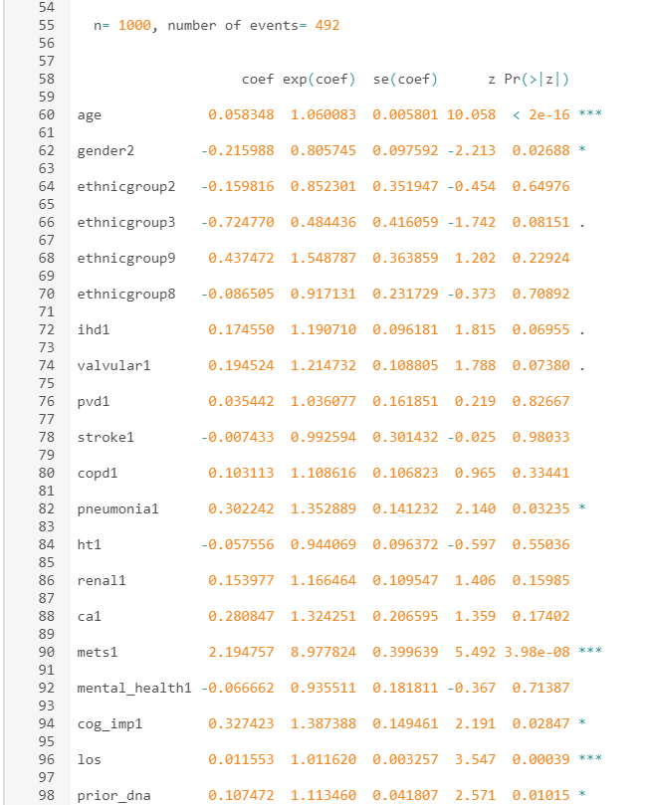

The first thing I looked at with this output was the standard errors, which are all comfortably low. Not tiny, as in less than 0.1, but certainly not big enough to worry about.

Then for this exercise you’re interested in the p-values to see which predictors you could drop to make the final table of results much more digestible. Only six have p-values below the conventional threshold of 0.05: age, gender, valvular disease, pneumonia, metastatic cancer and cognitive impairment. Two more – renal disease and ischaemic heart disease – have dots by their p-value, meaning that they’re just about the 0.05 threshold, but just above is still above. Once you’ve chosen an a priori threshold, you have to stick to it. So what happens when you keep these six and drop the rest?

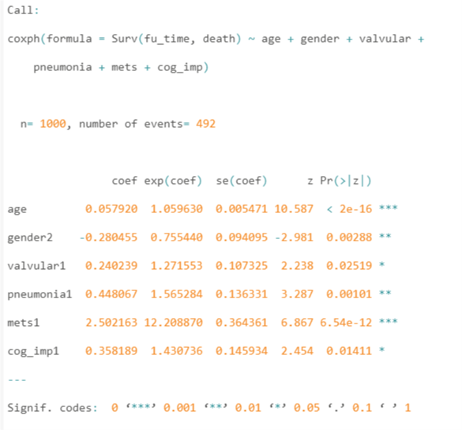

As the full model converged without problems, this simpler model will as well, and it did. Next, you need to compare the two sets of coefficients. The table below does this, using the hazard ratios, i.e. the numbers from the “exp(coef)” bit of the output.

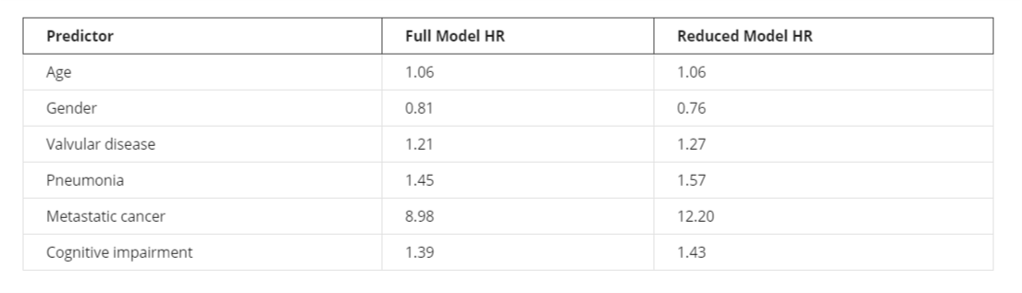

**What do you think of this comparison?**

The HRs for age, valvular disease, pneumonia and cognitive impairment are really similar, and the HRs for gender are also pretty close. That leaves metastatic cancer, whose HR went up from 8.98 to 12.20. That looks like a big increase, so should you worry? I think it depends on how the results are going to be used. If you just want to say which are the significant predictors and the approximate strength of the relation with mortality, then this is fine. If the HR is 9 or 12 it doesn’t matter – it’s a really strong relation. And there’s more evidence you can look at. When you did your descriptive statistics earlier on – I presume you *did*do them all – then a simple tabulation and then cross-tab between cognitive impairment and death will have shown this:

So only 79 patients had cognitive impairment, of whom 59 (74.7%) died. If you were doing logistic regression, you could convert this into an odds of death, giving 59 deaths divided by 20 non-deaths = 59/20=2.95. The impaired patients are three times more likely to die than they are to survive. For those without such impairment, the risk of death is 47% and the odds are 433/488=0.89. That’s pretty high. When logistic regression gives you an odds ratio for impairment, where their risk of death is 74.7%, or 3 in 4, the odds ratio will be high. When you have other predictors, the odds ratio will change, and because the odds for those without cognitive impairment are so high, it doesn’t take much for the odds ratio for those with the impairment to change a lot. If you recall the table of probabilities, odds and odds ratios from the course Logistic Regression for Public Health, odds ratios can get very high for only small changes in the underlying probability. It’s the same principle for hazard ratios from survival analysis. A change in the model (the removal of various covariates) that has little effect on HRs that are close to 1 – for example for age and gender – has a big effect on HRs that are far from 1, in this case much larger than 1. In summary, the change from an HR of 8.8 to 12.2 is not surprising and not important in this case.

**Testing the proportionality assumption on the remaining variables**

You're left with six variables to test. Here are the results:

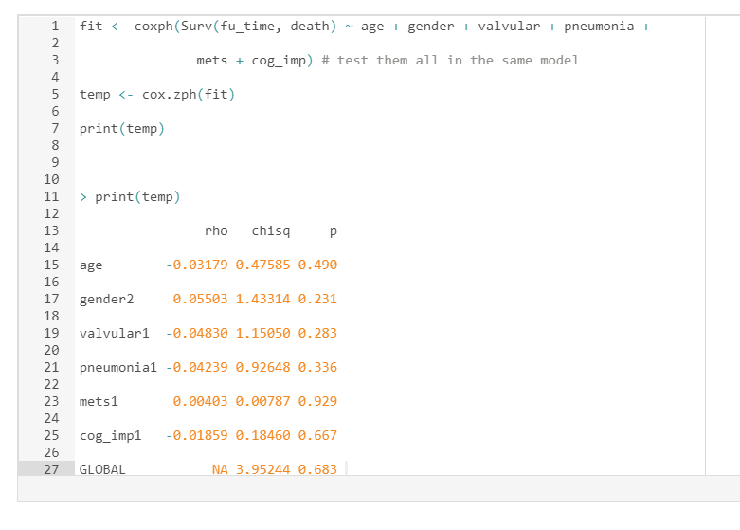  
Nice high p-values, so all’s well on that front.

**Why this final model differs from that in the report**

Even though similar data and variables were used in the report and to create your model, you got different results from the report. Why?

Various reasons:

1. The data were similar but not the same
2. The original set of variables was similar but not the same
3. The statistical methods and outcome were different
4. The size of your data set was much smaller than in the report

Let’s consider each of them. The data used in the report were a combination of Hospital Episodes Statistics (HES) and other, aggregate-level information. The data used for this course originated from HES but were put through a simulation macro in another stats package, SAS, so that the correlation structure and distributions for each variable matched those of the original HES but none of the original patients’ data were retained. So your data look like HES, walk like HES and talk like HES but they’re not HES, so patient confidentiality has been protected.

Secondly, the original set of variables in the project was larger than what you used. Information on intensive therapy unit use was something I mentioned earlier, but the inclusion of hospital-level and other information also had an impact on the p-values and standard errors of the other variables in the model.

Thirdly, the report used logistic regression with an outcome of mortality within one year of the admission, whereas in your survival analysis, the follow-up period was often much longer than a year. This will have an impact on the observed relations between each predictor and the outcome.

The main reason, however, is simply the size of the two data sets. The original report took two years of HES data, nearly 80,000 patients with heart failure, whereas for this course I generated a much smaller subset. That means you had a lot less statistical power to detect significant relations between a predictor and the outcome. Your final model contained far fewer variables than in the report and has without doubt missed some important predictors.

All this means that people studying the same problem – the effect of patient characteristics on mortality after admission for heart failure – can get different results if they don’t use the same data or methods. A thousand patients sounds like a lot – and it is a lot if you had to go out and recruit them yourself from scratch one patient at a time – but it’s still not enough to be able to pick up all the risk factors.