

Herm0ni Chess Bot

Final Report 2024-2025

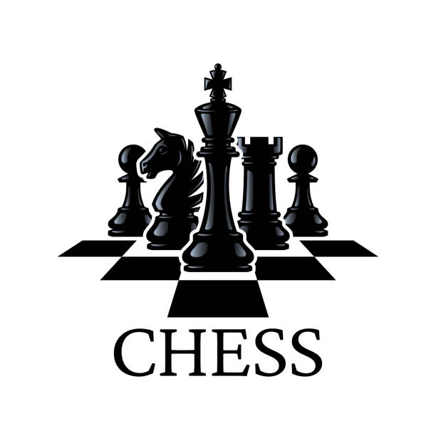

**Student Name:** Seán Rourke

**Student Number:** C00251168

**Supervisor:** Joseph Kehoe

Contents

Abstract 3

Introduction 3

Project Description 3

Challenges 3

Learning Outcomes 3

Project Review 3

Elements Achieved 3

Elements Not Achieved 3

Other Enhancements Identified 3

Personal Reflection 3

Differences 4

Change Process 4

Summary of Differences 4

Conclusions 4

Acknowledgements 4

Declaration 4

# Abstract

The purpose of this project was to develop an artificial intelligence (AI) chess bot and integrate it into the lichess.org website so that the bot could play chess games against both humans and other chess bots.

AI has been used in chess since the 1950s and has seen a massive amount of improvement in that time. Today chess bots can be used for analysis, practice or just for fun. The idea of the Herm0ni chess bot was to give players another resource to use, without requiring a subscription, as many bots today do.

# Introduction

This is the final report on the outcome of the Herm0ni chess bot project. The purpose of this report is to provide a description of the Herm0ni chess bot project, along with detailing the successes and failures of the project, how it the project changed over the along the way and the lessons learned during the completion of the project.

# Project Description

# Challenges

# Learning Outcomes

# Project Review

## Elements Achieved

## Elements Not Achieved

## Other Enhancements Identified

## Personal Reflection

# Differences

## Change Process

## Summary of Differences

# Conclusions

# Acknowledgements

I would like to thank Dr. Joseph Kehoe, my project supervisor. From the very beginning of this project, Joseph has offered me incredible support and guidance, from highlighting the key aspects of chess programming before this topic was chosen, to answering any question I had throughout the project.

# Declaration

* I declare that all works submitted in the completion of this project are of my own preparation and production.
* Where relevant, I have cited all external sources and included a Bibliography of terms as appropriate.
* I understand that failure to comply with the University’s regulations governing plagiarism constitutes a serious offence.

Student Name: Seán Rourke

Student No: C00251168

Date: April 2025