Seán Rourke

# Menu

## counterStock.php

# Add Counter Stock

## addCounterStock.php

## add.php

# Amend Counter Stock

## amendCounterStock.php

## amend.php

## listboxCounterStock.php

# Delete Counter Item

## deleteCounterStock.php

## delete.php

## deleteListbox.php

# Receive Drug Deliveries

## receiveDrugDeliveries.php

## receiveDrugDeliveries2.php

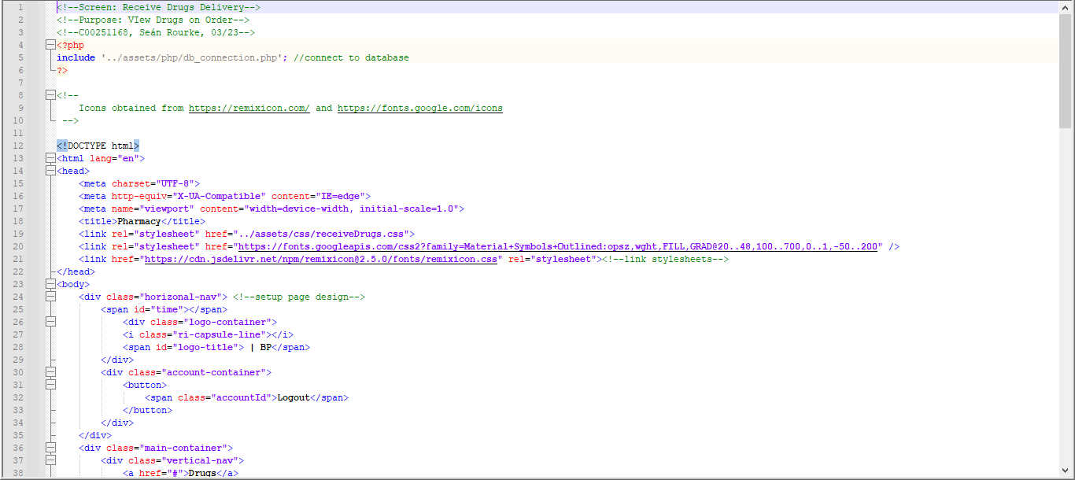

## receive.php

