|  |
| --- |
| SYI Games |
| 2D SSAC Shot! |
| **2D Shooting Game Maniacs** |
| Version #0.4.1  All work Copyright © 2015 by SYI Games.  All rights reserved. |
| **[Sangbeom Yi; 300857600]** |
|  |

**Logo.png**

|  |
| --- |
| October 5, 2015 |

**Table of Contents**

[Your Table of Contents should go here. Make sure that your document’s sections are hyperlinked to their corresponding pages.]

**# GitHub**  
https://github.com/SeanSBYi/2D_SSCA_SPACE_SHOOT/

**Version History**

Version 0.1.0  
Create default Camera, Player, Enemy  
Scroll Background

Version 0.2.0  
 Player can shot the bullet

Version 0.2.1  
Make Enemy shot function

Version 0.2.5  
Make enemy crowd pattern

Version 0.3.1  
Check a collision [Player to Enemy, Bullet to Enemy]  
Score board

Version 0.3.3  
Game Over and High Score

Version 0.4.1  
Make a Boss Enemy

[This is the body of your video game design document. You should add and delete sections as they pertain to your game’s design.]

1. **Game Overview**

*Get ready to descend into Bullet Hell! You must survive on the battlefield and get the high score!*

1. **Game Play Mechanics**

*Shot and Destroy the enemy.*

1. **Camera**

*Top view width-scroll 2D space shooting game.*

1. **Controls**

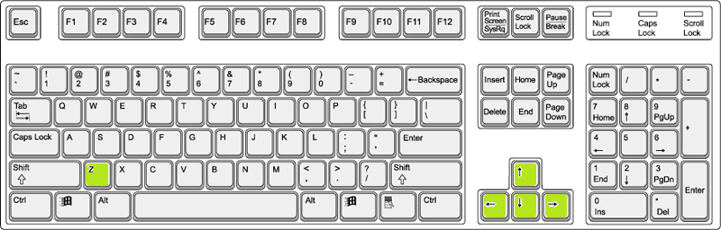

* *Up, Down, Left, Right : My Character (ship) move*
* *Z : Start Game (Title Menu)*

*Shot a bullet (Playing Game)*

1. **Saving and Loading**

*This game doesn’t support the save and load*

*But it can remember your “High score”*

*(*If turn off the game, your high score will be deleted)*

1. **Interface Sketch**

*(What does the game interface look like? Provide a screen shot or sketch)*

1. **Menu and Screen Descriptions**

*(Include additional screen shots and accompanying descriptions for any menus and additional screen)*

1. **Game World**

*(Describe Your Game Environment)*

1. **Levels**

*(Describe Each of your game levels)*

1. **Game Progression**
2. **Characters**

*(Describe Your game avatar if applicable)*

1. **Non-player Characters**

(Describe Any Computer controlled Allies and how they work)

1. **Enemies**

*(Describe computer-generated enemies and boss monsters)*

1. **Weapons**

*1. Normal shot*

*2. Homing shot (Version 0.5.1 Expected)*

1. **Items (Version 0.6.1 Expected)**
2. *Shield*
3. *HP Recover*
4. **Script**
5. **Scoring**

*Normal enemy : 100 point*

*Boos : 1000 point*

1. **Sound Index**

*Effect: Explosion Effect Sound, Player shot Bullet Sound.*

*BGM : FunkyTonk*

#Open Source :  
http://www.econovation.co.kr/ecnvb/%EA%B0%9C%EB%B0%9C%EC%9E%90-%EC%A7%80%EC%9B%90/%EC%98%A4%ED%94%88%EC%86%8C%EC%8A%A4/

1. **Story Index**

*(Outline your game story here)*

1. **Art / Multimedia Index**

*(Include an index of all your graphic and video assets here)*

1. **Design Notes**

*(Include additional design notes here)*

1. **Future Features**

*Various Type of Enemy*

*New Design and Animation*

*Various Type of Shooting*

*New score combo System*

*Check the distance player to enemy, if two objects are close, player can get higher score.*

*New Stage*

*New Platform  
 Unity Web Player, Mobile*