**Practice Problems using Looping Construct**

**Bug Collector**

A bug collector collects bugs every day for five days. Write a program that keeps a running total of the number of bugs collected during the five days. The loop should ask for the number of bugs collected for each day, and when the loop is finished, the program should display the total number of bugs collected.

**Calories Burned**

Running on a particular treadmill you burn 4.2 calories per minute. Write a program that uses a loop to display the number of calories burned after 10, 15, 20, 25, and 30 minutes.

**Distance Traveled**

The distance a vehicle travels can be calculated as follows:

distance=speed×time

For example, if a train travels 40 miles per hour for three hours, the distance traveled is 120 miles. Write a program that asks the user for the speed of a vehicle (in miles per hour) and the number of hours it has traveled. It should then use a loop to display the distance the vehicle has traveled for each hour of that time period. Here is an example of the desired output:

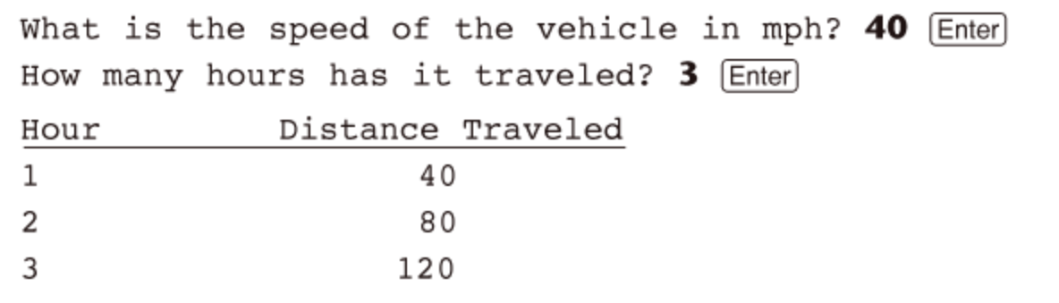

**Celsius to Fahrenheit Table**

Write a program that displays a table of the Celsius temperatures 0 through 20 and their Fahrenheit equivalents. The formula for converting a temperature from Celsius to Fahrenheit is

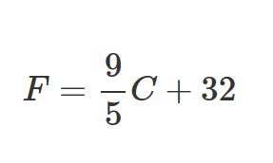

**Pennies for Pay**

Write a program that calculates the amount of money a person would earn over a period of time if his or her salary is one penny the first day, two pennies the second day, and continues to double each day. The program should ask the user for the number of days. Display a table showing what the salary was for each day, and then show the total pay at the end of the period. The output should be displayed in a dollar amount, not the number of pennies.

**Ocean Levels**

Assuming the ocean’s level is currently rising at about 1.6 millimeters per year, create an application that displays the number of millimeters that the ocean will have risen each year for the next 25 years.