**CS 424/524**

**U1: Undergraduates Team 1**

**Jennifer Hill, Ryan Kane, Dorothy Kirlew,**

**Donald Shaner, Sean Weber**

**3D MANIPULATOR**

**USER MANUAL**

**Table of Contents**

**1. Introduction**  
 1.1 What is the 3D Manipulator?  
 1.2 License  
 1.3 Architecture  
   
**2. Installation**  
 2.1 Compatibility  
 2.2 Installation under Windows  
 2.3 Installation under Linux Fedora  
   
**3. Using The 3D Manipulator**  
 3.1 Getting Started  
 3.2 Menu Bar

3.3 Shapes Creation

3.3 Canvas Manipulation

3.4 Re-Size Panel

3.5 Rotation Panel

3.6 Aesthetics Panel

3.7 Shapes Panel

3.8 Zoom Slider

3.9 Logger

## 1. Introduction

**1.1 What is the 3D Manipulator**

The 3D Manipulator is a stand-alone geometric rendering application designed to create and manipulate three-dimensional shapes. Users can alter the aesthetics of the shapes (including the face color, edge color, and edge weight); adjust the height, width, and depth; and rotate around the x, y, and z axes.

### 1.2 License

The 3D Manipulator is released under the GNU GPLv3 license and is freely distributable for educational use only.

### 1.3 Architecture

This software package was designed using the Java3D API. The API requires the following imports: java.awt, javax swing, javax media, java util, and the j3d.util libraries.

## 2. Installation

### 2.1 Compatibility

This software package is compatible on most operating systems including Windows, Linux and Mac as it uses a JAR executable to launch the program. The 3D Manipulator is a stand-alone application, meaning that it does not require any other programs running in conjunction with it in order to operate properly.

### 2.2 Installation under Windows

Execute the *3DManipulator.jar* file.

### 2.3 Installation under Linux

Execute the *3DManipulator.jar* file.

## 3. Using the 3D Manipulator

### 3.1 Getting Started

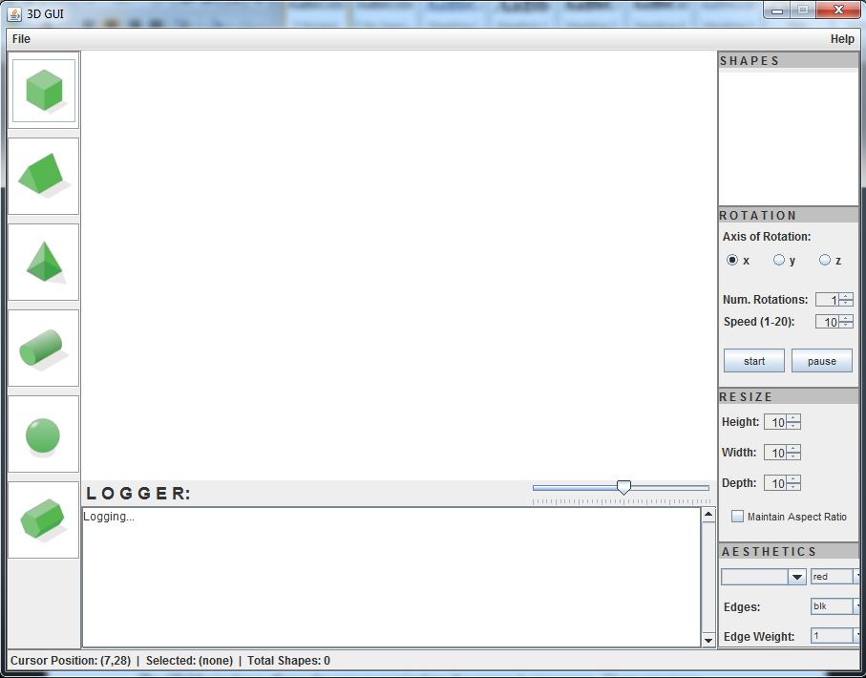

Upon opening the 3D Manipulator, the user will see a blank, white workspace, or canvas, which takes up the majority of the screen. The left-hand toolbar contains six buttons, one to create each of the six three-dimensional shapes supported by the rendering engine. Below the canvas is the logger panel, which contains a scrolling text box that displays the most recent user actions. The right-hand side of the window displays four functional panels: the Shapes panel, Rotation panel, Resize panel, and Aesthetics panel.

The canvas also outputs the activity of the mouse in the form of the *x*- and *y*-axis cursor position along the bottom bar. A menu bar is included along the top with a file pull-down menu containing a load, save, and exit functionality.  The menu bar also includes an “About” button which displays information about the program.

### 3.2 Menu Bar and Status Bar

#### 3.2.1 Menu Bar

The upper menu bar has two drop-down menus. The “file” menu contains a function for saving activity performed during the current session and loading previous logs, a run function which executes the loaded log file, as well as a function to exit the program. Saving causes the logger to output a text file to the root directory of the software package which can later be loaded to resume working on the previous canvas. The help menu will drop down to an about window, which contains the names of the developers with the current version of the software, the license under which the program is released, and the release date. Lastly, this user guide will be displayed upon its selection from the help menu.

#### 3.2.2 Status Bar

The status bar along the bottom of the application window shows cursor position when the user’s mouse is inside the canvas. The *x* and *y* coordinates are constantly updated and displayed. There is also a counter which tells the user how many shapes are on the canvas and which shape is currently selected.

statusbar.JPG

### 3.3 Shape Creation

On the left side of the screen, the user can choose to create any one of the following shapes: a rectangular prism, a triangular prism, a square pyramid, a cylinder, a sphere, or hexagonal prism. Clicking on a button will create that particular shape in the center of the canvas. The canvas can simultaneously render as many shapes as the user desires.

### 3.4 Canvas Manipulations

The 3D Manipulator allows the user to manipulate the canvas in two ways.  Users can move individual shapes around the canvas by left-click dragging. Right-clicking and dragging anywhere on the canvas will pan the view of it. .

3.5 Delete Shapes

To delete a shape from the canvas, simply select the desired shape in the canvas and press the delete key on the keyboard. This deletes the shape from the canvas and also removes the name of the selected shape from the shapes panel.

### 3.6 Resize Pane

### When a shape is selected, it can be resized in two different ways.  The user can individually increase or decrease the height, width, or depth of the selected shape using the up and down arrows next to the dimensional name.  Selecting the “Maintain Aspect Ratio” box locks the height, width, and depth fields to the same value, causing the shape to grow or shrink proportionally in all three dimensions.

### 3.7 Rotation Panel

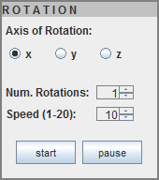The rotation panel allows a user to rotate a selected shape.  Rotations can be performed on the *x*-, *y*-, or *z*- axes.  The user can specify a number of times to rotate the shape (as many as 25 times and as few as one time) and the speed at which to rotate the shape (between 1 and 20, where 1 is the slowest speed and 20 is the fastest).  Once the user has chosen the axis, number of rotations, and speed of the rotation, clicking the “start” button will begin the rotation. Clicking on “start” again while the shape is currently rotating will stop the current rotation and return the shape to its starting state.  To pause the rotation of the selected shape, click the “pause” button.Clicking “pause” again will resume the selected shape’s rotation. Shapes can continue to rotate while others have been stopped or paused.

### 3.6 Aesthetics Panel

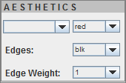The aesthetics panel allows the user to change the colors of individual faces on a selected shape, as well as the color and weight of the edges.  When a shape is selected, the user can select which face to change from the drop-down menu.  The user can then change the color of the selected face from the drop-down menu directly to the right of the face menu.  The color of the edges of the shape can be changed from the drop-down menu marked “edges” and the weight of the edges can be changed with the “edge weight” drop-down menu.

### 3.7 Shapes Panel

The shapes panel displays each of the shapes currently displayed on the canvas. This panel dynamically updates to show which shapes are currently on the canvas and which shape is currently active. When a shape is deleted from the canvas, it is also removed from the shapes panel.

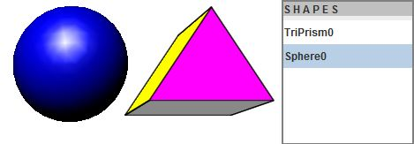

### 3.8 Zoom Slider

The zoom slider is located below the canvas above the logger panel.  The zoom slider begins at 100% and can be changed by increments of 5% every time it is moved. The canvas can be zoomed out to as far as 5% and as close as 200% of the default viewing dimensions. Click and drag the slider to the right to zoom in, and drag the slider to the left to zoom out.

Zoom slider.JPG

### 3.9 Logger

The logger keeps track of all insertions, deletions, and manipulations on the canvas. At the start of every session a text file with an extension of “.log” is created with the current date and time. As the user manipulates shapes on the canvas, be it resizing, rotating, or changing face or edge color or edge weight, there is a log of every instance in which the shape has undergone a change. When you are satisfied with your changes you can select the save option. Before closing the 3D Manipulator, the canvas state must be saved by using either the save or exit button found under the file menu on the menu bar. Upon saving, a message pops up displaying the name of the .log file that had been created at the instantiation of the 3D Manipulator and has been updated as changes have been made on the canvas. If the user would like to load a previous log they would have to select the load option under the file menu. This option brings up a file chooser allowing you to select any log files that you have previously saved. After the log file has been loaded the user can then press the run option located under the file menu. This will call the parser, which in turn will replay the log session that has been selected.