**Seán Whelan**

Email: [seanwhelan117@gmail.com](mailto:seanwhelan117@gmail.com)

Phone: 085 164 2499

GitHub: seanwhelan117

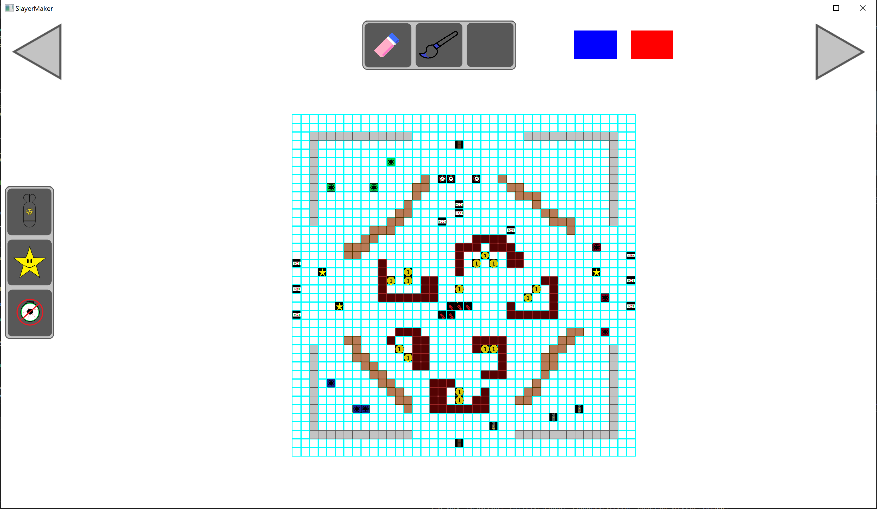

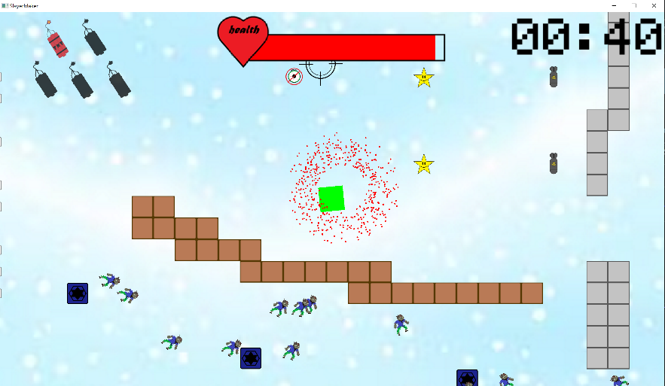

**SlayerMaker 2D**

Description:

My project is a no-code game editor built with C++ and the SFML graphics library. It enables people with no coding or programming experience to create 2D top-down “shootemups”. With a variety of game modes, walls, enemies, items, power-ups, and objectives, players can customize their games their way. Additionally, the project allows the players to play their game directly in the game editor and save their games for later. My goal is to make game development more accessible to everyone.

