**Question 1:**

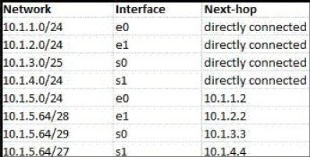

According to the routing table, where will the router send a packet destined for 10.1.5.65? Why?

10.1.5.65 belongs to 10.1.5.65/28, /29, 27.

Longest Match = 10.1.5.65/29 also has the most bits

Binary conversion/ next hop = 10.1.3.3

**Question 2:**

Classless Inter-domain Routing (CIDR) receives a packet with address 131.23.151.76. The router’s routing table has the following entries:

Prefix Output Interface Identifier

131.16.0.0/12 3

131.28.0.0/14 5

131.19.0.0/16 2

131.22.0.0/15 1

The identifier of the output interface on which this packet will be forwarded is ______. Why?

Indentifier is 1.

Because the first entry on the table has a mask of the first 12 bits of network and remaining 20 are host.

Last entries mask is 255.254.0.0

Longest prefix match between 1 and 3 is 1.

**Question 3:**

Consider the following routing table of a router.

| **PREFIX** | **NEXT HOP** |
| --- | --- |
| 192.24.0.0/18 | D |
| 192.24.12.0/22 | B |

Consider the following three IP addresses, what their next hop will be?

1. 192.24.6.0 => D
2. 192.24.14.32 => B
3. 192.24.54.0 => D

Mask first prefix: 11111111.11111111.11000000.00000000

Mask second prefix: 11111111.11111111.11111100.00000000

First IP:

192.24.0.0/18 Subnet 1 = 192.24.0.0 => Next hop = D

Second IP:

192.24.12.0/22 Subnet 1 = 192.24.0.0 Subnet 2 = 192.24.12. => Next hop = B

Third IP:

192.24.54.0. Subnet 1 = 192.24.0.0 Subnet 2 = 192.24.52.0 => Next hop = D

**Question 4:**

Draw an TCP header. Capture packets using wireshark and explain the fields for a particular TCP packet captured. Try to explain the purpose of each field.

**Question 5:**

Draw an UDP header. Capture packets using wireshark and explain the fields for a particular UDP packet captured. Try to explain the purpose of each field.

