**UML Report**

Group 14: Online Retailer

**Flynn, Shengxin, William, Tao**

Design Process:

When first tasked with conducting this project for your company, we thought it best to first meet up as a group and delegate the roles and responsibilities that each of us would undertake in order to fulfill our goals as efficiently as possible. Before that though, we had to decide the manner in which we would communicate and the tools we would use in order to draw the required material.

We settled upon Discord as our method of communication as it allowed us to easily keep in contact with one another throughout the project and it also allowed us to share files between each member in a convenient manner. We also utilized its voice call functionality to discuss the next steps in our work when meeting face to face was impossible. When it came to writing this very report, we created a Google Doc in order for our individual work to sync up which allowed us to operate as a team in a much more efficient manner.

When it came to deciding upon our drawing tool, we took time to first lay out all of the functions that we needed from one. Eventually after trialing a few, we decided upon Lucidchart. Its shared free trial made it a very accessible tool for every member of the team. With its robust but simple to use options, the tool made it simple to design the various diagrams we needed to fulfill our goals. Each diagram was able to go on its own page, making it easy for us to work on multiple at the same time. These various reasons made Lucidchart the best choice for us as a team.

Background Research:

Before we started to design our information system, we thought it best to fully comprehend how an information system encompassing an online retailer would operate. We started by researching the general topic of online retailers, the process involved in their operation and the user experience at their forefront. We learned about its various aspects such as shipment and payment systems that form the system as a whole. We delved further into these so that we could represent them to their full capacity in our information system. However, all this initial preliminary research helped us to hone in on what should be the primary focus of the system.

We knew how important it was to first understand Amazon as a company and the values that you hold before we chose our focus. The one that struck us across every facet of our research was your dedication to and obsession over the customer. It has remained your focus throughout your long history of business which is commendable. We sampled many quotes from your very own CEO, Jeff Bezos, about this obsession, our favorite in particular being “From the beginning, our focus has been on offering our customers compelling value… We will continue to focus relentlessly on our customers.” Another one that particularly inspired us was “The number one thing that has made us successful by far is obsessive compulsive focus on the consumer” It was clear to us that user experience should be the foundation of the information system that we had to design so we could stay in accordance with your steadfast values.

We also decided that we needed to further our understanding of your current information system so that we would be able to iterate and build upon it. We explored every facet of amazon.co.uk in order to gather as much information on how the current system operates.

We also explored other online retailers such as eBay to see if we could garner any inspiration from how they operated and handled user accounts particularly. Yet again, we noticed a common denominator present across every online retailer, that being a focus on the user experience. This cemented what we already believed and made us confident in the direction that we wanted to take the information system.

Ethics:

When designing any information system, it’s vital to consider its ethical backing. This ‘Ethics Canvas’ describes the thoughts and concerns we had surrounding the system we developed for you.

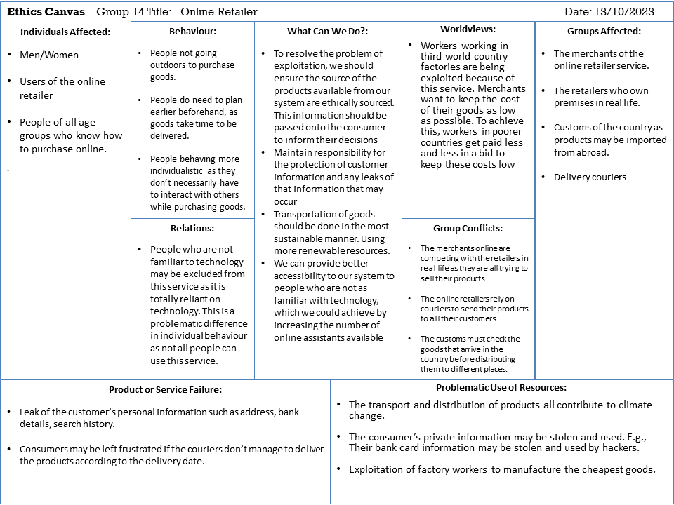

UML Use Cases:

In this section, you’ll see the Use Case Diagram as presented in our video presentation along with textual descriptions for each use case involved:

**Register Account**

|  |  |
| --- | --- |
| Name | Register Account |
| Participating Actor | New User |
| Entry Condition | New User tries to access the service |
| Exit Condition | The User’s account has been registered |
| Normal Scenario | - A New User accesses the online system and is prompted to create an account  - They input the required information to create the account  - This information is validated by the ‘Authenticate Account’ use case |
| Error Scenario | The New User’s provided information is invalid.  -Prompt User to resubmit their corrected information |

**Login To Account**

|  |  |
| --- | --- |
| Name | Login to Account |
| Participating Actor | Registered User |
| Entry Condition | Registered User tries to access the service |
| Exit Condition | The Registered User is logged into their account |
| Normal Scenario | - A Registered User accesses the online system and is prompted to login to their account  - They input their information (email/password)  - This information is validated by the ‘Authenticate Account’ use case |
| Error Scenario | The Registered User’s provided information is invalid.  -Prompt User to resubmit their corrected information |

**Authenticate Account**

|  |  |
| --- | --- |
| Name | Authenticate Account |
| Participating Actor | Service Authenticator |
| Entry Condition | A New User or Registered User has submitted their information to the system |
| Exit Condition | The New User or Registered User’s accounts are authorized/authenticated |
| Normal Scenario | -The User’s inputted information is sent to the authentication server  -If it’s from a New User, their information will be logged into the system  -If it’s from a Registered User, the server will compare the information with all user credentials in storage  -If the check is successful, the system will authenticate the user |
| Error Scenario | The provided information is invalid.  -Log the error and send prompt to the users to resubmit their corrected information |

**Add Selected Items to Shopping Cart**

|  |  |
| --- | --- |
| Name | Add Selected Items to Shopping Cart |
| Participating Actor | Registered User |
| Entry Condition | Registered User has browsed the store |
| Exit Condition | Item has been added to shopping cart |
| Normal Scenario | -The Registered User browses the store for the item they want  -The Registered User selects the item they want and its quantity to add to their cart |
| Error Scenario | The selected item is out of stock.  -Message is sent informing the Registered User that the item is no longer in stock |

**Proceed to Checkout**

|  |  |
| --- | --- |
| Name | Proceed to Checkout |
| Participating Actor | Registered User |
| Entry Condition | The Registered User has accessed their shopping cart |
| Exit Condition | The Registered User is forwarded to the payment process |
| Normal Scenario | -The Registered User clicks the prompt to proceed to checkout with the items in their shopping cart |
| Error Scenario | The Registered User’s cart is empty.  -Message is sent informing the Registered User that their cart is empty and they are prompted to return to the storefront |

**Make Payment**

|  |  |
| --- | --- |
| Name | Make Payment |
| Participating Actor | Registered User |
| Entry Condition | The Registered User has proceeded to checkout with items in their cart |
| Exit Condition | The Registered User’s payment is successful |
| Normal Scenario | -Registered User chooses their method of payment  -Registered User enters their billing information when requested  -This information is passed along to a payment processor  -The payment is processed |
| Error Scenario | The Registered User’s funds are insufficient.  -Cancel the order and inform the Registered User that their funds are insufficient for the transaction |

**Process Payment**

|  |  |
| --- | --- |
| Name | Process Payment |
| Participating Actor | Credit Card Processor, PayPal |
| Entry Condition | The Registered User has submitted their payment information |
| Exit Condition | The Registered User’s payment is validated |
| Normal Scenario | -The Registered User’s payment information is passed along to a payment processor  -The payment processor sends an authorization request to the issuing bank with the parameters they received from the user  -The issuing bank sends an approval message back to the processor who then approves the payment |
| Error Scenario | The Registered User’s funds are insufficient.  -Log the error and pass along the information to the retailer |

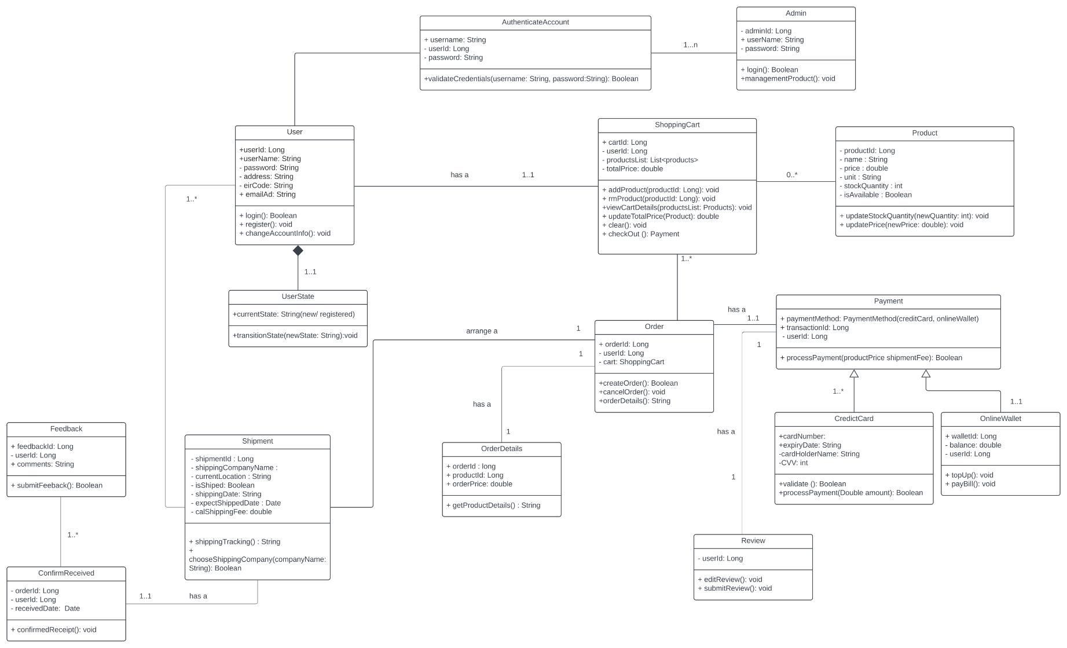Class Diagram:

This class diagram gives a clear idea of how our newly designed information system for Amazon operates, encompassing user management (User, Admin, AuthenticateAccount), order processing (ShoppingCart, Order, Product), diverse payment mechanisms (Payment, CreditCard, OnlineWallet), shipment details (Shipment), and various feedback channels (Feedback, ConfirmReceived, Review). Central to the design is the clear delineation of responsibilities, ensuring efficient security via a dedicated authentication class, flexible shopping and payment options, dynamic product management, and comprehensive user feedback mechanisms. The defined relationships, with clear cardinalities, alongside visibility indicators, offer a holistic view of user interactions and data flows within the system.

Firstly, there are two main types of users: regular users (shoppers) and admins (system managers). Regular users have a name, address, email, etc. and they can log in, sign up, or change their details. Admins, on the other hand, are delegated special tasks such as managing the items for sale.

To keep things secure, there's an aspect of the system named AuthenticateAccount. It checks if the username and password are correct before letting someone use the system.

When a user wishes to purchase a product, they add items to their ShoppingCart, akin to a basket in a physical retailer. Each item they want to buy is labelled a Product, which has associated details such as its name, price, and how many are in stock. When they're ready to buy, they make an Order. The Order has all the details about what they're buying and how much they need to pay.

Payment is another essential component. There are two ways to pay: using a credit card or an online wallet. Both methods have their own details and manner of operation.

After completing a purchase, items get sent to the user. This is shown in the Shipment part of the diagram. It has details like which company is sending the items and when they will arrive.

Lastly, after users receive their items, they can provide feedback. They can say if they liked the item or not, confirm they got it, or even write a full review. This helps other users decide what to buy and helps you to improve.

Activity Diagrams: 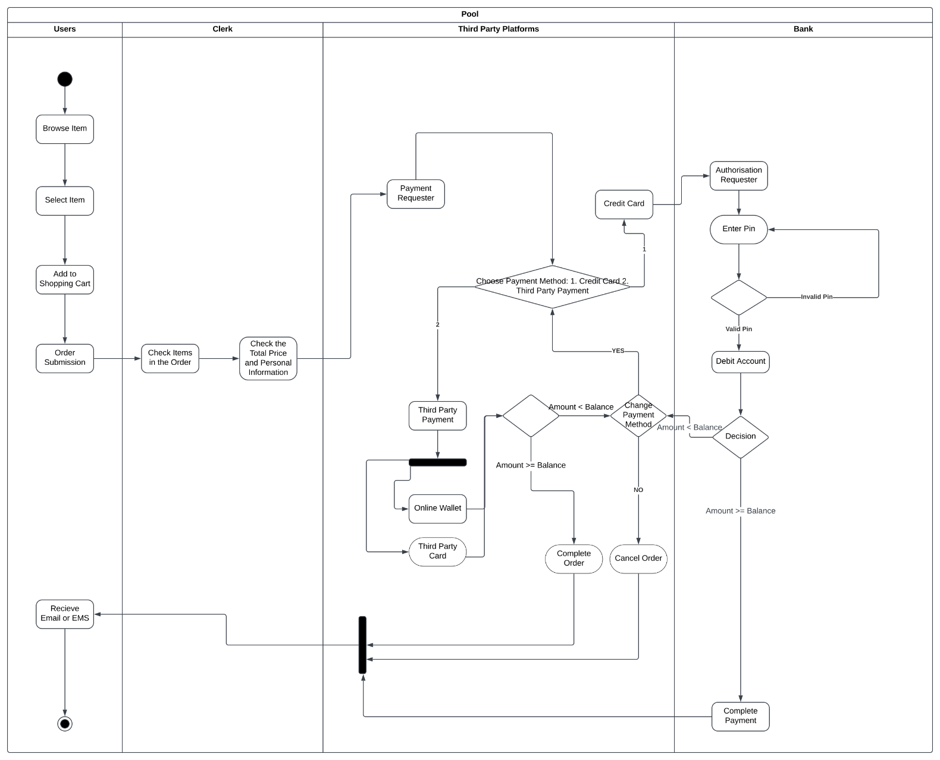

**Activity Diagram 1:**

The first activity diagram describes the ‘Make Payment’ use case. As it involves four different entities, we design four lanes in the pool to include diverse states of the user.

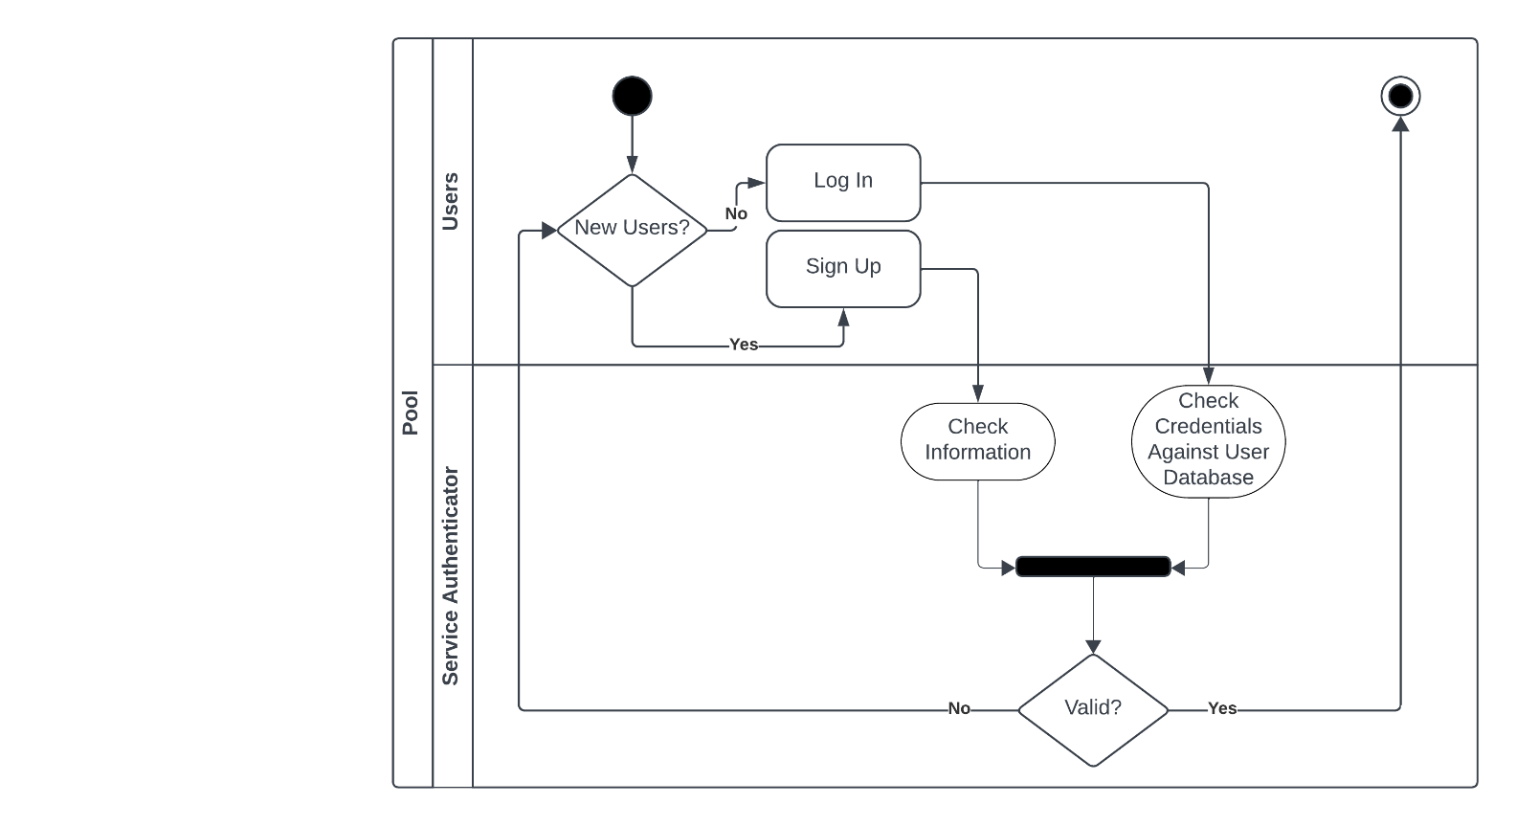The first lane comprises the start and the end of the flowchart. It begins with three basic steps of item selection that are singularly linked by transitions. Next, the order is submitted to the system, with the clerk in the second lane checking the order’s information in regard to the quantity and total price of the order. Then, the user’s payment request is delivered to the third-party platforms in the third lane, with this lane being critical for selecting different payment methods. If the user insists on paying the order through the third-party platforms, with an online wallet and third-party cards being the usual payment methods which the user can use to complete the transaction. But if the user selects to pay via the Bank card, the states in the last lane are activated at the start of the authorization request. We set two condition boxes after the request with the first one being used to check the validity of the pin. If the pin is invalid, the user cannot proceed unless the entered pin is approved. The second is to determine whether the balance is sufficient to cover the order fees. Finally, returning to the third lane, we designed the condition boxes in terms of the sufficiency of the funds associated with the bank account in the last lane. If the total amount is lower than the balance, the transaction is completed and the user will receive the message about transaction success, otherwise, the order is cancelled, and the user is informed.

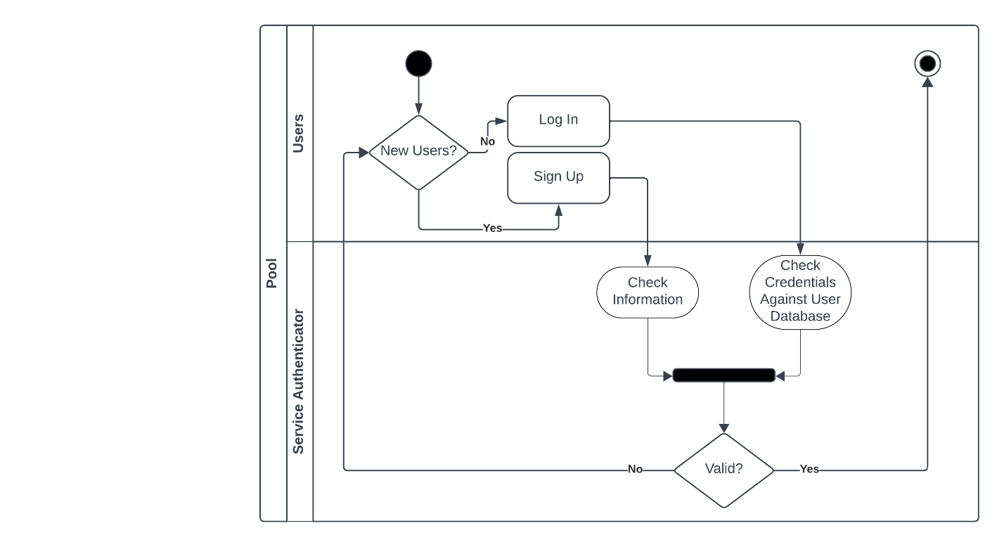

**Activity Diagram 2:**

This activity diagram describes the ‘Authenticate Account’ use case. It begins with a conditional box where it’s determined if it’s a New User or a Registered User. If the user is new, they are directed to sign up for an account while an existing user is prompted to login. Once completed, we move into the second lane. If it’s a New User, their information is checked by the service authenticator to see if all requirements have been fulfilled. If it’s a Registered User, their credentials are checked against the existing database of user information. These two then fork into a validity check. If valid, the process is complete but if any of the information is invalid, the user is directed back to the start of the process where they can re-input their information.

Strengths/Weaknesses:

* We strongly believe that our primary strength lies in our focus on the user. Throughout every facet of our research, Amazon’s focus on the consumer shone through which is something we believe we captured within the bounds of our information system. The majority of our system’s interactions stem from the different types of users, which allows it to retain its key focus.
* We believe another strength lies in the breadth of preliminary research we undertook before we began designing the system. By fully understanding each aspect of the system in its totality before production began, it allowed us to cover essentially all major aspects of the system in a comprehensive manner.
* However, upon reflection, we believe our goal to comprehensively cover each aspect of the system led to some aspects becoming over convoluted. Taking our payment methods as one example, we believe we overdesigned in relation to the scope of our information system, leading to some redundant classes. If the time scope of this project was larger, one of our main priorities would be to streamline these methods in order to improve the usability and efficiency of our system.
* Finally, we believe another flaw of our system to be its lack of focus on shipments. Due to the tight schedule of this Project, we chose to focus more on the user which is a strength we’re proud of. However, this led to other aspects falling through the cracks such as details with shipping and distribution, a key aspect of any online retailer. If given additional time, we’d love to expand upon our shipment process, integrate it further and truly represent it as a key aspect of the system.

Challenges:

* As a team, we knew meeting in person often was essential as it was the best manner of conveying our thoughts and feedback to one another. However, throughout the development of this project, we often struggled to gather entirely as one group. With most meetings lacking one or two members at a time, it made it hard to communicate our next steps to one another without having to eventually pass this along at another time. With communication taking on this staggered form, it made it difficult to tackle the project as a singe unit. However, towards the end of the project, we took increased measures to meet as a group which allowed us to run across the finishing line.
* Another challenge we encountered was near the beginning of the process in regard to choosing our drawing tools. No one tool had everything that we wanted to get out of them, which made the process of deciding between them quite difficult. We trialed quite a few tools such as Creately and SmartDraw, yet none satisfied every condition that we laid out. When we settled upon Lucidchart, we encountered more difficulties in regard to membership, with each of us switching between accounts in order to have continued free access to the full swath of features Lucidchart provides.
* Finally, our last challenge concerned the Ethics Canvas. As there is a lack of resources concerning it on the internet, it made it difficult for us to fully grasp and understand the differences between each section of the canvas. In particular, we found it difficult to differentiate between the Behaviour and Relations sections present on the canvas without further explanation due to their similar descriptions.

Tasks:

Each week during our designated meetings, each member of the team pooled together our ideas and offered each other feedback on our designs when applicable.

When deciding upon who should be delegated which tasks, we first considered where our individual strengths lay and then decided after.

Flynn’s main role was creating the Use Case Diagram as well as writing the textual descriptions for each use case. He also wrote the section concerning our Design Process. Along with William, he also conducted thorough background research and wrote the Background Research component of this report.

Shengxin’s job was to create the class diagram based of our information system along with writing the textual description that came alongside it in the report.

Tao was tasked with creating both the activity diagrams based of our use cases as well as writing their descriptions.

William’s primary task was to consider the ethics behind our information system for your company and condense his and the team’s thoughts into our ‘Ethics Canvas’. Along with Flynn, he also conducted thorough background research and wrote the Background Research component of this report.

Finally, we all pooled our thoughts together in order to decide upon the strengths and weaknesses of our design as well as ruminate upon the challenges that we encountered along the process of creating the information system.

Sources:

* <https://aws.amazon.com/executive-insights/content/the-imperatives-of-customer-centric-innovation/>
* <https://www.economicclub.org/events/jeff-bezos>
* <https://media.corporateir.net/media_files/irol/97/97664/reports/Shareholderletter97.pdf>
* <https://www.amazon.co.uk/>
* <https://www.aboutamazon.com/about-us>
* <https://thedo.world/customer-obsession-is-key-to-amazons-success/>
* <https://www.ecwid.com/blog/online-retail-business.html>
* <https://www.lucidchart.com/>
* <https://www.smartdraw.com/>
* <https://ethicscanvas.org/>
* <https://stripe.com/ie/resources/more/payment-processing-explained#:~:text=Payment%20processing%20is%20the%20sequence,transactions%20through%20electronic%20payment%20systems>.
* <https://www.clickpost.ai/blog/how-does-online-shipping-work>