# Step by step Full Stack deployment

This document provides a step by step instruction on how to deploy your assignment 3 project.

**Only follow these steps once you have completed all the requirements and validated that everything works locally.**

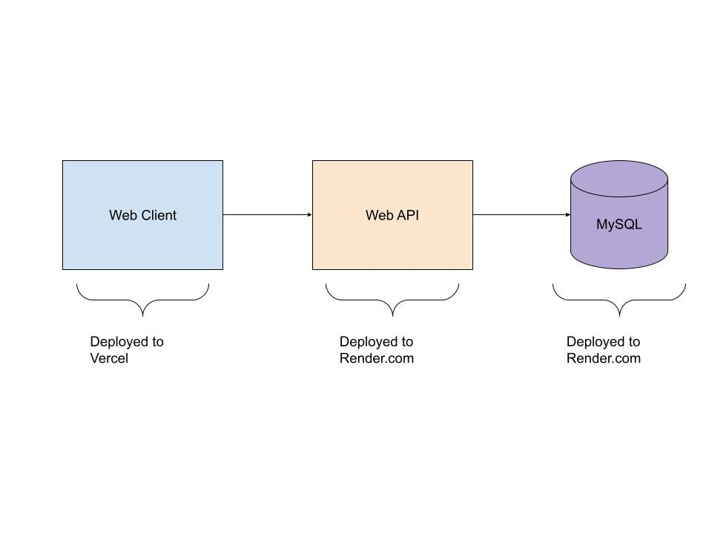

### Prerequisites

1. Create a [render](https://render.com/) account
2. Create a [Vercel Account](https://vercel.com/)
3. Install [Vercel CLI](https://vercel.com/docs/cli)

### Deploy your Database

1. Login to your render.com account and create your new Postgres database
   1. 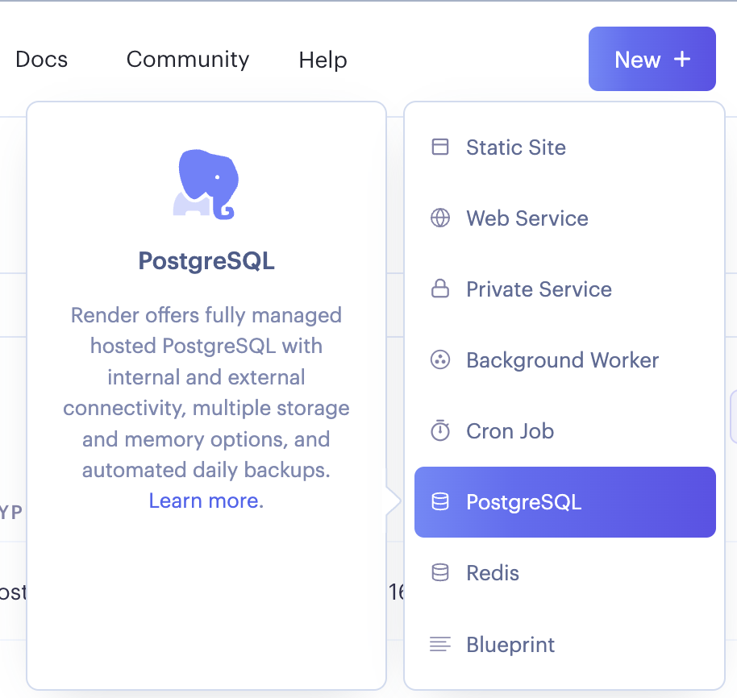
2. Follow the instructions for a free tier.
3. Copy external database URL (connection string)
   1. 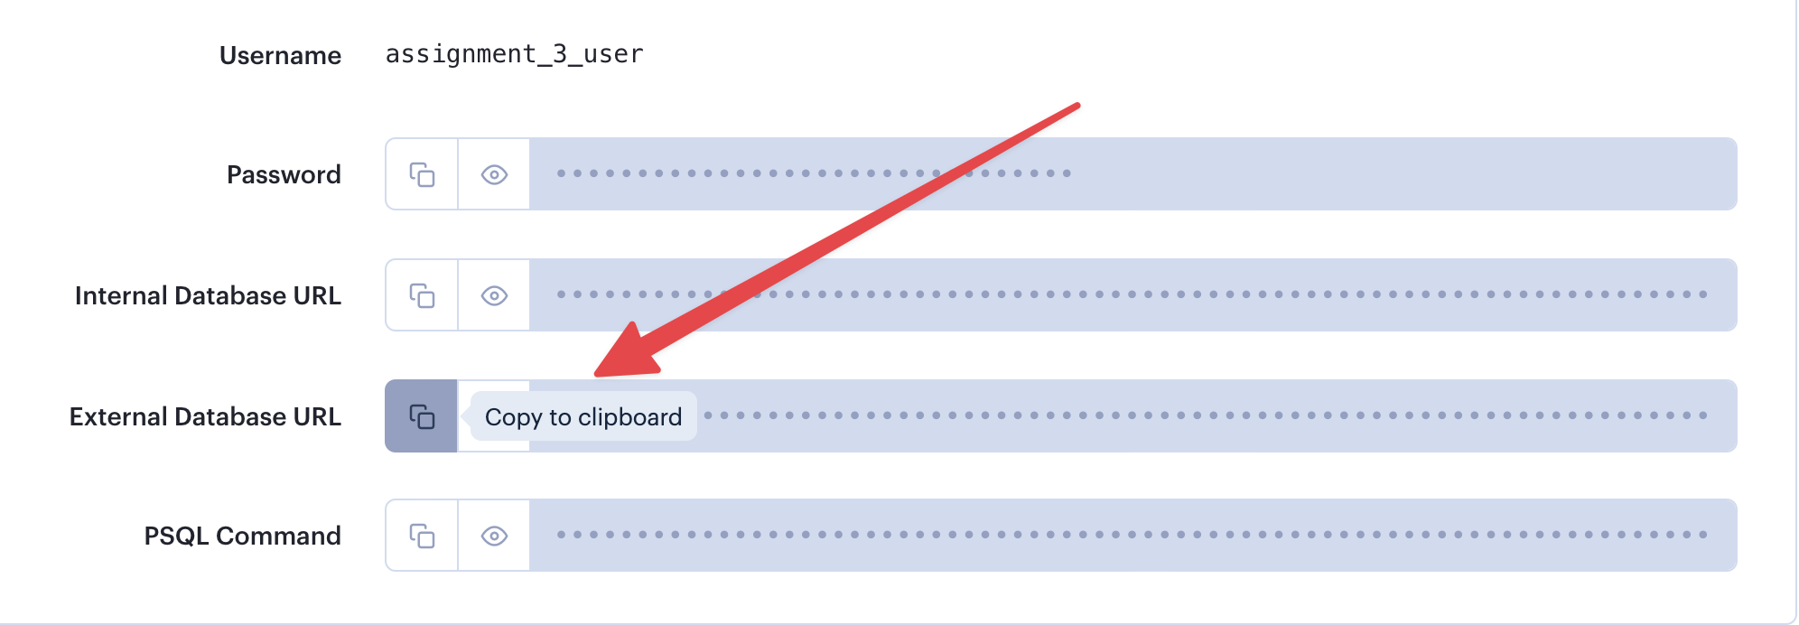
4. Go to API folder: Update .env file with your new connection string.
5. Unfortunately render.com only provides Postgres database so we’ll have to change our prisma.schema file. Replace mysql with **postgresql**
6. Run npx prisma db push to push your local prisma schema changes to your hosted database.
   1. Run this command every time you want to update your changes.
   2. There is currently an issue running migrations to databases hosted in the cloud. I would recommend generating migration files to your local database by changing to your local database connection string. When you are ready to push to the hosted db run the push command.
7. Running npx prisma studio will point to your new database and you will be able to verify the tables and insert/update/delete data.

### Deploy your API

1. Update your index.js file so that it uses a PORT from .env file. This is only needed for the server, no need to put a port in your local .env file.

|  |
| --- |
| const PORT = parseInt(process.env.PORT) || 8080;  app.listen(PORT, () => {  console.log(`Server running on http://localhost:${PORT} 🎉 🚀`);  }); |

1. Add relationMode to schema.prisma file

|  |
| --- |
| generator client {  provider = "prisma-client-js"  **previewFeatures = ["referentialIntegrity"]**  }  datasource db {  provider = "mysql"  url = env("DATABASE_URL")  **relationMode = "prisma"**  } |

1. Update package.json file start script
   1. 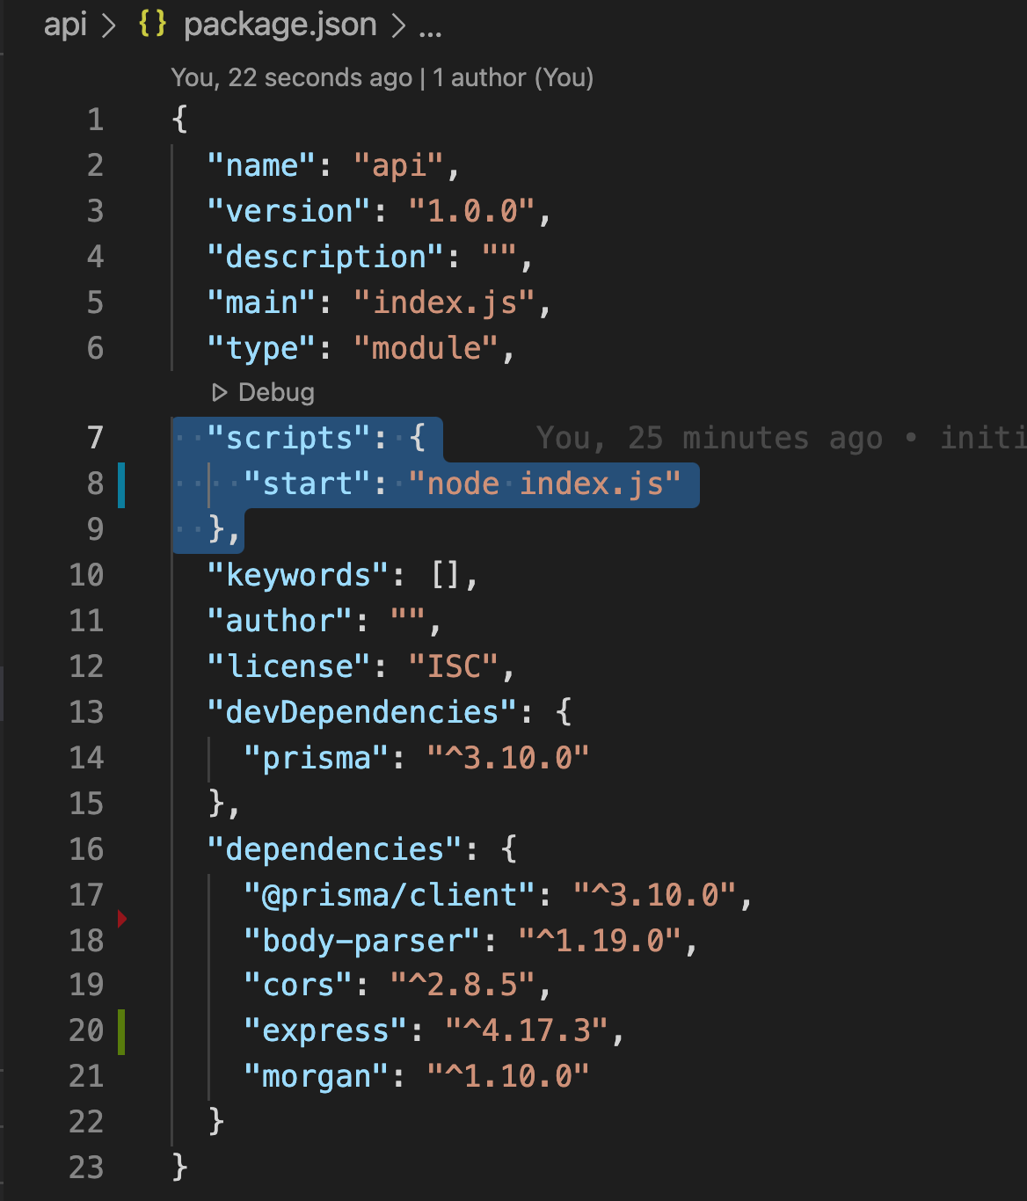
2. Create a new webservice from your render.com account
   1. 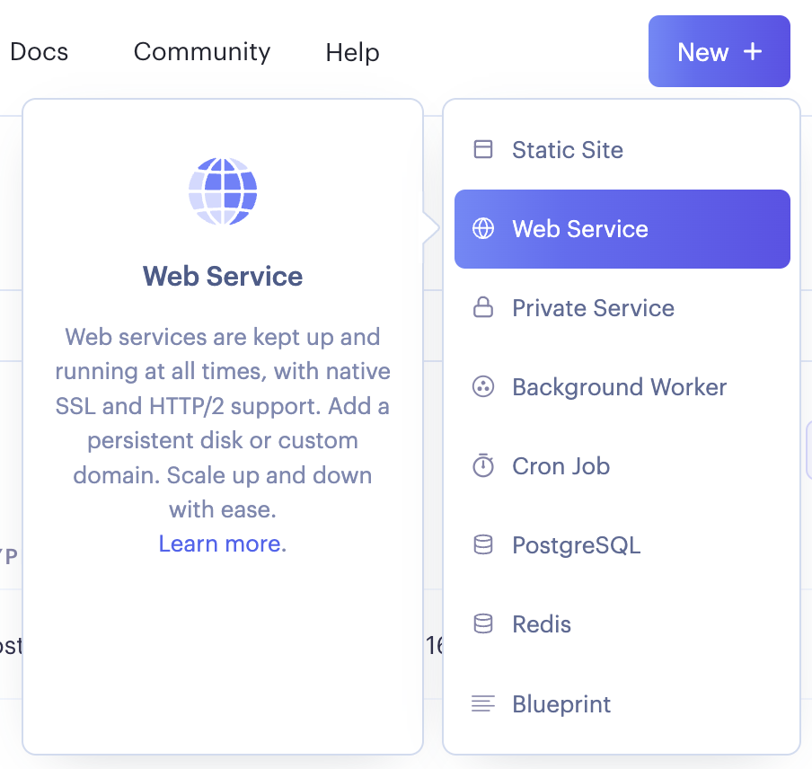
3. Select the “Build and deploy from a Git repository” option
4. Connect with your assignment 3 github repository,
5. Start command: npm start
6. Root Directory: api
7. Build command: npm install
8. Configure Environment variables from the UI
9. Once the API is deployed you will get a URL
10. Test some of your endpoints in Postman with the new URL, I recommend testing /ping endpoint first
11. Official Documentation for reference <https://docs.render.com/deploy-node-express-app>
12. Troubleshooting :

If you encounter 500 Server Error after deploying the app.

If you see prisma migrate errors after deploying, add these to scripts in package.json

"preinstall": "npm i -D prisma"

"postinstall": "npx prisma db push"

### Deploy your Web client

1. Update your API Url in your client folder
2. Go to your website/client directory and run the command "vercel". Follow the default settings just by pressing enter on each question.

### Auth0 Changes

Change your setting in Auth0 in order to add your newly created client side URL. There is no need to remove your localhost:3000 domain in auth0, you can just add multiple domains as comma separated values.