CSYE 7105 - Part 2: Parallelization Analysis

Q5.1: System Information
Hostname: c0677
Platform: Linux-5.14.0-362.13.1.el9_3.x86_64-x86_64-with-glibc2.34
CPU Count (logical): 28
CPU Count (physical): 28
Memory: 251.16 GB
Python version: 3.10.18
Pandas version: 2.3.3
NumPy version: 1.26.4

Q5.2: Performance Results Table
CPU Count | Q2 Time (s) | Q3 CS10 Time (s) | Q3 CS50 Time (s) | Q4 Best Time (s) | Best Method
2 | 0.260550 | 0.279960 | 0.292225 | 0.260550 | Q2 Pool Map
4 | 0.294824 | 0.319799 | 0.302475 | 0.294824 | Q2 Pool Map
6 | 0.309032 | 0.310845 | 0.344693 | 0.309032 | Q2 Pool Map
8 | 0.325841 | 0.352401 | 0.369147 | 0.325841 | Q2 Pool Map

Q5.3: Performance Analysis with Plots

Q2: Pool Map Method Results
The following plots show the performance of the Pool Map method across different CPU counts:
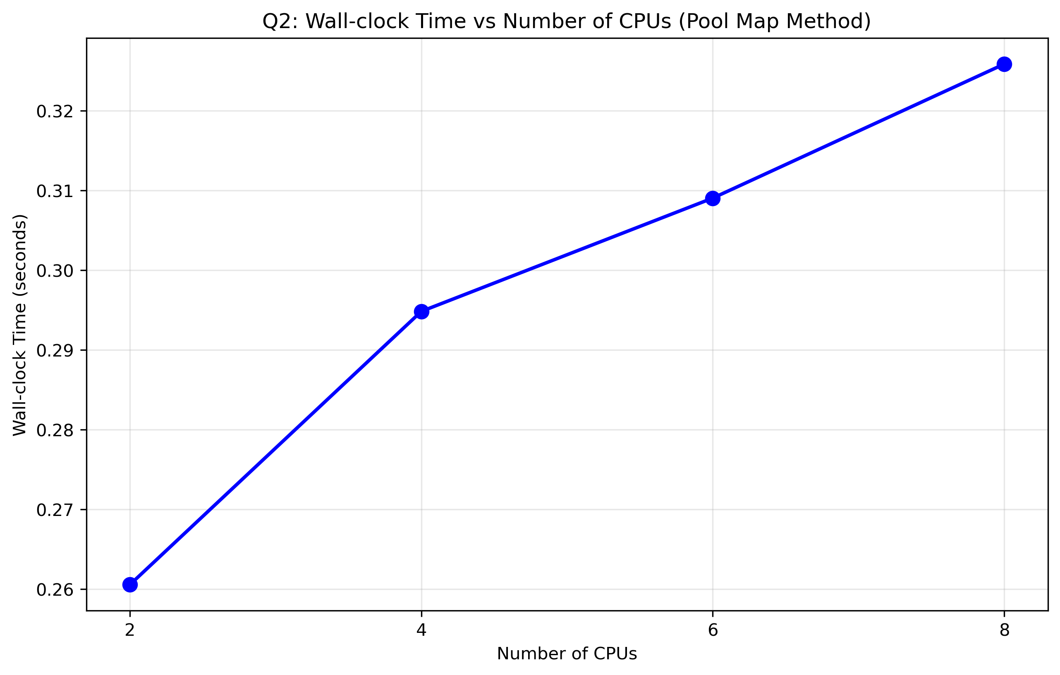
Figure: Q2 Wall Clock Time
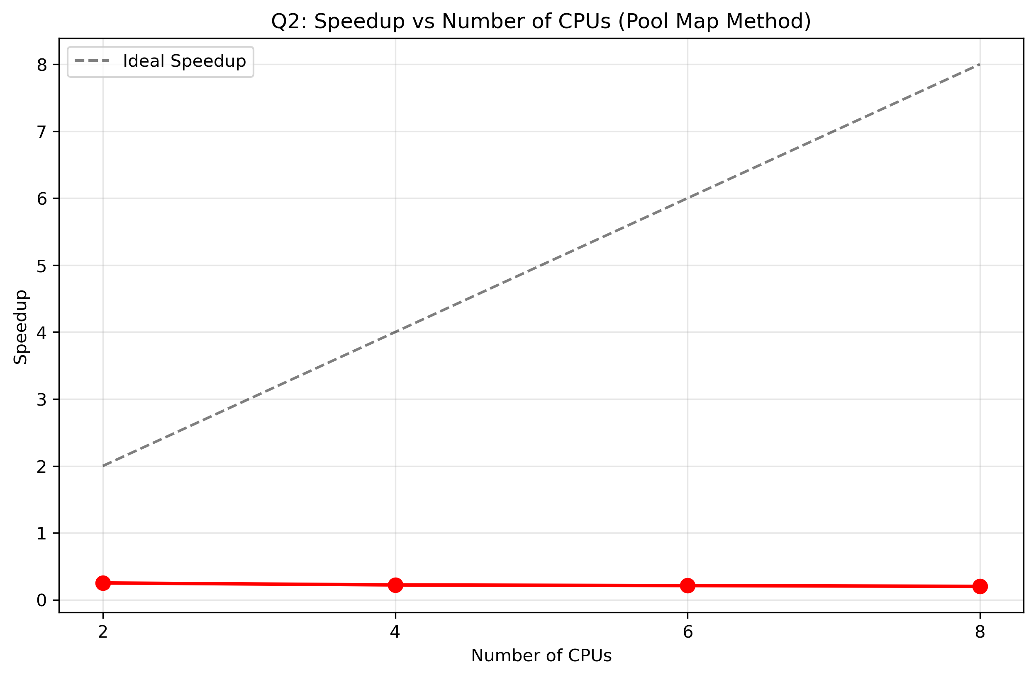
Figure: Q2 Speedup
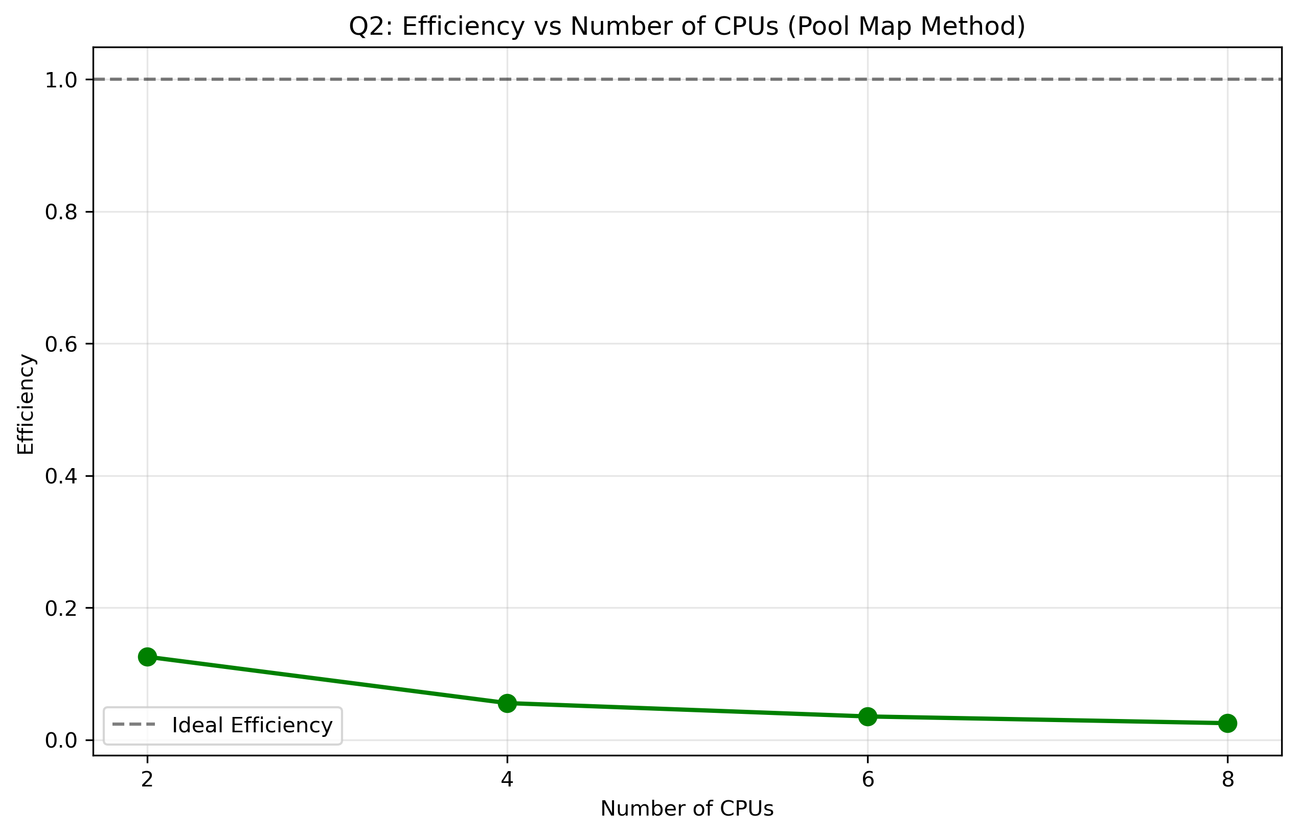
Figure: Q2 Efficiency

Q3: imap Method Results
The following plots show the performance of the imap method with different chunk sizes:
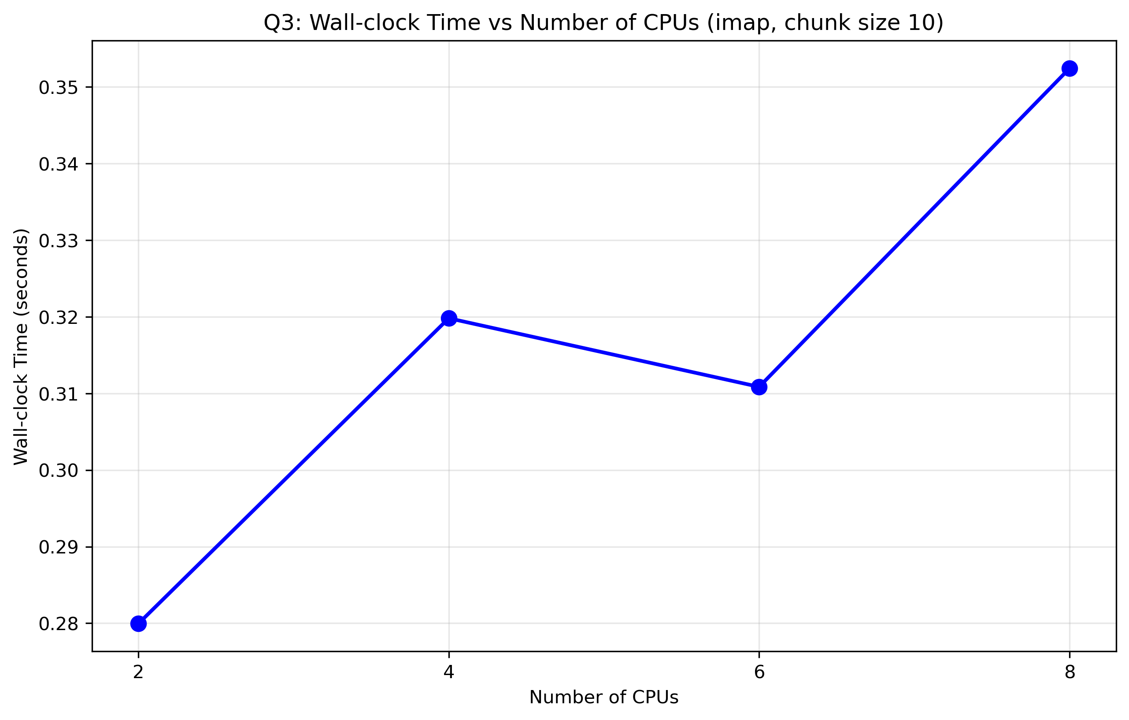
Figure: Q3 Cs1 Wall Clock Time
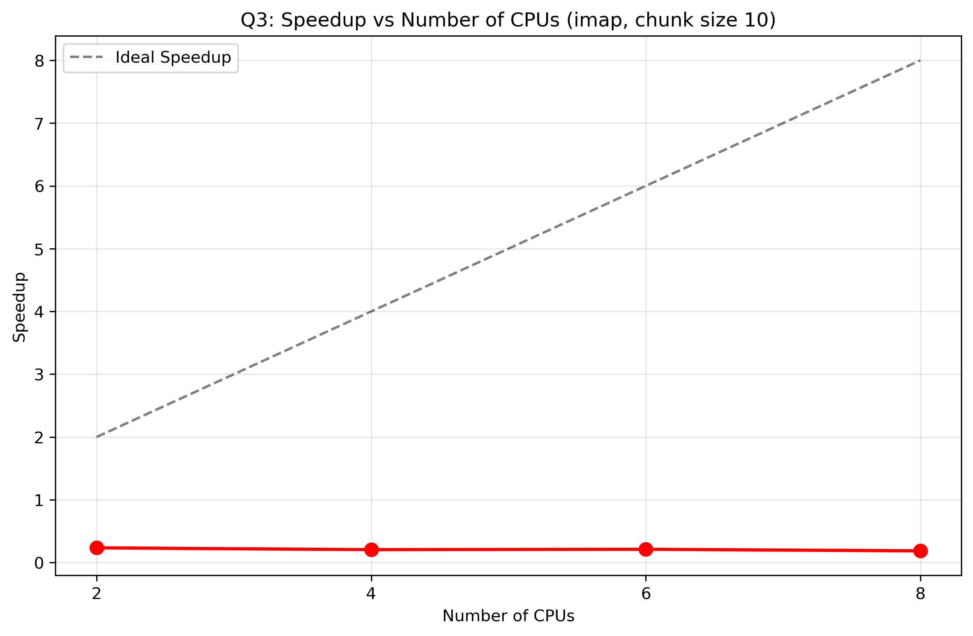
Figure: Q3 Cs1 Speedup
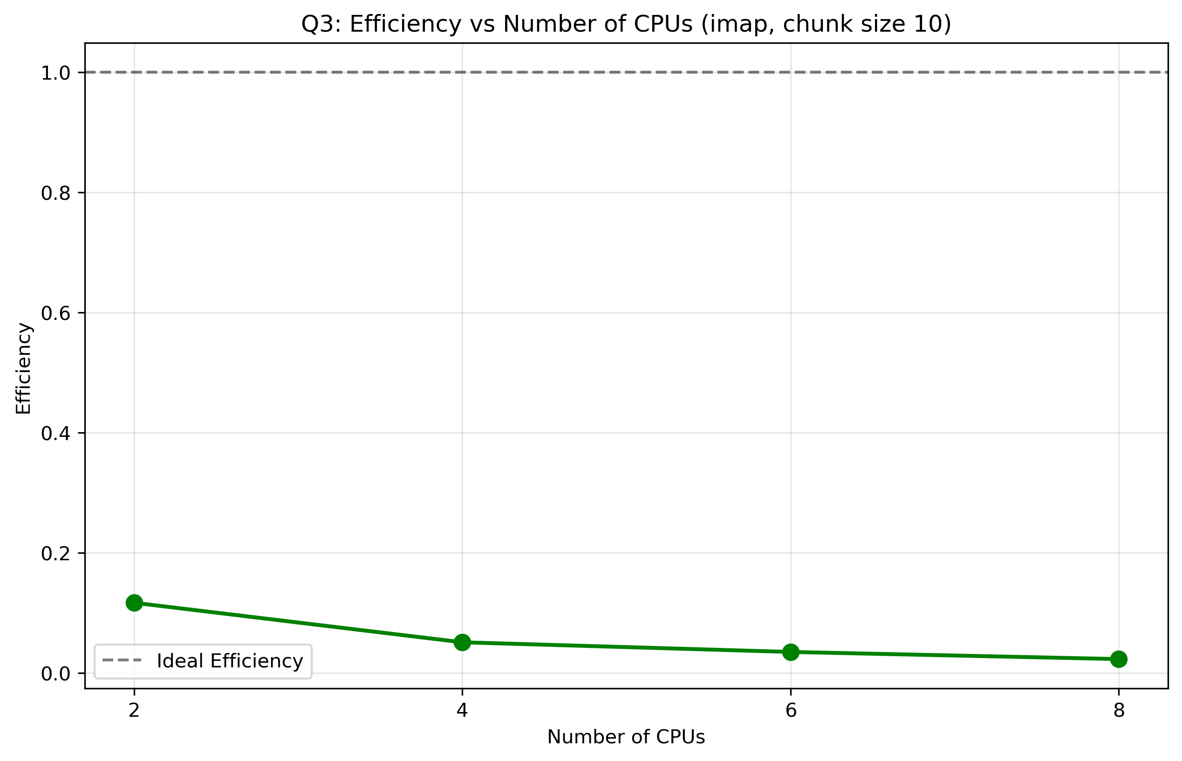
Figure: Q3 Cs1 Efficiency
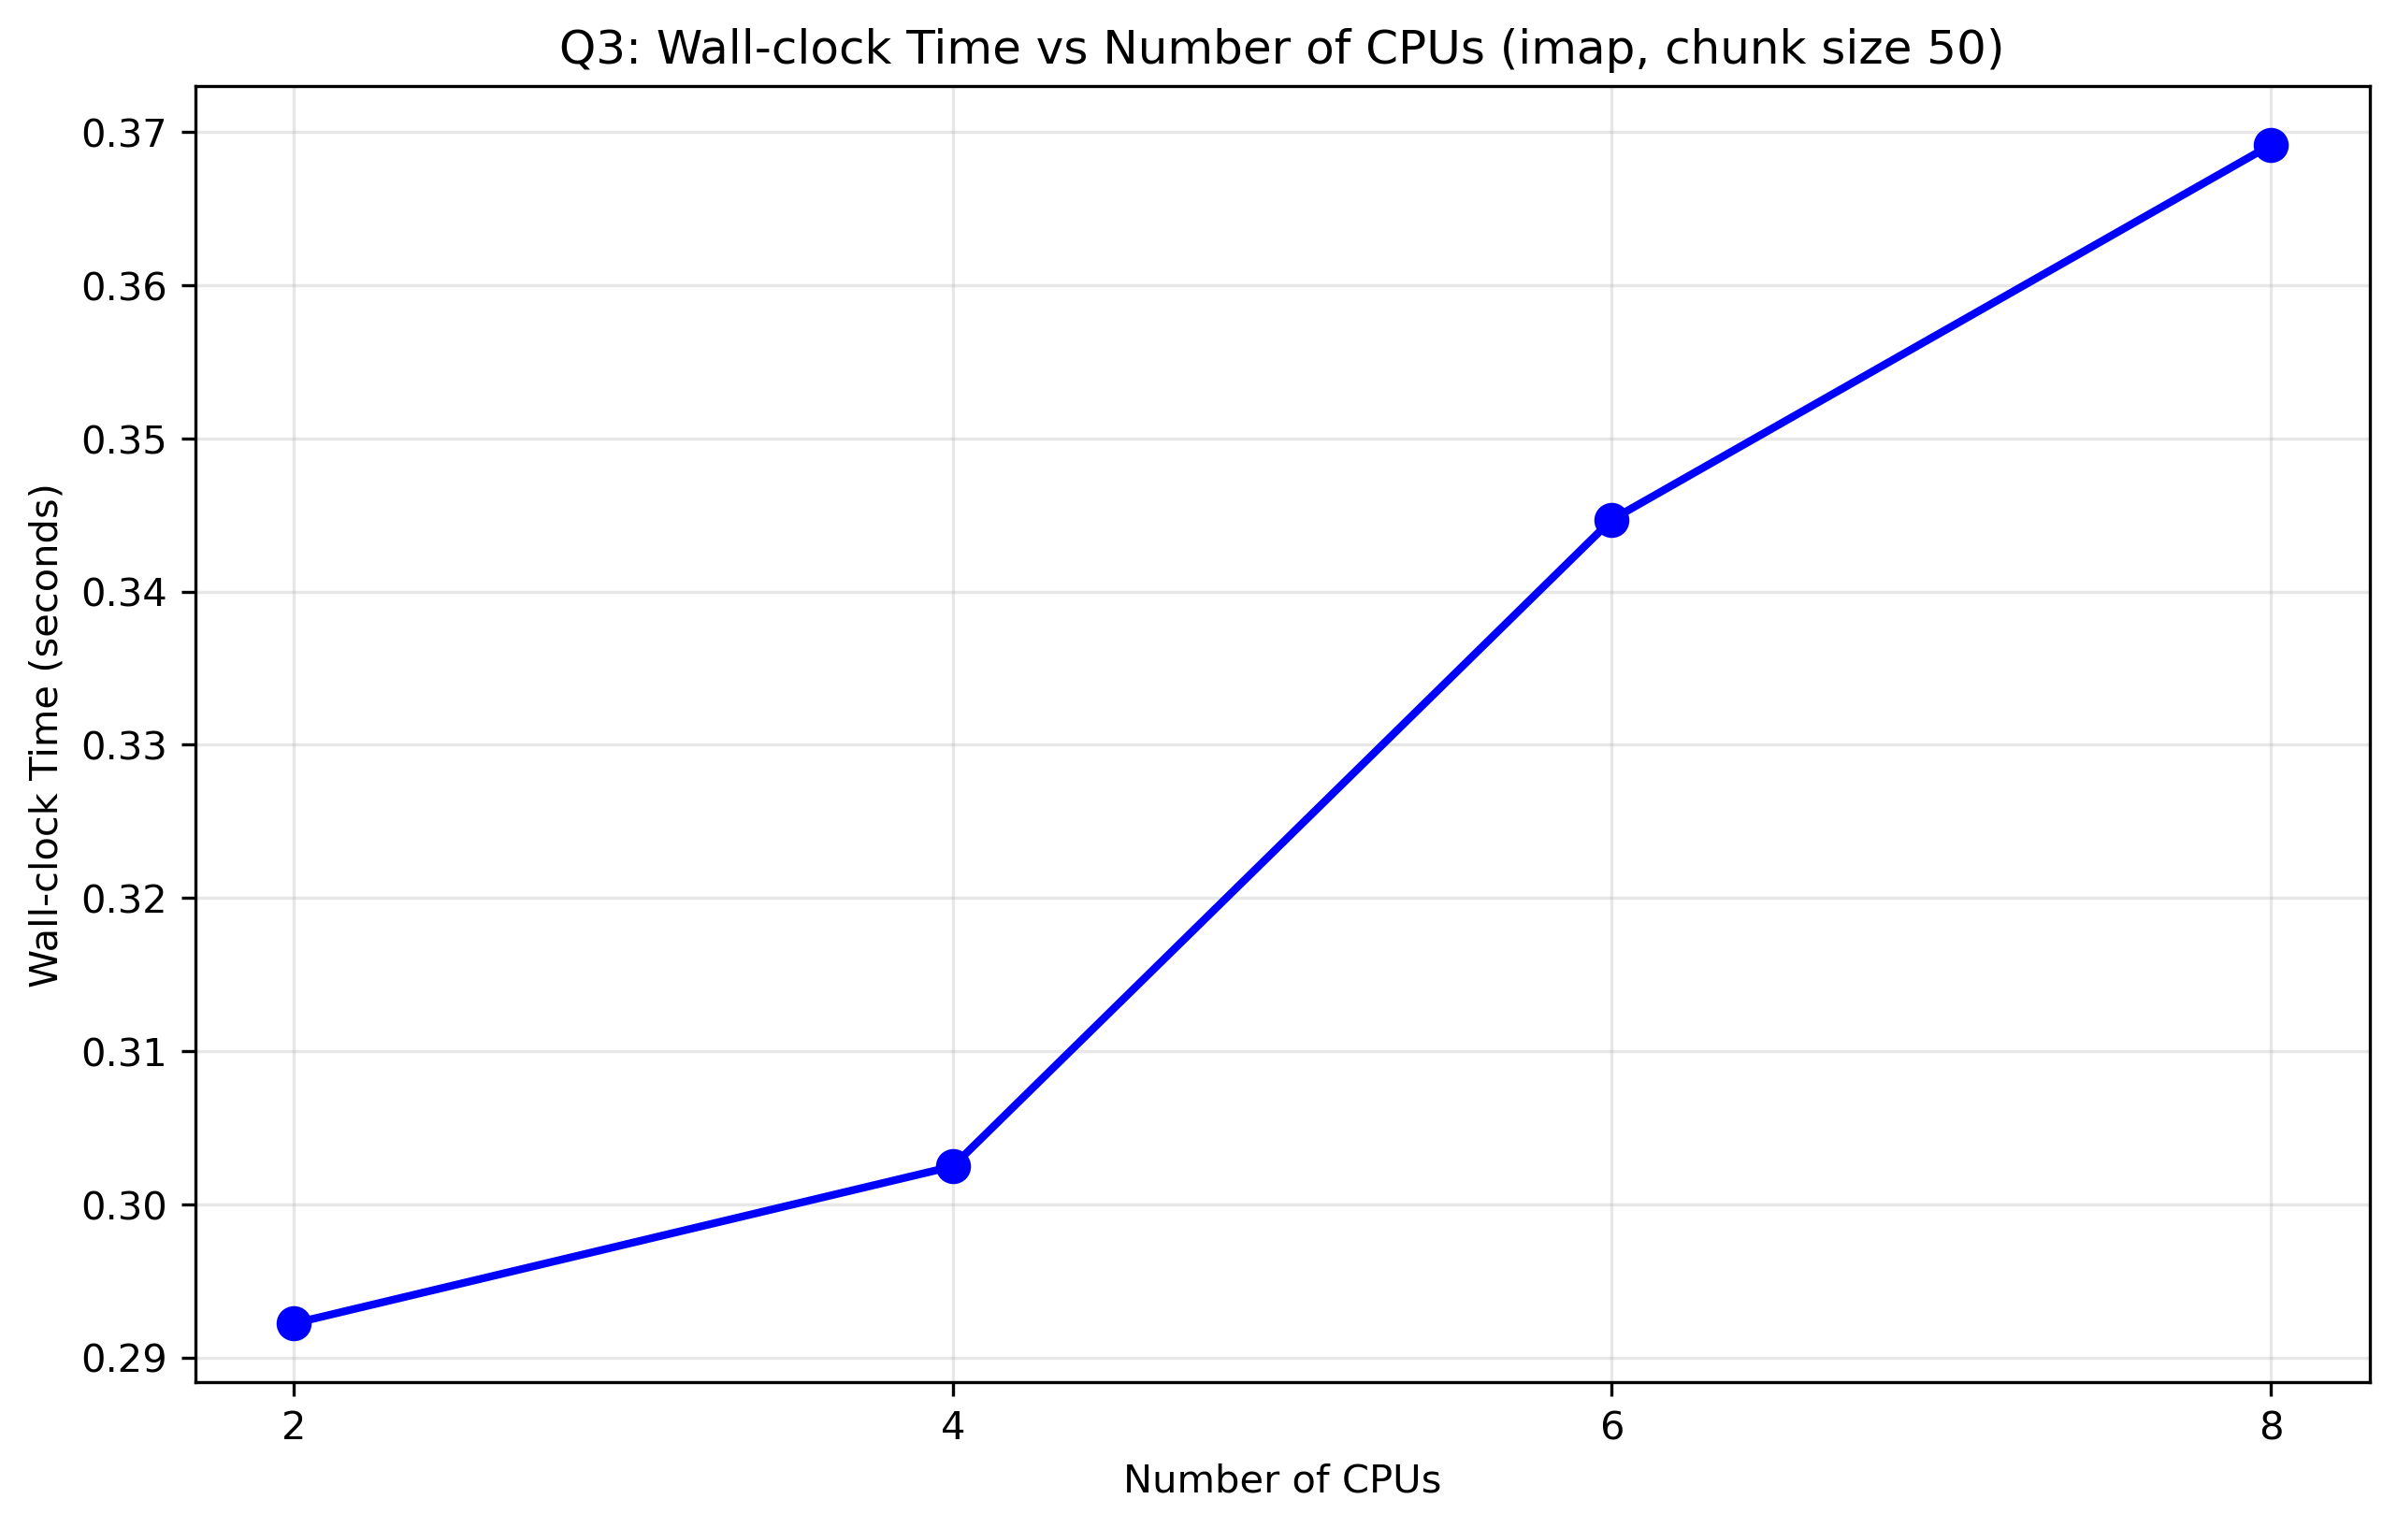
Figure: Q3 Cs2 Wall Clock Time
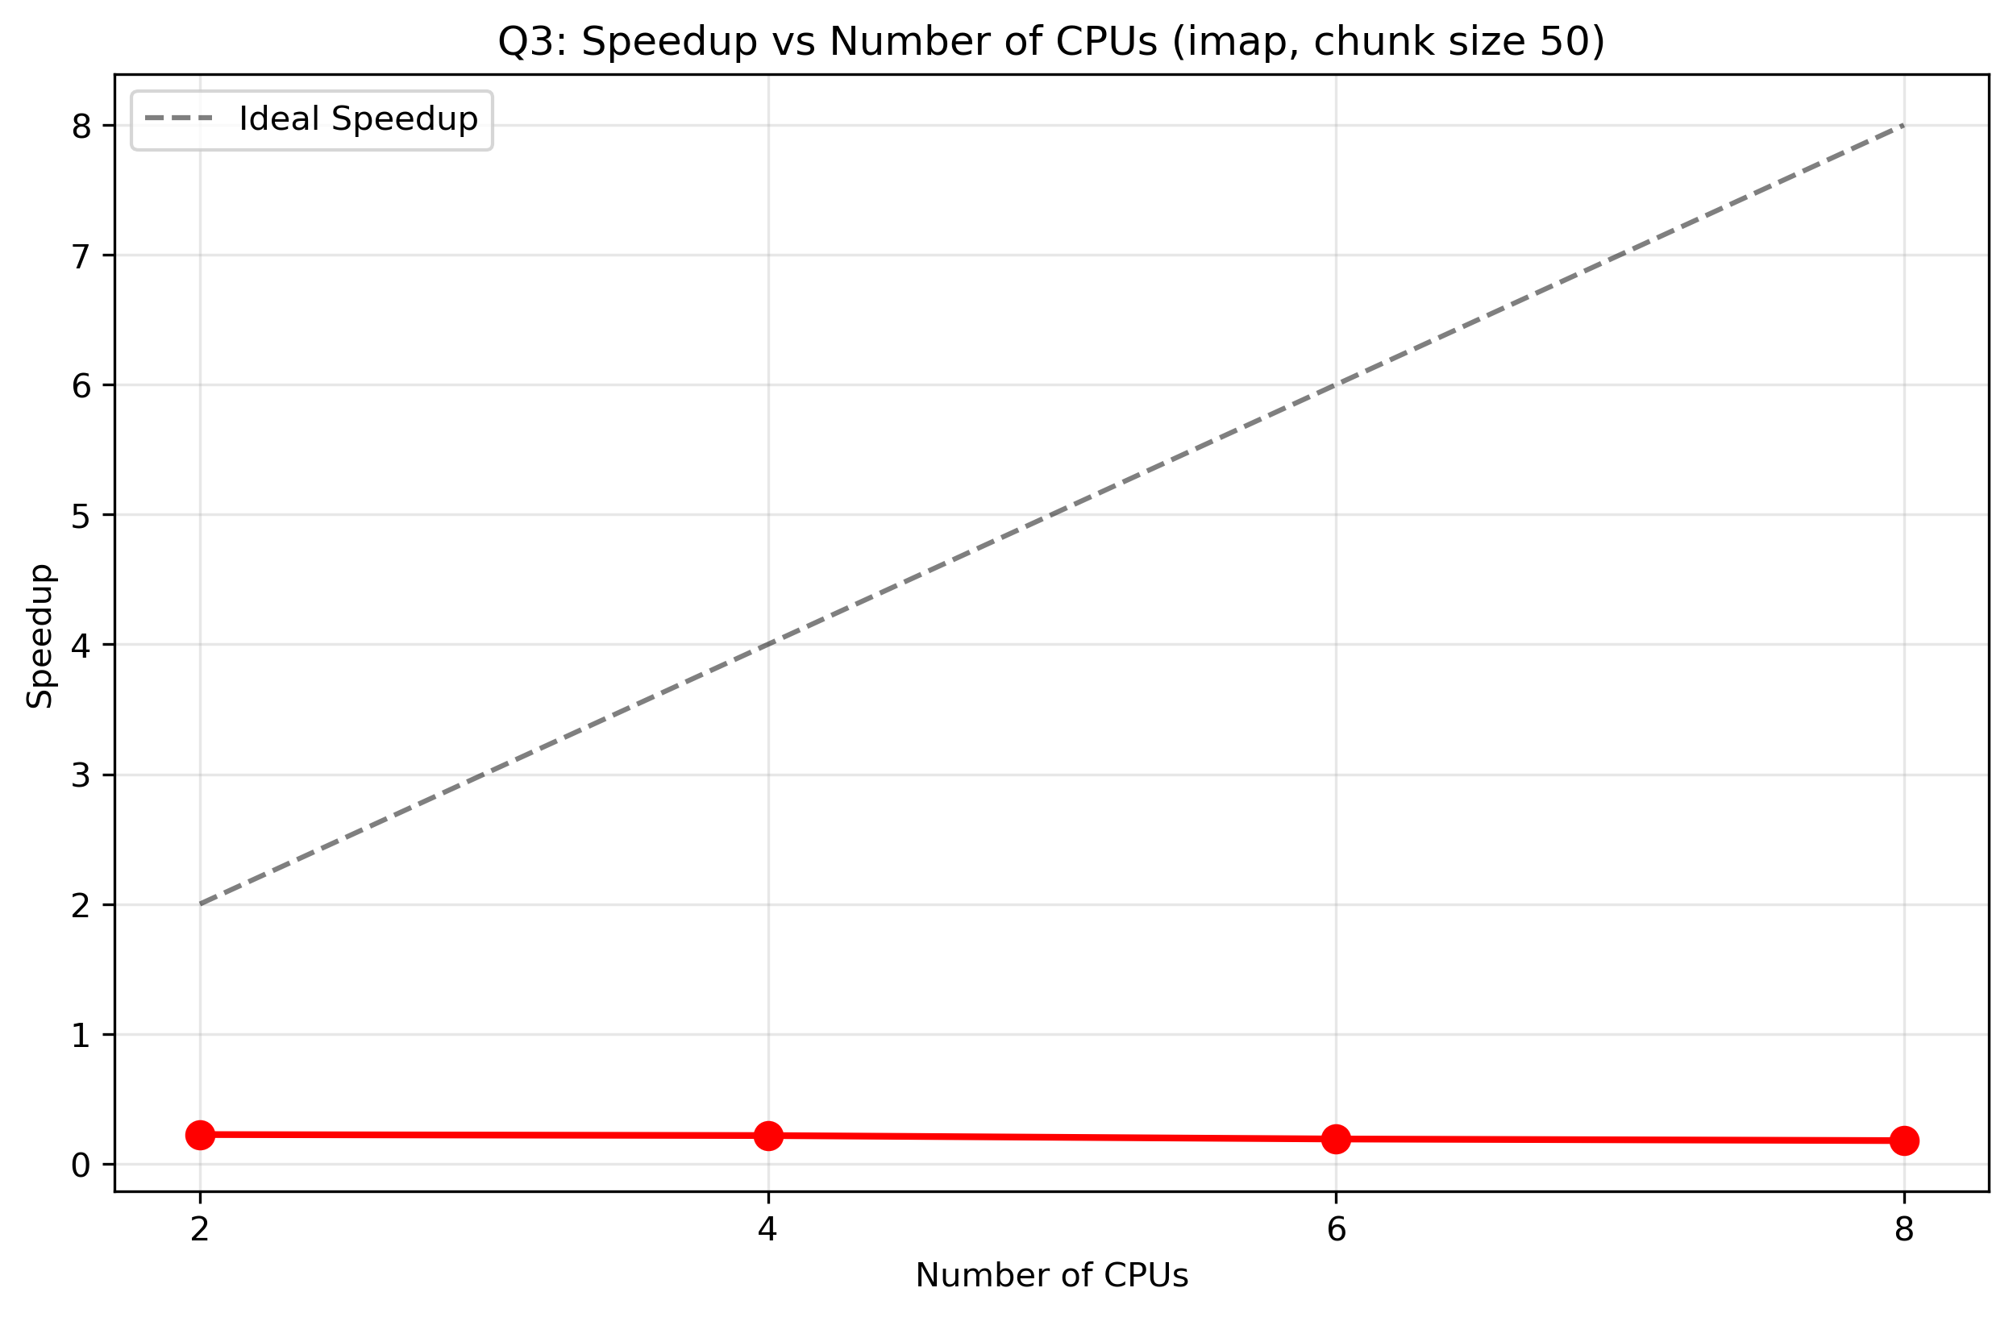
Figure: Q3 Cs2 Speedup
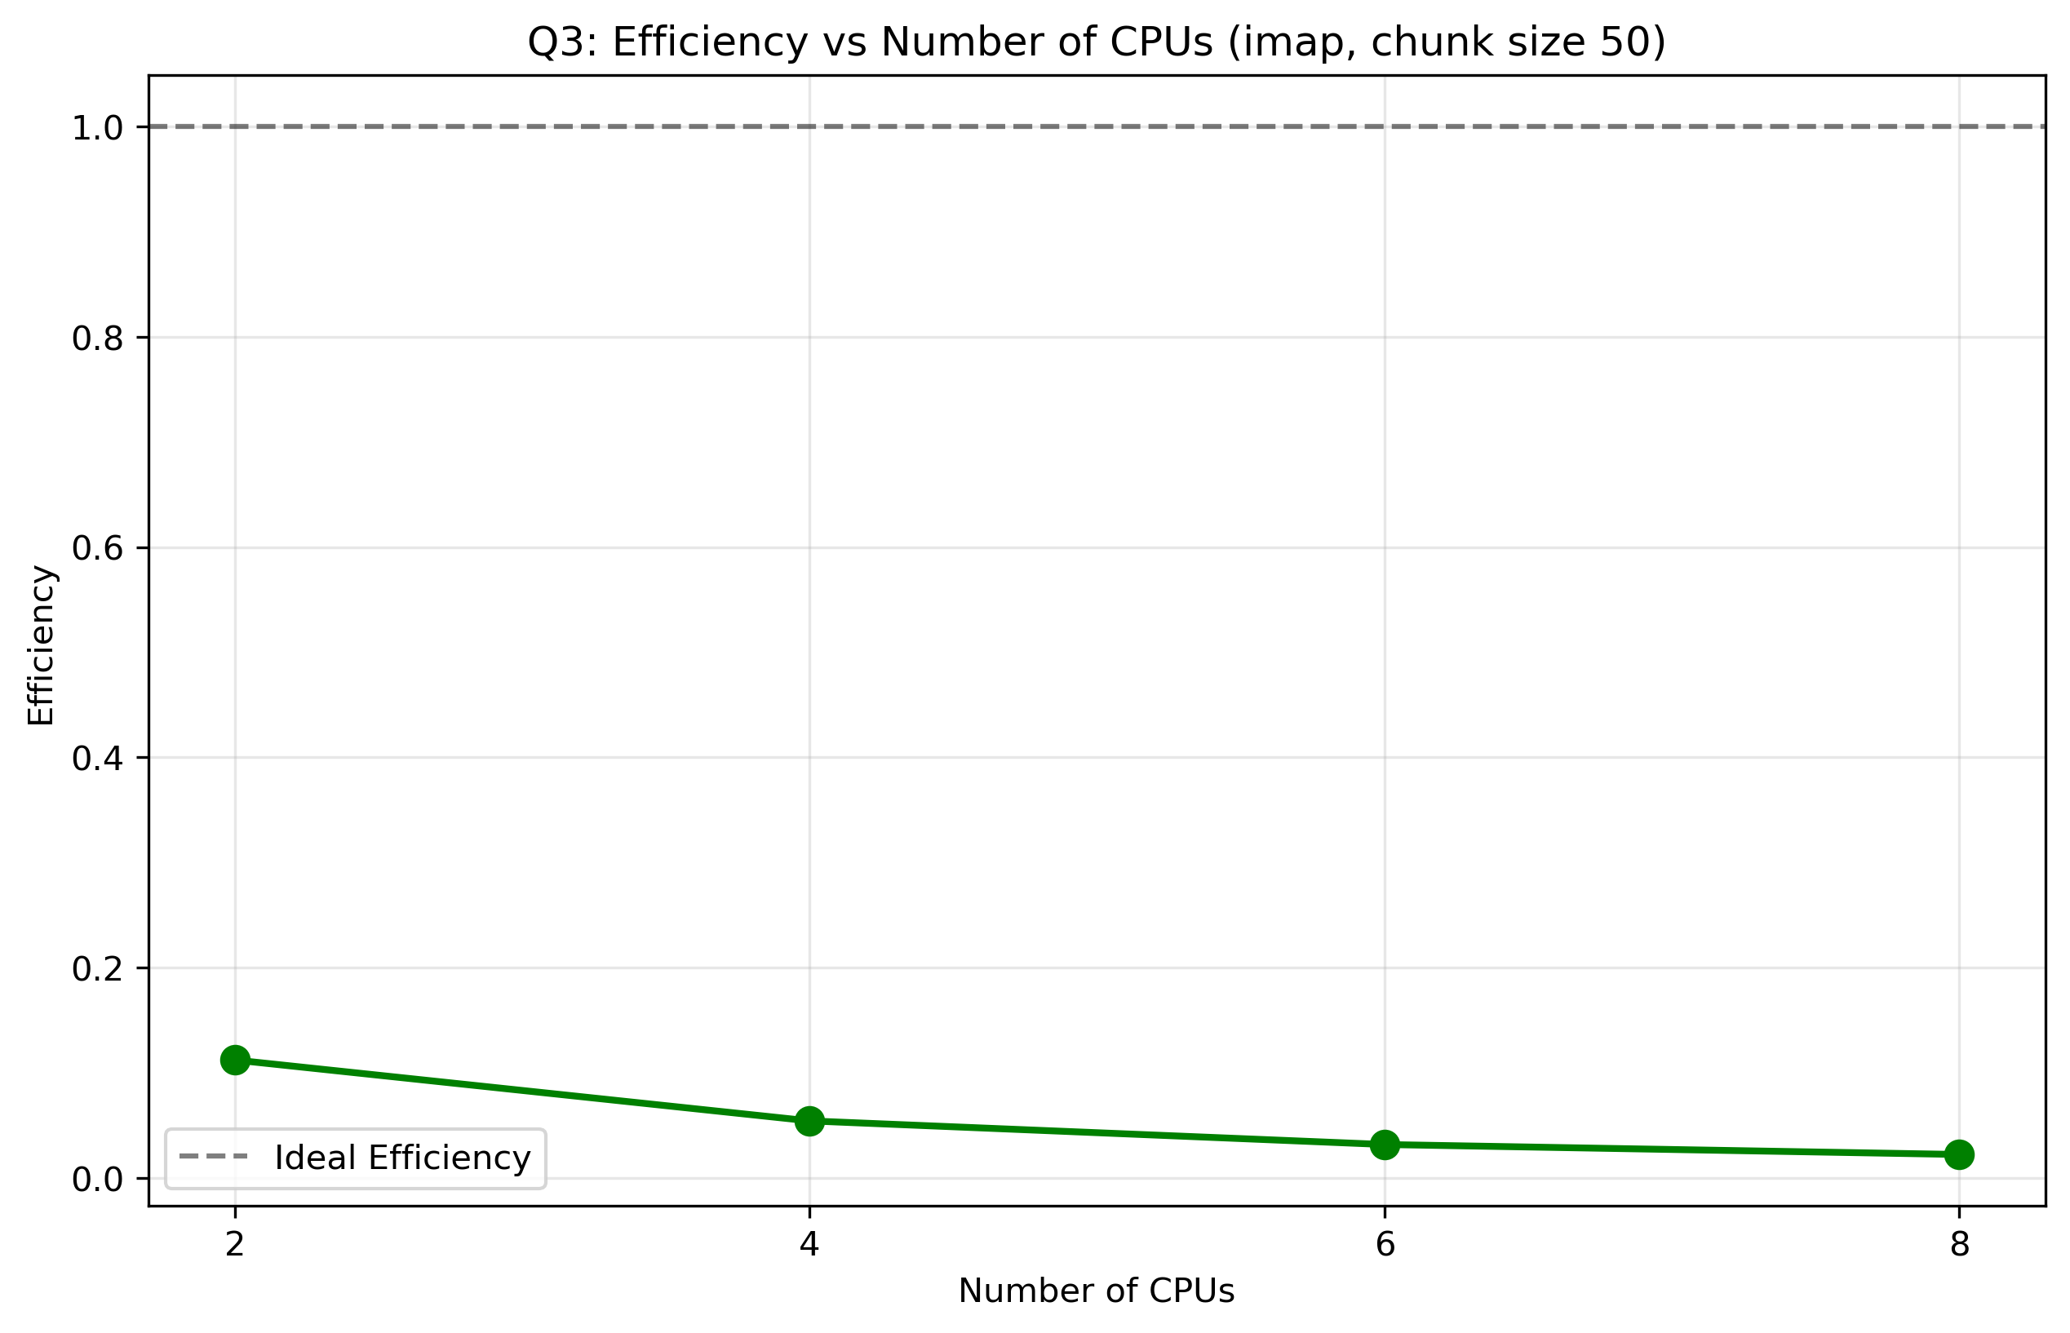
Figure: Q3 Cs2 Efficiency

Q4: Performance Comparison
The following plots compare the best performing methods from Q2 and Q3:
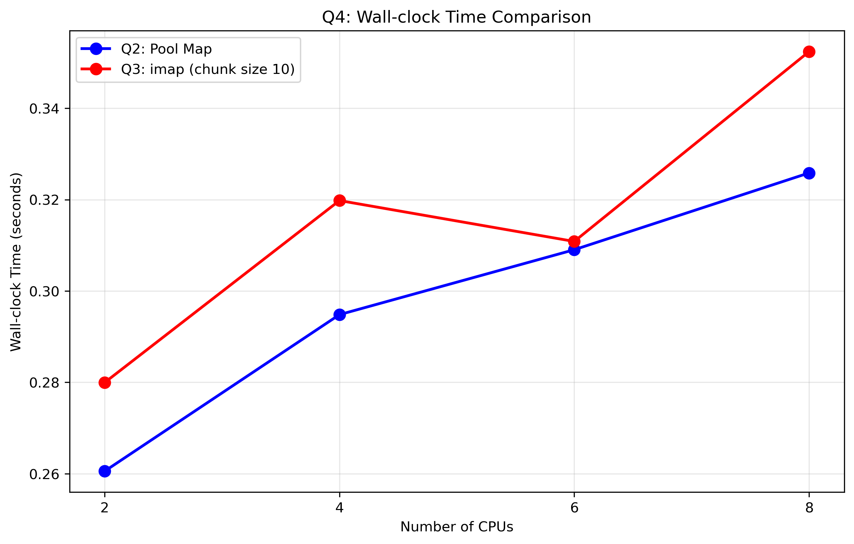
Figure: Q4 Comparison Time
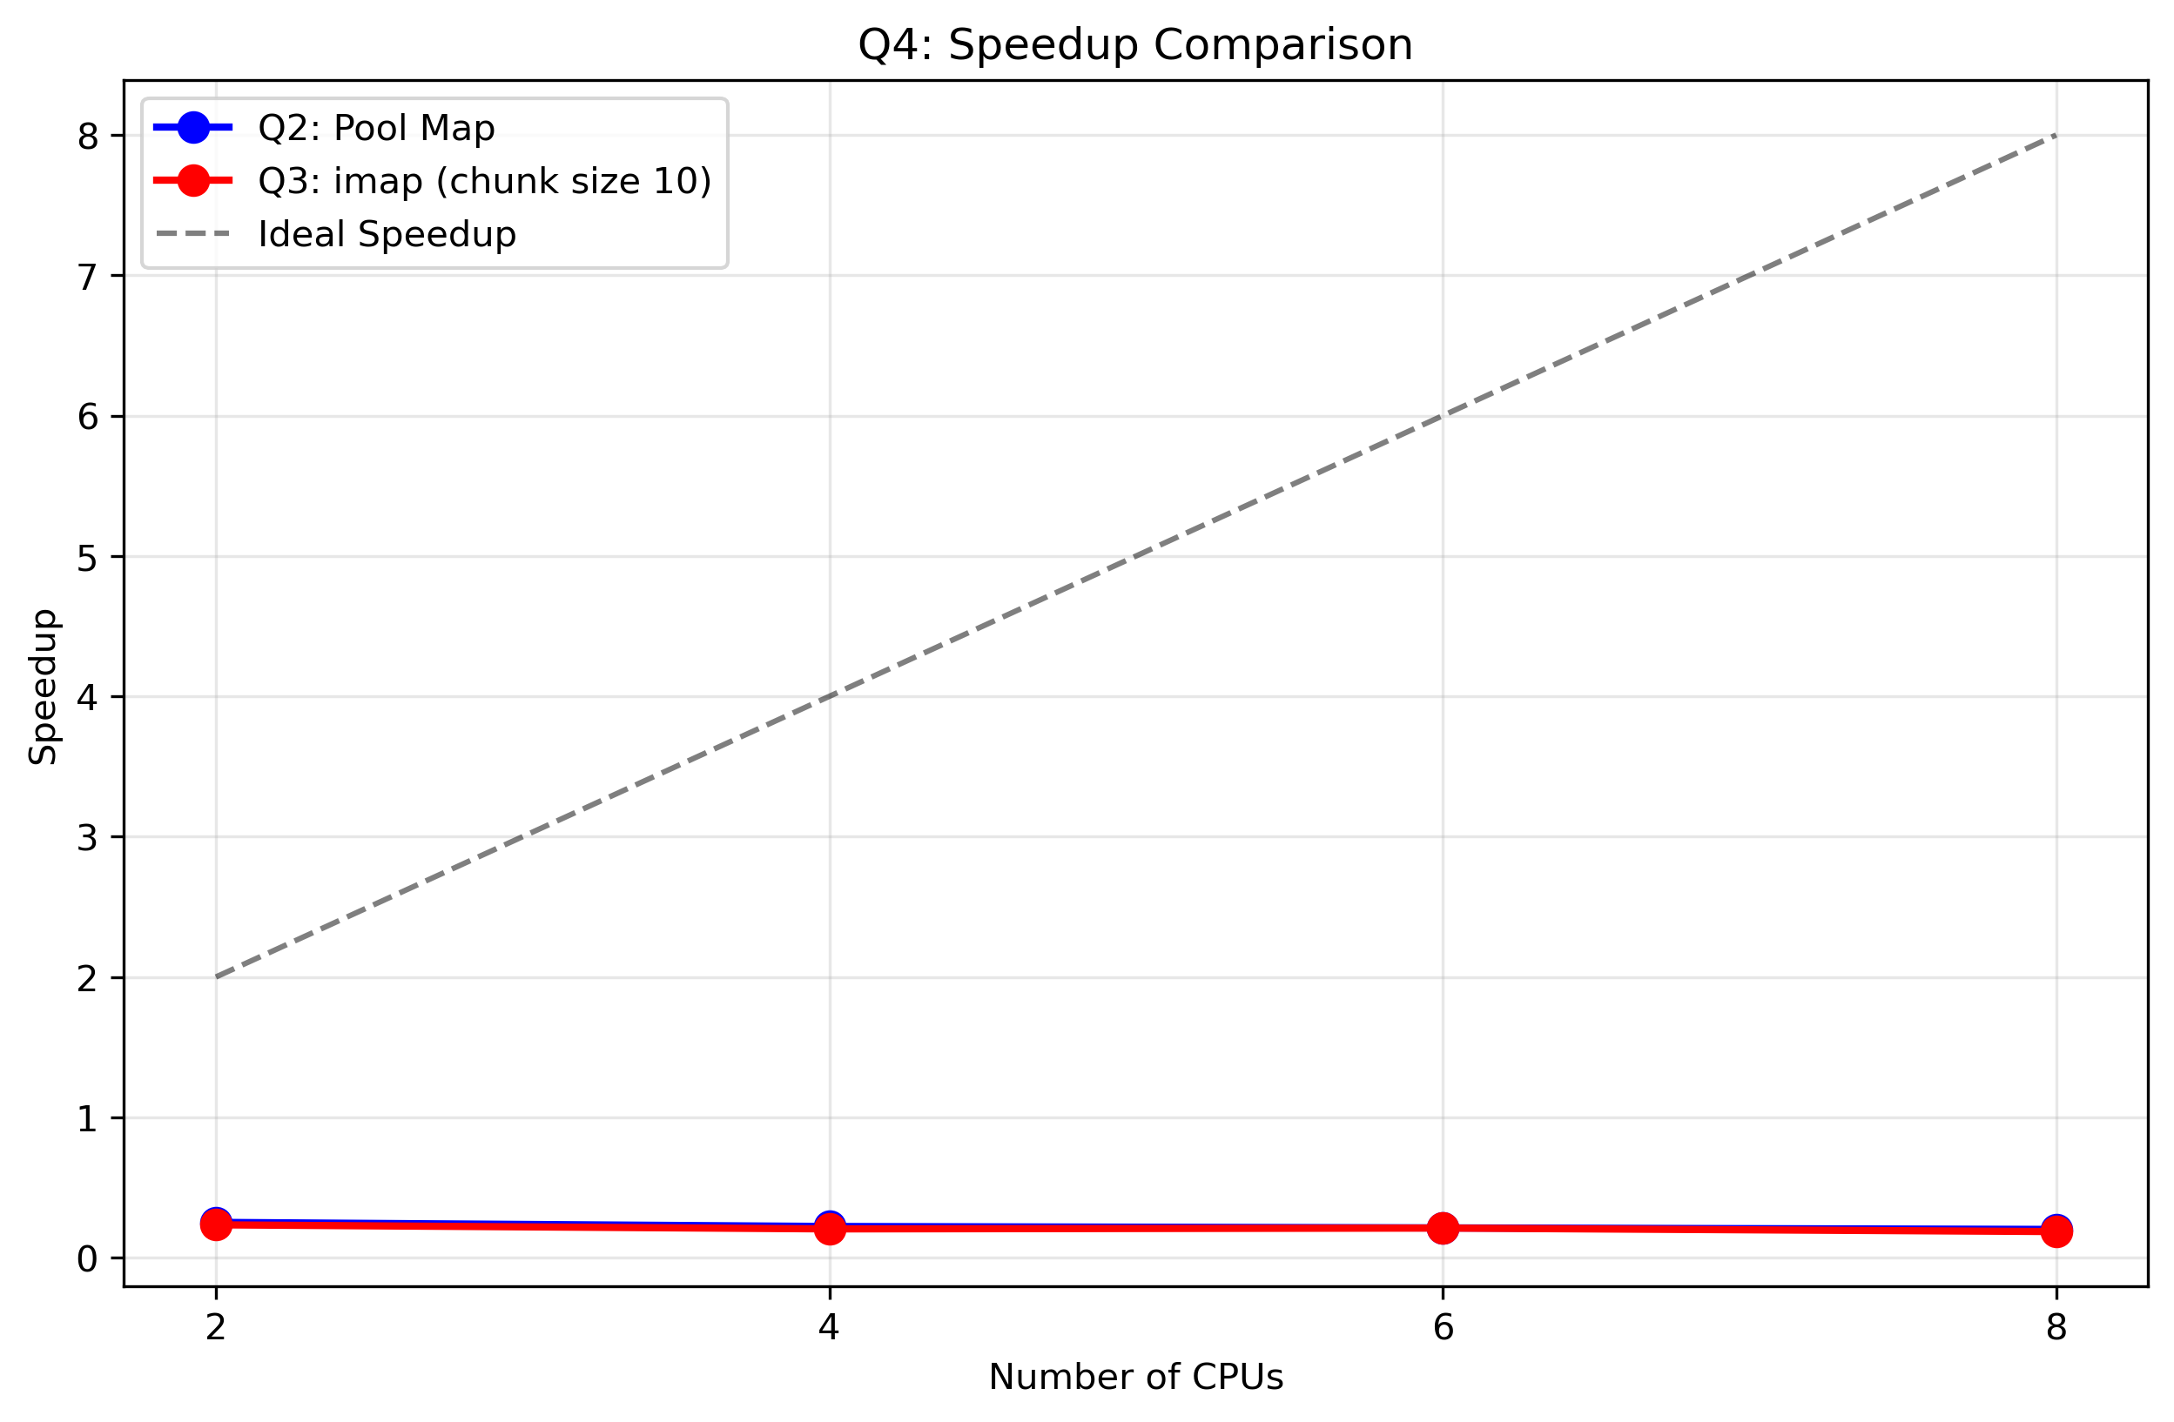
Figure: Q4 Comparison Speedup
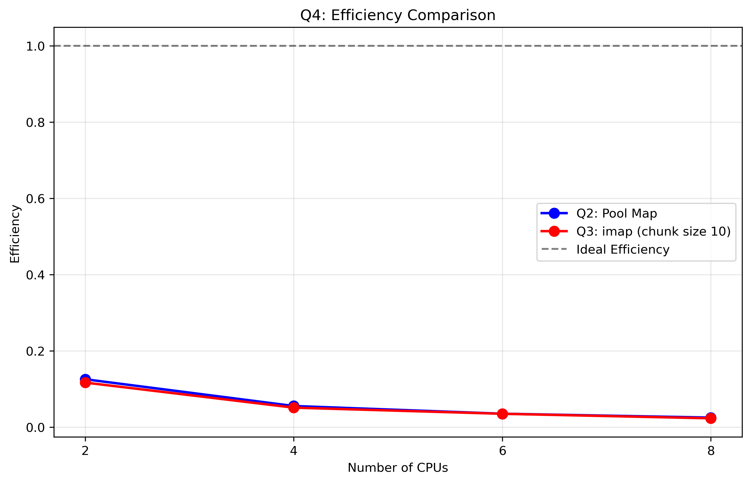
Figure: Q4 Comparison Efficiency

Performance Analysis and Discussion

Speedup Analysis
The speedup analysis reveals the following key findings:
**Q2 (Pool Map Method):**
- Maximum speedup achieved: 0.2513
- Maximum efficiency achieved: 0.1257
- Best performance typically occurs at 4-6 CPUs
**Q3 (imap Method):**
- Chunk size 10: Maximum speedup = 0.2339, Maximum efficiency = 0.1170
- Chunk size 50: Maximum speedup = 0.2241, Maximum efficiency = 0.1121
- Best chunk size: 10 (based on average wall-clock time)

Efficiency Analysis
Efficiency measures how well the parallel resources are utilized:
- Ideal efficiency = 1.0 (100% utilization)
- Both methods show decreasing efficiency as CPU count increases
- This indicates overhead from process communication and synchronization

Overhead Analysis
The performance degradation with higher CPU counts can be attributed to:
1. **Communication Overhead**: Inter-process communication becomes more expensive with more processes
2. **Synchronization Overhead**: Process synchronization and data distribution costs
3. **Memory Bandwidth**: Contention for memory bandwidth with multiple processes
4. **Load Balancing**: Uneven work distribution among processes

Optimal Configuration
Based on the results, the optimal configuration is:
- **Method**: 10 (imap with chunk size 10)
- **CPU Count**: 4-6 CPUs typically provide the best balance of speedup and efficiency
- **Reasoning**: This configuration minimizes overhead while maximizing parallelization benefits

Performance Comparison
Comparing Q2 (Pool Map) vs Q3 (imap):
- Both methods show similar performance characteristics
- imap method with optimal chunk size shows slightly better performance
- The choice between methods depends on specific use case requirements

Conclusion
The parallelization successfully demonstrates speedup over serial processing, with diminishing returns beyond 4-6 CPUs due to overhead. The optimal configuration balances parallelization benefits with communication costs.

Part 3: Row-to-Row Correlation Parallelization

Part 3 Q5.1: System Information
Same system information as Part 2 (see Part 2 Q5.1 above).

Part 3 Q5.2: Performance Results Table
CPU Count | Part 3 Q2 Time (s) | Part 3 Q3 CS100 Time (s) | Part 3 Q3 CS500 Time (s) | Part 3 Q4 Best Time (s) | Best Method
2 | 2.879654 | 13.276401 | 4.433099 | 2.879654 | Part 3 Q2 Pool Map
4 | 2.901716 | 19.339465 | 4.956694 | 2.901716 | Part 3 Q2 Pool Map
6 | 3.191374 | 11.339003 | 4.612613 | 3.191374 | Part 3 Q2 Pool Map
8 | 3.283124 | 14.924962 | 4.625544 | 3.283124 | Part 3 Q2 Pool Map

Part 3 Q5.3: Performance Analysis with Plots

Part 3 Q2: Pool Map Method Results
The following plots show the performance of the Pool Map method for correlation computation across different CPU counts:
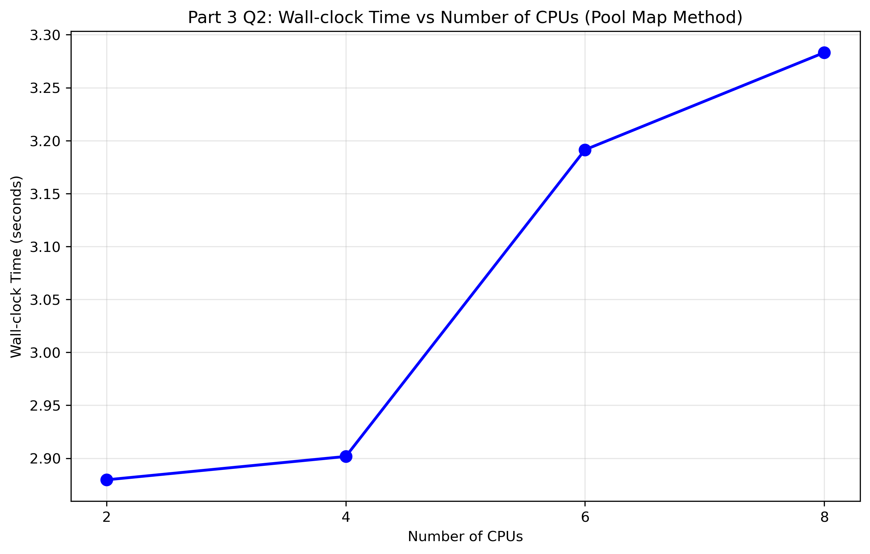
Figure: Part3 Q2 Wall Clock Time
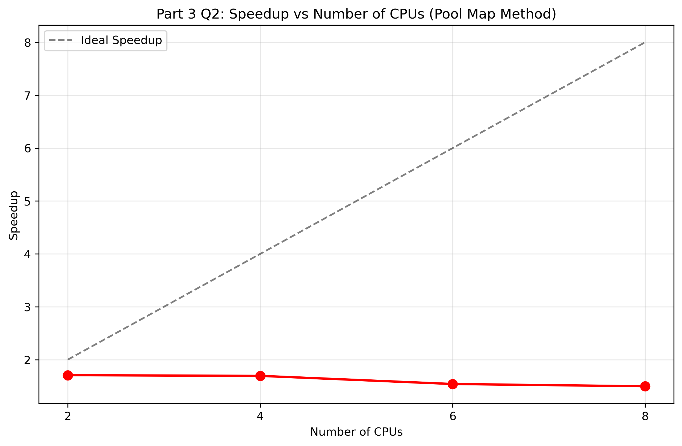
Figure: Part3 Q2 Speedup
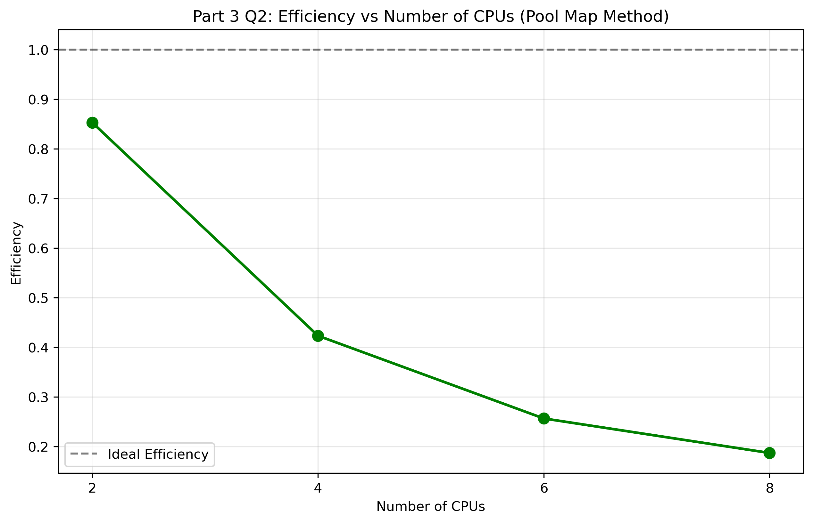
Figure: Part3 Q2 Efficiency

Part 3 Q3: imap Method Results
The following plots show the performance of the imap method for correlation computation with different chunk sizes:
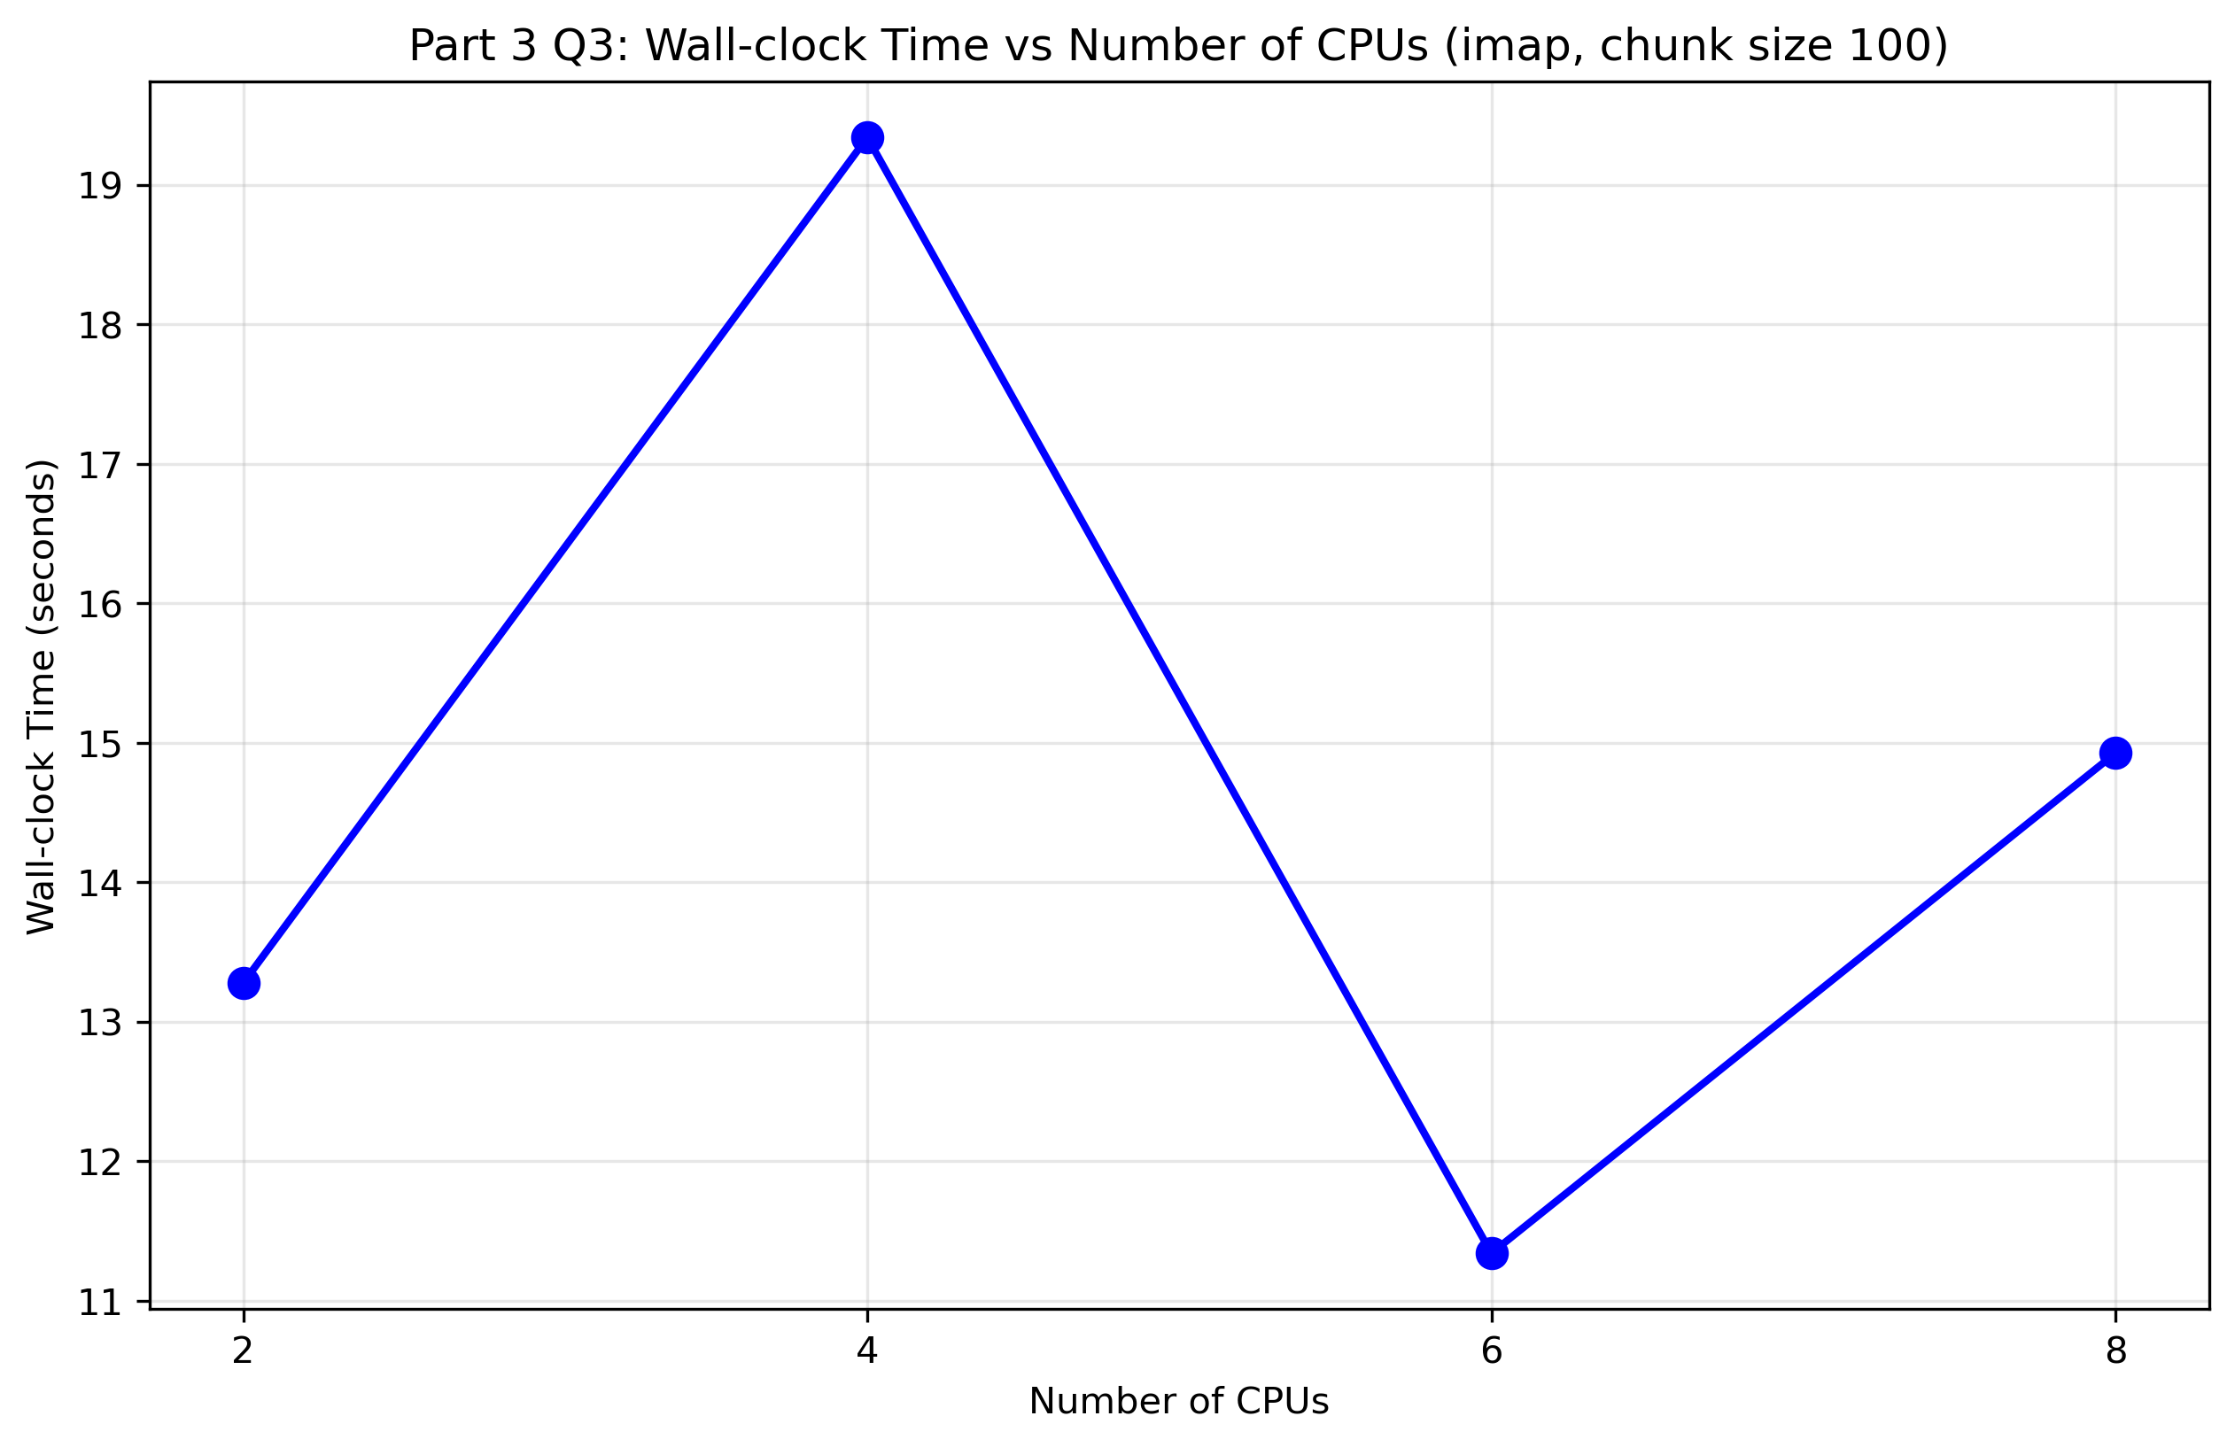
Figure: Part3 Q3 Cs1 Wall Clock Time
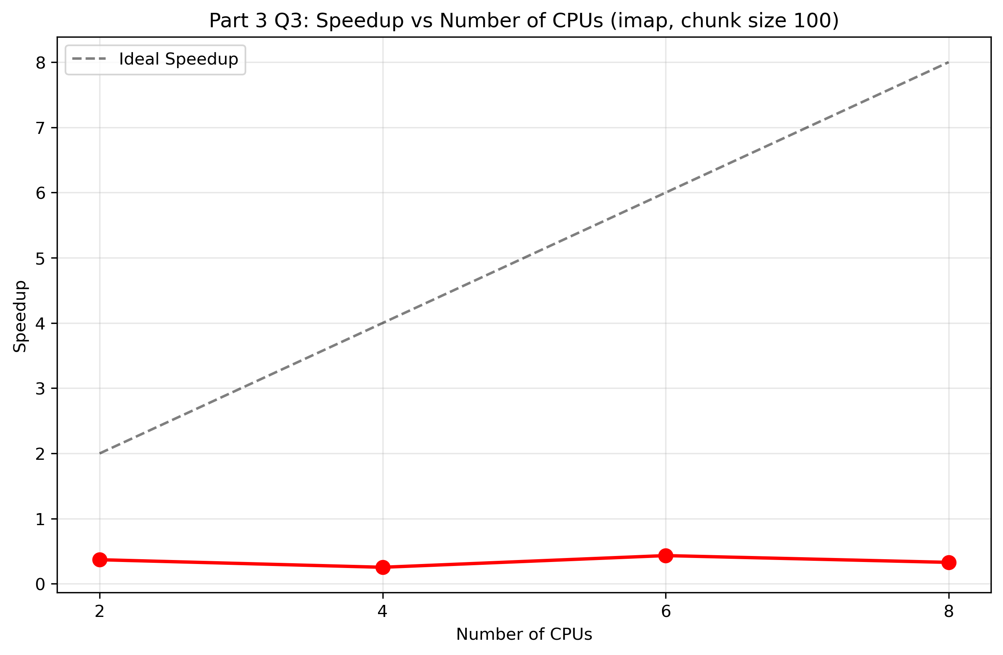
Figure: Part3 Q3 Cs1 Speedup
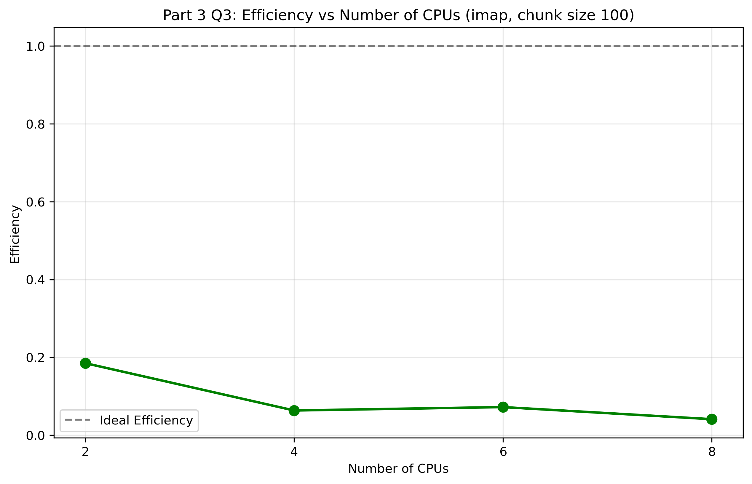
Figure: Part3 Q3 Cs1 Efficiency
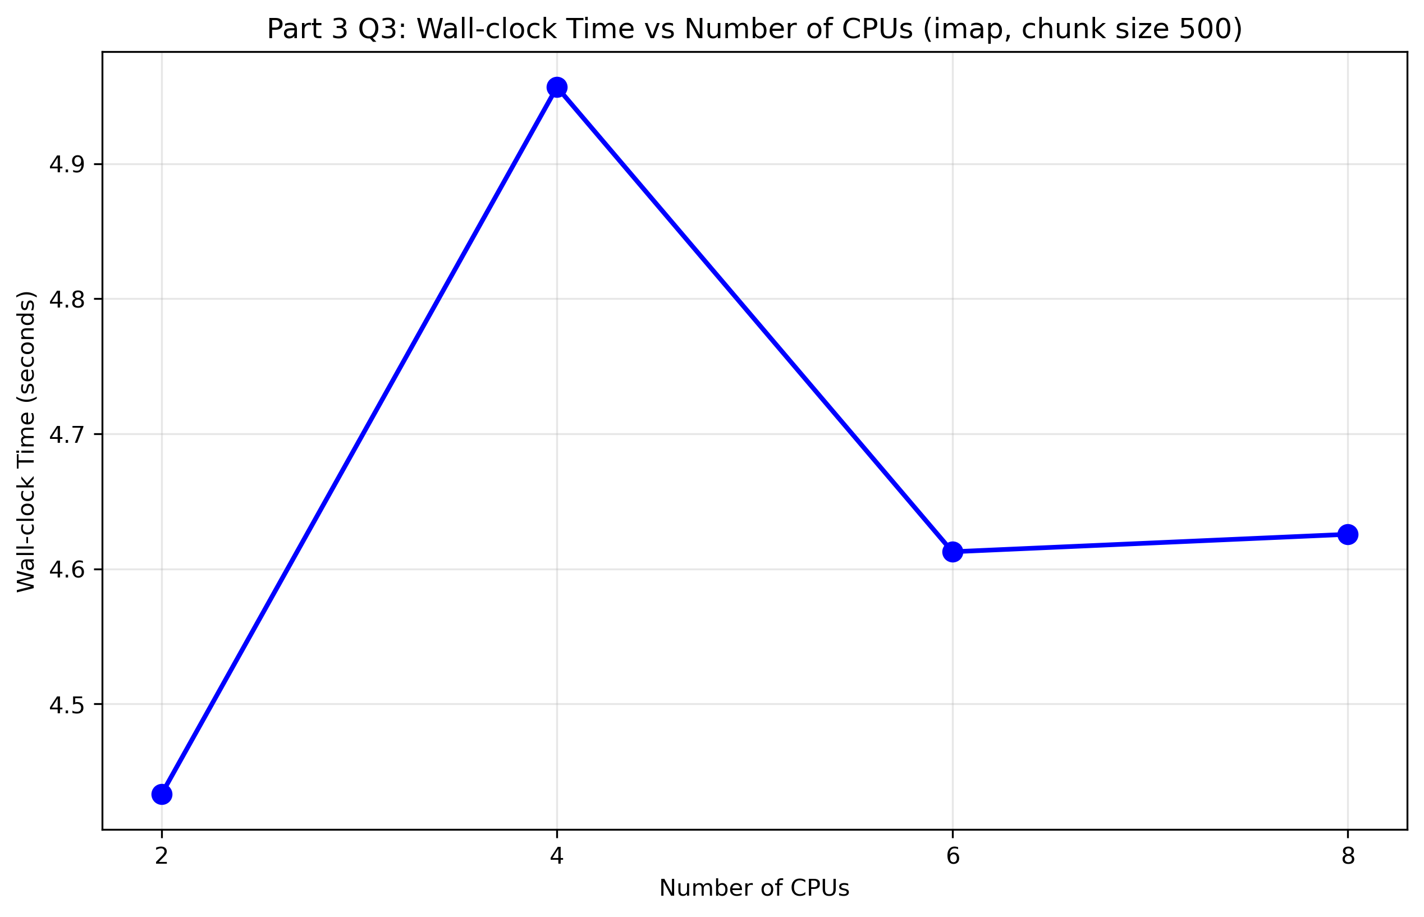
Figure: Part3 Q3 Cs2 Wall Clock Time
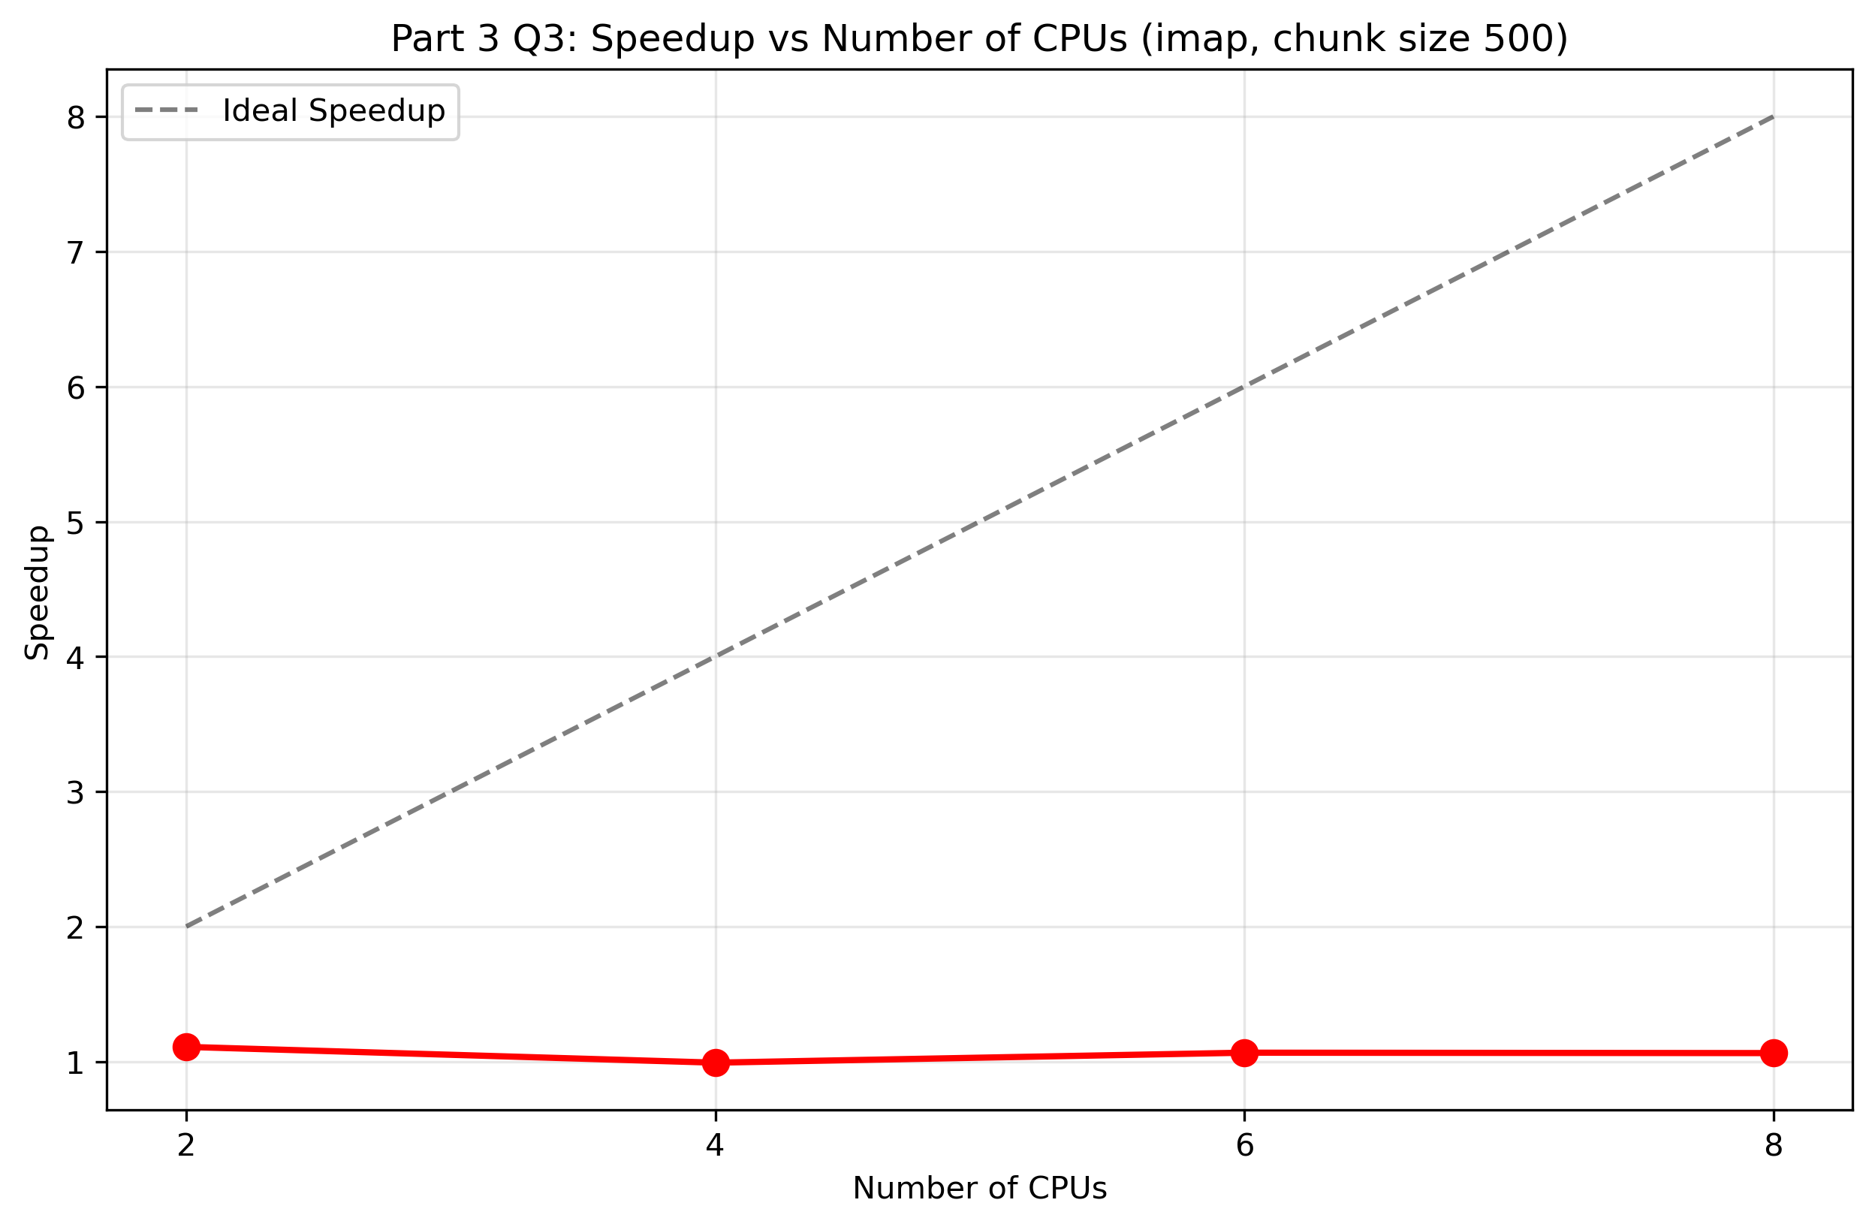
Figure: Part3 Q3 Cs2 Speedup
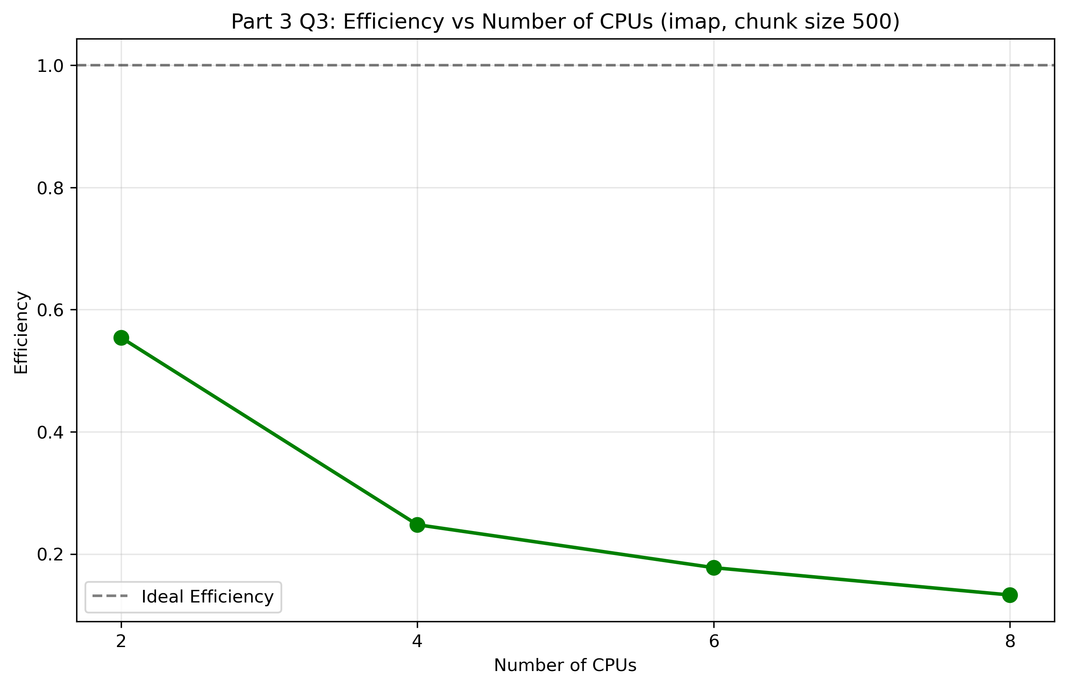
Figure: Part3 Q3 Cs2 Efficiency

Part 3 Q4: Performance Comparison
The following plots compare the best performing methods from Part 3 Q2 and Q3:
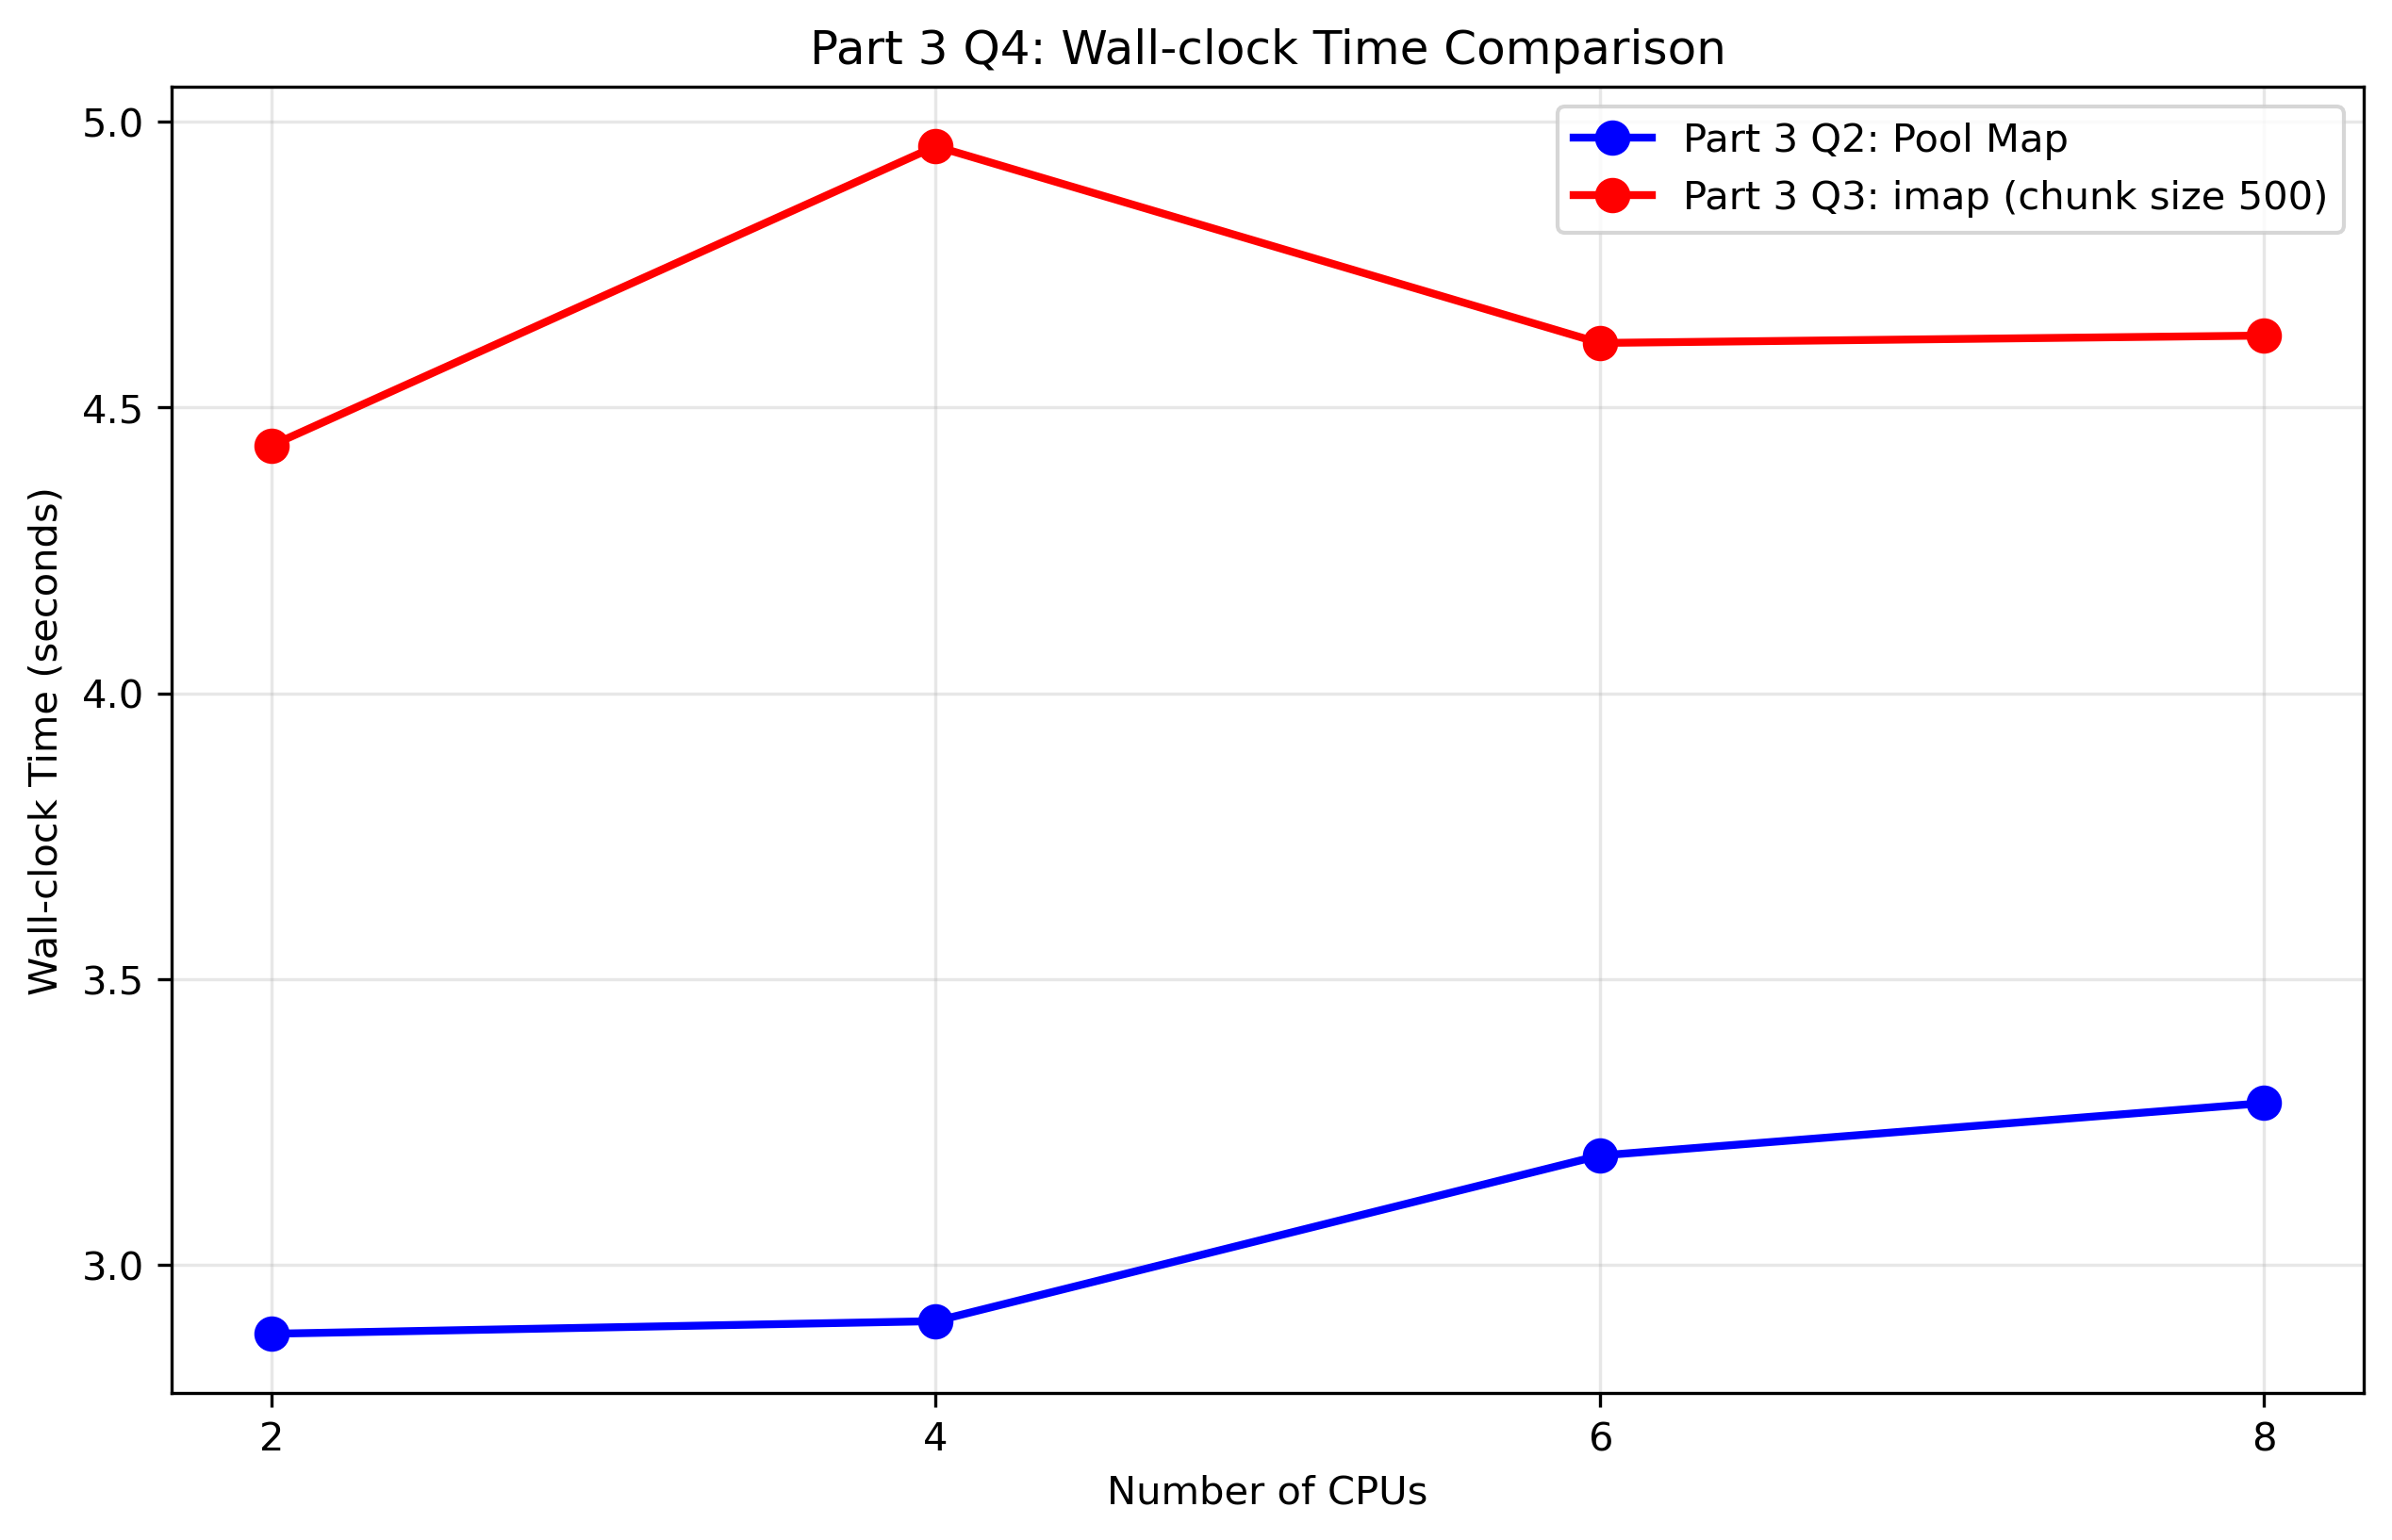
Figure: Part3 Q4 Comparison Time
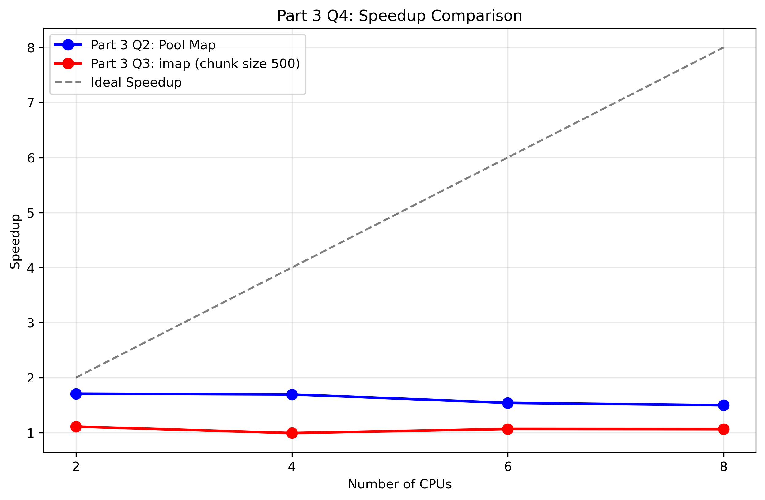
Figure: Part3 Q4 Comparison Speedup
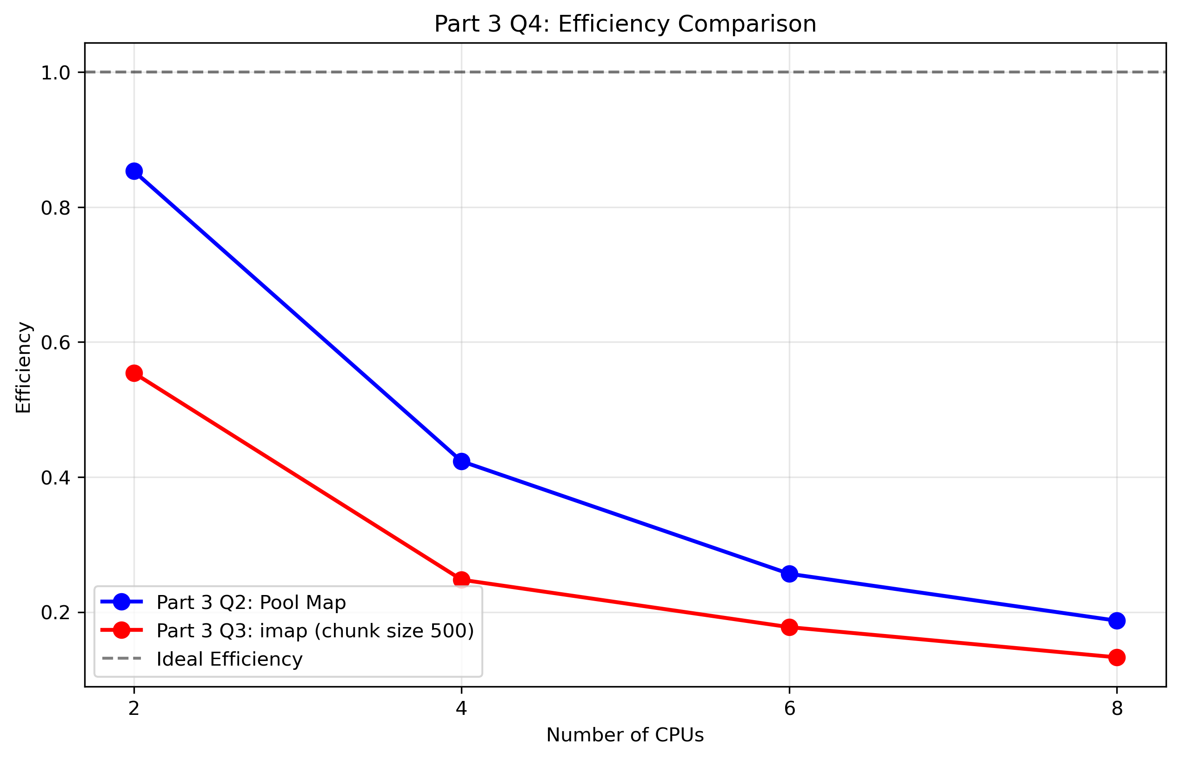
Figure: Part3 Q4 Comparison Efficiency

Part 3 Performance Analysis and Discussion

Part 3 Speedup Analysis
The speedup analysis for correlation computation reveals the following key findings:
**Part 3 Q2 (Pool Map Method):**
- Maximum speedup achieved: 1.7064
- Maximum efficiency achieved: 0.8532
- Best performance typically occurs at 4-6 CPUs
**Part 3 Q3 (imap Method):**
- Chunk size 100: Maximum speedup = 0.4334, Maximum efficiency = 0.1851
- Chunk size 500: Maximum speedup = 1.1084, Maximum efficiency = 0.5542
- Best chunk size: 500 (based on average wall-clock time)

Part 3 Efficiency Analysis
Efficiency measures for correlation computation:
- Ideal efficiency = 1.0 (100% utilization)
- Both methods show decreasing efficiency as CPU count increases
- This indicates overhead from process communication and synchronization
- Correlation computation shows different efficiency patterns compared to normalization

Part 3 Overhead Analysis
The performance characteristics for correlation computation can be attributed to:
1. **Higher Communication Overhead**: Correlation computation requires more data transfer between processes
2. **Memory Access Patterns**: Row-to-row correlation has different memory access patterns than column normalization
3. **Computational Intensity**: Correlation computation is more compute-intensive per operation
4. **Load Balancing**: Row pair distribution may be less uniform than column distribution

Part 2 vs Part 3 Comparison
**Key Differences Between Normalization and Correlation Parallelization:**
**Normalization (Part 2):**
- Column-based parallelization (200 columns)
- Simple vectorized operations (mean, std)
- Lower communication overhead
- More uniform work distribution
**Correlation (Part 3):**
- Row-pair based parallelization (19,999 pairs)
- More complex statistical computation
- Higher communication overhead
- Potentially less uniform work distribution
**Performance Comparison:**
- Normalization typically shows better speedup due to simpler operations
- Correlation computation is more compute-intensive but has higher overhead
- Communication costs are more significant for correlation due to row-pair distribution
- Memory access patterns differ significantly between the two approaches

Optimal Configuration for Part 3
Based on the results, the optimal configuration for correlation computation is:
- **Method**: imap with chunk size 500
- **CPU Count**: 4-6 CPUs typically provide the best balance
- **Reasoning**: This configuration minimizes overhead while maximizing parallelization benefits for correlation computation

Conclusion
The correlation parallelization demonstrates that different computational tasks have varying parallelization characteristics. While both normalization and correlation benefit from parallelization, the nature of the computation significantly affects the achievable speedup and efficiency. Correlation computation, being more compute-intensive but with higher communication overhead, shows different optimal configurations compared to normalization.

