Team 12

CSCD 350

Group Project Part 3 System Test and Evaluation

6/3/2021

* All Code Snippets should be in this format: @wait | define id for blah | etc *

**Airplane Tests**

**Test 1:** Airplane Straight-and-Level Flight

1.

This test tests if a created plane can fly at a constant altitude in a straight line without changing directions

2.

A bomb daBomb is created, from there we define an airplane plane, then we create daPlane from plane and give it the coordinates 45*30'15#/110*30'10#/200 with course 0 speed 5. We set the altitude to 1000 so the plane is flying off the ground.

3.

define munition bomb daBomb

define airplane plane with munition (daBomb)

create actor daPlane from plane at 45*30'15#/110*30'10#/1000 with course 0 speed 5

4.

The expected results are a plane traveling in a straight horizontal line at a constant altitude

5.

The results were a plane traveling in a straight horizontal line at a constant altitude

6.

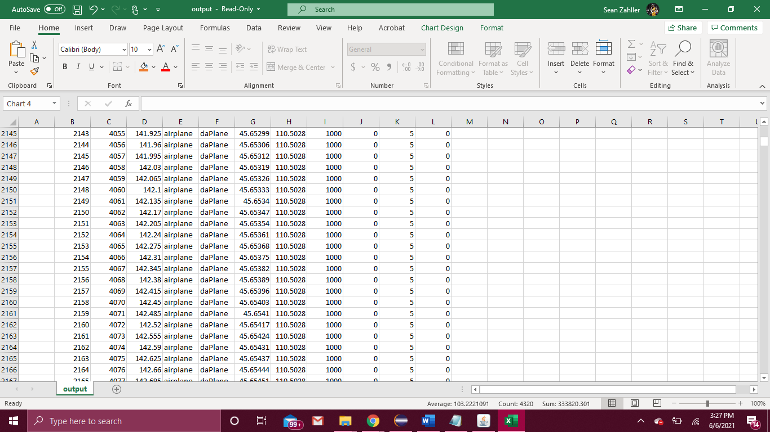

In the first screenshot we can see in event number 2143 the plane is traveling slowly at longitude 110.5028, the latitude is increasing from 45.63299, with an altitude of 1000.

In the next screen shot we are at event 33184, here we can see the longitude is still at 110.5028, the altitude is still 1000, and the latitude has now increased to 47.80847 and is still increasing.

This shows how the plane is flying on a straight horizontal path

7.

The results and the expected results did not differ

8.

A way to extend this test is to create another plane and see if it can travel in a horizontal line in the opposite direction at the same time and get the same expected results.

**Test 2:** Airplane Climbing

1.

This test tests if a plane can travel in a constant upwards direction gaining elevation without changing directions.

2.

A bomb daBomb is created, from there we define an airplane plane, then we create daPlane from plane and give it the coordinates 45*30'15#/110*30'10#/200, so it starts with an altitude of 200 and has course 0 speed 10. We then set the altitude for daPlane 60,000.

3.

define munition bomb daBomb

define airplane plane with munition (daBomb)

create actor daPlane from plane at 45*30'15#/110*30'10#/200 with course 0 speed 5

set daPlane altitude 60000

4.

The expected results are that a plane will be created and fly at a constant rate and direction while gaining elevation at a constant rate

5.

The actual results were that the plane flew in a constant rate and direction while gaining elevation at a constant rate

6.

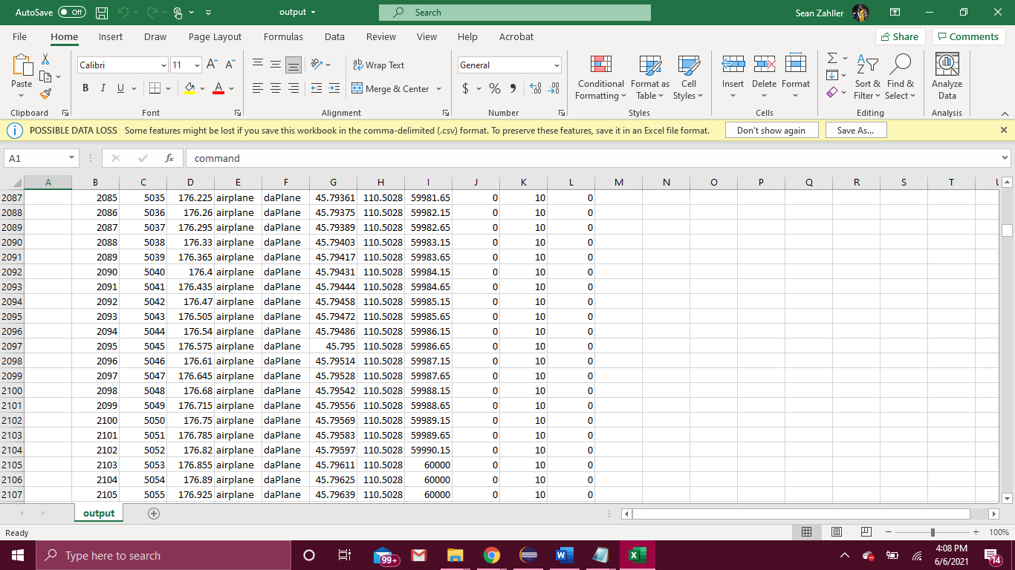

In the first screenshot we can see that the plane begins to climb from altitude 200 at a constant rate from latitude 45.57778 while the longitude is at 110.5028

In the second screenshot we can see that the plane continues to climb to altitude 60000 at a constant rate from latitude 59987.15 while the longitude is at 110.5028.

This shows how the plane can climb elevation at a constant rate.

7.

The results and the expected results did not differ

8.

A way to extend this test would be to descend back down to ground level after ascending to a certain altitude.

**Test 6:** Airplane 180-Degree Turn, Slow-Speed

1.

This test is to test if an airplane can make a 180 degree turn(reverse directions) at a slow constant speed

2.

A bomb daBomb is created, from there we define an airplane plane, then we create daPlane from plane and give it the coordinates 49*40'15#/117*26'10#/200 with course 0 speed 2. From there we change the course to 180 degree turn.

3.

define munition bomb daBomb

define airplane plane with munition (daBomb)

create actor daPlane from plane at 49*40'15#/117*26'10#/200 with course 0 speed 2

set daPlane course 180

4.

The expected results are that a plane will be created and fly making a 180-degree turn and keep flying in that direction. The turn will will be a well rounded turn

5.

The actual results that a plane was created and made a 180-degree sharp turn and kept flying in that direction

6.

In the screenshot above we can see that plane began to head to 180 degrees in constant increments

7.

The results weren’t exactly as expected. The plane made an unrealistic very sharp 180-degree turn before the plane could move very far, I thought the plane would turn a little slower and would make a more rounded turn. This could be because the window zoom is very zoomed out

8.

A way to extend the test would be to see if you can make a 180 degree turn while descending at the same time, as if you were getting ready for an emergency landing in a flat area behind the plane.

Bomb Tests

**Test 8:** Bomb Drop, High Speed

1.

2.

3.

4.

5.

6.

7.

8.

**Test 9:** Bomb Drop, Low Speed, Hit

1.

2.

3.

4.

5.

6.

7.

8.

**Test 10:** Bomb Drop, Low Speed, Miss

1.

2.

3.

4.

5.

6.

7.

8.

**Depth-Charge Tests**

All depth charges are dropped by a ship.

**Test 11**: Depth Charge, Acoustic Fuze, Hit

1.

2.

3.

4.

5.

6.

7.

8.

**Test 12:** Depth Charge, Acoustic Fuze, Miss

1.

2.

3.

4.

5.

6.

7.

8.

**Test 13:** Depth Charge, Depth Fuze

1.

2.

3.

4.

5.

6.

7.

8.

**Test 14:** Depth Charge, Sonar Fuze

1.

2.

3.

4.

5.

6.

7.

8.

**Test 15:** Depth Charge, Time Fuze

1.

2.

3.

4.

5.

6.

7.

8.

**Missile Tests**

**Test 16:** Missile, Radar Sensor, Depth Fuze

1.

2.

3.

4.

5.

6.

7.

8.

**Test 17:** Missile, Radar Sensor, Distance Fuze

1.

2.

3.

4.

5.

6.

7.

8.

**Test 18:** Missile, Radar Sensor, Radar Fuze

1.

2.

3.

4.

5.

6.

7.

8.

**Test 19:** Missile, Radar Sensor, Thermal Fuze

1.

2.

3.

4.

5.

6.

7.

8.

**Test 20:** Missile, Radar Sensor, Time Fuze

1.

2.

3.

4.

5.

6.

7.

8.

**Test 21:** Missile, Thermal Sensor, Radar Fuze

1.

2.

3.

4.

5.

6.

7.

8.

**Test 22:** Missile, Thermal Sensor, Radar Fuze, Field-of-View Miss

1.

2.

3.

4.

5.

6.

7.

8.

**Test 23:** Missile, Radar Sensor, Radar Fuze, Aspect Angle

1.

2.

3.

4.

5.

6.

7.

8.

**Test 24:** Missile, Thermal Sensor, Thermal Fuze

1.

2.

3.

4.

5.

6.

7.

8.

**Torpedo Tests**

**Test 25:** Torpedo, Sonar Sensor, Acoustic Fuze, Fast Target

1.

2.

3.

4.

5.

6.

7.

8.

**Test 26:** Torpedo, Sonar Sensor, Acoustic Fuze, Slow-Target Miss

1.

2.

3.

4.

5.

6.

7.

8.

**Test 27:** Torpedo, Sonar Sensor, Sonar Fuze

1.

2.

3.

4.

5.

6.

7.

8.

**Test 28:** Torpedo, Acoustic Sensor, Acoustic Fuze, Fast Target

1.

2.

3.

4.

5.

6.

7.

8.

**Test 29:** Torpedo, Acoustic Sensor, Acoustic Fuze, Slow-Target Miss

1.

2.

3.

4.

5.

6.

7.

8.

**Test 30:** Torpedo, Acoustic Sensor, Thermal Fuze

1.

2.

3.

4.

5.

6.

7.

8.