Sean Kanaley

3/8/2017

SQL DBM 126

create table DogLicense

(

License int primary key not null,

Expires date check(Expires > '01/01/1990') not null,

Sex nvarchar(2) check(Sex = 'M' or Sex = 'F' or Sex = 'NM' or Sex = 'SF') not null,

PetName nvarchar(50),

Breed nvarchar(20),

OwnerLastName nvarchar(20) not null,

OwnerFirstName nvarchar(20),

Address nvarchar(50) not null,

City nvarchar (20) default 'Spokane',

State nvarchar(2) default 'WA',

Zip nvarchar(5) check(Zip >= 99201 and Zip <= 99212),

Phone nvarchar(15),

Fee money check(Fee >= $10 and Fee <= $90) not null,

AgressiveDog nvarchar(1) check(AgressiveDog = 'T' or AgressiveDog = 'F') default 'F'

)

1. 8 Done with Top 200 Edit, remaining two to show the other methods.

insert into DogLicense (License, Expires, Sex, PetName, Breed, OwnerLastName, OwnerFirstName, Address, City, State, Zip, Phone, Fee, AgressiveDog)

values (122, '2018-05-22', 'M', 'Lincoln', 'Shitzu', 'Mako', 'Jamey', '503. E Milton', 'Spokane', 'WA', '99207', '509-467-8656', '60', 'F');

insert into DogLicense

values (132, '2018-06-15', 'SF', 'Milly', 'Pug', 'Jameson', 'Michael', '411 Westland', 'Spokane', 'WA', '99208', '509-467-4252', '42', 'T');

Starting Records

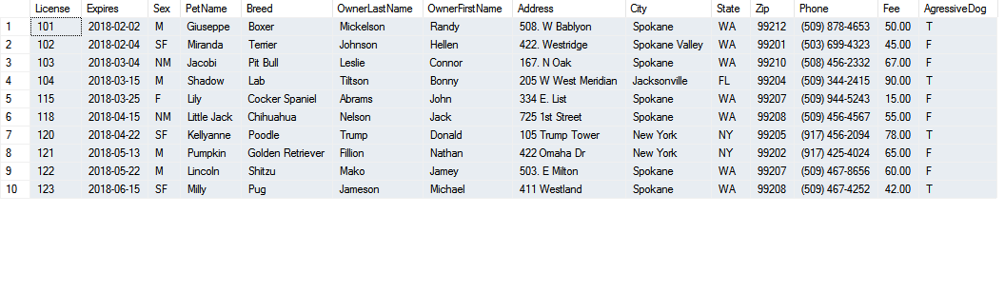

update DogLicense

set Phone = '(509) 555-9897'

where License = '118'

delete from DogLicense

where OwnerFirstName = 'Connor' and OwnerLastName = 'Leslie'

update DogLicense

set City = 'Spokane Valley'

update DogLicense

set Fee = '50'

where Sex = 'F' or Sex = 'M'

update DogLicense

set Fee = '25'

where Sex != 'F' and Sex != 'M'

update DogLicense

set Fee = '35'

where Sex = 'SF' or Sex = 'NM'

delete from DogLicense

where AgressiveDog = 'T'

Remaining records

