**Java Database Connectivity (JDBC)**

JDBC is a software layer that allows developers to write real client-server projects in Java. JDBC was designed to be a very compact, simple interface focusing on the execution of raw SQL statements and retrieving the results. The components of JDBC are Application, Driver manager and Driver.

1. Database called db1 containing some basic information of student was created using MySQL Workbench 8.0.

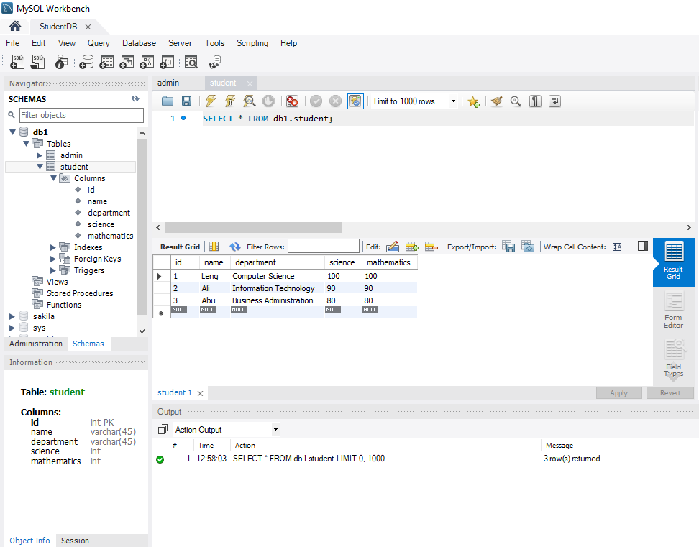

1. Java project that used to retrieve the student information from database was created using Eclipse.

