Assignment 1
- This is the wireframe for my homepage
- It features a header nav bar footer and an image
- Also features a small intro paragra[h about myself
- T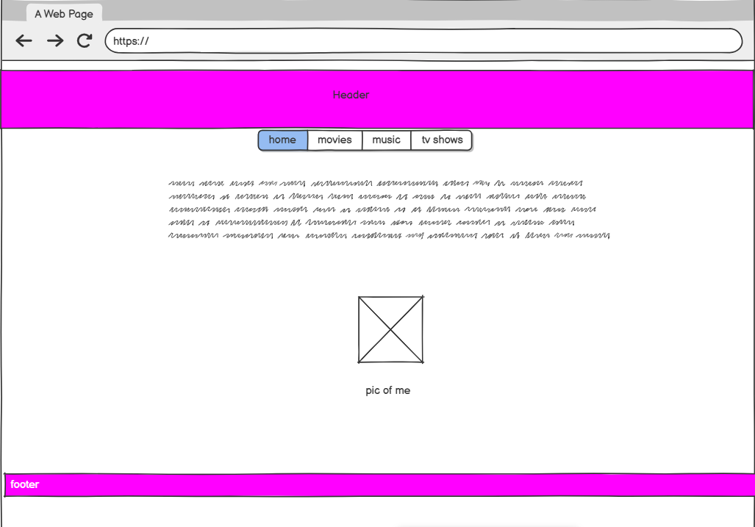
- This is the music page of my site
- It featuresa header footer nav bar and background image of my guitar
- And a paragraph on music in my life
- 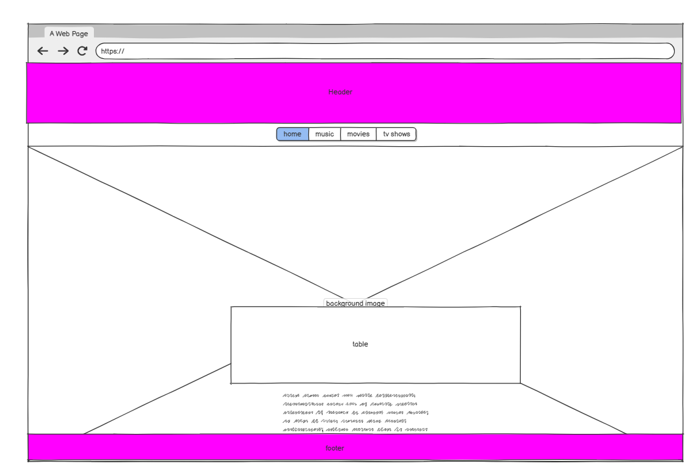
- This is the movies page of my site
- Featues a header nav bar table footer and a link
- Also a paragraph on why I like film and cinema
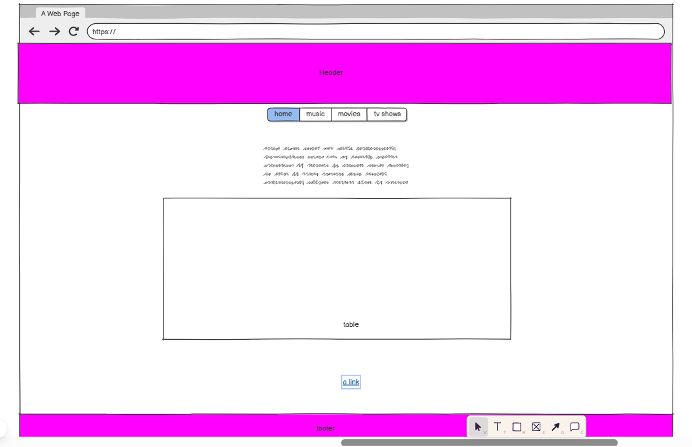

- This is the final page of my site
- It is about tv shows and why I like them so much
- It features a header nav bar footer table
- Also a para``graph on my interest in this media
